Experiment – 3
Application Building using
Zia Assistant
College Student Administration System in Zoho Creator
Department of Computer Science and Engineering
Student Name: Ashwanth K
Roll No: 240701057
Application Name: College Student Administration System

Objective
To build a complete, working College Student Administration System in Zoho Creator using the Zia AI Assistant (App Builder), by supplying a natural-language description of the required application, reviewing the use cases and data model generated by Zia, and verifying the resulting forms, reports, and dashboard.

Application Overview
Zia is the artificial-intelligence assistant of Zoho Creator. Instead of creating forms field by field, the developer describes the application in plain English and Zia derives the use cases, the data model with all required fields and relationships, the entry forms, the reports, and an analytics dashboard. The generated application is then reviewed and published.
The application built in this experiment allows administrators and faculty of a college to maintain department details, register students, define courses with their instructors and prerequisites, enrol students in courses, record class attendance, and store assessment marks, percentages, and grades.

Prompt Given to Zia
Create a Student Management Application for a college. The application should allow administrators/faculty to manage students, departments, courses, attendance, marks, and student records.

Use Cases Proposed by Zia
Before creating the application, Zia analysed the prompt and proposed the following use cases:
- Student Enrollment Processing — register new students and assign them to specific departments and courses.
- Departmental Staff Allocation — assign faculty members to manage specific academic departments and courses.
- Attendance Tracking System — record daily student attendance status for each scheduled class session.
- Grade Calculation and Storage — compute final marks for students based on entered assessment data.
- Academic Record Retrieval — access and view historical student performance and enrollment details.

Modules Generated
- Departments — department name, code, head of department, contact details, location, status, and budget allocation.
- Student Profiles — student name, student code, contact details, date of birth, gender, enrollment date, academic year, current status, and emergency contact.
- Courses — course name, code, credits, semester, description, prerequisites, instructor, and owning department.
- Enrollments — student, course, enrollment date and status, semester, academic year, registration fee, and primary-course flag.
- Attendance — student, course, date, attendance status, remarks, recorded-by, session ID, and compulsory flag.
- Marks Records — student, course, assessment type, marks obtained and possible, percentage, grade, and assessment date.
- Dashboard — summary tiles, marks analysis charts, attendance status counts, and quick-link actions.

Data Model Generated by Zia
Form | Key Fields | Relationship
Department | Department Name, Department Code, Head of Department, Department Email, Department Phone, Location, Created Date, Status, Description, Budget Allocation | Referenced by Course
Student Profile | Student Name, Student Code, Email Address, Phone Number, Date of Birth, Gender, Enrollment Date, Academic Year, Current Status, Emergency Contact | Referenced by Enrollment, Attendance and Marks Record
Course | Course Name, Course Code, Credits, Semester, Description, Prerequisites, Instructor, Department | Lookup to Department
Enrollment | Student, Course, Enrollment Date, Enrollment Status, Semester, Academic Year, Registration Fee, Is Primary | Lookup to Student Profile and Course
Attendance | Student, Course, Attendance Date, Attendance Status, Remarks, Recorded By, Session ID, Is Compulsory | Lookup to Student Profile and Course
Marks Record | Student, Course, Assessment Type, Total Marks Obtained, Total Marks Possible, Percentage, Grade, Assessment Date, Remarks | Lookup to Student Profile and Course
Table 3.1: Forms and relationships generated automatically by Zia.

Screenshot-based lab record
The following pages contain the actual Zoho Creator screenshots showing the Zia App Builder prompt, the generated data model, the live forms, the reports, and the analytics dashboard of the College Student Administration System.

Screenshots 1 – Zia App Builder
The application description was entered in the Zia App Builder. Zia analysed the prompt and proposed the use cases together with a complete data model before the application was created.
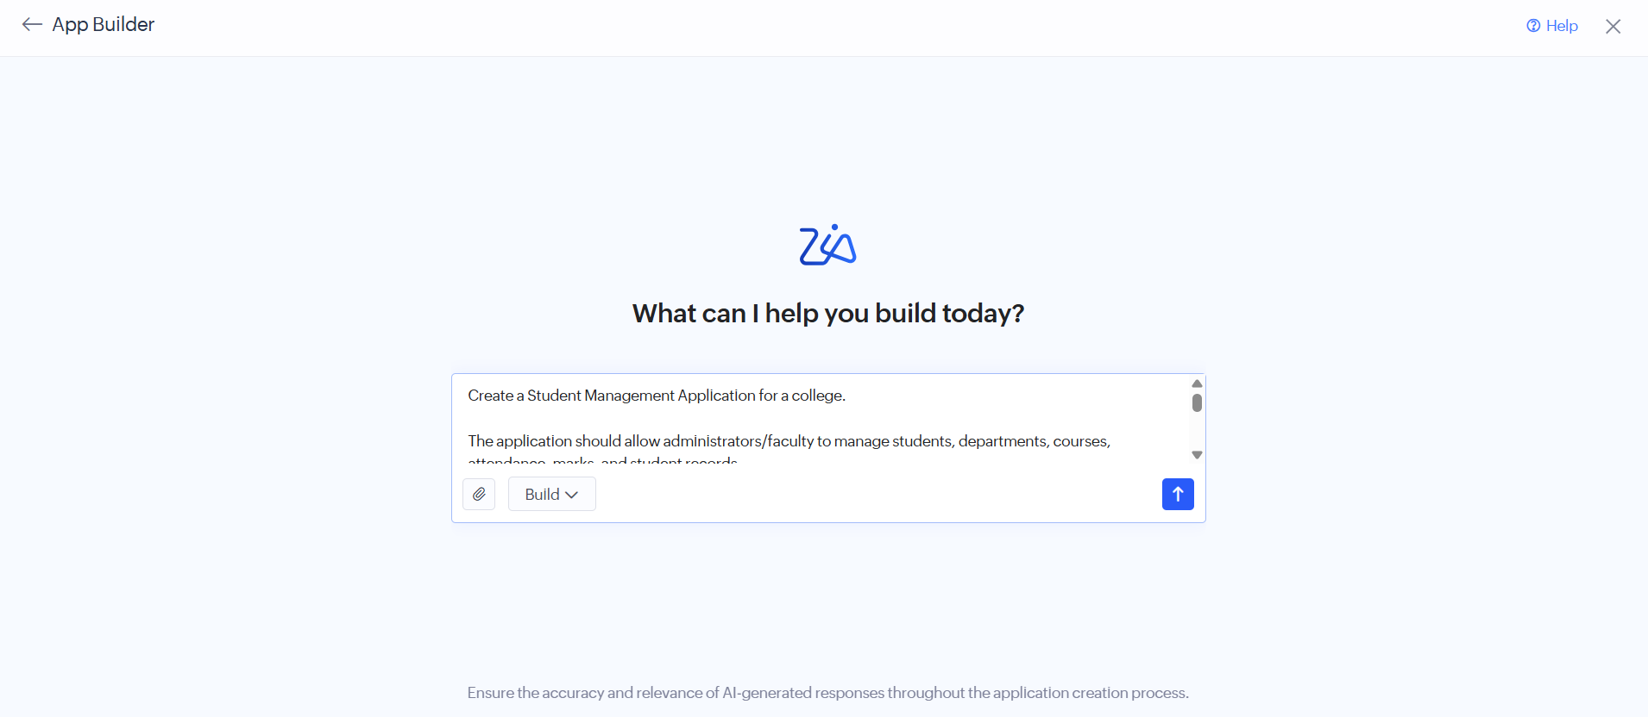
Figure 1.1: Application requirement described in the Zia App Builder prompt.
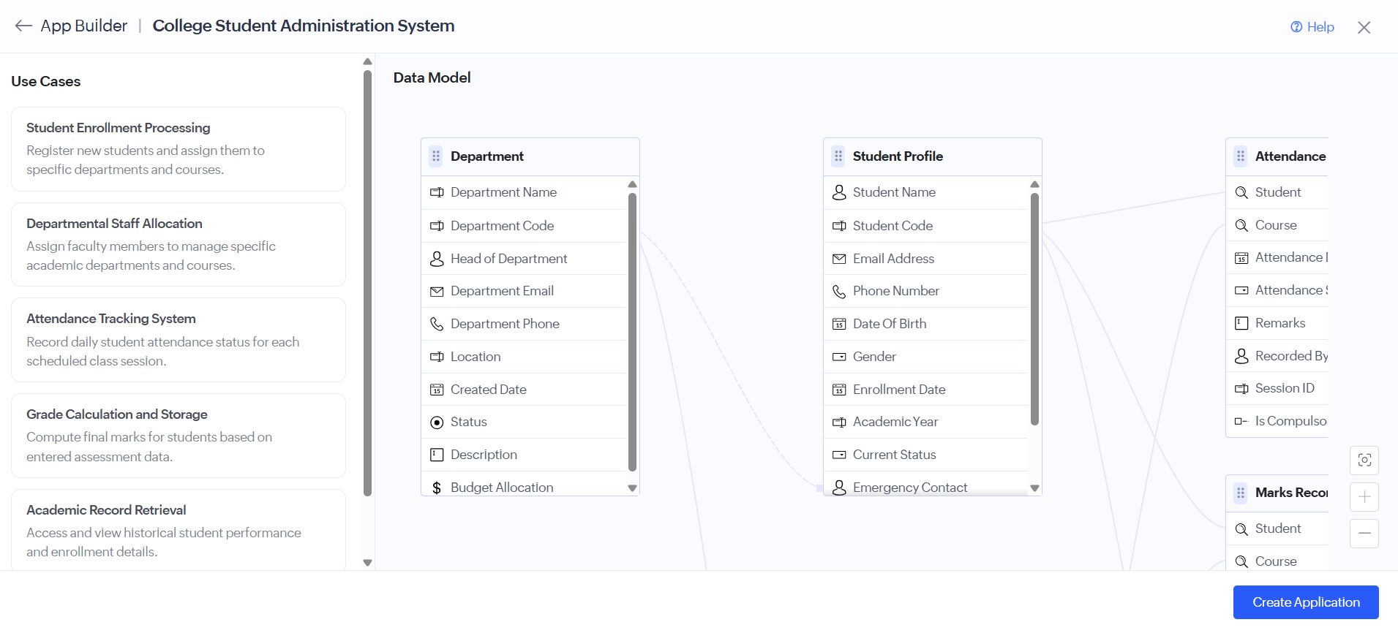
Figure 1.2: Use cases and data model generated by Zia, showing the Department, Student Profile, Attendance, and Marks Record forms and their linked fields.

Screenshots 2 – Generated Forms
Zia created the data-entry forms with appropriate field types — single line, number, decimal, date, drop-down, lookup, radio, phone, checkbox, and multi line — along with mandatory-field validation.
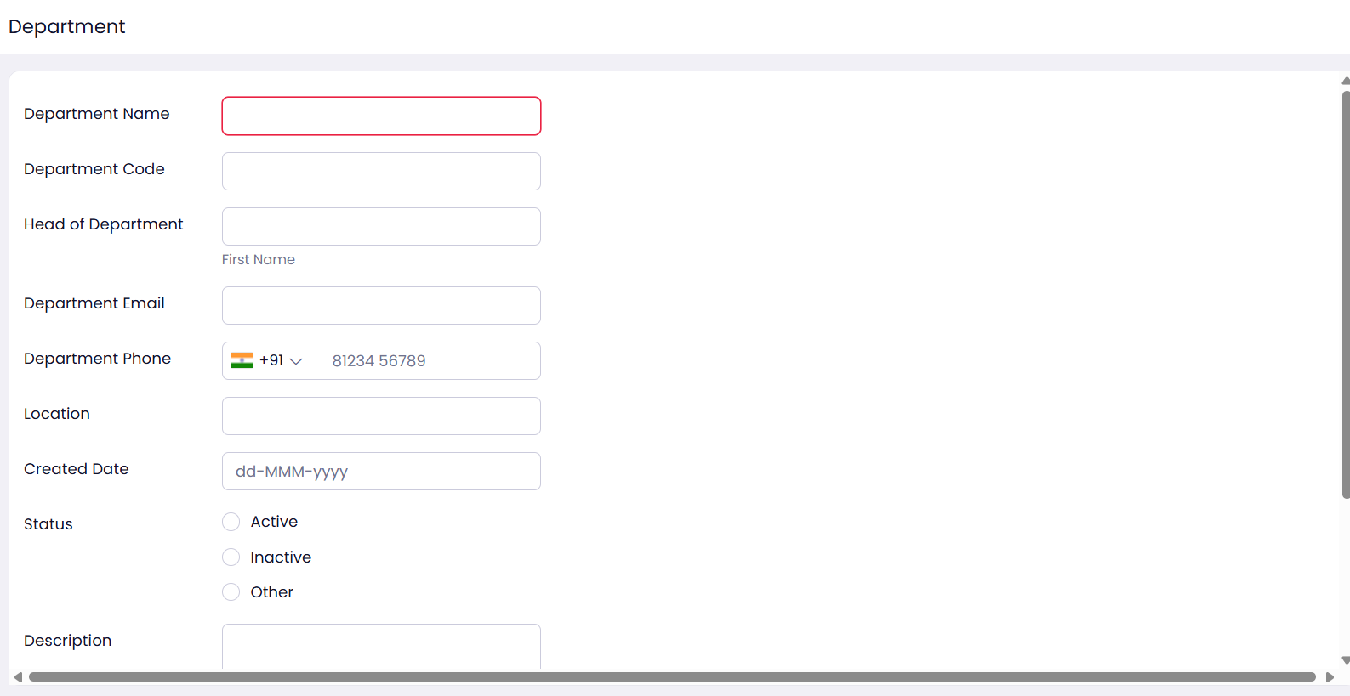
Figure 2.1: Department form with name, code, head of department, contact details, location, created date, and status options.
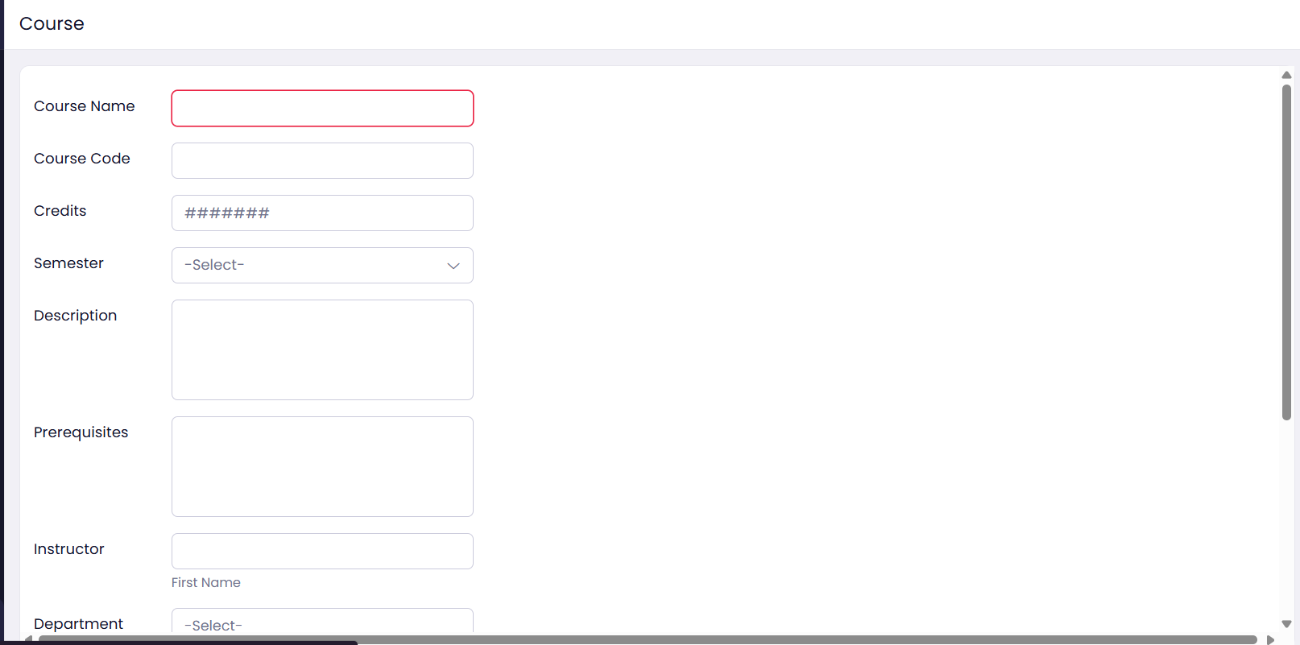
Figure 2.2: Course form with course code, credits, semester drop-down, description, prerequisites, instructor, and department.
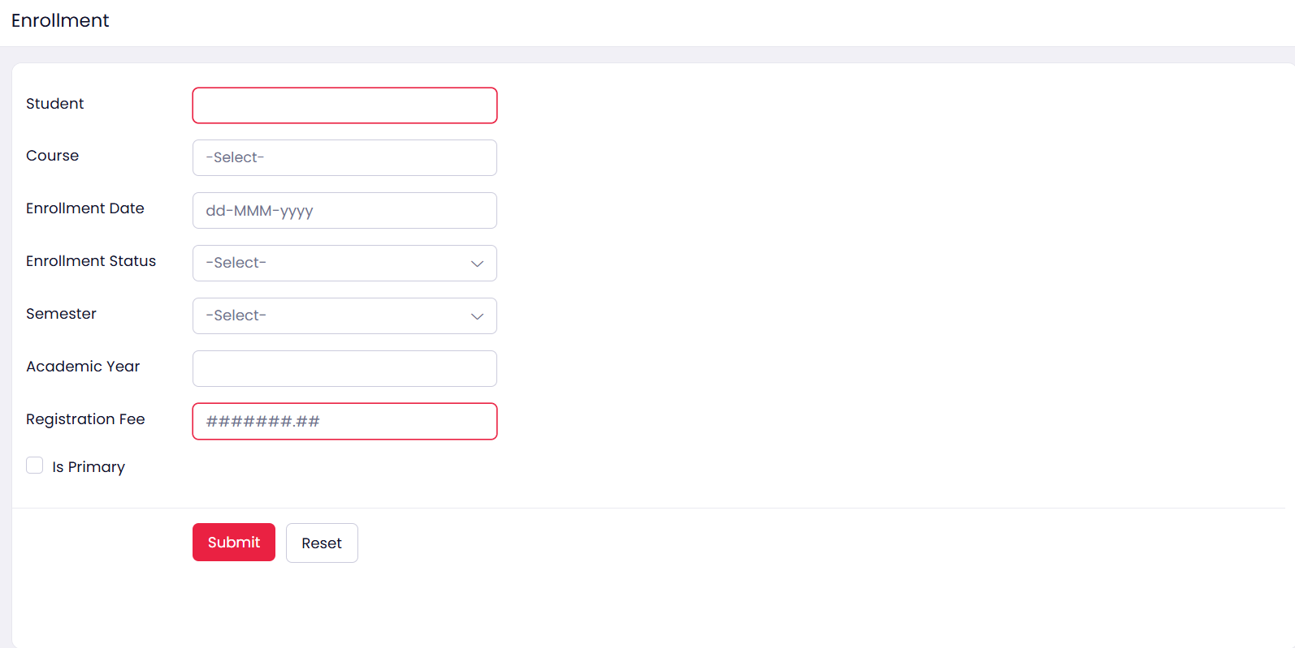
Figure 2.3: Enrollment form with student and course lookups, enrollment date, status, semester, academic year, registration fee, and primary flag.
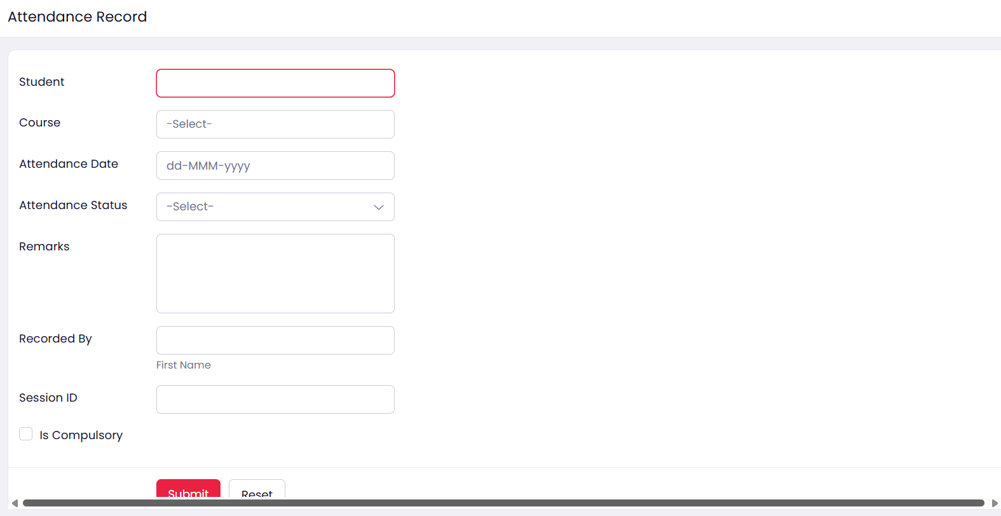
Figure 2.4: Attendance Record form with student and course lookups, attendance date, status drop-down, remarks, recorded-by, session ID, and compulsory flag.
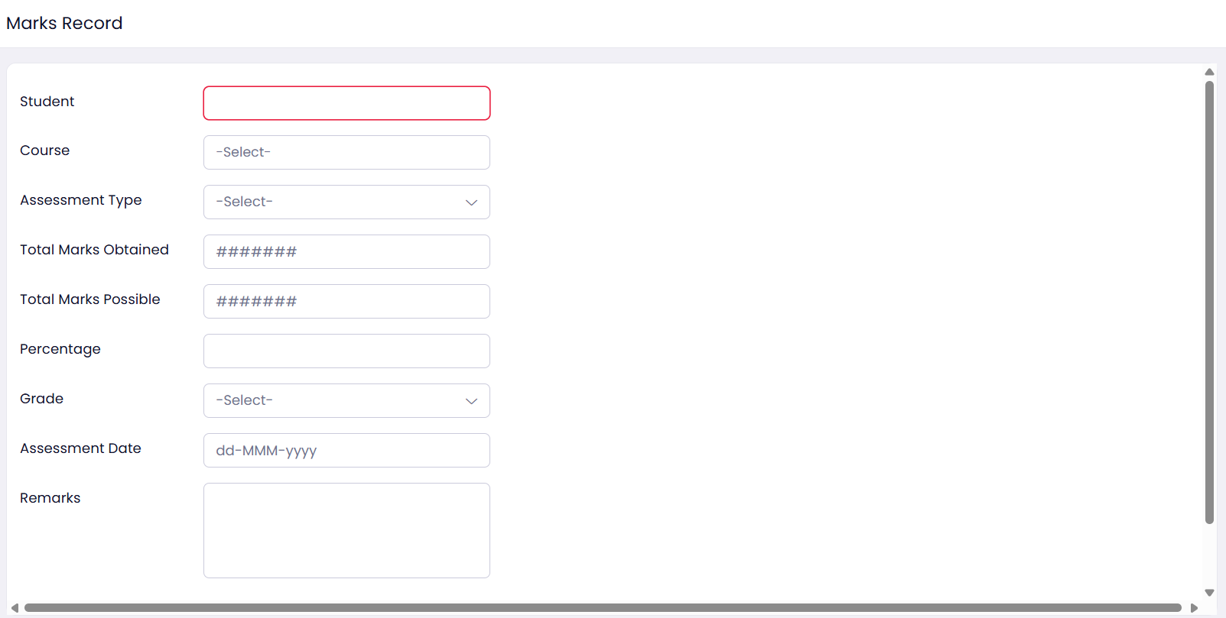
Figure 2.5: Marks Record form with student and course lookups, assessment type, marks obtained and possible, percentage, grade, assessment date, and remarks.

Screenshots 3 – Generated Reports
List and kanban reports were generated automatically for every form, allowing records to be viewed, searched, grouped, and summarised.
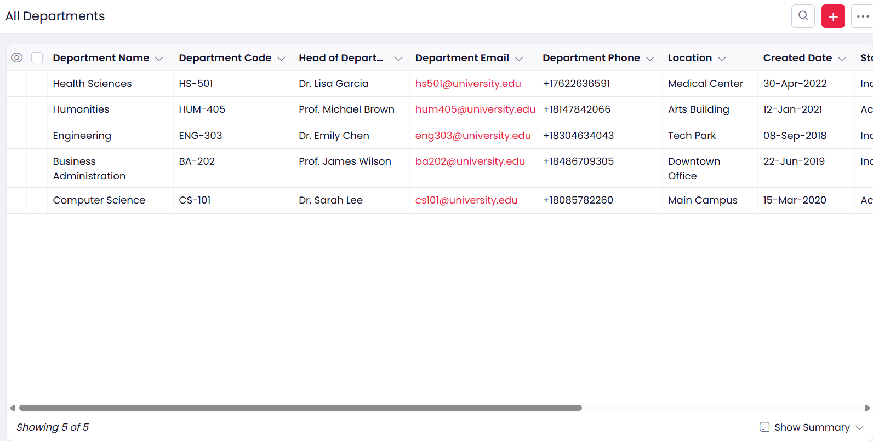
Figure 3.1: All Departments report showing five department records with head, email, phone, location, and created date.
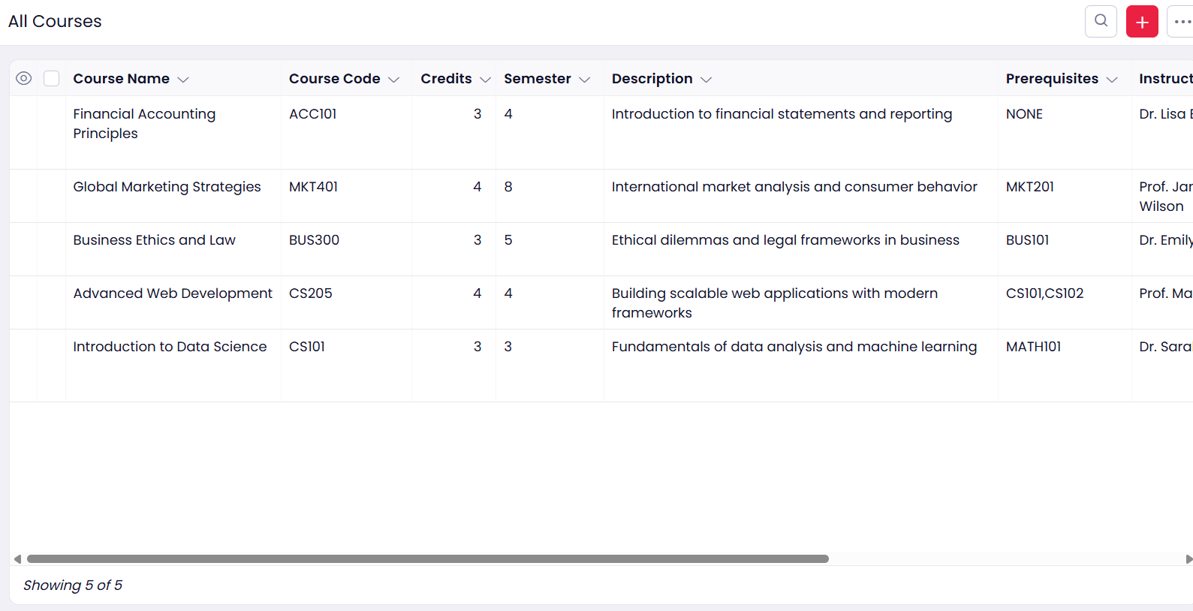
Figure 3.2: All Courses report showing five course records with code, credits, semester, description, and prerequisites.
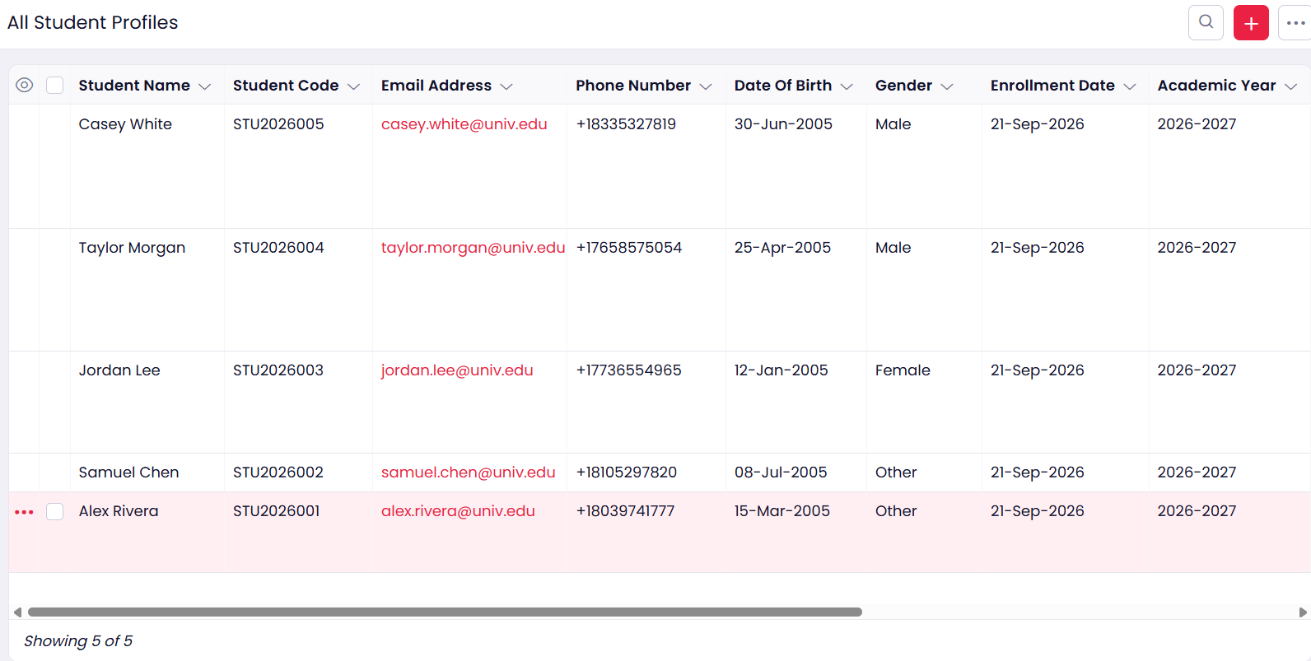
Figure 3.3: All Student Profiles report showing five registered students with code, email, phone, date of birth, gender, and academic year.
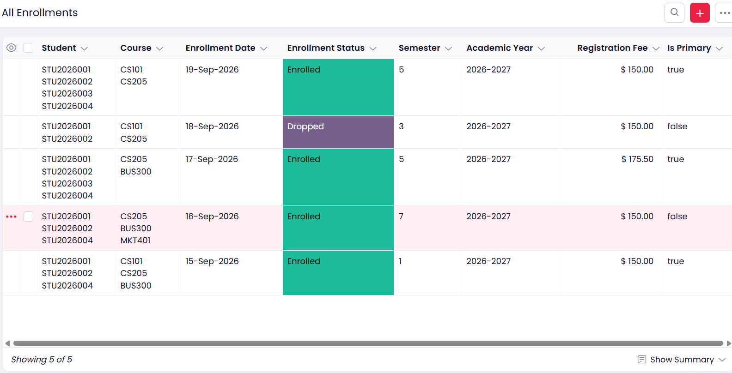
Figure 3.4: All Enrollments report showing five enrollment records with status, semester, academic year, and registration fee.
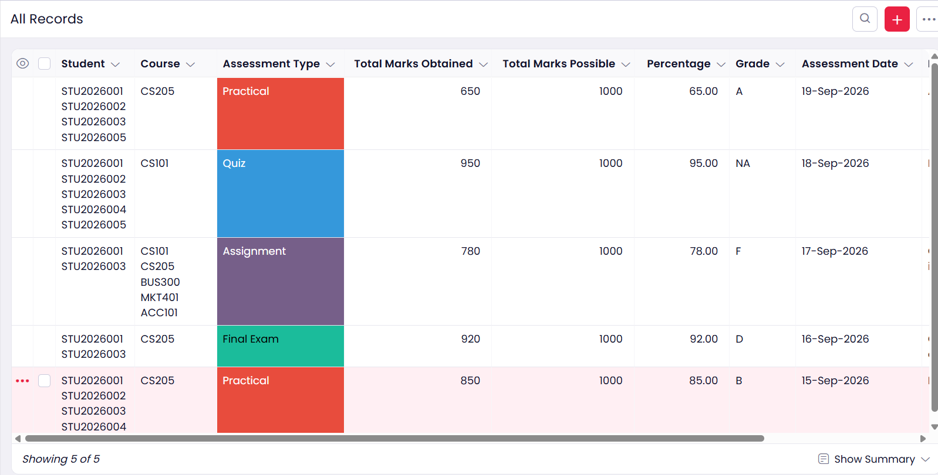
Figure 3.5: All Records report for marks, showing five assessment entries with type, marks obtained, marks possible, percentage, and grade.
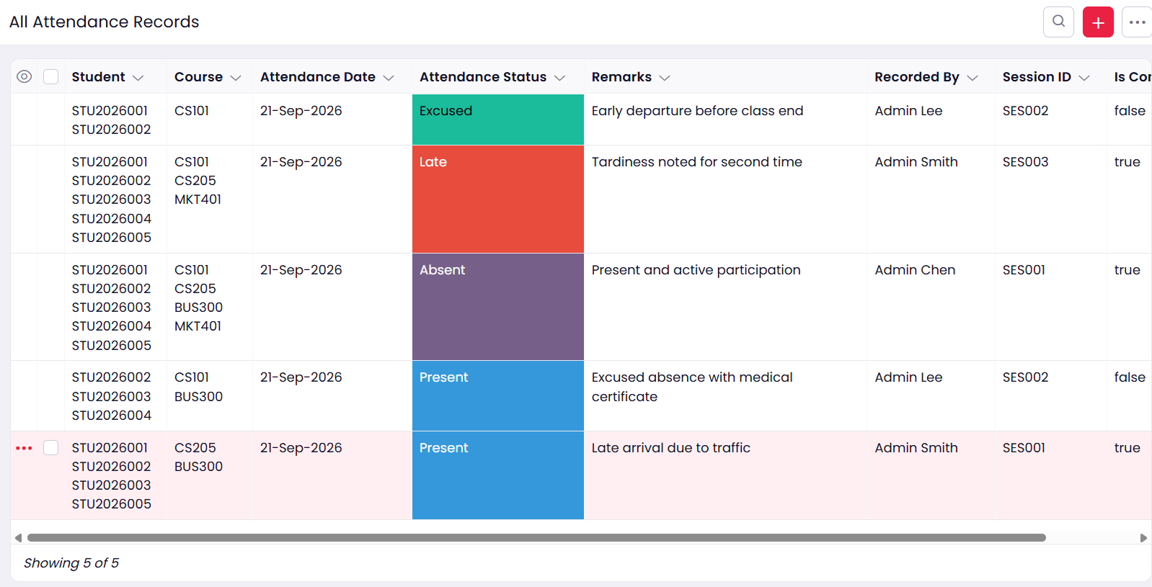
Figure 3.6: All Attendance Records report showing five entries with attendance status, remarks, recorded-by, and session ID.
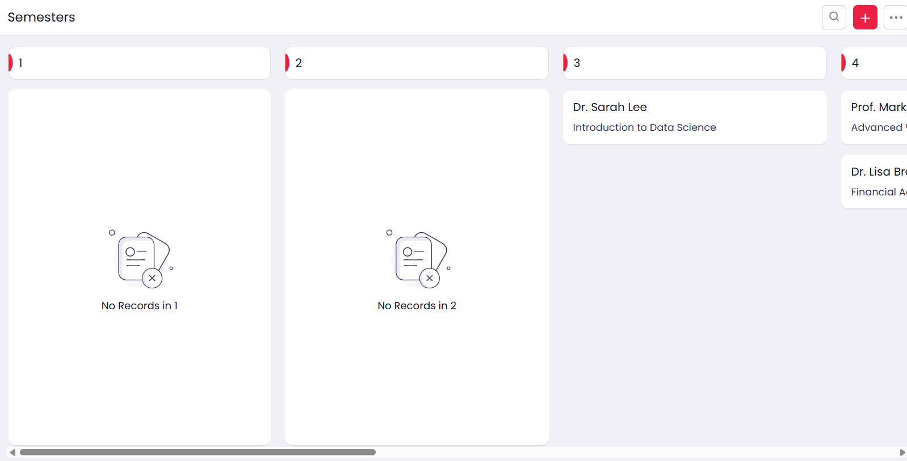
Figure 3.7: Semesters kanban report grouping courses and their instructors by semester.

Screenshots 4 – Dashboard
Zia also generated an analytics dashboard with summary tiles, charts, and quick links for frequent actions.
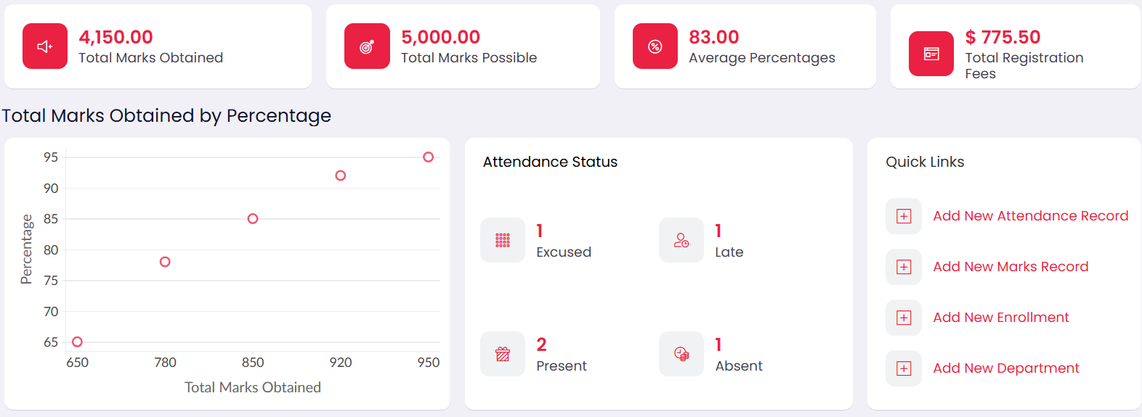
Figure 4.1: Dashboard with summary tiles, marks-by-percentage chart, attendance status counts, and quick links.
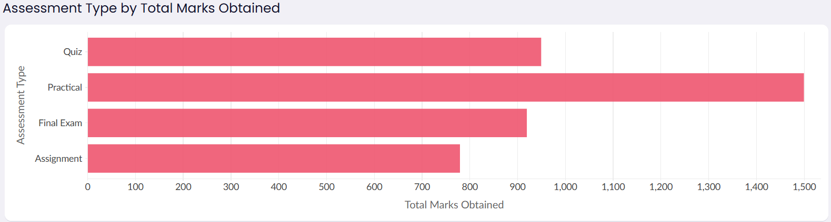
Figure 4.2: Distribution of total marks obtained by assessment type (Quiz, Practical, Final Exam, Assignment).

Observation
The entire application — six related forms, the corresponding reports, a kanban view, and an analytics dashboard — was produced from a single natural-language prompt, without manually creating any field, relationship, report, or chart. Zia inferred the lookup relationships between Course and Department, and between Enrollment, Attendance, Marks Record, Student Profile, and Course correctly, and assigned suitable data types to each field, such as radio buttons for status, a phone field with country code, a decimal field for the registration fee, checkboxes for flags, and drop-downs for semester, attendance status, and assessment type. Only minor review and data entry were required afterwards, which reduced the development effort further compared with building the same application manually in the Form Builder.

Result
The College Student Administration System was successfully built in Zoho Creator using the Zia AI Assistant. The generated data model, forms, reports, kanban view, and dashboard were verified with sample records, and the dashboard correctly summarised the data (4,150 marks obtained out of 5,000 possible, with an average percentage of 83). The application functioned as required.

