Experiment – 4
Reports
Creating and Viewing Reports in Zoho Creator
Department of Computer Science and Engineering
Student Name: Ashwanth K
Roll No: 240701057
Application Name: College Student Administration System

Objective
To study the different report types available in Zoho Creator and to create and view List, Grid, Kanban, and Calendar reports for the College Student Administration System, using the Attendance data.

Introduction
A report in Zoho Creator is a view that displays the records stored through a form. A single form can have any number of reports, each presenting the same data in a different arrangement, with its own columns, filters, grouping, sorting, and permissions. Reports are created without writing code; the required view type is selected and the fields to be displayed are chosen.

Report Types Used
Report Type | Description | Used For
List | Displays records row by row with selected columns, colour-coded status, search, sorting, and record count | All Attendance Records — viewing every attendance entry with its status, remarks, recorder, and session
Grid | A spreadsheet-like view in which records are numbered and values can be edited inline | All Attendance Records — quick review and correction of attendance data
Kanban | Groups records into vertical lanes based on a chosen field, shown as cards | Attendance records grouped by Attendance Status
Calendar | Plots records on a calendar using a date field, with Month, Week, and Day views | All Attendance Records — attendance entries plotted by Attendance Date
Table 4.1: Report types created in the College Student Administration System.

Screenshot-based lab record
The following pages contain the actual Zoho Creator screenshots of the List, Grid, Kanban, and Calendar reports created for the application.

Screenshots 1 – List Report
The List report displays the attendance records row by row with the columns Student, Course, Attendance Date, Attendance Status, Remarks, Recorded By, Session ID, and Is Compulsory. The Attendance Status values are colour-coded, and search, column-wise sorting, and a record count are available.
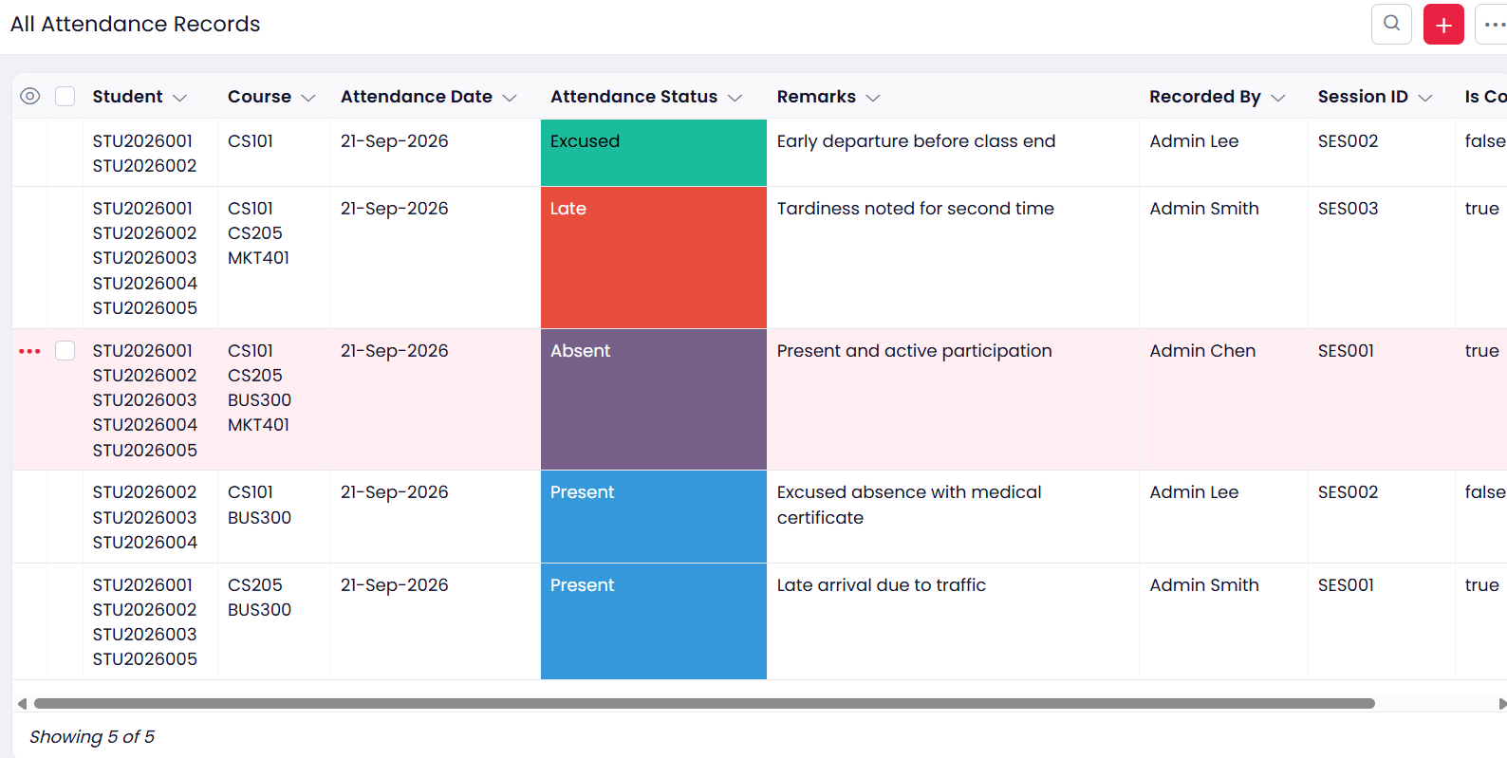
Figure 1: All Attendance Records List report showing five attendance records.

Screenshots 2 – Grid Report
The Grid report presents the same records in a spreadsheet-like layout with serial numbers against each row, which makes bulk review and inline editing convenient. Students and courses appear as editable tags, the date has a date picker, and the Attendance Status is a drop-down. Changes made in the grid are applied using the Save Changes option.
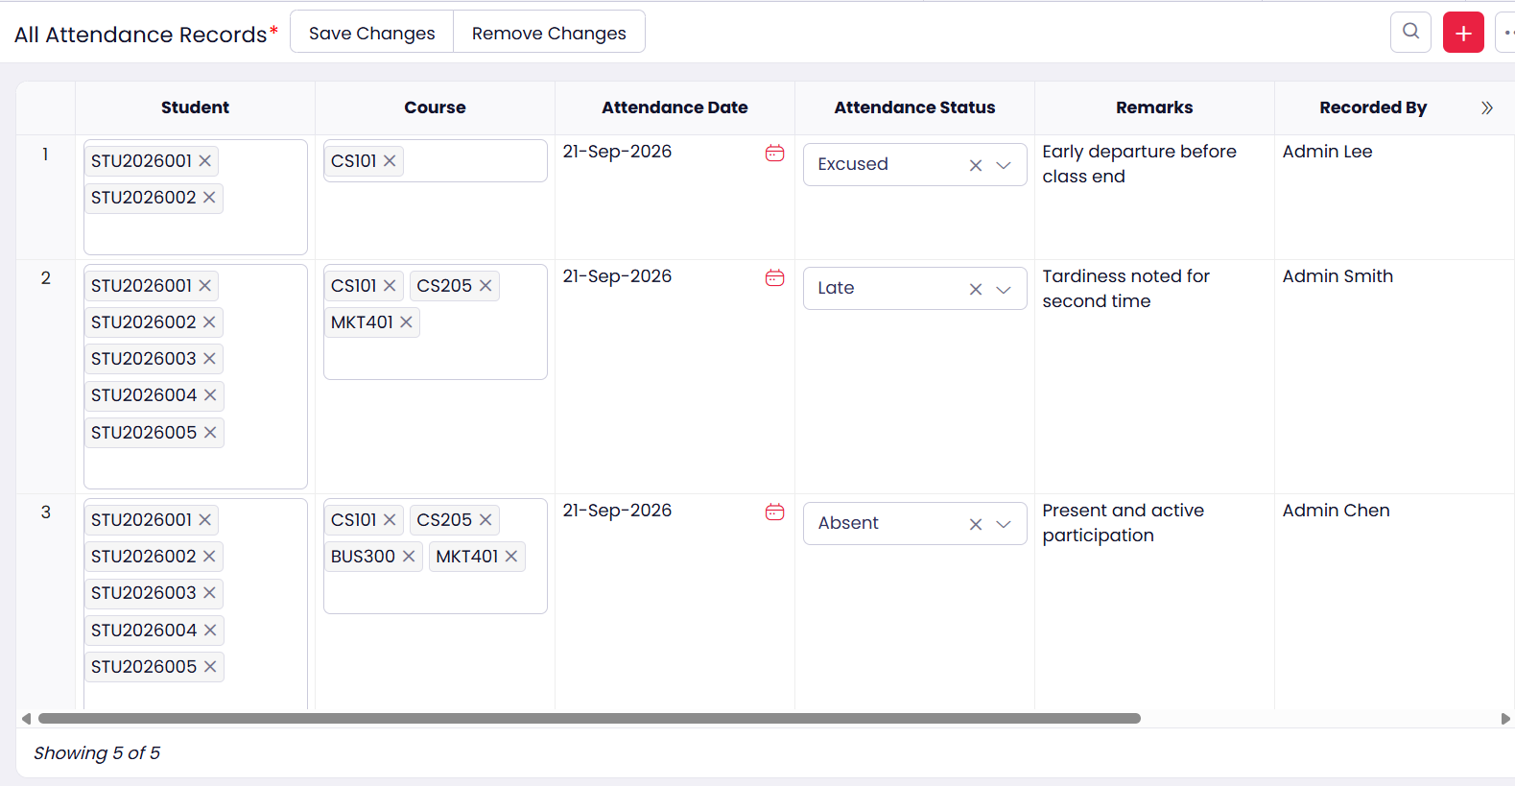
Figure 2: All Attendance Records Grid report with numbered rows and inline editing.

Screenshots 3 – Kanban Report
The Kanban report groups the attendance records into lanes based on the Attendance Status field. Each record is displayed as a card showing the attendance date, the courses, the status, the person who recorded it, and the session ID, and a card can be dragged from one lane to another to change its status.
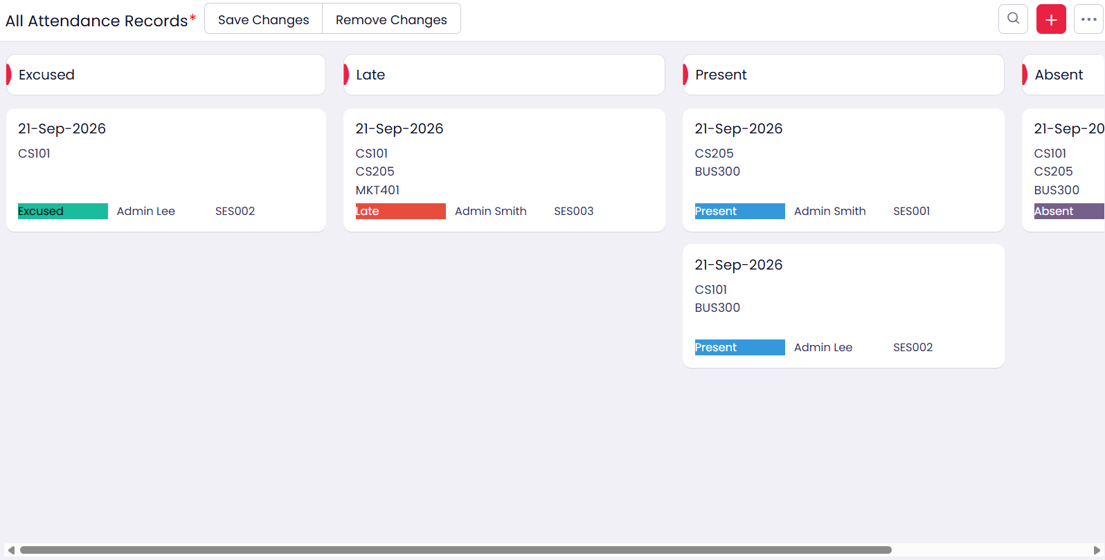
Figure 3: All Attendance Records Kanban report grouped by Attendance Status, with Excused, Late, Present, and Absent lanes.

Screenshots 4 – Calendar Report
The Calendar report plots the attendance records on a calendar using the Attendance Date field, so that every entry appears on the day it was recorded. The view can be switched between Month, Week, and Day, and the Week view can also be displayed with hour-wise time slots.
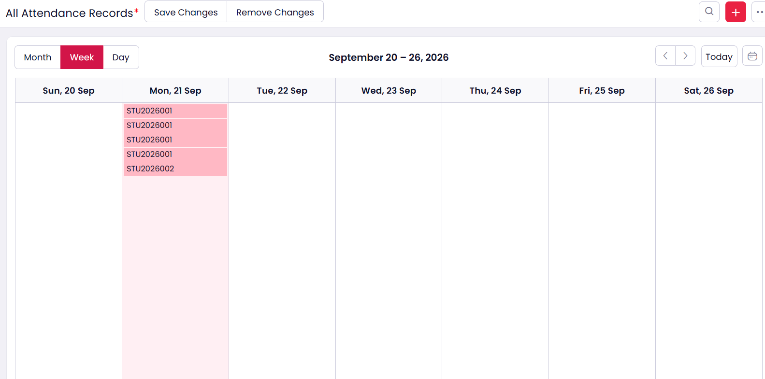
Figure 4.1: All Attendance Records Calendar report — Week view for 20–26 September 2026 showing the five entries on Monday, 21 September.
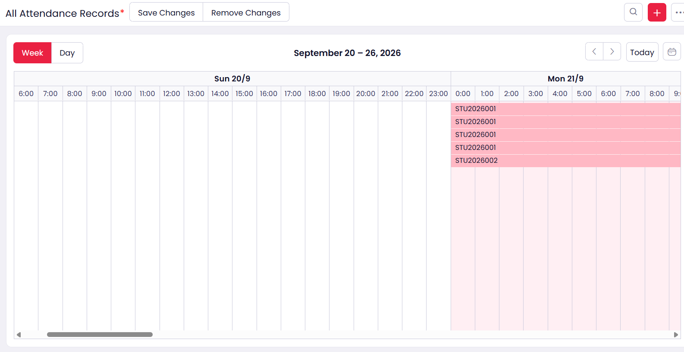
Figure 4.2: All Attendance Records Calendar report — Week view for 20–26 September 2026 with hour-wise time slots.

Observation
The same Attendance data was presented in three different ways — List, Grid, and Kanban — simply by creating different reports on the same form, and no data was duplicated. The Kanban report required only the selection of the Attendance Status field to group the records into Excused, Late, Present, and Absent lanes, and the Calendar report required only the selection of the Attendance Date field to place each entry on its day. This shows that in Zoho Creator the presentation layer is fully separated from the data layer, and that multiple views can be provided for different users without any additional coding.

Result
List, Grid, Kanban, and Calendar reports were successfully created and viewed for the College Student Administration System. The records were displayed correctly in each report type, and the grouping, inline editing, and date-based views functioned as required.

