Experiment – 5
Dashboard
Building an Analytics Dashboard in Zoho Creator
Department of Computer Science and Engineering
Student Name: Ashwanth K
Roll No: 240701057
Application Name: College Student Administration System

Objective
To design and configure a Dashboard page in Zoho Creator for the College Student Administration System, using Panel, Chart, and Report elements to present summary figures, a marks-by-percentage chart, attendance status counts, an assessment-type chart, and the underlying attendance records on a single page.

Introduction
A Dashboard in Zoho Creator is a separate page, built with the built-in Dashboard Builder, that combines multiple visual elements — panels, charts, gauges, and embedded reports — drawn from one or more forms. Each element is dragged onto the canvas and configured independently, without writing code, so that key figures and trends can be viewed at a glance instead of opening each report separately.

Dashboard Elements Used
Element | Configuration | Purpose
Panel (summary tile group) | Four tiles: Sum of Total Marks Obtained, Sum of Total Marks Possible, Avg of Percentage, Sum of Registration Fee | Quick-glance totals shown at the top of the dashboard
Chart (scatter) | Form: Marks Record, X-axis: Total Marks Obtained, Y-axis: Percentage (actual data) | Plots each assessment’s percentage against the marks obtained
Panel (Attendance Status) | Four Count (Ct) aggregates on Attendance Status: Excused, Late, Present, Absent | Breaks down attendance records by status
Panel (Quick Links) | Links to add a new Attendance Record, Marks Record, Enrollment, and Department | Gives one-click record creation from the dashboard
Chart (bar) | Form: Marks Record, X-axis: Assessment Type, Y-axis: Aggregate – Sum of Total Marks Obtained | Shows total marks obtained for each assessment type as a horizontal bar chart
Report (embedded) | All Attendance Records; Add, Edit, Delete, Duplicate, Search, Print, Export shown | Displays the underlying attendance records below the charts
Table 5.1: Elements configured on the College Student Administration System dashboard.

Screenshot-based lab record
The following pages contain the actual Zoho Creator screenshots of the Dashboard Builder configuration and the resulting live dashboard.

Screenshots 1 – Dashboard Builder – Layout
The Dashboard Builder canvas showing the placeholder elements before data is loaded. The top row holds four summary panels using Sum and Avg aggregates, followed by the scatter chart, the Attendance Status panel with Count aggregates, and the Quick Links panel. A second panel holds the Assessment Type bar chart and the embedded All Attendance Records report below it.
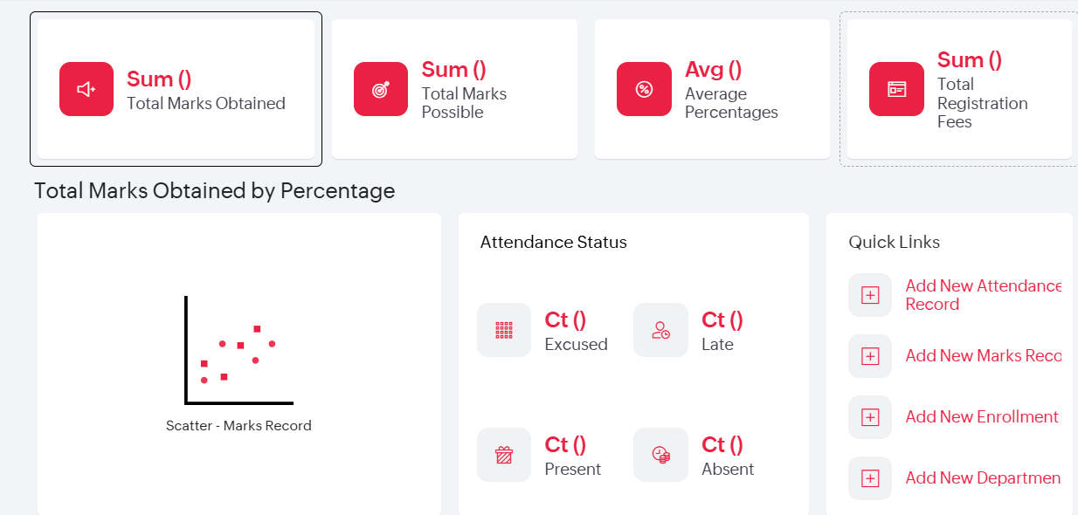
Figure 1.1: Dashboard Builder canvas showing the summary panels (Sum, Avg), the scatter chart, the Attendance Status panel (Ct), and the Quick Links panel.
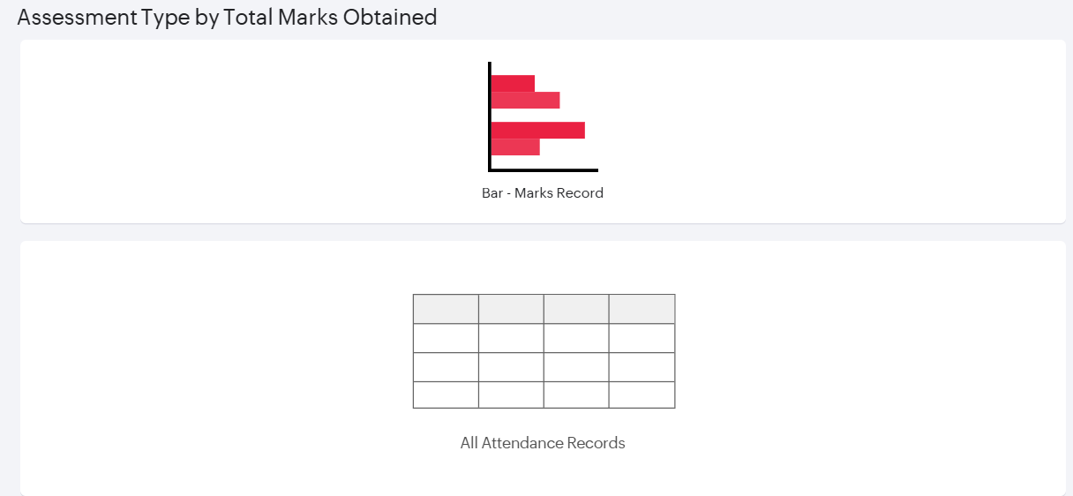
Figure 1.2: Dashboard Builder canvas showing the Assessment Type by Total Marks Obtained bar chart and the embedded All Attendance Records report.

Screenshots 2 – Report Embed Configuration
The embedded report element was configured to use the All Attendance Records report, with the Add, Edit, Delete, and Duplicate actions, the Search option, and the Print and Export options kept visible, so that records can be managed directly from the dashboard. The Retain Changes option was left hidden.
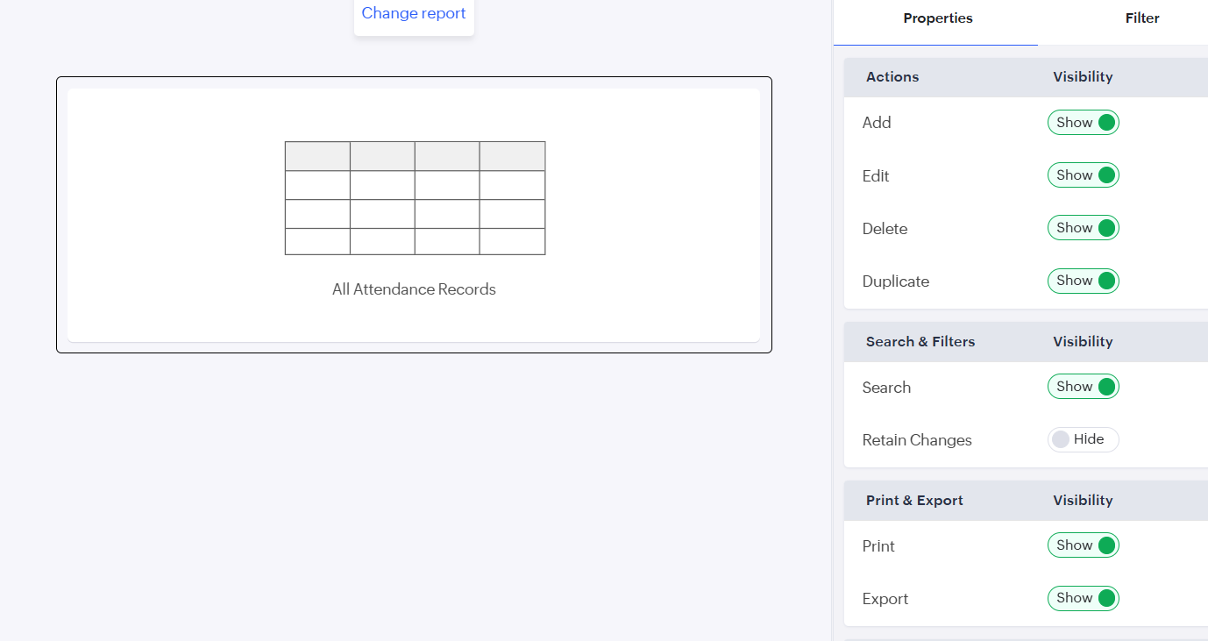
Figure 2: Report Embed Configuration for the All Attendance Records report, showing action, search, and print and export visibility settings.

Screenshots 3 – Chart Configuration
Two charts were configured on the Marks Record form. The scatter chart plots Percentage (actual data) against Total Marks Obtained on the X-axis, while the bar chart uses Assessment Type as the X-axis category and the Sum of Total Marks Obtained as the aggregated Y-axis value.
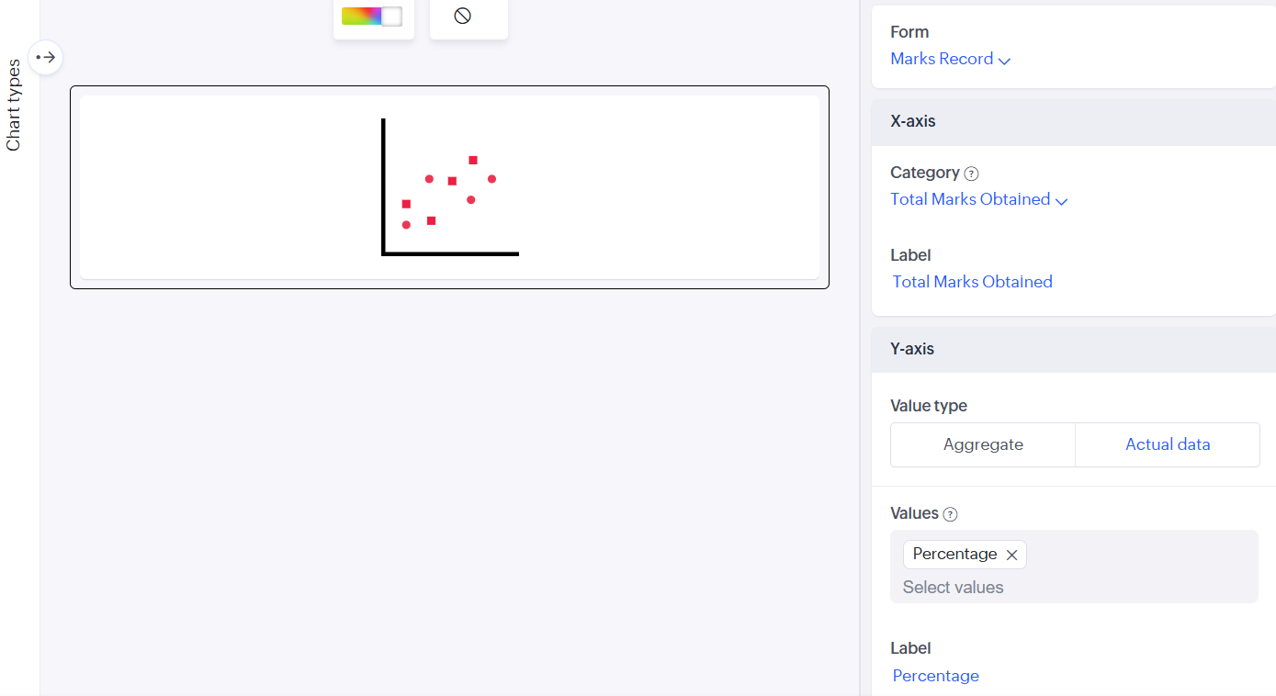
Figure 3.1: Scatter Chart Configuration — Marks Record form, X-axis Total Marks Obtained, Y-axis Percentage (actual data).
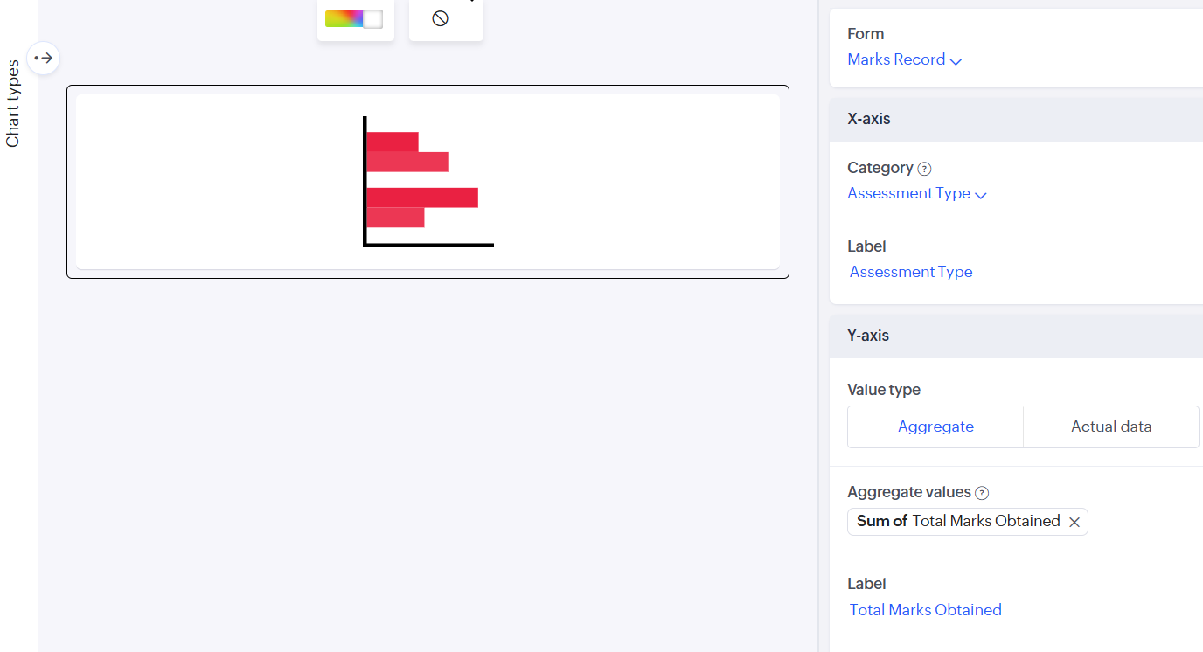
Figure 3.2: Bar Chart Configuration — Marks Record form, X-axis Assessment Type, Y-axis Sum of Total Marks Obtained.

Screenshots 4 – Live Dashboard
The published dashboard, showing the summary tiles, the Total Marks Obtained by Percentage scatter chart, the Attendance Status counts, the Quick Links panel, the Assessment Type by Total Marks Obtained chart, and the embedded All Attendance Records report.
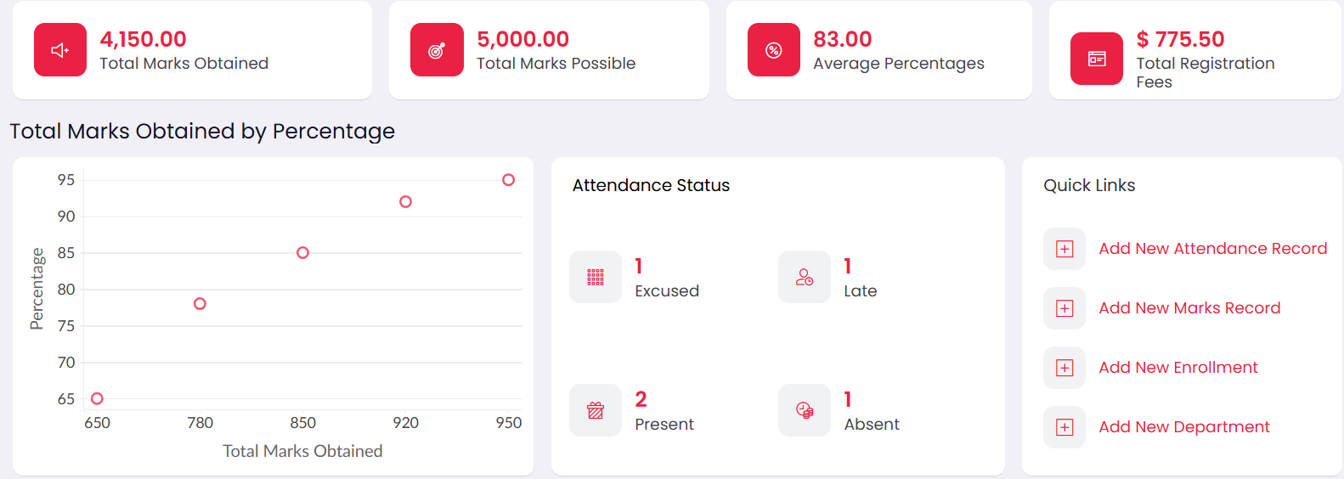
Figure 4.1: Live Dashboard — summary tiles (Total Marks Obtained, Total Marks Possible, Average Percentages, Total Registration Fees), scatter chart, Attendance Status counts, and Quick Links.
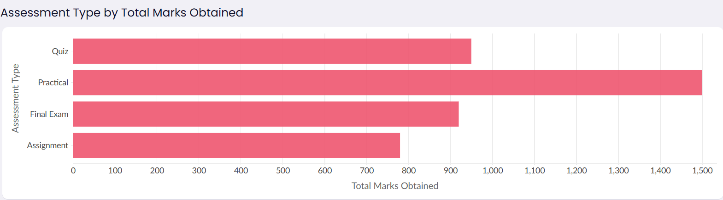
Figure 4.2: Live Dashboard — Assessment Type by Total Marks Obtained chart for Quiz, Practical, Final Exam, and Assignment.
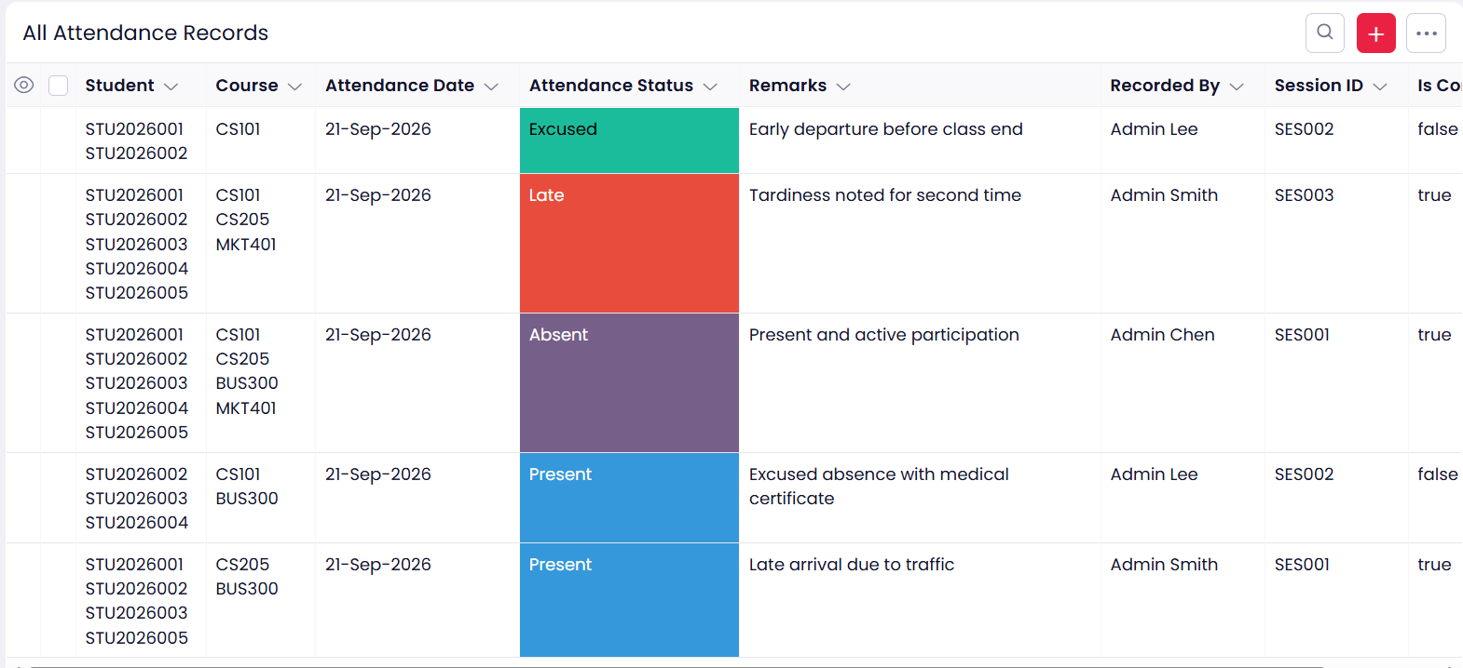
Figure 4.3: Live Dashboard — All Attendance Records report embedded on the dashboard, showing five attendance entries.

Observation
The dashboard combined data from the Marks Record, Attendance, and Enrollment forms into a single page, with quick links to the Department form, using only pre-built Panel, Chart, and Report elements configured through their Display, Style, and Action settings. No custom code was required to compute the totals, the average percentage, the attendance status counts, or the marks per assessment type, since each panel and chart derives its value directly from the aggregate settings — Sum, Avg, Count — applied to the chosen form and field. The live dashboard shows 4,150 of 5,000 possible marks, an average percentage of 83, and total registration fees of $775.50, with Practical assessments contributing the highest total (1,500). This shows that Zoho Creator separates the presentation of aggregated data from its storage and computation, allowing a fully interactive dashboard to be assembled visually.

Result
A Dashboard for the College Student Administration System was successfully designed and published in Zoho Creator, incorporating summary panels, a marks-by-percentage scatter chart, attendance status counts, an assessment-type bar chart, and an embedded attendance report, and all elements were verified to display the correct live data.

