**FACIAL AND VOICE BASED AUTHENTICATION SECURITY SYSTEM**

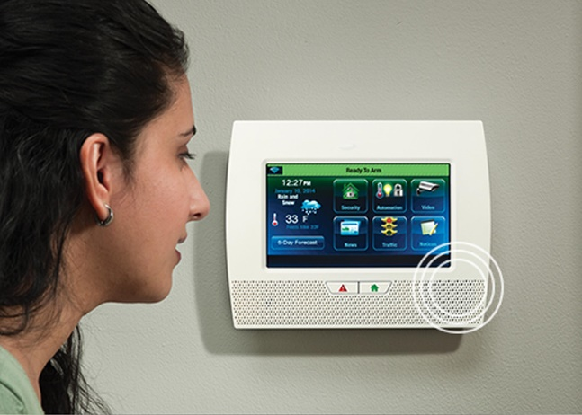**ANALYSIS AND CONCLUSION**

The project is one where we are trying to develop a two factor authentication security system which combines face recognition and voice authentication system. We are also combining a motion detector to run in the background which keeps recording any motion of a human being. The instances when anyone enters and exits is recorded and displayed in a graphical format.

**ANALYSIS**

Observations:

1. The face was recognized by the facial recognition system, but since it is a continuous video feed 2% of the time the face might be recognized as a known face even if unknown. 98 % of the time, the algorithm recognized the face correctly.
2. We know that facial recognition system as a standalone is not 100% efficient. Even Apple’s 3D facial recognition system fails at times, which is why it cannot be the only criteria for a security system.
3. So we decided to keep face recognition as the initial authentication step and then after a person’s face is detected we decided to give him a voice authentication system as the second metric.
4. Here users are expected to say a catch phrase and if it matches with his existing voice phrase prints, it gives him access to the building or house.
5. Sometimes an unknow face in the video is recognized as a known face which is why there is a voice based authentication.
6. Also, while uploading sample images for the face recognition system, we had to make sure that the image doesn’t consist of multiple images as it was throwing us an array index out of range error.
7. We adopted the voice authentication systems from voiceIt and enrolled users with their voice print faces. In this case the confidence level set by voiceit is 85% and since a user cannot repeat a phrase in the exact modulation and tone everytime we decided to decrease the confidence level to 80%. We read online that a confidence level of 75% would be enough for voice authentication.
8. We used bokeh for plotting any motion in front of the camera.

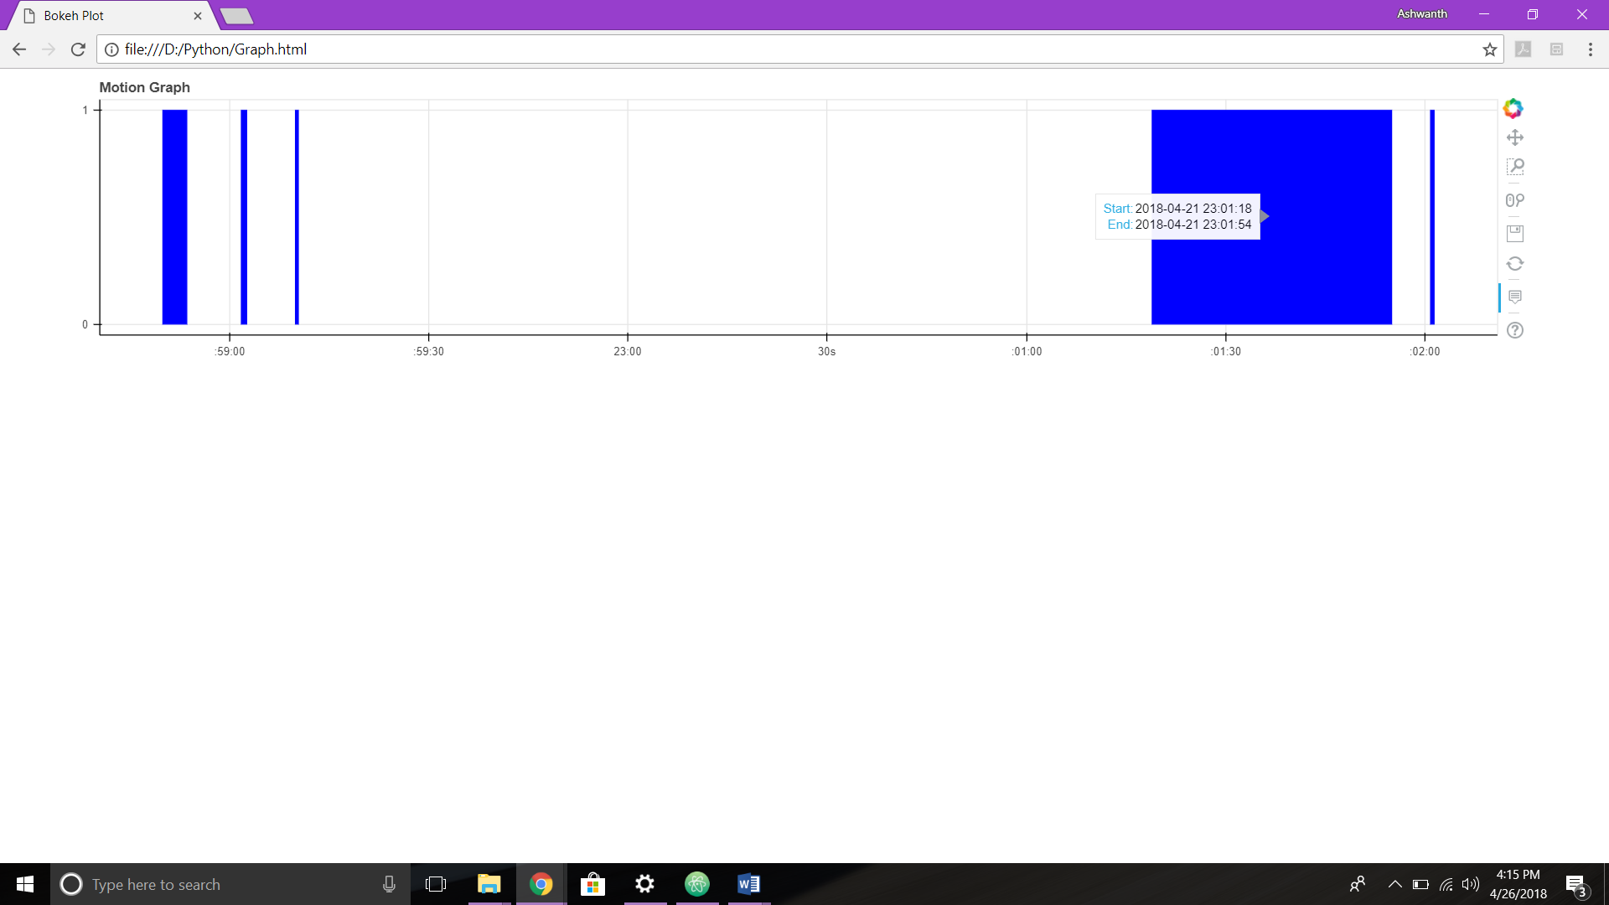

**FUTURE IMPLEMENTATION AND SCOPE:**

### In the future we would scale by building one of our own video intercom doorbell camera panel monitor kit.

### C:\Users\ashwa\AppData\Local\Microsoft\Windows\INetCache\Content.Word\2.jpgThe panel will consist of

### A video camera

### A display LED screen

### An intercom system with a mic

### A speaker

### Once we have developed this we will also develop a phone App where people can record their voice print phrases, enter the phone number which they want to receive alerts to, add new users and upload sample images, instead of them accessing the underlying API’s.

### We also plan to add multiple catch phrases instead of only one, since recorded voice phrases cannot be used. So each time a user comes he will be given a random catch phrase

### Set up cloud to store unknown faces and send the face image as a message to the user.

### Set a detailed business development plan and find investors to invest in the hardware manufacturing and also help hire developers and sales people.

### If given the next three weeks we will:

**Week 1:**

1. Improve on the existing system by tweaking bugs on multiple faces in the camera.
2. Implement the multiple catch phrases functionality
3. Start workingon developing our own algorithms for both face and voice

**Week 2:**

### Work on developing the phone app.

### Continue working on developing our own algorithms for both face and voice

### Test system with multiple users

### Week 3:

### Continue building the phone app and finish a prototype.

### Start working on integrating hardware pieces necessary for the program to run.

### CONCLUSION:

### We decided to build this application, to have an exposure to building a cognitive service. Our first step towards this was by leveraging the existing API’s and in future we would like to develop an application with our own algorithm and integrate with the proposed hardware. It was a good learning experience for the both of us.