**IMAGE RECOGNITION WITH IBM CLOUD VISUAL RECOGNITION**

**Problem Statement**:

Develop an image recognition system using IBM Cloud Visual Recognition. Share your passion for photography by uploading images and watch as the system accurately classifies and describes their contents. Craft engaging visual stories with the help of AI-generated captions. Connect with your audience through captivating visuals and compelling narratives!

**Problem Definition:**

The project involves creating an image recognition system using IBM Cloud Visual Recognition. The goal is to develop a platform where users can upload images, and the system accurately classifies and describes the image contents. This will enable users to craft engaging visual stories with the help of AI-generated captions, enhancing their connection with the audience through captivating visuals and compelling narratives.

**Design Thinking:**

* Image Recognition Setup: Set up the IBM Cloud Visual Recognition service and obtain the necessary API keys.
* User Interface: Design a user-friendly interface for users to upload images and view the AI-generated captions.
* Image Classification: Implement the image classification process using the IBM Cloud Visual Recognition API.
* AI-Generated Captions: Integrate natural language generation to create captions for the recognized images.
* User Engagement: Design features to allow users to explore, save, and share their AI enhanced images.

**Cloud Service:**

The IBM Watson Visual Recognition Cloud Service allows Clients to add image recognition capabilities to applications by either accessing pre-built models on the Cloud Service or by creating a custom model using the Cloud Service.

**Use case:**

Image recognition use cases are found in different fields like healthcare, marketing, transportation and e-commerce. It can be used to identify objects in images to categorize them for future use

**To design an innovative solution for image recognition using IBM Cloud Visual Recognition,**

* **Problem Identification and Understanding :**
* We should begin by clearly defining the problem which we want to solve with image recognition.
* Understanding the specific requirements and challenges associated with the problem is important.
* **Data Collection and Preparation :**
  + We have to gather a diverse and representative dataset of images related to the problem.
  + Annotate and label the dataset to create ground truth data.
  + Clean and preprocess the data to ensure consistency and quality.
* **IBM Cloud Visual Recognition Setup :**
  + We must sign up for an IBM Cloud account and access the Visual Recognition service.
  + Then create a new Visual Recognition instance and set up our credentials.
* **Model Training :**
  + The idea is to train a custom image classification model using our prepared dataset.
  + We have to fine-tune the model to improve accuracy, using techniques such as transfer learning.
* **Innovation Ideas :**
* Innovative features and enhancements to improve image recognition performance and user experience:

1. Real-Time Processing :
   * + Implement real-time image recognition for immediate results.
2. Multi-Modal Recognition :
   * + Combine visual recognition with other modalities like text or audio to provide more context-aware results.
3. Object Detection :
   * + Extend the solution to not only classify objects but also detect and locate them within the image.
4. Interactive Interfaces :
   * Create a user-friendly interface (web or mobile app) that allows users to easily upload and analyze images.
5. Cross-Platform Compatibility :
   * Ensure that our solution works seamlessly on various platforms and devices.
6. Language Support :
   * Enabling recognition in multiple languages for a global user base.
7. Feedback Mechanism :
   * We have to implement a feedback loop where users can correct or provide feedback on recognition results to improve the model
8. Continuous Learning :
   * Empower an automated system that periodically retrains the model with new data to keep it up-to-date.

* **Integration :**
* Integrate your IBM Cloud Visual Recognition model into your chosen platform or application.
* **Testing and Validation :**
* Thoroughly test our solution with a variety of images to ensure accuracy and robustness.
* **User Feedback and Iteration :**
* Collect feedback from users and make necessary improvements based on their input.
* **Scalability and Performance Optimization :**
* Optimize our solution for scalability to handle a growing number of users and images.
* **Monitoring and Maintenance :**
  + Implement monitoring tools to track the performance of our image recognition system.
  + Regularly update the model and system to adapt to changing data and requirements.
* **Documentation and Support :**
  + Provide comprehensive documentation and support for users and developers who want to use our solution.
* **Security and Privacy :**
  + Ensure that user data and images are handled securely and with respect to privacy regulations.
* **Marketing and Adoption :**
  + Develop a strategy to market and promote your innovative image recognition solution to your target audience.

**Image recognition setup:**

IBM Watson Visual Recognition is a tool that uses deep learning algorithms to analyze images and allow users to automatically identify subjects and objects contained within the image and organize and classify these images into categories.

To create an IBM Cloud account, set up the Visual Recognition service, and obtain API keys, following steps are followed

**Prerequisites:**

1. IBM Cloud account (A credit card is NOT required to sign up for IBM Cloud Lite account and there is no charge associated in creating a Lite plan instance of the Watson Discovery service).
2. Device with good internet connection.

**Procedure**

**Step 1**: Create an IBM Cloud Account

Use the link given to signup or login to IBM cloud. <https://cloud.ibm.com/registration>.

**Step 2**: Confirm Your Email Address

An email is sent to your email address to confirm your account. Go to your email account, and click on the “Confirm Account” link in the email that was sent to you.

**Step 3**: Login to Your Account

**Step 4**: Create a New Resource

On your dashboard page, click on the Create a resource on the top right to create a new source.

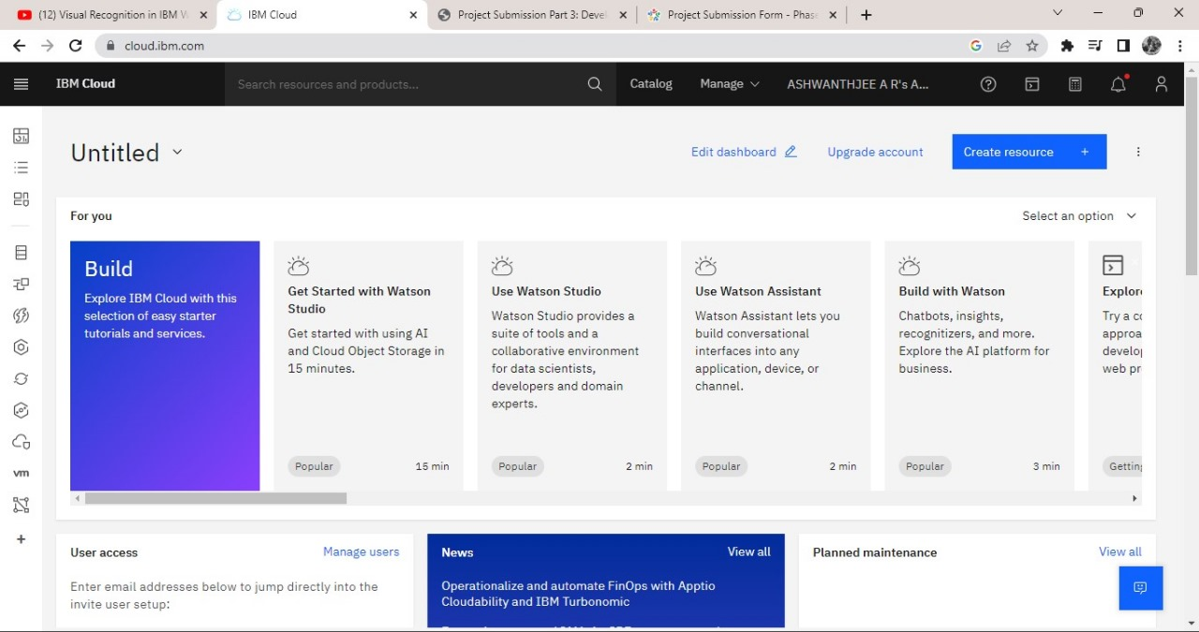

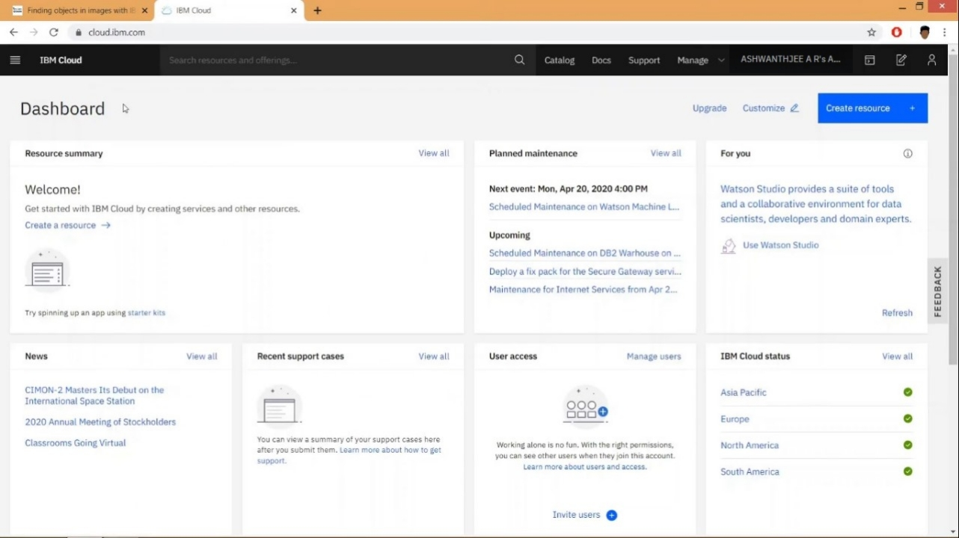

**Step 5**: Create a Visual Recognition and Watson Studio Resource

On the Catalog page, select the AI category from the left pane, and then select the Watson Studio resource.

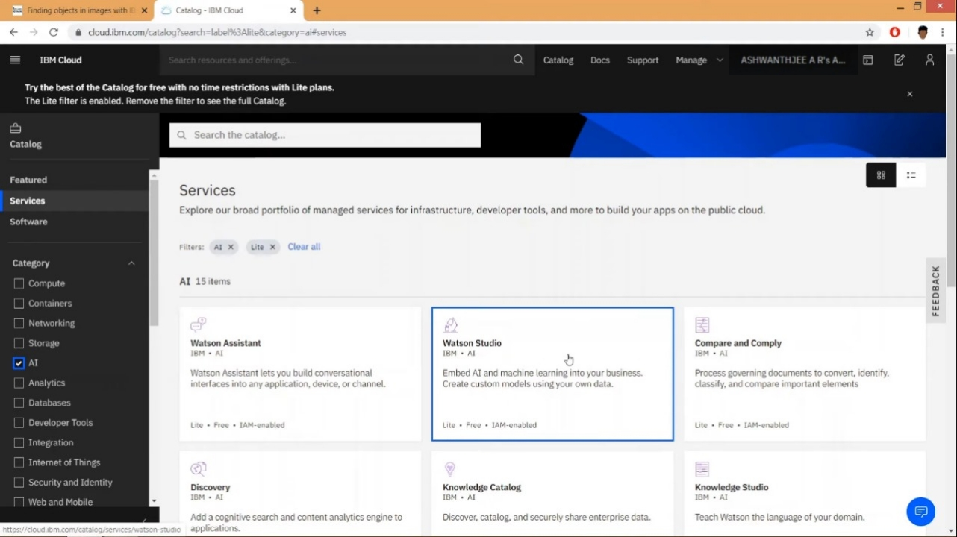

On the next page, you will get to name your service instance and choose your region. Click on the arrow to reveal the drop-down menu of regions. Make sure to select the region that is closest to you. Then scroll down and make sure that the lite plan is selected, and click the Create button.

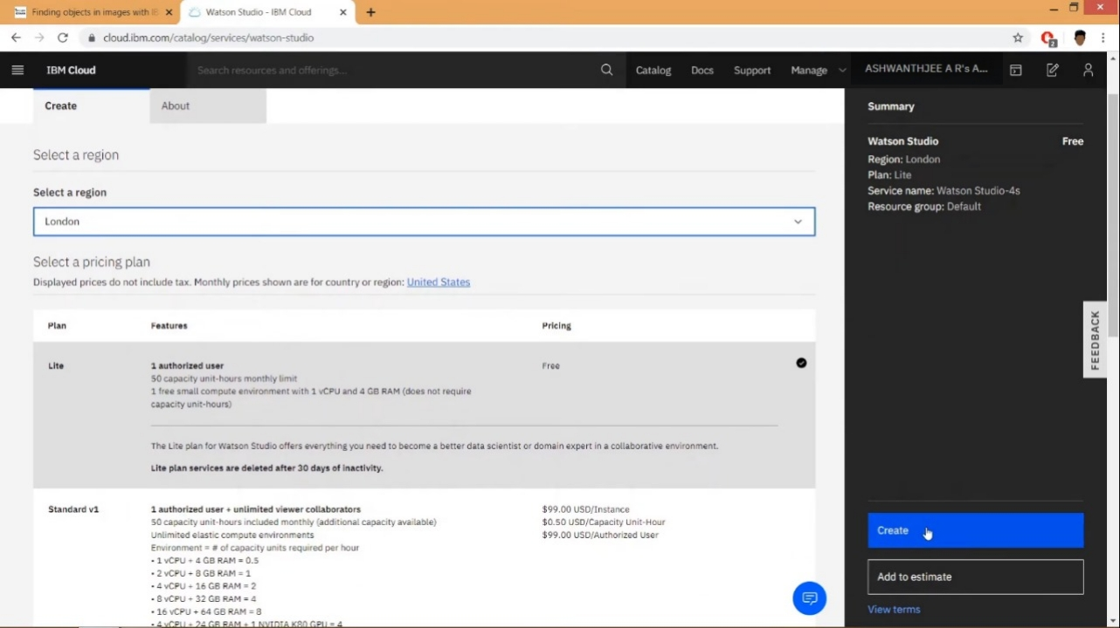

On the next page, click the Get Started button to start using Watson Studio.

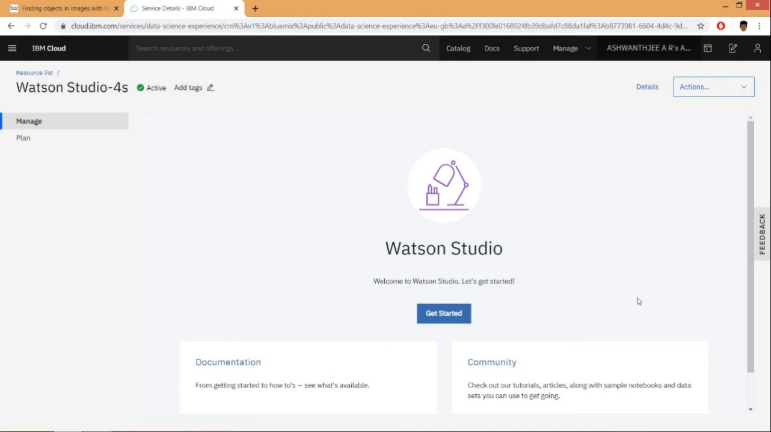

Once the provisioning process is complete, click the Get Started button to start using Watson Studio.

**Step 6**: Create a Project

Once you land on the IBM Watson Studio main page, start by creating a project.

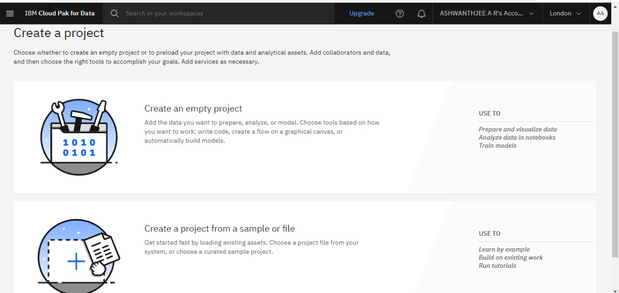

Choose create empty project

**Step 7**: Set up Your Project

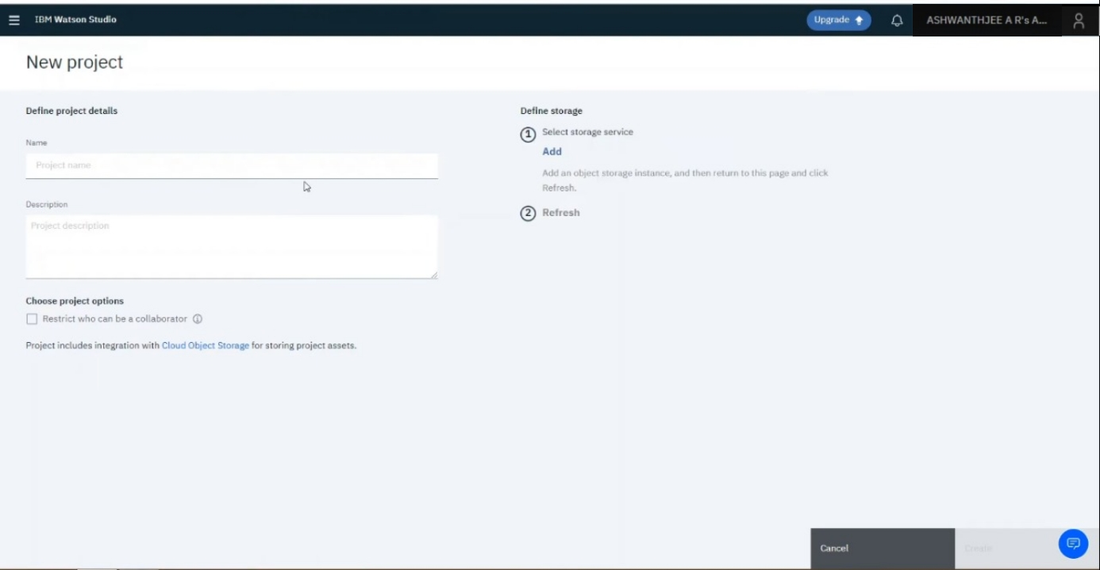

fill in some project details and click Create. The IBM Cloud Object Storage, which provides you storage for your images, should be automatically created for you but if not created you can click on add button below the heading on top right part of screen. if it is already created it will show you name and will not let you create a new one.

Create the storage service with the lite plan and click on create button. Go to Add to project and choose Image classification.

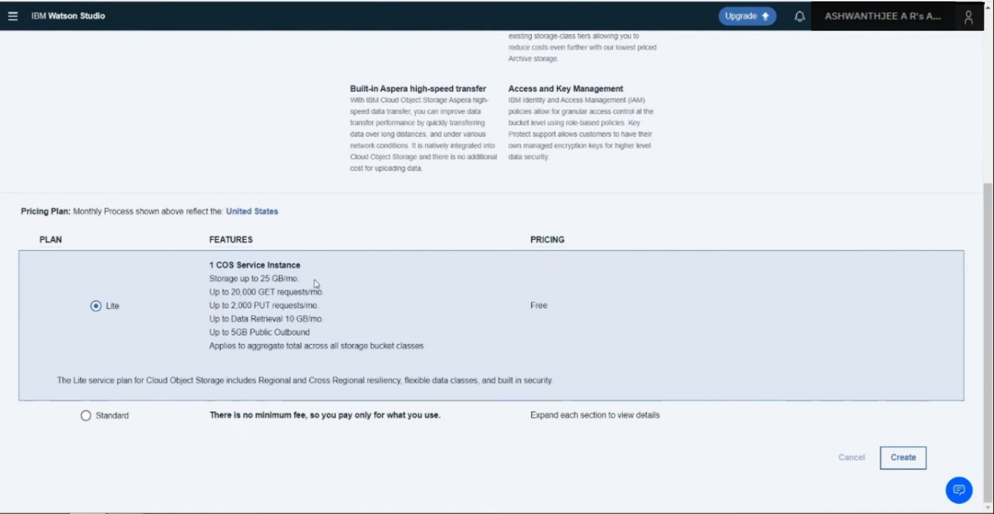

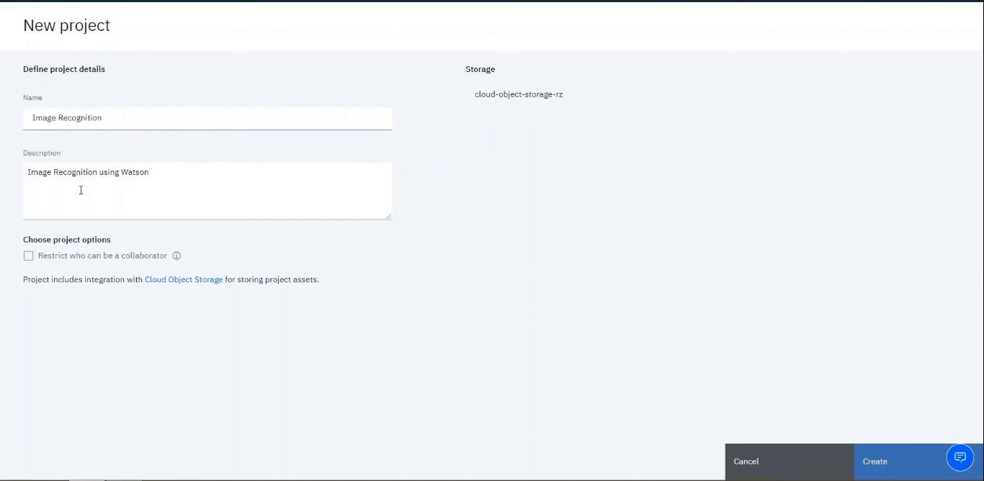

**Add the Visual Recognition to the project**

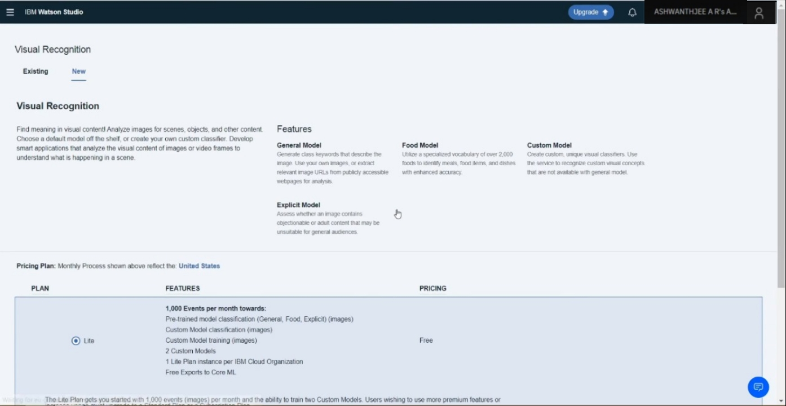

**Step 8: Selecting Built-in Models for Watson Visual Recognition**

After creating your project, by default, you will land on the page where you can perform some advanced tasks but we will skip this for now and use the built-in models. To access the built-in models, click on the name of the service, as seen in the red box below:

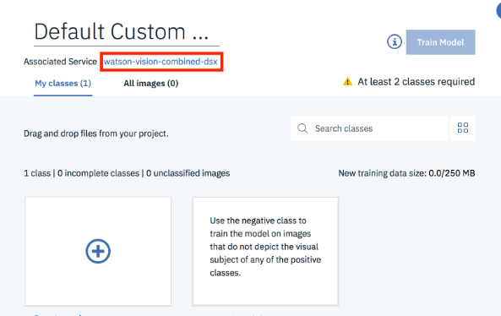

**Step 9**: Choose the General model.

Now you can see all the built-in image classification models that IBM Watson provides! Let’s try the General model.

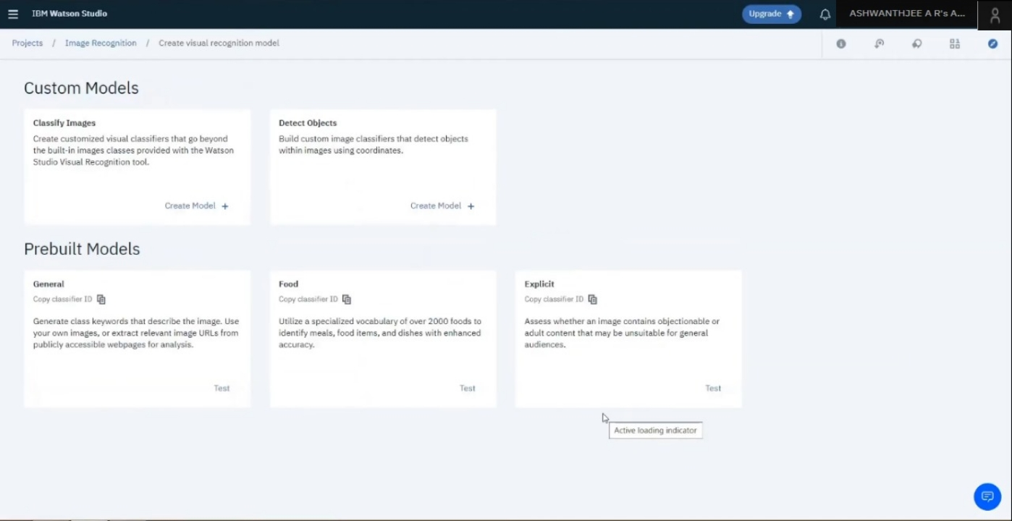

**Step 10**: Try out the General model

To test the General model, click on Test tab on top of screen.

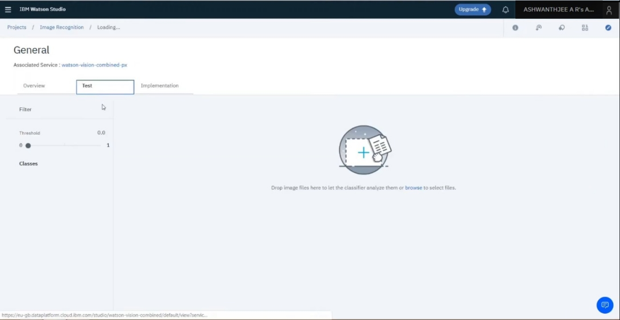

**Step 11**: Upload Your Images

Now you can upload any images you’d like by clicking on Browse. Remember that you will have to upload all the images that you want to test in a single go as once you upload images then you cannot add more images one by one. you will have to go back and upload all images including the new ones.

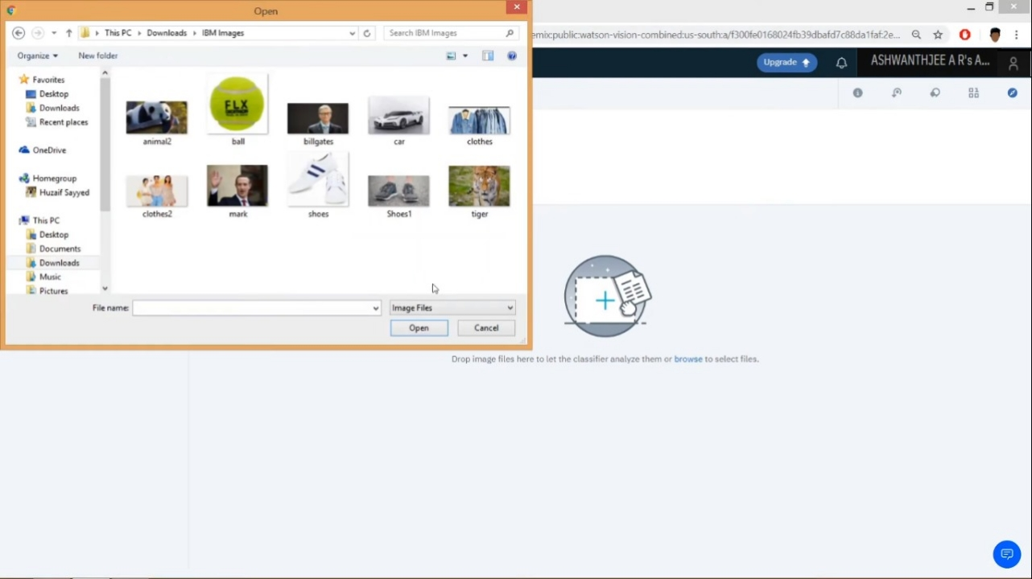

**Step 12**: Check Out the Results!

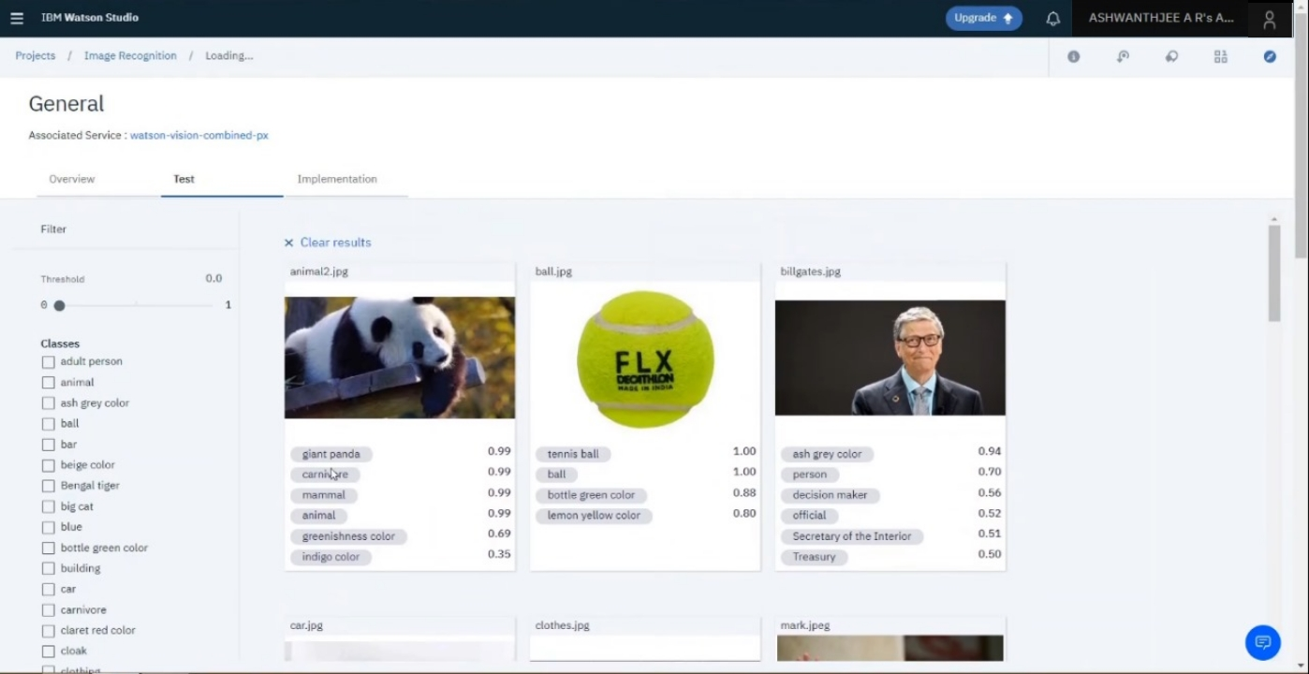

Once you have uploaded your images, it will tell you what it found in your images! Beside each class of object (or color, age, etc.), it will also give you a confidence score (between 0 and 1) on how confident it thinks it found that particular object in your image (0 for lowest confidence and 1 for highest confidence).

**USER INTERFACE:**

To design a simple web interface where users can upload images and view the AI-generated captions.

<!DOCTYPE html>

<html lang="en">

<head>

<meta charset="UTF-8">

<meta name="viewport" content="width=device-width, initial-scale=1.0">

<title>Image Recognition System</title>

<link rel="stylesheet" href="styles.css">

</head>

<body>

<header>

<h1>Image Recognition System</h1>

</header>

<section>

<form enctype="multipart/form-data" action="upload" method="post">

<input type="file" name="image" accept="image/*">

<button type="submit">Upload</button>

</form>

</section>

<section id="result">

<h2>AI-Generated Caption:</h2>

<p id="caption">Waiting for image recognition...</p>

</section>

<footer>

<p>&copy; 2023 Image Recognition System. All rights reserved.</p>

</footer>

</body>

</html>

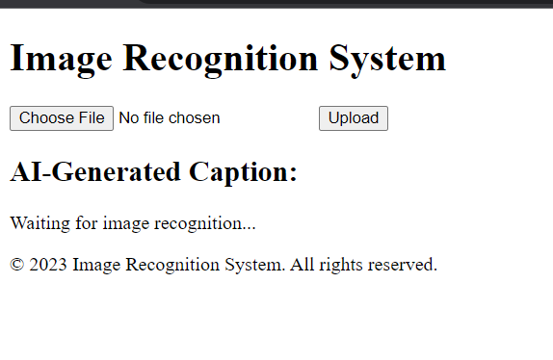

**Image classification:**

Implement the image classification process using the IBM Cloud Visual Recognition API.

**AI-Generated Captions:**

Using natural language generation to create captions for the recognized images.

**Program:**

const form = document.querySelector('form');

const caption = document.querySelector('#caption');

form.addEventListener('submit', async (e) => {

e.preventDefault();

const formData = new FormData(form);

const imageFile = formData.get('image');

const response = await fetch('https://api.example.com/visual-recognition', {

method: 'POST',

body: formData

});

const data = await response.json();

caption.textContent = data.caption;

});

CSS: style.css

@import url(https://maxcdn.bootstrapcdn.com/font-awesome/4.5.0/css/font-awesome.min.css);

@import url('https://fonts.googleapis.com/css?family=Roboto');

// Vars and Reset

//

$theme: #454cad;

$dark-text: #5f6982;

html,body,* { box-sizing: border-box; font-size: 16px;}

html,body { height: 100%; text-align: center;}

body { padding: 2rem; background: #f8f8f8;}

h2 {

font-family: "Roboto", sans-serif;

font-size: 26px;

line-height: 1;

color: $theme;

margin-bottom: 0;

}

p {

font-family: "Roboto", sans-serif;

font-size: 18px;

color: $dark-text;

}

// Upload Demo

//

.uploader {

display: block;

clear: both;

margin: 0 auto;

width: 100%;

max-width: 600px;

label {

float: left;

clear: both;

width: 100%;

padding: 2rem 1.5rem;

text-align: center;

background: #fff;

border-radius: 7px;

border: 3px solid #eee;

transition: all .2s ease;

user-select: none;

&:hover {

border-color: $theme;

}

&.hover {

border: 3px solid $theme;

box-shadow: inset 0 0 0 6px #eee;

#start {

i.fa {

transform: scale(0.8);

opacity: 0.3;

}

}

}

}

#start {

float: left;

clear: both;

width: 100%;

&.hidden {

display: none;

}

i.fa {

font-size: 50px;

margin-bottom: 1rem;

transition: all .2s ease-in-out;

}

}

#response {

float: left;

clear: both;

width: 100%;

&.hidden {

display: none;

}

#messages {

margin-bottom: .5rem;

}

}

#file-image {

display: inline;

margin: 0 auto .5rem auto;

width: auto;

height: auto;

max-width: 180px;

&.hidden {

display: none;

}

}

#notimage {

display: block;

float: left;

clear: both;

width: 100%;

&.hidden {

display: none;

}

}

progress,

.progress {

// appearance: none;

display: inline;

clear: both;

margin: 0 auto;

width: 100%;

max-width: 180px;

height: 8px;

border: 0;

border-radius: 4px;

background-color: #eee;

overflow: hidden;

}

.progress[value]::-webkit-progress-bar {

border-radius: 4px;

background-color: #eee;

}

.progress[value]::-webkit-progress-value {

background: linear-gradient(to right, darken($theme,8%) 0%, $theme 50%);

border-radius: 4px;

}

.progress[value]::-moz-progress-bar {

background: linear-gradient(to right, darken($theme,8%) 0%, $theme 50%);

border-radius: 4px;

}

input[type="file"] {

display: none;

}

div {

margin: 0 0 .5rem 0;

color: $dark-text;

}

.btn {

display: inline-block;

margin: .5rem .5rem 1rem .5rem;

clear: both;

font-family: inherit;

font-weight: 700;

font-size: 14px;

text-decoration: none;

text-transform: initial;

border: none;

border-radius: .2rem;

outline: none;

padding: 0 1rem;

height: 36px;

line-height: 36px;

color: #fff;

transition: all 0.2s ease-in-out;

box-sizing: border-box;

background: $theme;

border-color: $theme;

cursor: pointer;

}

}

Some sample outputs are given:

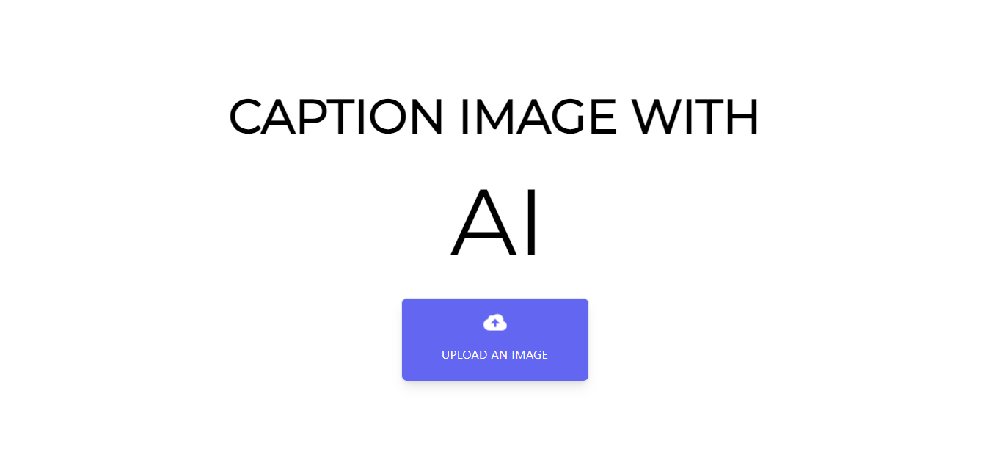

Upload the images here..

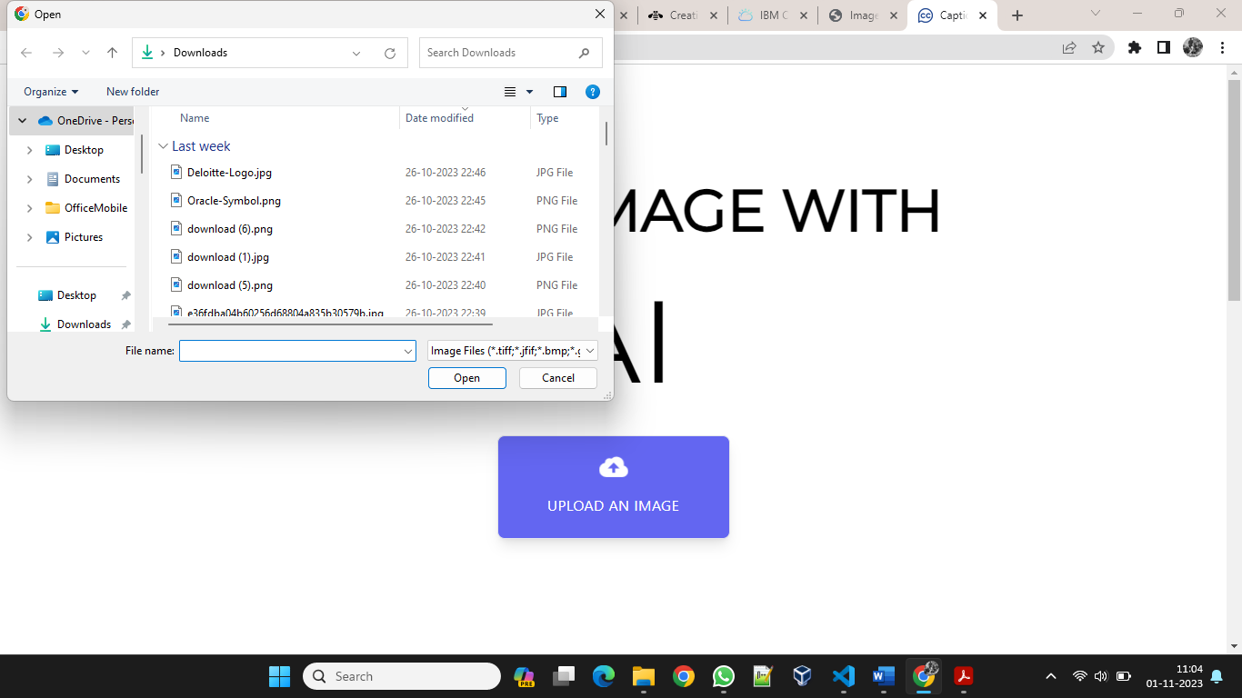

Select the type of caption from the given options.

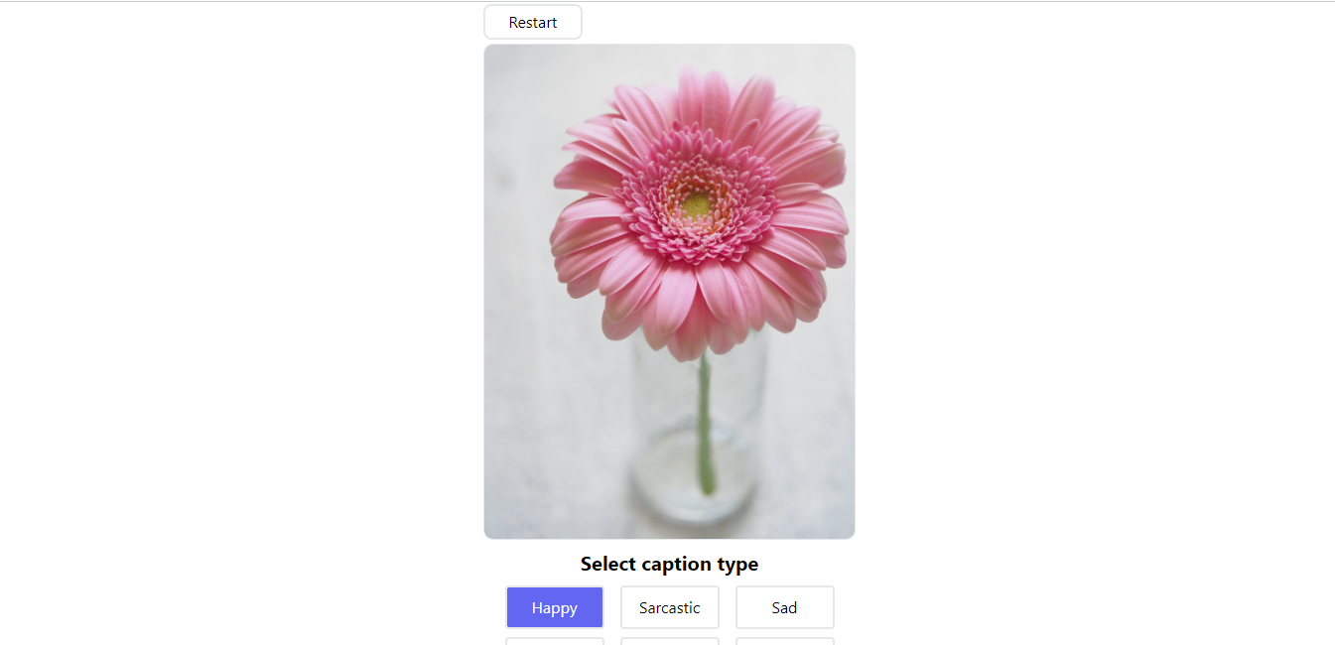

Multiple captions are generated for the given image and the specified type of the caption.

