# OBJECTIVE:

To be able to work in your organization as a python Django developer where I can fully utilize my skills in HTML, JavaScript, CSS, Python, Django technologies.

**RESUME**

**C**

**ASHWAQ BASHA**

C.

As

waqbasha

@gmail.com

7406223816

#86 ANEPALYA, 1

ST

CROSS NELASANDARA

,

BANGALORE

-

560047.

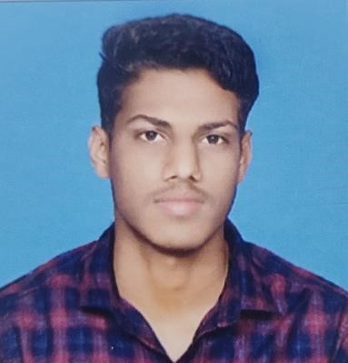

# EDUCATIONAL QUALIFICATION:

* **Bachelor of Computer Application (BCA),** 2019

SSMRV college 7.1(CGPA)

**II PUC (CEBA),** 2017

Cathedral comp Pu College, 61%

* **SSLC**, 2015

The crystal school, 68%

# PROJECTS:

* **Project Name:** ONLINE CAR RENTALS

**Technologies Used:** PYTHON, DJANGO, HTML, CSS, JAVASCRIPT, AND SQLITE3

**Operating System**: Windows 10 pro

**Description**:

ONLINE CAR RENTALS is a online reservation system which helps the customers to book cars

Rather then using the traditional manual system of vehical reservation . online car rentals

Eleminates the risk of erroneous bookings and reduces overall lead time and ensures growth

In customer satisfaction.

* **Project Name:** COURIER MANAGEMENT SYSTEM

**Technologies Used:** VB.NET and SQL Server **Operating System:** Windows 10 pro **Description:**

Courier Management System is a windows-based application. The main objective of this project is to manage the details of Employees, Couriers, Delivery. The project is totally built at administrative end and thus only the administrator is guaranteed the access. The purpose of the

Project is to build an application program to reduce the manual work for managing the Employees, Couriers, Delivery. It tracks all the details about the Couriers and Delivery.

# CERTIFICATIONS & ACHIVEMENTS:

* Certification in making “Quad copter”.
* Certification in participating “Math’s Scholarship Exam”.

# TECHNICAL SKILLS:

* Programming Language : C, C++, JAVA and VB.NET.
* Software : MS-SQL Server, Visual Studio, Word, Excel, PowerPoint.
* Web designing languages : HTML.
* Languages known : English, Hindi, Tamil and Urdu.

# SOFT SKILLS:

* Confident.
* Teamwork.
* Analytical.
* Good presentation skills.

# INTERESTS:

• Web Development, Playing Volley ball, Cricket.