1) Logic:

createTable([[2,3],[3,4],[3,2],[4,3]]) -> This function call in js file will be creating the seating layout, The change in array values would change the layout we want.

createTabStructure(rows,cols,index,length){} -> This function is responsible for structuring the layout.

fillSeats(seatsToBeFilled) -> This function would fill the seats over the layout.

**DOM Manipulation** is ultimately used for this Implementation.

2) Visual Representation:

Green colored seats - > window seats

Light-blue colored seats -> Aisle seats

Red colored seats-> center seats

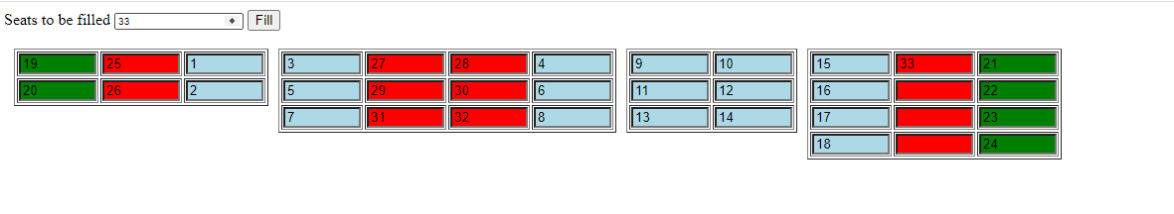

3) Unit Test cases:

1. If seats to be filled greater than number of seats, alert is thrown and fill the available seats.

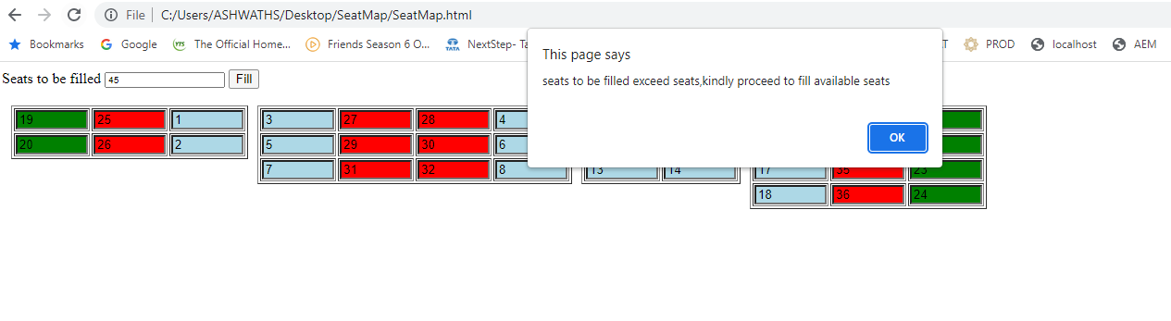

1. Aisle seats are filled first followed by window and center seats.

