TECHNICAL EVALUATION REPORT
Hybrid CI/CD Pipeline & Serverless Backend Application Deployment on AWS
Candidate Profile: Junior DevOps Engineer (1-2 Years Experience)
Date: July 3, 2026

1. Abstract
This project evaluates the deployment of a hybrid cloud infrastructure on AWS Free Tier, combining a containerized frontend application deployed via an automated CI/CD pipeline with a serverless API backend. The frontend application is containerized with Docker, deployed on an AWS EC2 instance, and automated natively by a Jenkins runner. The serverless backend uses AWS API Gateway, AWS Lambda (Python), and Amazon S3 to handle dynamic client lookups. Observability is managed via Amazon CloudWatch metrics, logs, and alarms, while performance is evaluated using k6 load tests.

2. Objectives
The core objectives of this deployment project are:
1. Automation: Establish a declarative, version-controlled CI/CD pipeline triggered automatically on git push to build, test, and deploy a containerized web application.
2. Resource Efficiency: Deploy on Free Tier resources (t2.micro) while utilizing Docker-level memory capping to prevent system out-of-memory errors and ensure host stability.
3. Observability: Configure agent-based and service-native logs, metrics, dashboards, and alarms to notify operations of host and database failures.
4. Security Integration: Enforce IAM least-privilege policies, security groups, dynamic DNS, and TLS termination to secure data-in-transit and management entry points.
5. Performance Verification: Execute performance load tests to analyze system latency, throughput, error rates, and resource limits under steady and spike scenarios.

3. System Architecture
The architecture is designed around two distinct execution paths. The CI/CD Pipeline Flow operates via GitHub push webhooks triggering Jenkins natively on the EC2 instance. Jenkins compiles the Docker image, verifies the run status on port 8081, and uploads static artifacts to S3. The Application Request Flow routes user HTTPS requests from DuckDNS to Nginx. Nginx terminates the TLS tunnel and proxies the cleartext traffic to the frontend container. The serverless API backend uses API Gateway to direct GET /health requests to a Python Lambda function, which fetches configuration details from S3 and reports telemetry to CloudWatch.
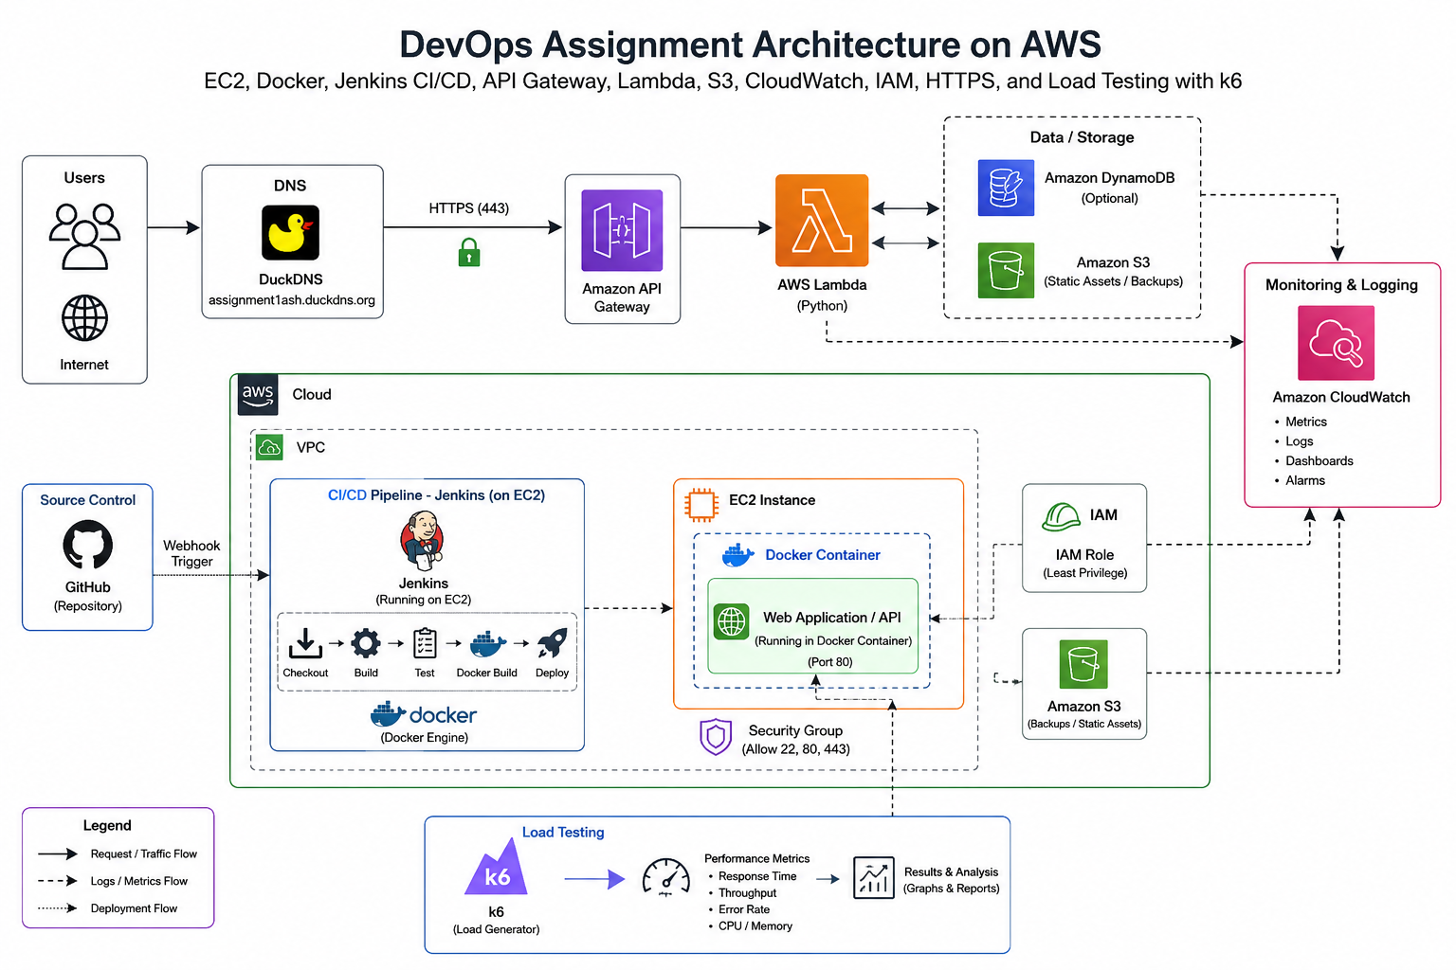
Figure: Hybrid AWS DevOps Architecture Topology

4. AWS Infrastructure & Component Provisioning

4.1. EC2 Virtual Compute Instance
To host the application container engine and the Jenkins build manager, we provisioned an Ubuntu 22.04 LTS t2.micro compute instance within the default VPC. We associated an Elastic IP (13.201.11.78) to prevent public IP changes on instance reboot. To support the container operations and Jenkins workspace logs without running out of disk space, the root volume was sized to 20 GiB using gp3 SSD storage, leaving it unencrypted for Free Tier compatibility.
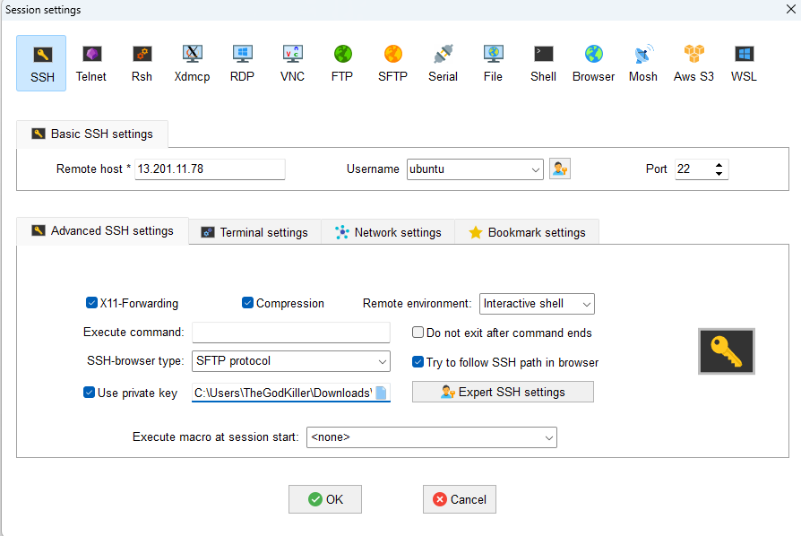
Figure: MobaXterm SSH Basic Connection Configuration to Host 13.201.11.78
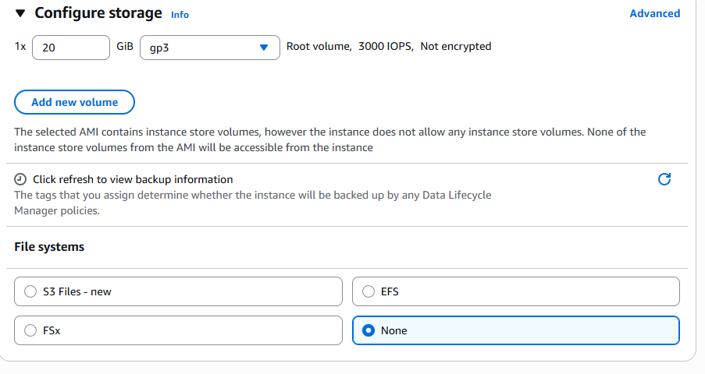
Figure: Configure Storage gp3 20 GiB SSD Volume for Ubuntu Host

4.2. IAM Roles & Least-Privilege Policies
To align with the principle of least privilege, we avoided storing long-lived AWS Access Keys on the host server. Instead, we created an IAM Role (EC2-App-Role) targeting the EC2 service as a trusted entity. This role attaches the CloudWatchAgentServerPolicy to permit log and metrics forwarding. It also contains a custom inline S3 policy that restricts S3 access strictly to bucket backupandstorage-ash, permitting only the s3:PutObject, s3:GetObject, s3:ListBucket, and s3:DeleteObject operations.
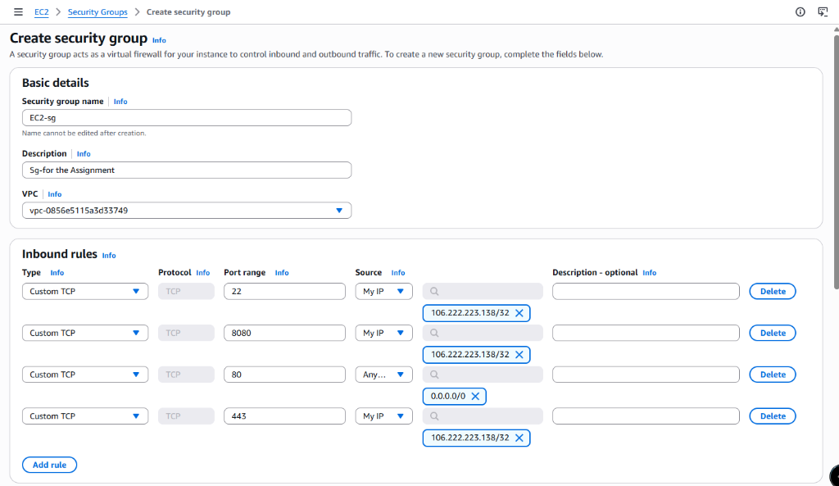
Figure: IAM Role Trusted Entity Type Selection for EC2 Use Case
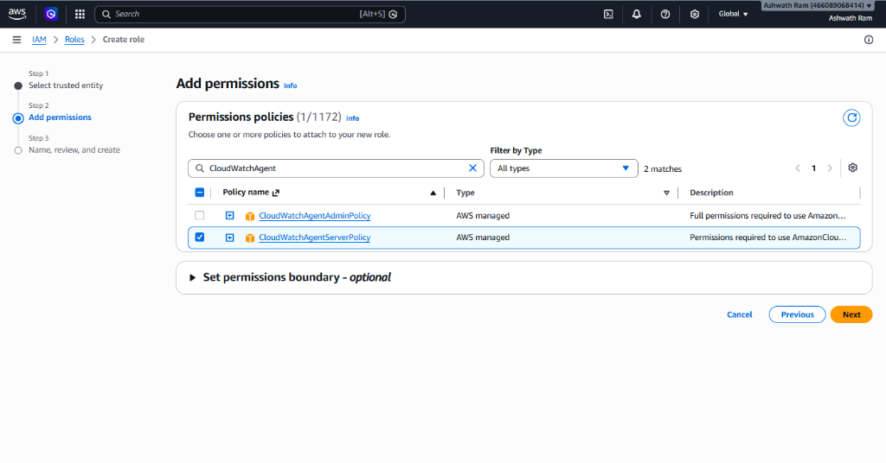
Figure: IAM Role Policies Attachment - Adding CloudWatchAgentServerPolicy

4.3. Security Groups & Inbound Rules
A restrictive firewall security group named EC2-sg was created. To block public exposure of administrative interfaces, Port 22 (SSH), Port 8080 (Jenkins UI), and Port 443 (HTTPS) are restricted strictly to the administrator's development IP address (106.222.223.138/32). Port 80 (HTTP) is left open to Anywhere (0.0.0.0/0) to receive incoming user web requests and support certificate verification routing.
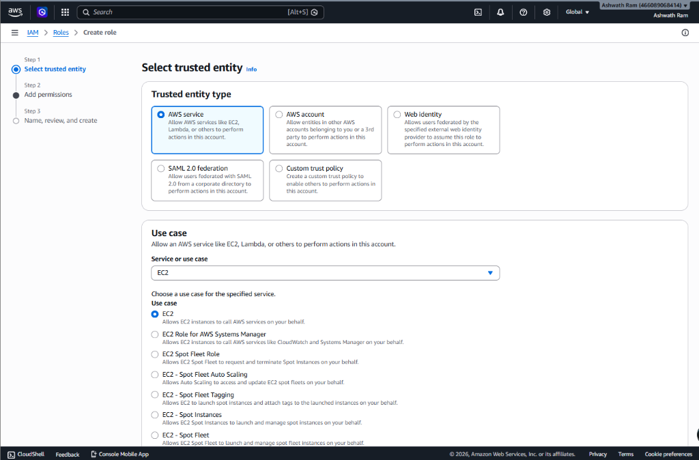
Figure: Security Group Inbound Rules Setup for EC2-sg

5. Host Configuration & Docker Deployment
After connecting to the EC2 instance, we installed the Docker runtime, Git, and the AWS CLI. To allow Jenkins to manage builds natively on the host without Docker-in-Docker overhead, we launched Jenkins as a container mounting the host's Docker socket (/var/run/docker.sock) and running as root. We then installed the docker-ce-cli and awscli packages inside the Jenkins container, enabling pipeline stages to call docker and aws utilities directly.

6. CI/CD Automations (Jenkinsfile Pipeline)
We configured a Git repository and integrated it with Jenkins via GitHub webhooks. The automated pipeline is defined in a declarative Jenkinsfile, executing these stages on git push:
• Checkout: Pulls the repository code from SCM.
• Read Metadata: Parses config/metadata.json to dynamically extract variables, avoiding hardcoding.
• Build Docker Image: Compiles the Dockerfile using Nginx Alpine, capping build memory to 512MB.
• Deploy Container: Stops any running container, cleans up resources, and launches the app container on port 8081 with a 256MB RAM cap and 10MB log rotation limit.
• Health Check: Performs a curl request against port 8081 to verify the web server is responsive.
• Backup: Synchronizes static frontend assets and timestamped configurations to the private S3 bucket.

7. Observability & Performance Load Testing

7.1. Observability Configurations
Observability is managed using Amazon CloudWatch. We installed the CloudWatch Agent on the Ubuntu host and configured it to collect CPU, memory, and disk usage metrics. It also forwards log files, including Nginx logs, Docker container logs, and system logs, to CloudWatch log groups. We created a CloudWatch Dashboard to display system resource telemetry alongside Lambda backend metrics. Finally, we configured a CPU Utilization alarm (>70% for 5 minutes) linked to an SNS topic that sends email alerts to the administrator.

7.2. k6 Load Testing Results
To evaluate system performance and stability under load, we executed a k6 performance test against the HTTPS endpoint from an external test runner. The test used a multi-stage ramping model scaling to 50 concurrent users over a 3.5-minute duration. The test results are summarized below:
Performance Metric | Measured Value | SLA Threshold Status
Total Requests Executed | 5,249 | Completed
Error Rate (Failed Requests) | 0 (0.00%) | PASSED (Rate < 5.0%)
HTTP Connection Success Rate | 100.00% | PASSED
Average Response Time | 32.69 ms | Highly Responsive
P95 Latency SLA | 38.63 ms | PASSED (p95 < 2,000.00 ms)
Maximum Response Time | 163.60 ms | Within Limits
Peak CPU Utilization | 8% - 12% | Normal (CPU credit balance stable)

The small difference between the average response time (32.69 ms) and the p95 latency (38.63 ms) confirms that latency remained consistent throughout the load test. Serving static HTML pages via Nginx is not CPU-intensive, keeping host CPU usage between 8-12% during peak loads and preventing CPU credit balance depletion. No connection errors or timeouts occurred, proving the system's stability.

8. Challenges & Solutions
• Host Memory Exhaustion: Running Jenkins, Docker builds, Nginx, and application containers on a t2.micro instance (1GB RAM) caused system memory exhaustion, leading the Linux OOM-killer to terminate the Jenkins daemon. We resolved this by configuring swap space on the host and capping Jenkins container compiler processes to 512MB RAM and container runtimes to 256MB RAM in the pipeline configuration.
• Docker Permission Denied inside Jenkins: The Jenkins container could not access /var/run/docker.sock on the host by default, preventing image builds. We resolved this by mounting the host's Docker socket into the Jenkins container and running the container as root (-u root).
• Certbot TLS Mappings: Dynamic IP changes on reboot break Certbot certificates. We resolved this by allocating and associating an AWS Elastic IP to establish a static IP (13.201.11.78) and routing it via DuckDNS before running Certbot.

9. Recommendations & Future Scope
1. Infrastructure as Code (IaC): Use Terraform or CloudFormation to automate the provisioning of EC2 instances, IAM roles, S3 buckets, and Security Groups to ensure repeatable deployments.
2. Horizontal Scalability: Deploy the application across multiple EC2 instances managed by an Auto Scaling Group (ASG) behind an Application Load Balancer (ALB) to handle traffic spikes and eliminate single points of failure.
3. Managed Container Services: Migrate frontend container workloads to Amazon ECS (Fargate) to remove host administration overhead and separate build tools from runtime execution environments.

10. Conclusion
This project demonstrates a secure, automated deployment on AWS Free Tier. By combining containerized frontend pipelines with serverless backend architectures, the system achieves rapid deployments, secure access controls, real-time observability, and high performance. The performance results (p95 latency < 40ms, 100% success rate) confirm the setup is stable, secure, and ready for production-grade workloads.

