Git(global information tracker)-day 03
Git init
It initializes the empty repository in local first we create the repository in local then added to remote
Create some files in local
Touch file1 file2
Add this file to staging area
Git add file1
Here only one file is added to staging area
If you want to add all the files then use git add -A
Git add . it will add the all files from pwd-present working directory
Git commit -m “first commit”
Commit the changes to local repository here -m refer the message add any message related to commit
Once add the commit to local then push this changes to local repository to remote repository
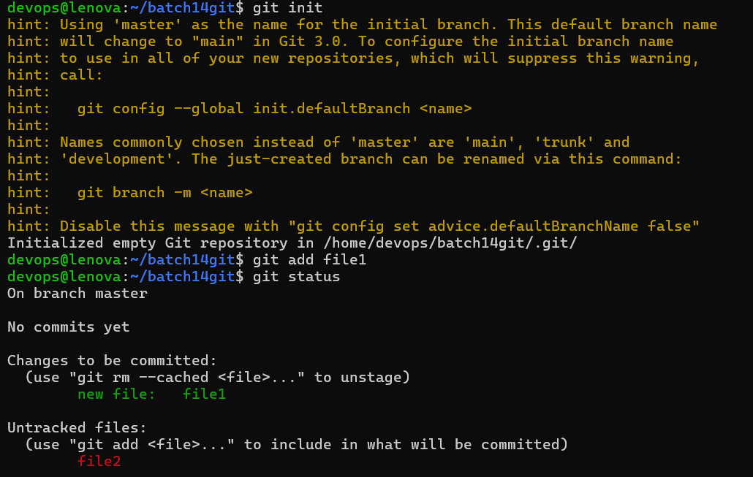
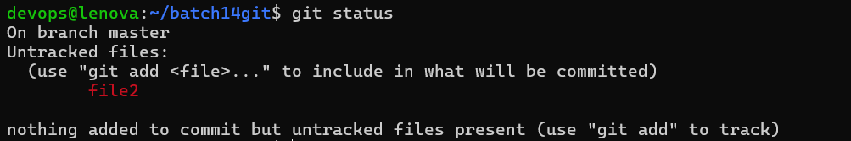

Add remote repository to local repo
git remote add origin <Remote_SSH_URL >
To find remote ssh url.,
Git push -u origin <branch-name>
Git push -u origin master
Git push origin main
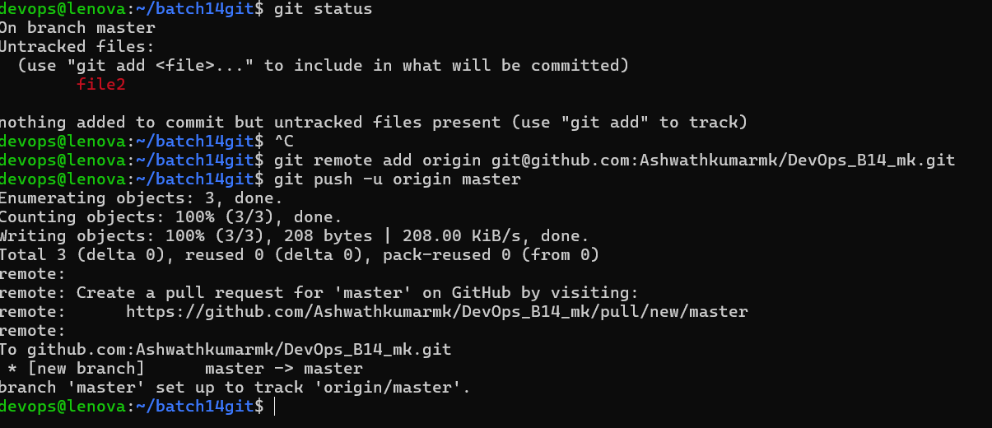
After push we can see these changes in remote repository as shown in below screenshot
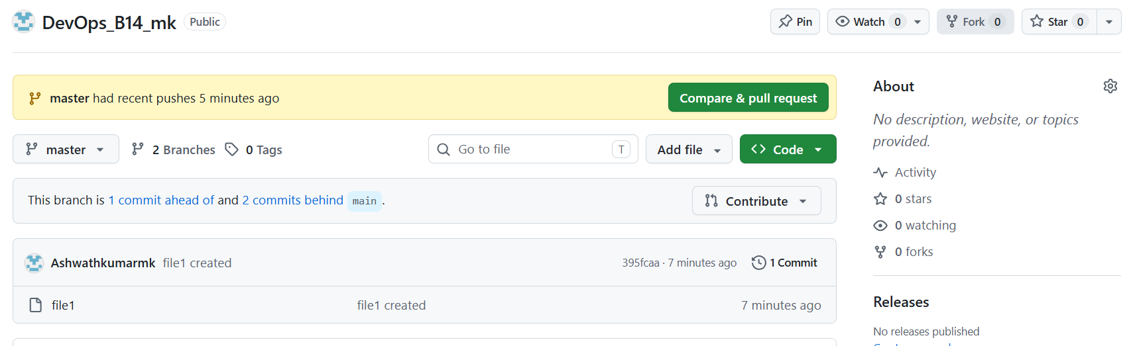

Here file1 was push from local to remote
Git pull origin master-command to download and update the local repo with remote repo. Or to pull the changes made to a specific branch by our team mates,
Git pull lets us know what changes have made by others from team members
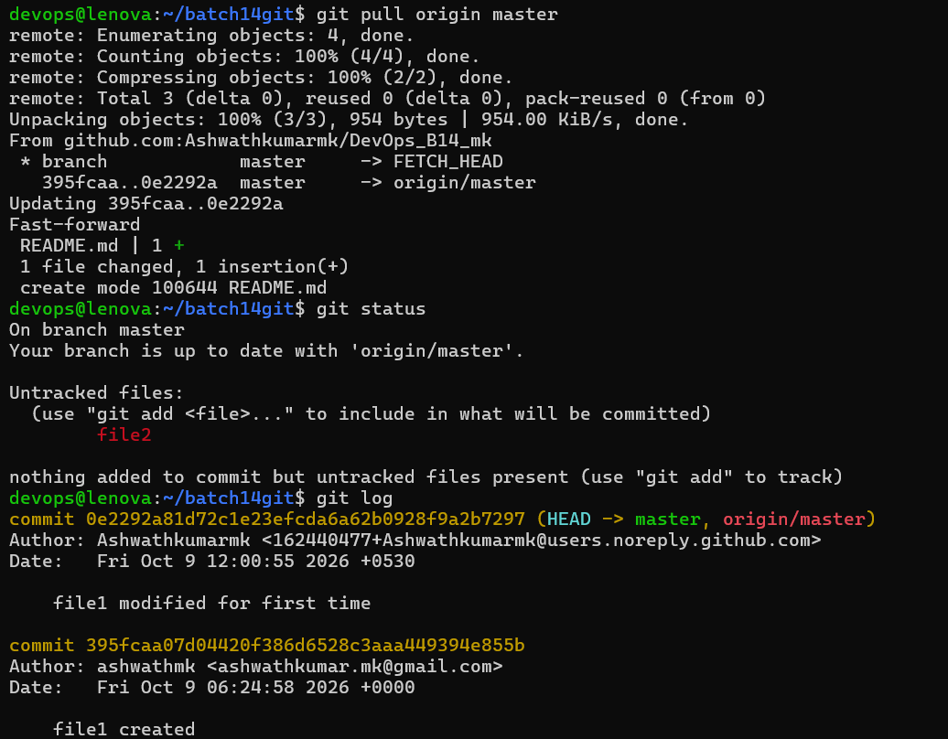

In the above screenshot we can see the any commit changes made by any branhes from local or remote

