Git class 2-8/10/2026
In the terminal config our email and username globally
git config –global user.email “user@gmail.com”
git config –globa user.name “username”

Next creating a public key
-ssh-keygen –t rsa –b 4096 –C “your_email_id”
-t indicates type of key which is rsa type
-b number of bits of key which is 4096
-C indicates comment, we can add mail id’s as a comment
When asked for a file location, press Enter to accept the default (~/.ssh/id_rsa).
Don't set a passphrase for security. Press Enter
Then add the key to the SSH agent:
eval "$(ssh-agent -s)"
ssh-add ~/.ssh/id_rsa
To get the key
- cat <path to key>
- e.g - cat /home/user_name/.ssh /id_rsa.pub
- copy the public key

Go to Github account
- In Github account --- Go to Profile. Click on Settings, click on SSH and GPG keys (Left side of the screen)
- Click on Add new ssh key
- Enter the name for the key
- Paste the copied key in respective box and save

Test SSH Connection to GitHub
ssh -T git@github.com
If successful, you’ll see:
"Hi your-username! You've successfully authenticated..."
In below screenshot illustrated the above steps
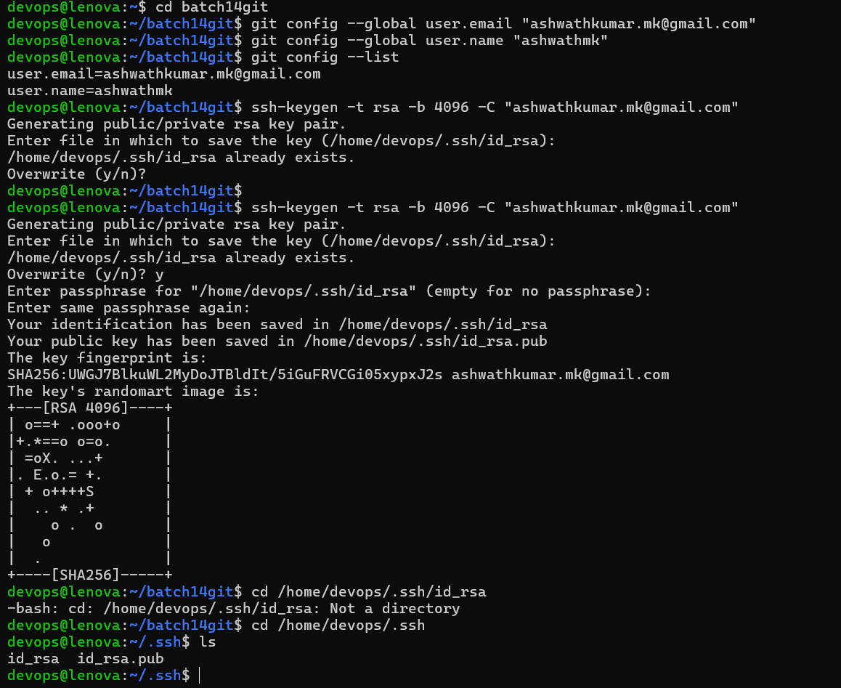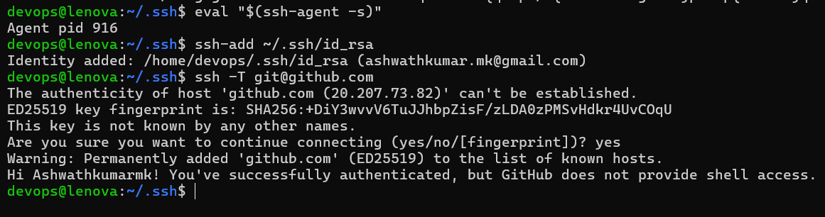

Why Add the Private Key to the SSH Agent?
- The private key (id_rsa) is secret and never shared.
- You add it to the SSH agent so the agent can use it to prove your identity during authentication, without exposing the key itself.
ssh-add ~/.ssh/id_rsa
The SSH agent then "remembers" this key and uses it when Git tries to connect to GitHub.
Why Add the Public Key to GitHub?
- The public key (id_rsa.pub) is meant to be shared.
- You paste it into GitHub's SSH key settings.
- GitHub stores this key and uses it to recognize you when your private key is used to connect.

