1.What is linux?
Linux is an open source operating system(OS) used manage computer hardware and software resources
Linux widely used in
Serveres ,cloud computing,software development,networking,cyber security etc

2. What is Linux terminal?
A Linux terminal is a text-based interface where we can interact with the Linux operating system by entering commands.
Ex: ls
This commands displays the files,directories,links in the current location
Practicing basic linux commands:
:pwd-present working direcoty
It will display present working directory
:ls
The above command displays the files,directories,links in the present working directory
:mkdir <dir1> <dir2>
The above command will create the directory
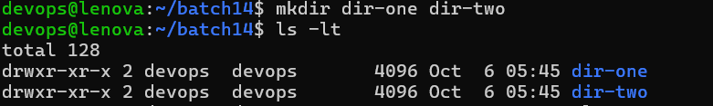
In the above screenshot dir-one dir-two two directories are created
Note: If we dont have parent dir and if we want to create a parent dir and child dir inside parent dir then -p option should be used
:mkdir -p <parent-dir>/<child-dir>
:rmdir <dir-name>
The above command will remove the directory
:rm -r <dir-name>
The above command will remove directory and its content recursively
:tree
The tree command used display ths contents of present workig directory in a tree like format
The below screenshot displays the contents of pwd in a tree format
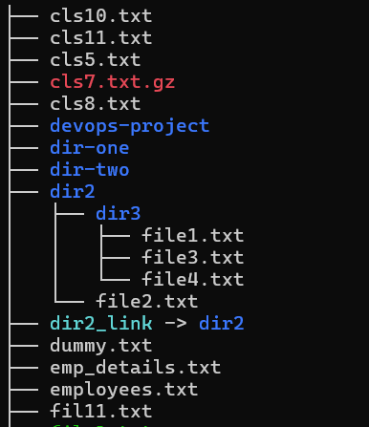
:clear
The above command will clear the terminal screen
:touch file1 file2
:touch command is used to create empty files
:rm -r file-name
The above command will remove file
:rm file1 file2
The above command will remove multiple files
:cd batch 14
The above command change the dir to batch 14
:cd ../.. – change directory
To get back to previous two directories

:man <command-name>
The man command will display the manual page of the command name
:<command-name> --help
The help command used to display basic or limited information about the command
