Date:23/09/2026 - class:2
Types of commands
1 internal commands-commands which are inbuilt in operationg system
2 external command-the command need to install or added to linux environment
Using command
:sudo apt -get install <command-name>
Example of external commands are: tree,wget,open-ssh client,lsof
:ls -l
The above command will displays the list pf files,directories,links in long format
:ls -lt
The above command will list from latest to oldest
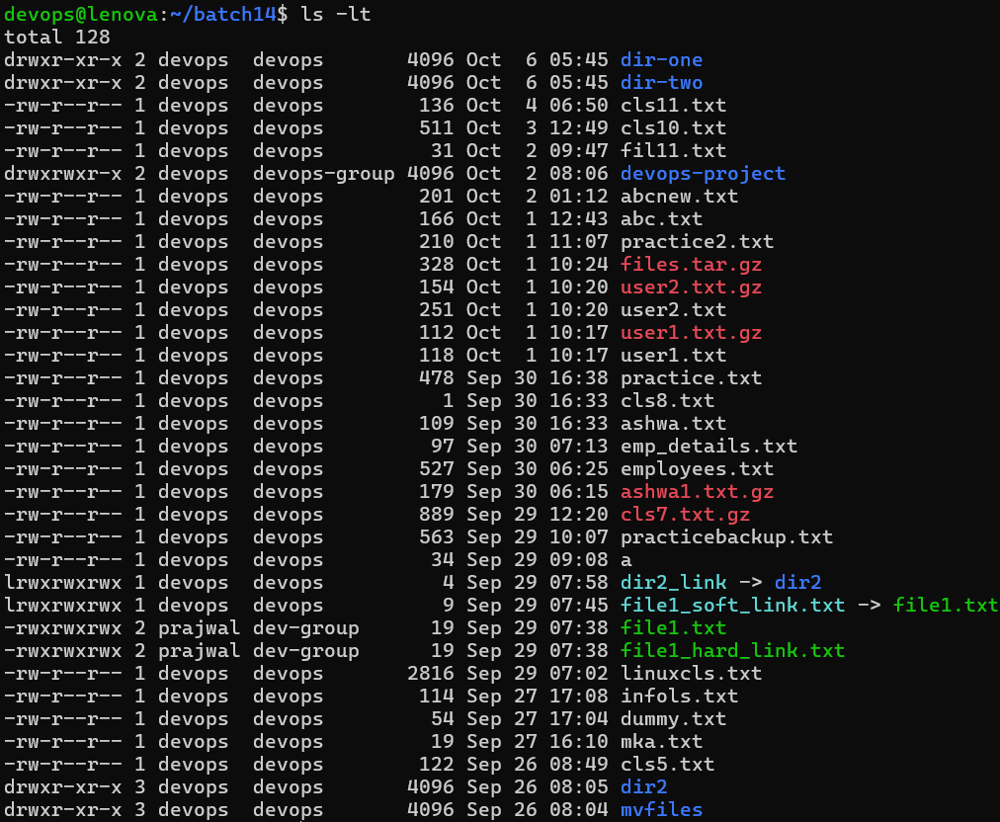

:ls -lrt
The above command list all the dir,files,links in oldest to latest
:ls -a
The above command will list all the hidden files and directories
In below screenshot all hidden files,directories.links are displayed
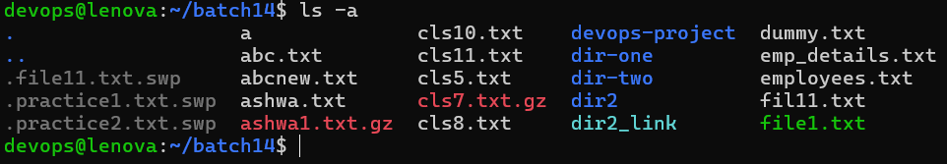

:history
History command will display all the previously executed commands
:date
Date command is used display system current date and time
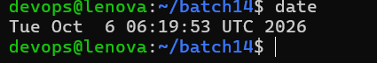

:uname
The above command display the operating system name
:uname -a
The above command display the OS name along with kernel details
:whoami
The above command display the user name
:who
The above command display the logged in user name along with system boot name
:mv file1 file1
The above command used rena,e the file from file 1 to file2
:mv <source-path> <destination-path>
The above command move the files from one location to another location
In below screenshot the cls8.txt renamed to cls12.txt
Emp_details moved to batch14 dir to batch14/dir-one
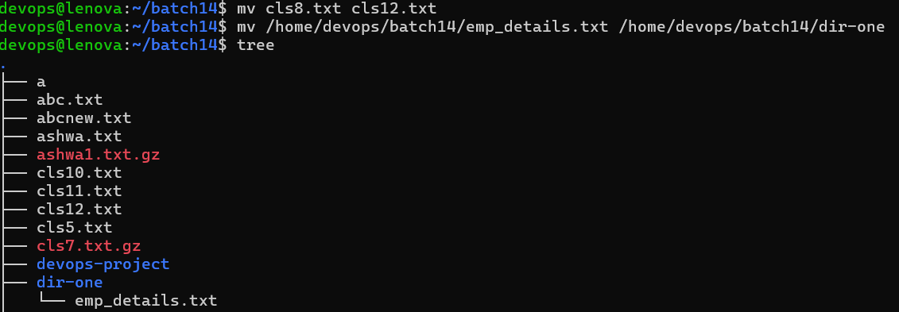

:devops@lenova:~/batch14$ mv /home/devops/batch14/dir-one/emp-details.txt .
The above command move the emp_details.txt to current directory here . indicates pwd
:cp <source-path> <destination-path>
The above command will copy the files or dir from one location to another location
:cp /home/devops/batch14/ashwa.txt /home/devops/batch14/dir-one
The above command copy Ashwa.txt from batch14 dir to /home/devops/batch14/dir-one location
:cp /home/devops/batch14/dir-one/employees.txt .
The above command copy the emplyees.txt to present working directory . indicates pwd

:cp -r <source-path> <destination-path>
The above command copy directory and its content from onr location to another location
Here r- recursively

