Date:24/10/2026 - Linux:class 3
Vi editor (vim- vi modified)
vi <file-name>
The above command will create file
Noe: if file exist it will open the file
If file not exist it will create and open for edit
There are 2 modes in vi editor
1. command mode
2. insert mode
When you execute vi <file-name> by default it will be opened in command mode
To switch from command mode insert mode use i
esc :wq
To save file use esc :wq
w-write(saving the file)
q-quit
to come out of file without saving use esc:q!
esc:set nu
The above command will set the linumbers too a file
esc:set nonu
The above command will removes the line numbers from a file
esc G
The above command will move the cursor to last line
esc A
The above command will go to end of the line where the cursor is pointing
esc 5 G
The above command will go 5th line
esc: dd
The above command will delete the lines where the cursor is ponting
esc: 2dd
The above command will delete 2 lines from where the cursor is pointing
esc: 5d
The above command will delete 5th line
esc :%d
The above command will delete entire content
How to search and replace the string from where the cursor is pointing?
esc:s/<search-pattern>/<return-pattern>
The above command will search only the first occurrence
esc:s/<search-pattern> <return-pattern>/g
The above command will replace all the occurrence
esc:s/morning/evening/g
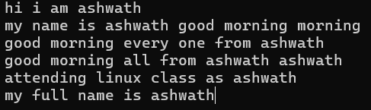
After executing the command esc:%s/morning/evening/g
In entire file morning replaced with evening as shown in below screenshot
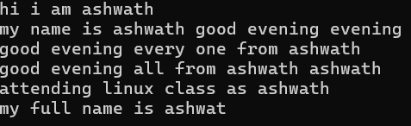
esc:5s/<search-patten>/<return-pattern>/g
above command replace all patterns in line 5
esc:1,5s/<search-pattern>/<replace-pattern>/g
above command replaces from 1st line to 5th line
esc:1,$s/<search-pattern>/<return-pattern>/g
above command will replace from 1st line to last line here $ inficates last line
esc:%s/<search-pattern>/<replace-pattern>/gi
above command will replace case insensitive match in the entire file of all the occurences

