Administrative commands or configuration commands
It is used to create user groups add user to groups etc
How to create a user
sudo adduser <user-name>
Here sudo – super user do who has all admin privileges
How to check if the user is create or not
cat /etc/passwd
How to create switch to root user
sudo su
How to switch to particular user
sudo su <user-name>
How to come out of user
exit
How to create a group
sudo addgroup <group-name>
How to check group is create or not
cat /etc/group
getent group <group-name>
Get the entries like specific group
How to change the password of user
sudo passwd <user-name>
It will ask new password to enter then enter the new password
How to add multiple user to group using single command
sudo gpasswd -aG user1,user2 <group-name>
How to add single user at a time
sudo usermod -aG <group-name> <user-name>
How to delete user
sudo deluser <user-name>
How to delete multiple users in a single command
sudo gpasswd -d user1,user2 <group-name>

In below screenshot user is added, group is created, user deleted from the group then added multiple
users to a group
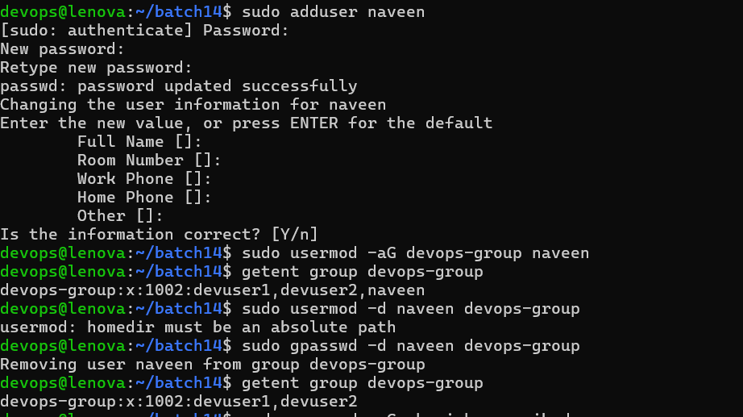

How to delete a group
sudo delgroup <group-name>
Permissions?
Files/dir's /links
User permission who is the owner of file/directory
group Provide a particular permission to a group
other Any user who is neither the owner of the file or member of the group
d=represent directory
-=Represent file
l=represent link
r=read
w=write
x=excecute
4=read
2=write
1=execute
g-group
u-user
o-other

1 3 3 3
dir/file/links <user-perm> <group-perm> <other-perm>
4 2 1 4 2 1 4 2 1
r w x r w x r w x
...........................................................
777 1 1 1 1 1 1 1 1 1
700 1 1 1 0 0 0 0 0 0
440 1 0 0 1 0 0 0 0 0
414 1 0 0 0 0 1 1 0 0

sudo chmod 777 <file-name> or sudo chmod u+rwx,g+rwx,o+rwx <file-name>
The above command will give all the permisssions to given file
sudo chmod 740 <file-name>
The above command will give all permissions to user,read permission for group and no permission for others
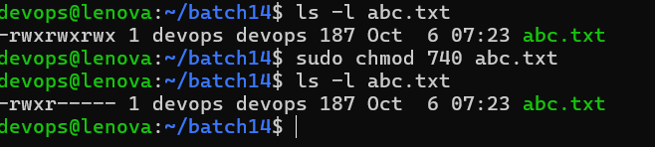

sudo chmod o+x file1.txt
Above command will provide execute permissons for others

