Class 7
Links
Links is a pointer to a file or directory
Types of links
1.hard link
2.soft link
Hard link
Syntax ln <file-name> <link-name>
Points to remember
1.when you change the content of file you can see those changes in link also
2.in hard link both file and hard link will share the same inode
3.if you rename a file link will work
4.if you delete a file link will work

Soft link
Syntax ln -s <file-name> <link-name>
Here s- refer soft link
Points to remember
1.in soft link if you make any changes to file you can see those changes in file
2.in soft link file and soft link will never share the same inode
3.if you rename the file soft link will not work
4.if you delete the file soft link will not work

More command
More command used to display the contents of files in a page wise on the terminal
If you press down arrow next page content will display
Syntax more file-name

Less command
Syntax less <file-name>
Less command is used display the content of the file on the terminal by default it will display first page of the file

Then press down arrow it will go to next line by line in downword direction
If you press upward arrow the cursor is moving line by line in upward direction

Class 8
Grep- global regular expression
grep command is used to search or filter the pattern on a closed file
Limitation of grip is we can not replace the content
Syntax is grep <search-pattern> <file-name>

1.grep -w <pattern> <file-name>
Above command will display the lines where the exact pattern is present
2.grep -o <pattern><file-name>
The above command will display only the exact pattern not the line
3.grep -v <pattern><file-name>
The above command will display the lines where the pattern is not present
4.grep -i <pattern><file-name>
The above command will display the lines where the case insensitive pattern is present
5.grep -c <pattern > <file-name>
The above command will display total number of lines where the pattern is present
6.grep -n -i <search-pattern> <file-name>
The above pattern will display the lines where the case insensitive pattern is present along with line numbers
7.grep -e <pattern><file-name> -e <patter> <file-name>
The above command is used to search multiple pattern

Awk command
awk command is used extract the column wise content on the terminal from a structured file

Syntax awk ‘{print }’ <file -name>
1.awk ‘{print $1}’ <file-name>
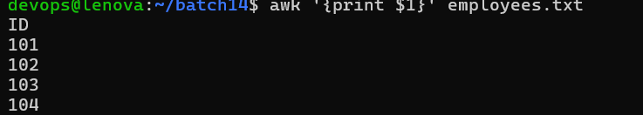

The above command will display the first column on the terminal
2.awk ‘{print $2,$4}’ <file-name>
The above command will display the second and fourth column contents on the terminal
3.awk ‘{print $NF}’ <file-name>
The above command will display the last column content on the terminal
4.awk ‘{print $0,$NF}’ <file-name>
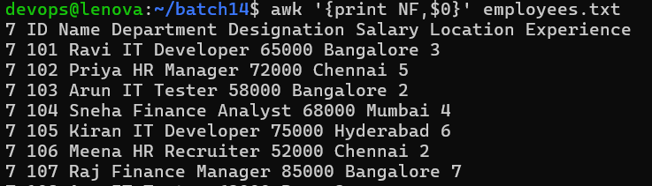
The above command will display the all the contents along with number of field,words,column on each line
5.awk ‘{print NR,$2}’ <file-name>
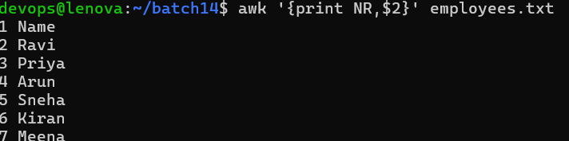
The above command will display the second column content along with row number

