Vi editor continue

How to insert a blank line in vi editor below the line where the cursor is pointing?
esc o
How to insert a blank line in vi editor above the line where the cursor is pointing?
esc --shift---o or capita O
esc x
the above command will delete a character where the cursor is pointing
echo command
echo command is used to display a message on the terminal
echo “good morning”
we can redirect the output to a file
echo “good morning Ashwath”>> file1.txt
above command will append the content into file1.txt
echo this is a linux class>file2.txt
above command will replace the above message to file2.txt
cat command
cat command is used to display the contents files on the terminal
cat file1.txt
above command will display the content on the terminal
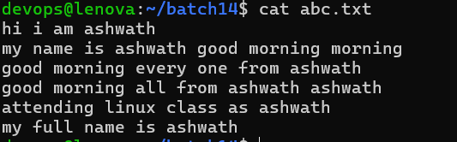
cat -n file.txt
the above command will display the content along with the line number
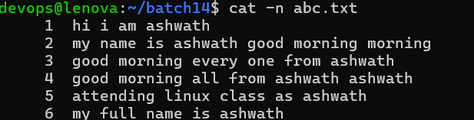
cat -b file.txt
The above command will display the content along with line number where the content is present
If blank line is there then that will not consider and assign line number
cd -s file.txt
Above command will display the content of the file on the terminal by supressing multiple empty lines into single empty line
cat -n -s file.txt
The above command will display the content of the file on the terminal along with line number and suppressing all the blank lines into single line
cat <f1.txt><f2.txt>
The above command will display content of file 1 and file2 on the terminal
wc command
Wc command is used to display line numbers,words count,char or byte count on the terminal
wc <file-name>
The above command will display total number of lines,words,char or bytes on the terminal
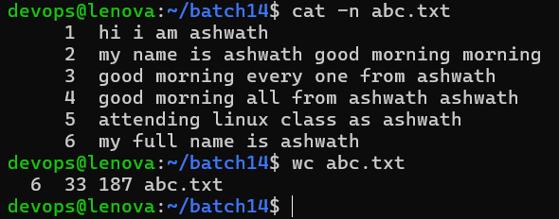
In the above screenshot the abc file conataines
6 lines
33 words
187 characters
cat -l <file-name>
The above command will display the only total number of lines on the file
cat –w <file-name>
The above command will display the only total number of words of the file on the terminal
cat -m <file-name>
The above command wil display only the total number of characters/bytes of the file on the terminal
wc -L <file-name>
The above command will display the total number of characters from longest line of the file on the termina
head an tail command
head command is used to display first few lines of the files on the terminal
By default head will display first 10 lines of the file on the terminal
head <file-name>
The above command will display first 10 line of the file on the terminal
head -15 <file-name>
The above command will display the first 15 lines from the file on the terminal

tail command is used to display last few lines of the files on the terminal
By default last 10 lines will be displayed on the terminal
tail <file-name>
By default last 10 lines displayed on the terminal
tail -5 file-name
The above command will display last 5 lines of the terminal
Pipe (|) operator
Pipe operator used to send output of one command as an input to another command
head -10 <file-name> | tail -1
Abive command will display last line from 10 line
head -15 <file-name> | tail -5
The above command will display lines from 11 to 15 on the terminal
cat -n <file-name> | tail -1
Above command will display the last line of the file on the terminal
tee command
tee command is used with pipe operator which is used to read the input and copy to one or more files
Syntax command-1 | tee command-2
Ex cat class10.txt | tee fil8.txt
Above command will replace the content of file8.txt with the content of class10.txt
Ex ls | tee file.txt
Above command will move the output of ls to file.txt
Ex tail -8 file4.txt | tee mk.txt
Above command will copy last 8 lines of file4.txt into mk.txt

