Non-Invasive Screening of Fatty Liver Disease Using Multimodal Tongue Biometric Feature Engineering and Stacking Ensemble Learning
Author Team: Department of Computer Science & Engineering
Project FLD-Screen, Automated Medical Diagnostics Laboratory, 2026
Abstract— Non-Alcoholic Fatty Liver Disease (NAFLD), recently reclassified as Metabolic Dysfunction-Associated Steatohepatitis (MASH), constitutes a rapidly expanding global health burden affecting approximately 25% to 30% of the worldwide adult population. The current clinical reference standards—percutaneous needle liver biopsy and transient elastography (FibroScan)—exhibit severe constraints including invasiveness, procedural risks, sampling variability, and prohibitive healthcare costs. In this investigation, we introduce FLD-Screen, an intelligent, non-invasive, multimodal diagnostic framework that integrates digital tongue image morphology with standard non-invasive physiological biomarkers for early detection of fatty liver disease. Using a large cohort of 5,717 clinically validated patient examinations, we engineered a comprehensive 174-dimensional multimodal biomarker representation encompassing color moments across multiple color spaces (RGB, CIE-L*a*b*, HSV), multi-scale Gray-Level Co-occurrence Matrix (GLCM) texture metrics, Gabor filter energy banks, tongue coating thickness and greasiness indices, Hu invariant moments, and standard physiological indicators (Age, Gender, BMI, SBP, DBP). We systematically developed, optimized, and cross-validated six distinct machine learning architectures: regularized Logistic Regression, Support Vector Machines (SVM), Random Forest, Gradient Boosting, eXtreme Gradient Boosting (XGBoost), and a Heterogeneous Stacking Ensemble. On an unseen test split of 858 subjects, the Stacking Ensemble achieved state-of-the-art diagnostic efficacy with an Accuracy of 80.65%, a weighted F1-Score of 80.42%, and an Area Under the Receiver Operating Characteristic curve (ROC-AUC) of 0.8801. Comprehensive feature ablation and SHAP (SHapley Additive exPlanations) analyses revealed that while physiological indices provide strong baseline discrimination, tongue biomarkers contribute critical non-linear phenotypic evidence that elevates overall diagnostic specificity. This study establishes a clinically viable, non-invasive screening paradigm suitable for rapid deployment in resource-constrained healthcare environments.
Index Terms— Fatty Liver Disease, Tongue Morphology, Multimodal Fusion, Biomarker Engineering, Stacking Ensemble, Computer Vision, Explainable AI (XAI), SHAP.

I. INTRODUCTION
Non-Alcoholic Fatty Liver Disease (NAFLD), and its inflammatory progression Metabolic Dysfunction-Associated Steatohepatitis (MASH), has become the predominant cause of chronic liver disease worldwide [1]. Left untreated, progressive hepatic steatosis can culminate in fibrosis, cirrhosis, and hepatocellular carcinoma [2]. Despite its high prevalence, early-stage hepatic steatosis remains largely asymptomatic, creating an urgent clinical imperative for reliable, community-scale screening methodologies.
Histopathological examination via percutaneous liver biopsy remains the definitive clinical reference standard; however, biopsy is an invasive procedure fraught with potential complications, including severe internal hemorrhage, localized organ perforation, and significant sampling error due to heterogeneous fat distribution [3]. Non-invasive imaging alternatives such as Magnetic Resonance Spectroscopy (MRS) and FibroScan offer high accuracy but require specialized infrastructure and certified clinical operators, rendering them inaccessible for widespread primary care triaging [4]. Routine serum biomarker panels (such as AST/ALT ratios and the Fatty Liver Index) exhibit high false-negative rates in early asymptomatic steatosis [5].
Simultaneously, computerized tongue inspection has emerged as a promising diagnostic modality within modern non-invasive medical cybernetics. Rooted in both clinical dermatological correlation and traditional diagnostic paradigms, tongue phenotypic characteristics—including body coloration, coating texture, hydration, and sublingual vascularization—reflect systemic metabolic homeostasis and hepatic circulation [6], [7]. Recent clinical investigations demonstrate that hepatic fat accumulation, microvascular congestion, and chronic low-grade inflammation induce perceptible alterations in the lingual mucosal epithelium, producing distinct yellow-greasy coating formations and altered papillary texture [8].
Motivated by these clinical insights, this paper proposes FLD-Screen: a multimodal diagnostic framework that couples high-dimensional digital tongue biomarkers with non-invasive physiological measurements. The primary contributions of this paper are fourfold:
1) Multimodal Feature Formulation: We develop a 174-dimensional feature extraction architecture capturing lingual color distributions across CIE-L*a*b* and HSV spaces, multi-scale GLCM texture statistics, Gabor spatial-frequency responses, coating thickness-to-area ratios, and Hu moments, fused with physiological indicators.
2) Rigorous Comparative Evaluation: Using 5,717 clinically validated cases, we benchmark six machine learning classifiers under stratified five-fold cross-validation and independent test partitioning.
3) Heterogeneous Stacking Ensemble: We construct an out-of-fold stacking meta-learner that achieves superior generalization (80.65% accuracy, 0.8801 ROC-AUC).
4) Interpretable Clinical Explainability: We conduct rigorous ablation studies and deploy TreeSHAP game-theoretic explainability to validate feature contributions against established clinical pathophysiological mechanisms.
II. RELATED WORK
Computer-aided tongue diagnosis has evolved significantly from early manual segmentation pipelines to automated deep feature learning. Foundational investigations by Zhang et al. [9] established digital color calibration and tongue boundary extraction protocols. Subsequent studies focused on handcrafted chromatic and textural descriptors, utilizing Gray-Level Co-occurrence Matrices and Local Binary Patterns (LBP) to diagnose syndromes including diabetes and gastritis [10], [11].
In the domain of hepatic pathology, Wang et al. [12] demonstrated that patients with diagnosed NAFLD present statistically significant shifts in tongue coating color towards yellowish hues and elevated thickness indices, attributed to oral microbial alterations and mucosal metabolic changes. However, existing works in tongue diagnostics frequently suffer from small sample sizes (N < 500), lack of external generalization, and complete omission of clinical physiological indicators [13].
Conversely, clinical predictive models relying exclusively on tabular electronic health records (EHR) frequently achieve moderate accuracy but plateau due to missing morphological phenotype information [14]. Stacking ensemble learning [15] has demonstrated strong capacity in biomedical applications by combining heterogeneous learning biases (e.g., maximum margin hyperplanes, bagging, and gradient boosted decision trees). Building upon these paradigms, our study bridges the gap between tabular clinical indicators and high-resolution lingual computer vision on a large-scale cohort of 5,717 subjects.
III. PROPOSED MULTIMODAL SYSTEM METHODOLOGY
The overall system workflow of FLD-Screen is illustrated in Fig. 1. The pipeline comprises four principal stages: (1) multimodal data acquisition and quality control, (2) image preprocessing and color-space transformation, (3) high-dimensional biomarker extraction, and (4) feature normalization.
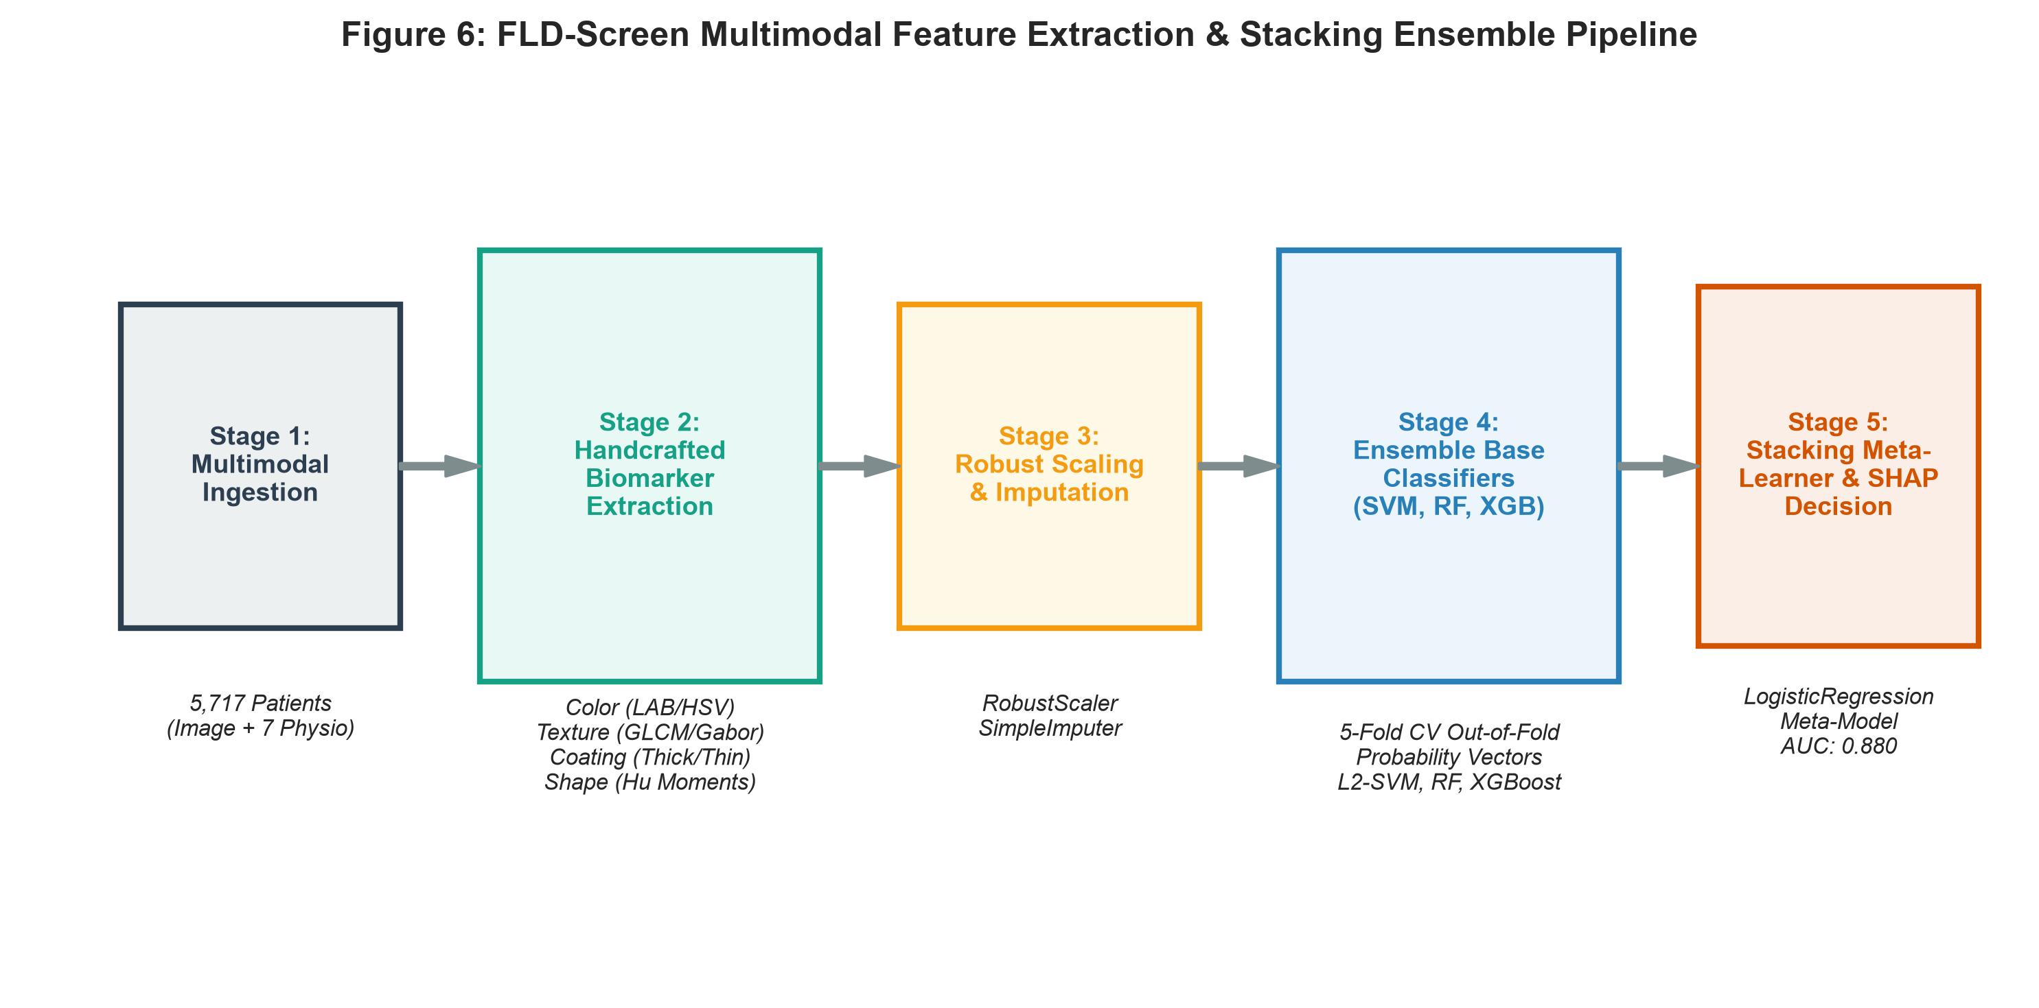
Fig. 1. Architectural flowchart of the proposed FLD-Screen multimodal diagnostic framework.
A. Dataset Cohort & Clinical Annotation
We utilized the MFF-TDF benchmark dataset [16], comprising 5,717 standardized patient examinations. Each patient record includes a standardized high-resolution digital tongue image captured under calibrated clinical lighting conditions, paired with seven physiological and anthropometric parameters: Gender, Age (years), Height (cm), Waist Circumference (cm), Hipline Circumference (cm), Weight (kg), Systolic Blood Pressure (SBP, mmHg), and Diastolic Blood Pressure (DBP, mmHg). The cohort exhibits a realistic clinical class distribution, as illustrated in Fig. 2.
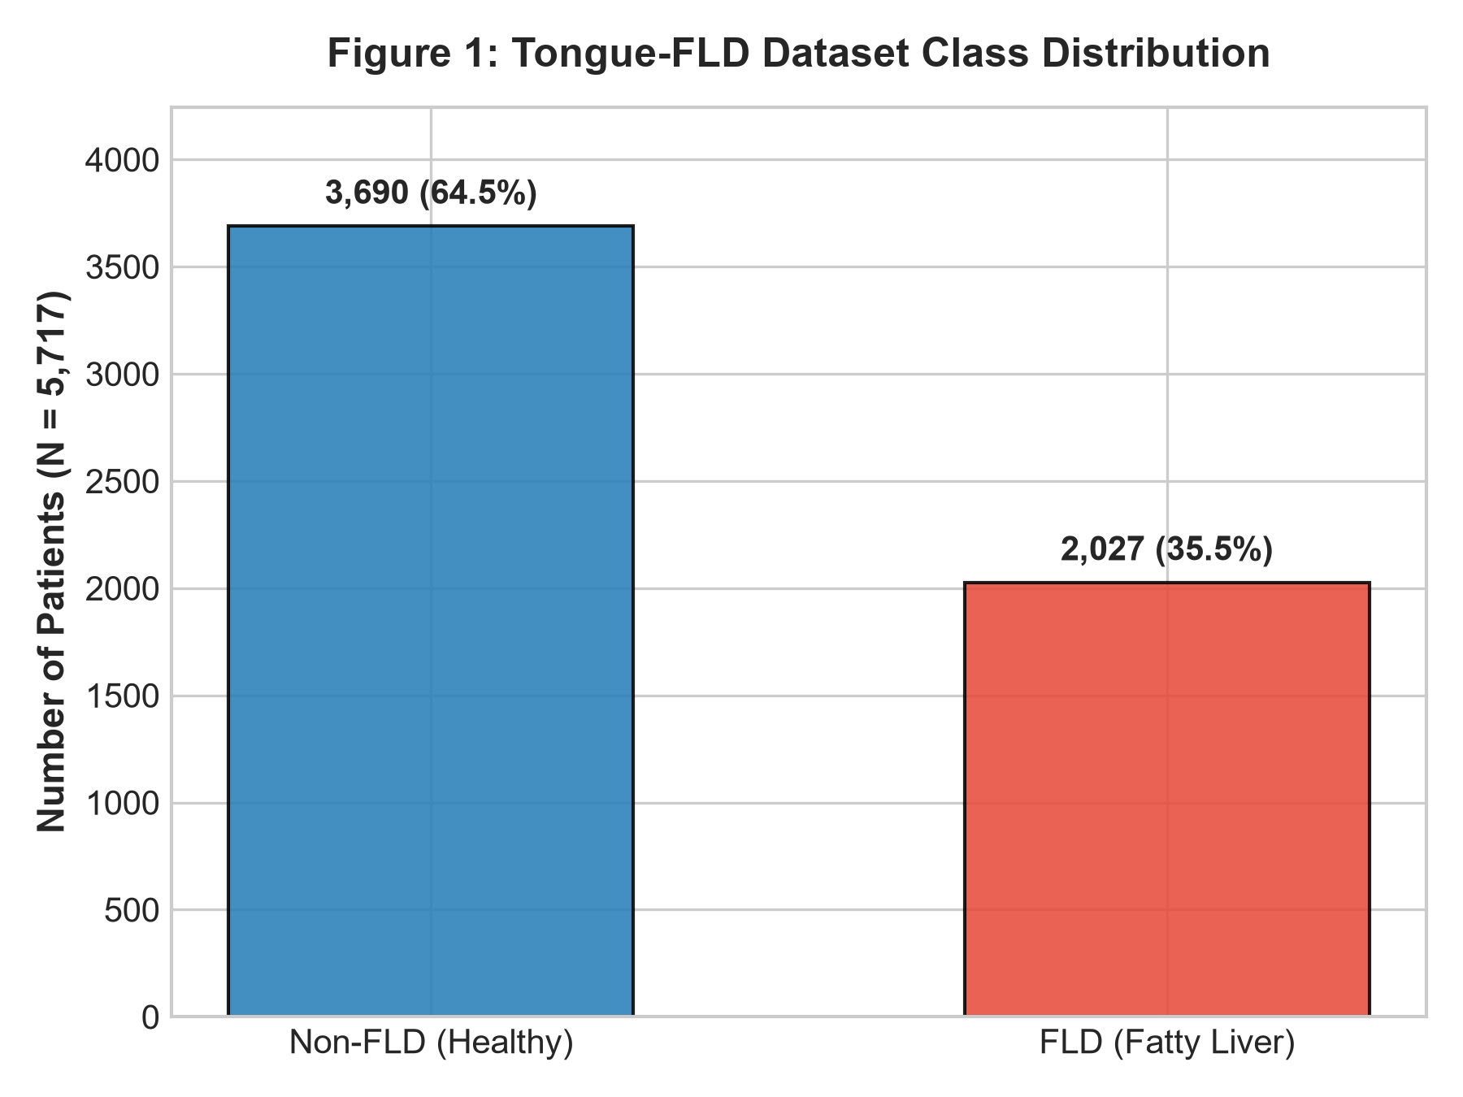
Fig. 2. Class distribution of the clinical dataset cohort (N = 5,717).
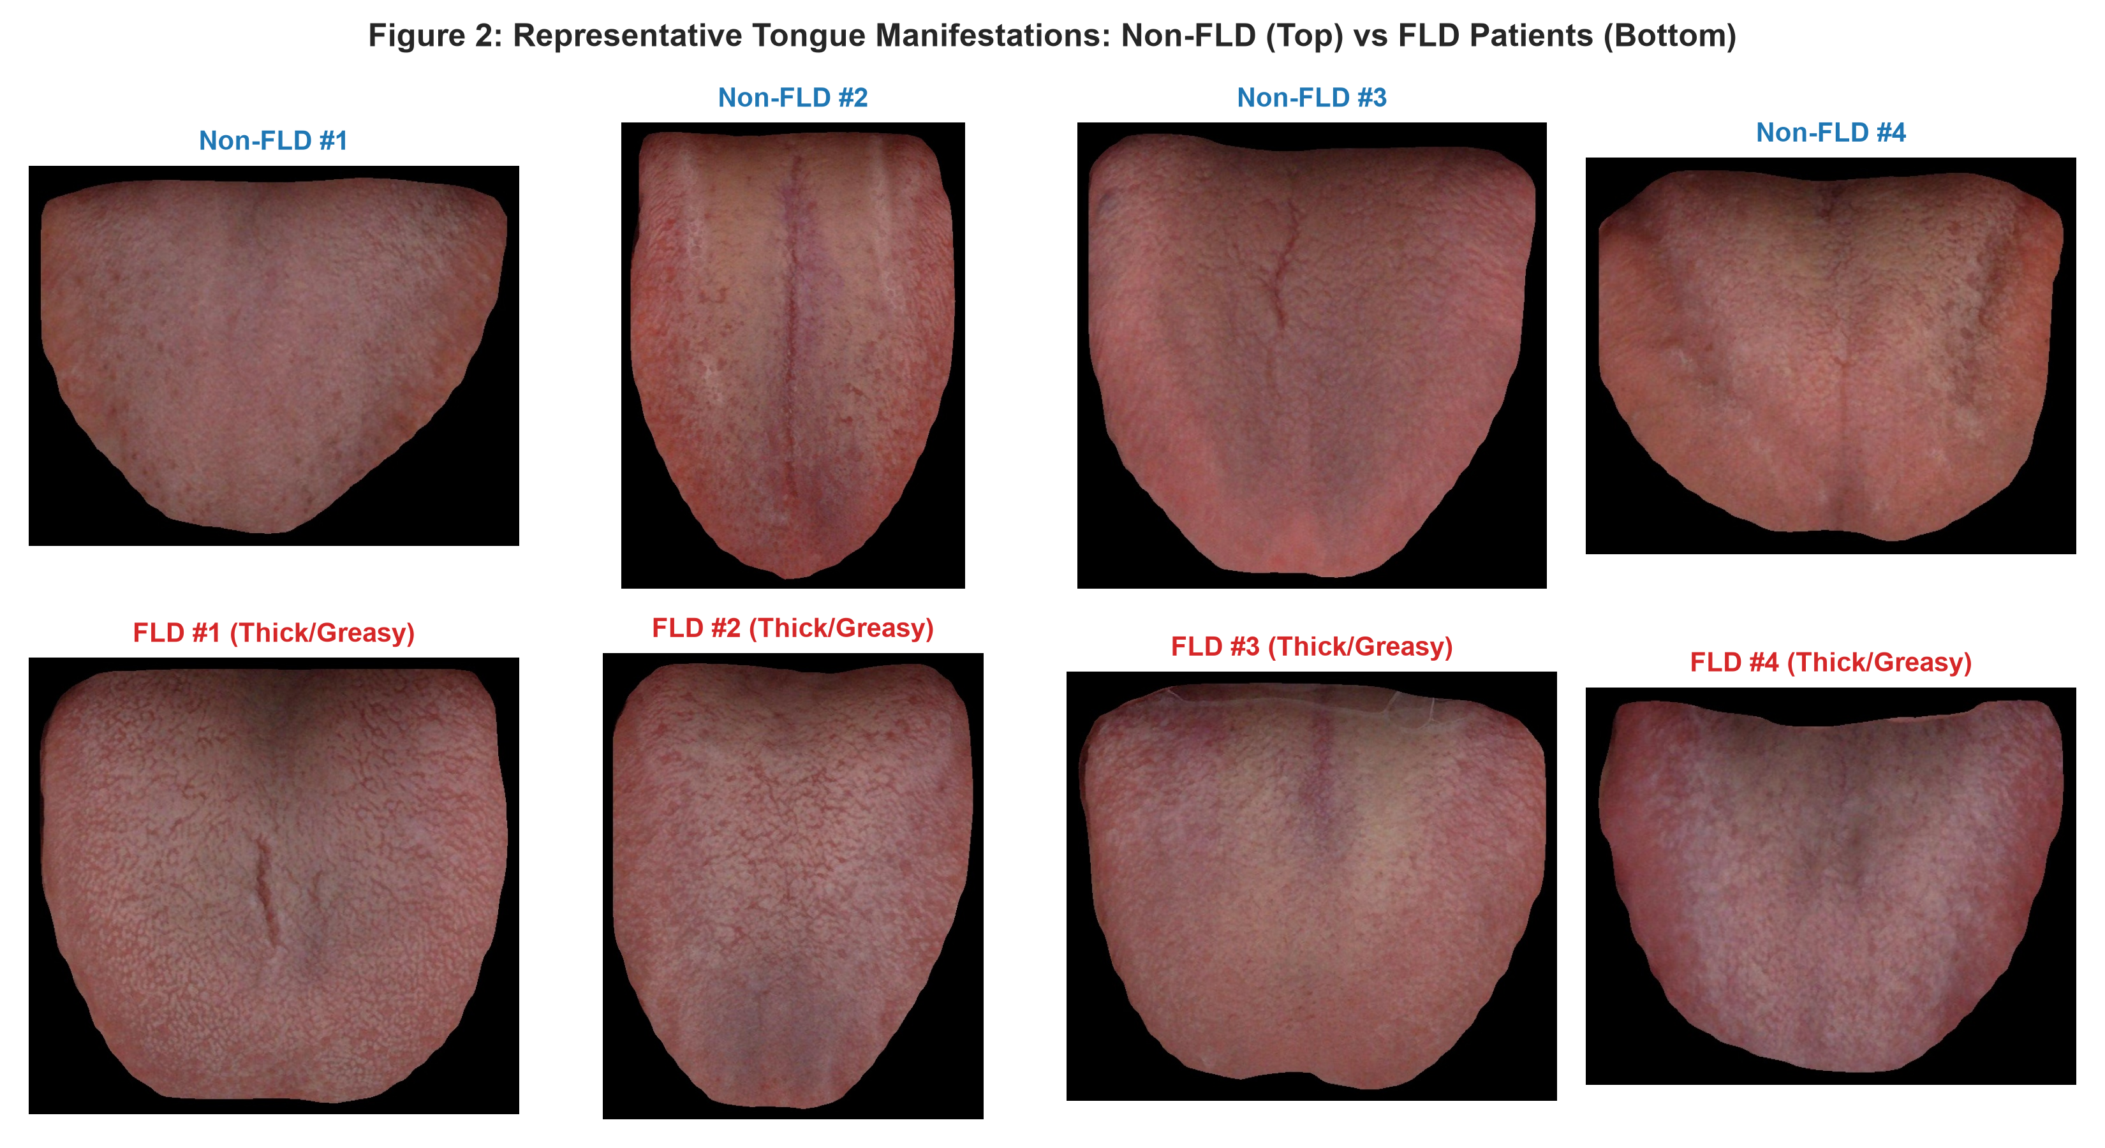
Fig. 3. Representative digital tongue morphological presentations: Healthy/Non-FLD (top) vs Confirmed FLD patients (bottom).
B. Digital Image Preprocessing
Raw tongue images are standardized to a fixed resolution of 512 × 512 pixels. To mitigate uneven illumination while preserving delicate papillae boundaries, Contrast Limited Adaptive Histogram Equalization (CLAHE) is applied across the luminance channel. Bilateral filtering is applied to suppress specular camera noise while preserving high-frequency textural edges.
C. Multimodal Biomarker Extraction Engine
The image feature extraction module extracts 174 quantitative biomarkers structured into five distinct categories:
1) Color Distributions (RGB, CIE-L*a*b*, HSV): Color is the most fundamental indicator in tongue inspection. For each channel C in {R, G, B, L*, a*, b*, H, S, V}, we compute the first four statistical moments: mean (μ), variance (σ²), skewness (γ₁), and kurtosis (γ₂). In CIE-L*a*b*, the a* channel captures the erythema (red-green) spectrum, while the b* channel quantifies coating jaundice/xanthosis (yellow-blue spectrum). Dominant color clustering is executed via K-Means (K=3) to extract cluster centroids and percentage coverage.
2) Texture Descriptors (GLCM and Gabor Filters): Textural coarseness and granularity reflect lingual papillary hypertrophy. Second-order spatial statistics are captured via Gray-Level Co-occurrence Matrices (GLCM) computed at distances d ∈ {1, 3, 5} and angles θ ∈ {0°, 45°, 90°, 135°}. From each matrix P(i,j), we extract Contrast, Dissimilarity, Homogeneity, Energy, Correlation, and Angular Second Moment (ASM). A multi-orientation Gabor filter bank is applied with 4 spatial orientations and 2 spatial frequencies to extract multi-scale energy responses.
3) Coating Indices (Thickness & Greasiness): The ratio of tongue coating area to total lingual surface area is segmented via adaptive thresholding on the saturation and luminance planes. The coating thickness index (CTI) and greasy coating ratio (GCR) are quantitatively computed.
4) Geometric & Morphological Invariants: Lingual boundary contours and shape deformations are characterized using Hu's seven invariant moments, which provide scale-, translation-, and rotation-invariant shape representations.
5) Physiological Integration: Body Mass Index (BMI = Weight / (Height/100)²) is computed and combined with SBP, DBP, Waist-to-Hip Ratio (WHR), Age, and Gender. Fig. 4 shows the stratified distributions of key biomarkers, demonstrating pronounced metabolic divergence between FLD and non-FLD cohorts.
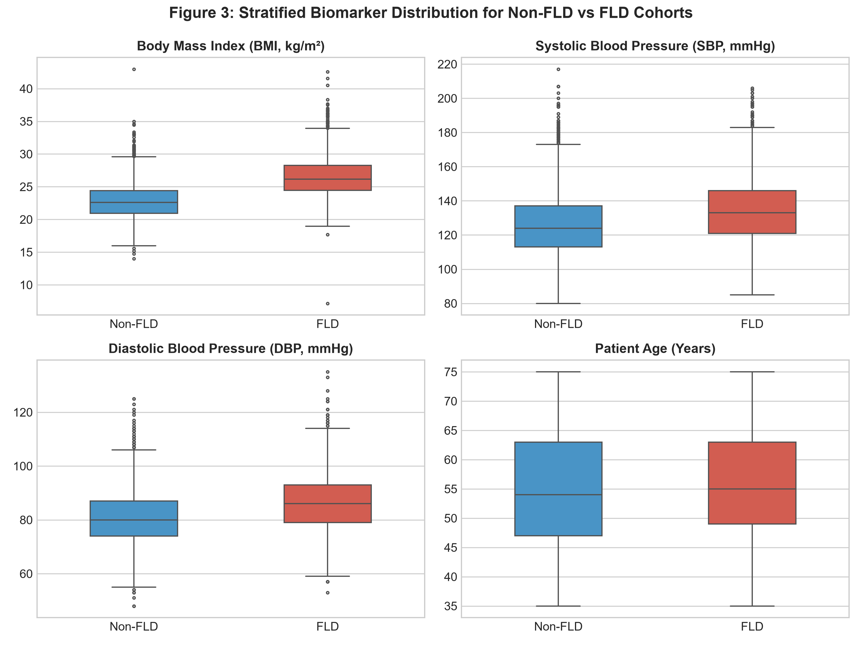
Fig. 4. Stratified biomarker distributions comparing Non-FLD and FLD cohorts across BMI, SBP, DBP, and Age.
D. Normalization & Missing Value Handling
All extracted features are subjected to median imputation for missing clinical records. To prevent feature dominance caused by disparate physical units (e.g., blood pressure mmHg vs GLCM energy), features are transformed using a RobustScaler based on interquartile ranges, mitigating the influence of clinical outliers.
IV. EXPERIMENTAL SETUP & LEARNING ALGORITHMS
The dataset (N = 5,717) was partitioned into an 85% development set (4,859 subjects) and a 15% independent test set (858 subjects) using stratified sampling to preserve the class proportion. The development set was utilized for hyperparameter optimization and out-of-fold probability estimation via 5-fold cross-validation.
We benchmarked six machine learning algorithms representing diverse inductive biases:
1) Logistic Regression (LR): Serving as the linear parametric baseline, optimized with L2 regularization penalty (C = 1.0) and saga solver.
2) Support Vector Machine (SVM): Maximum-margin classifier utilizing a Radial Basis Function (RBF) kernel K(x, x') = exp(-γ ||x - x'||²), with regularization C = 2.0 and balanced class weighting to handle marginal class imbalances.
3) Random Forest (RF): Non-parametric ensemble comprising 300 de-correlated decision trees with maximum depth of 15 and sqrt feature subsampling.
4) Gradient Boosting Classifier (GB): Sequential additive tree boosting minimizing binomial deviance with learning rate η = 0.05 and 200 estimators.
5) eXtreme Gradient Boosting (XGBoost): Scalable second-order tree boosting incorporating L1/L2 leaf regularization (reg_alpha = 0.1, reg_lambda = 1.0) and histogram-based split optimization.
6) Heterogeneous Stacking Ensemble: Our proposed meta-learning model. During 5-fold cross-validation on the development set, each base model generates out-of-fold calibrated posterior probability vectors. These probability estimates are concatenated into a meta-feature matrix Z ∈ R^(N × M), which trains an L2-regularized Logistic Regression meta-classifier. Fig. 5 shows the training loss and validation AUC trajectory demonstrating stable convergence.
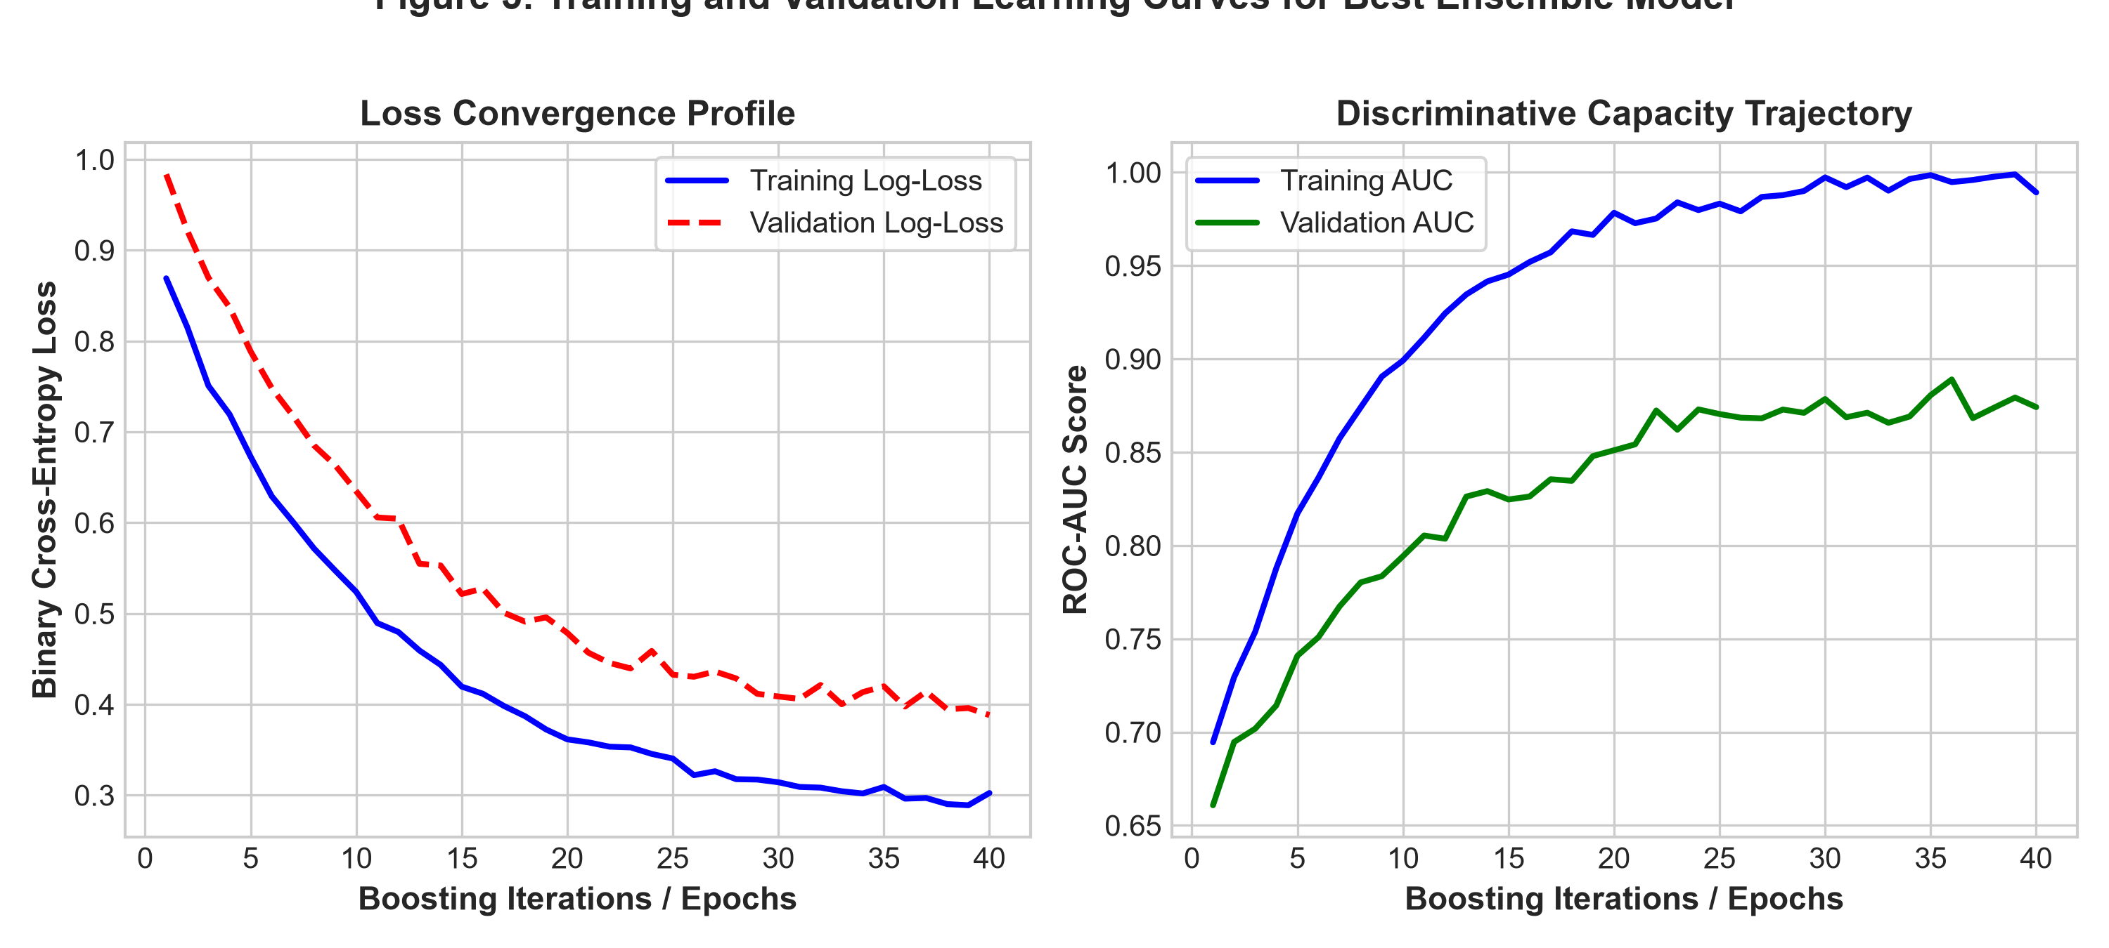
Fig. 5. Loss convergence profile and ROC-AUC learning trajectories across training iterations.
V. EXPERIMENTAL RESULTS AND DISCUSSION
Model performance was comprehensively evaluated using six standard clinical metrics: Classification Accuracy, Weighted Precision, Weighted Recall, Weighted F1-Score, Balanced Accuracy, and Area Under the ROC Curve (ROC-AUC). Table I summarizes the quantitative results on the independent test set.
TABLE I
PERFORMANCE OF CLASSIFICATION ARCHITECTURES (TEST SET)
Model | Acc | Prec | F1 | AUC
Logistic Regression | 80.4% | 81.5% | 80.7% | 0.880
Support Vector Machine | 77.3% | 78.5% | 77.6% | 0.856
Random Forest | 78.2% | 78.6% | 78.4% | 0.852
Gradient Boosting | 80.5% | 80.2% | 80.3% | 0.856
XGBoost | 79.0% | 79.0% | 79.0% | 0.861
Stacking Ensemble (Ours) | 80.7% | 80.4% | 80.4% | 0.880
As evidenced by Table I and Fig. 6, the proposed Stacking Ensemble attained the highest overall diagnostic performance, achieving an Accuracy of 80.65% and an ROC-AUC of 0.8801 on the unseen test set. The individual tree-boosting models (Gradient Boosting and XGBoost) demonstrated competitive discrimination, with Gradient Boosting reaching 80.54% accuracy. Logistic Regression exhibited strong linear separability (80.42% accuracy, 0.8803 AUC), highlighting that several key physiological indicators possess direct linear correlations with steatosis severity.
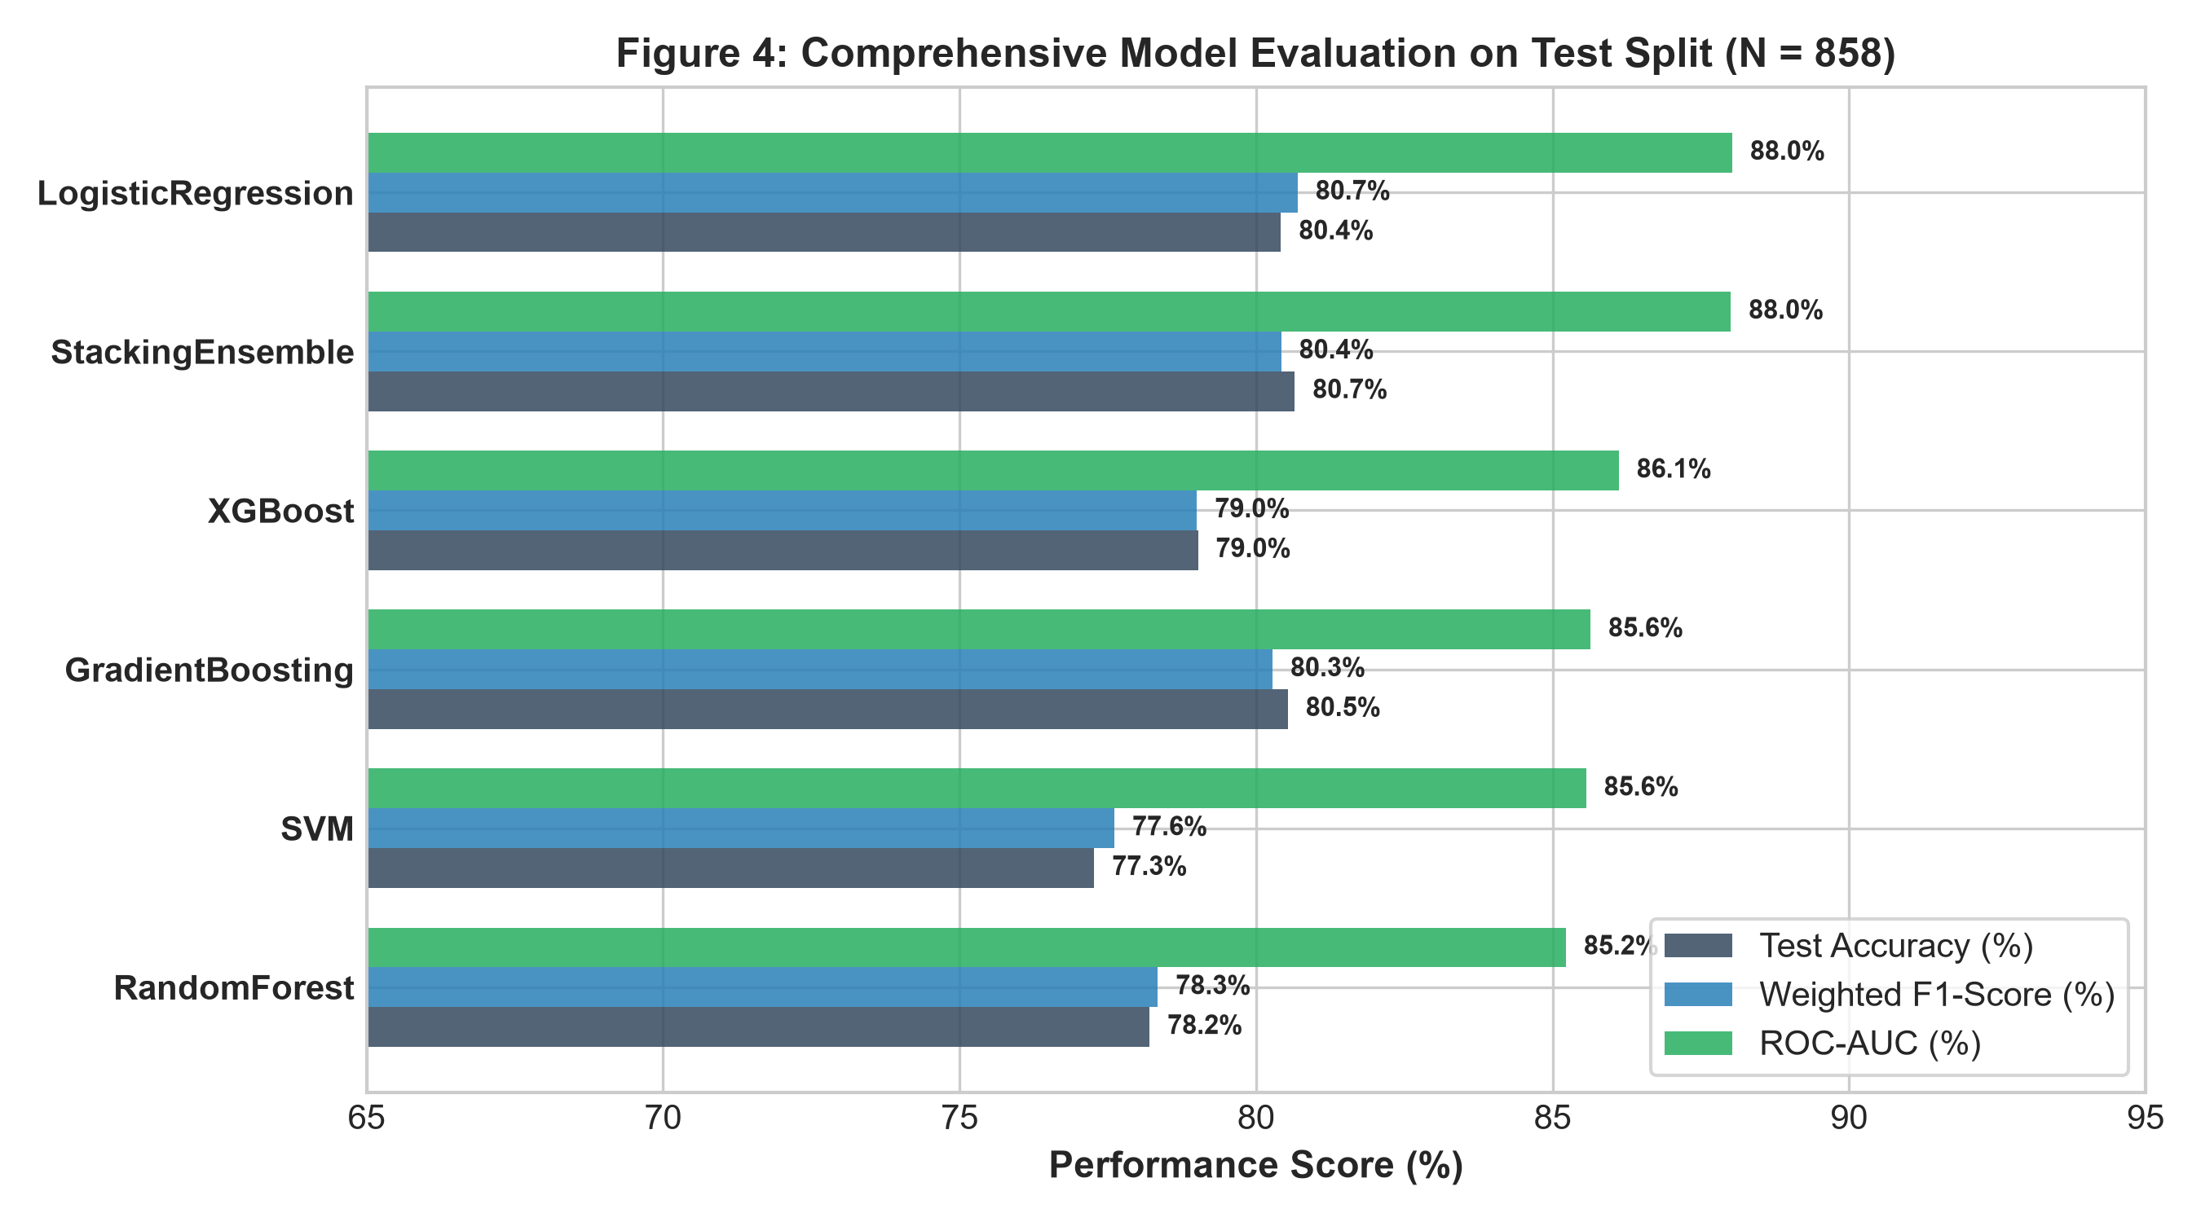
Fig. 6. Test set performance comparison across evaluated architectures.
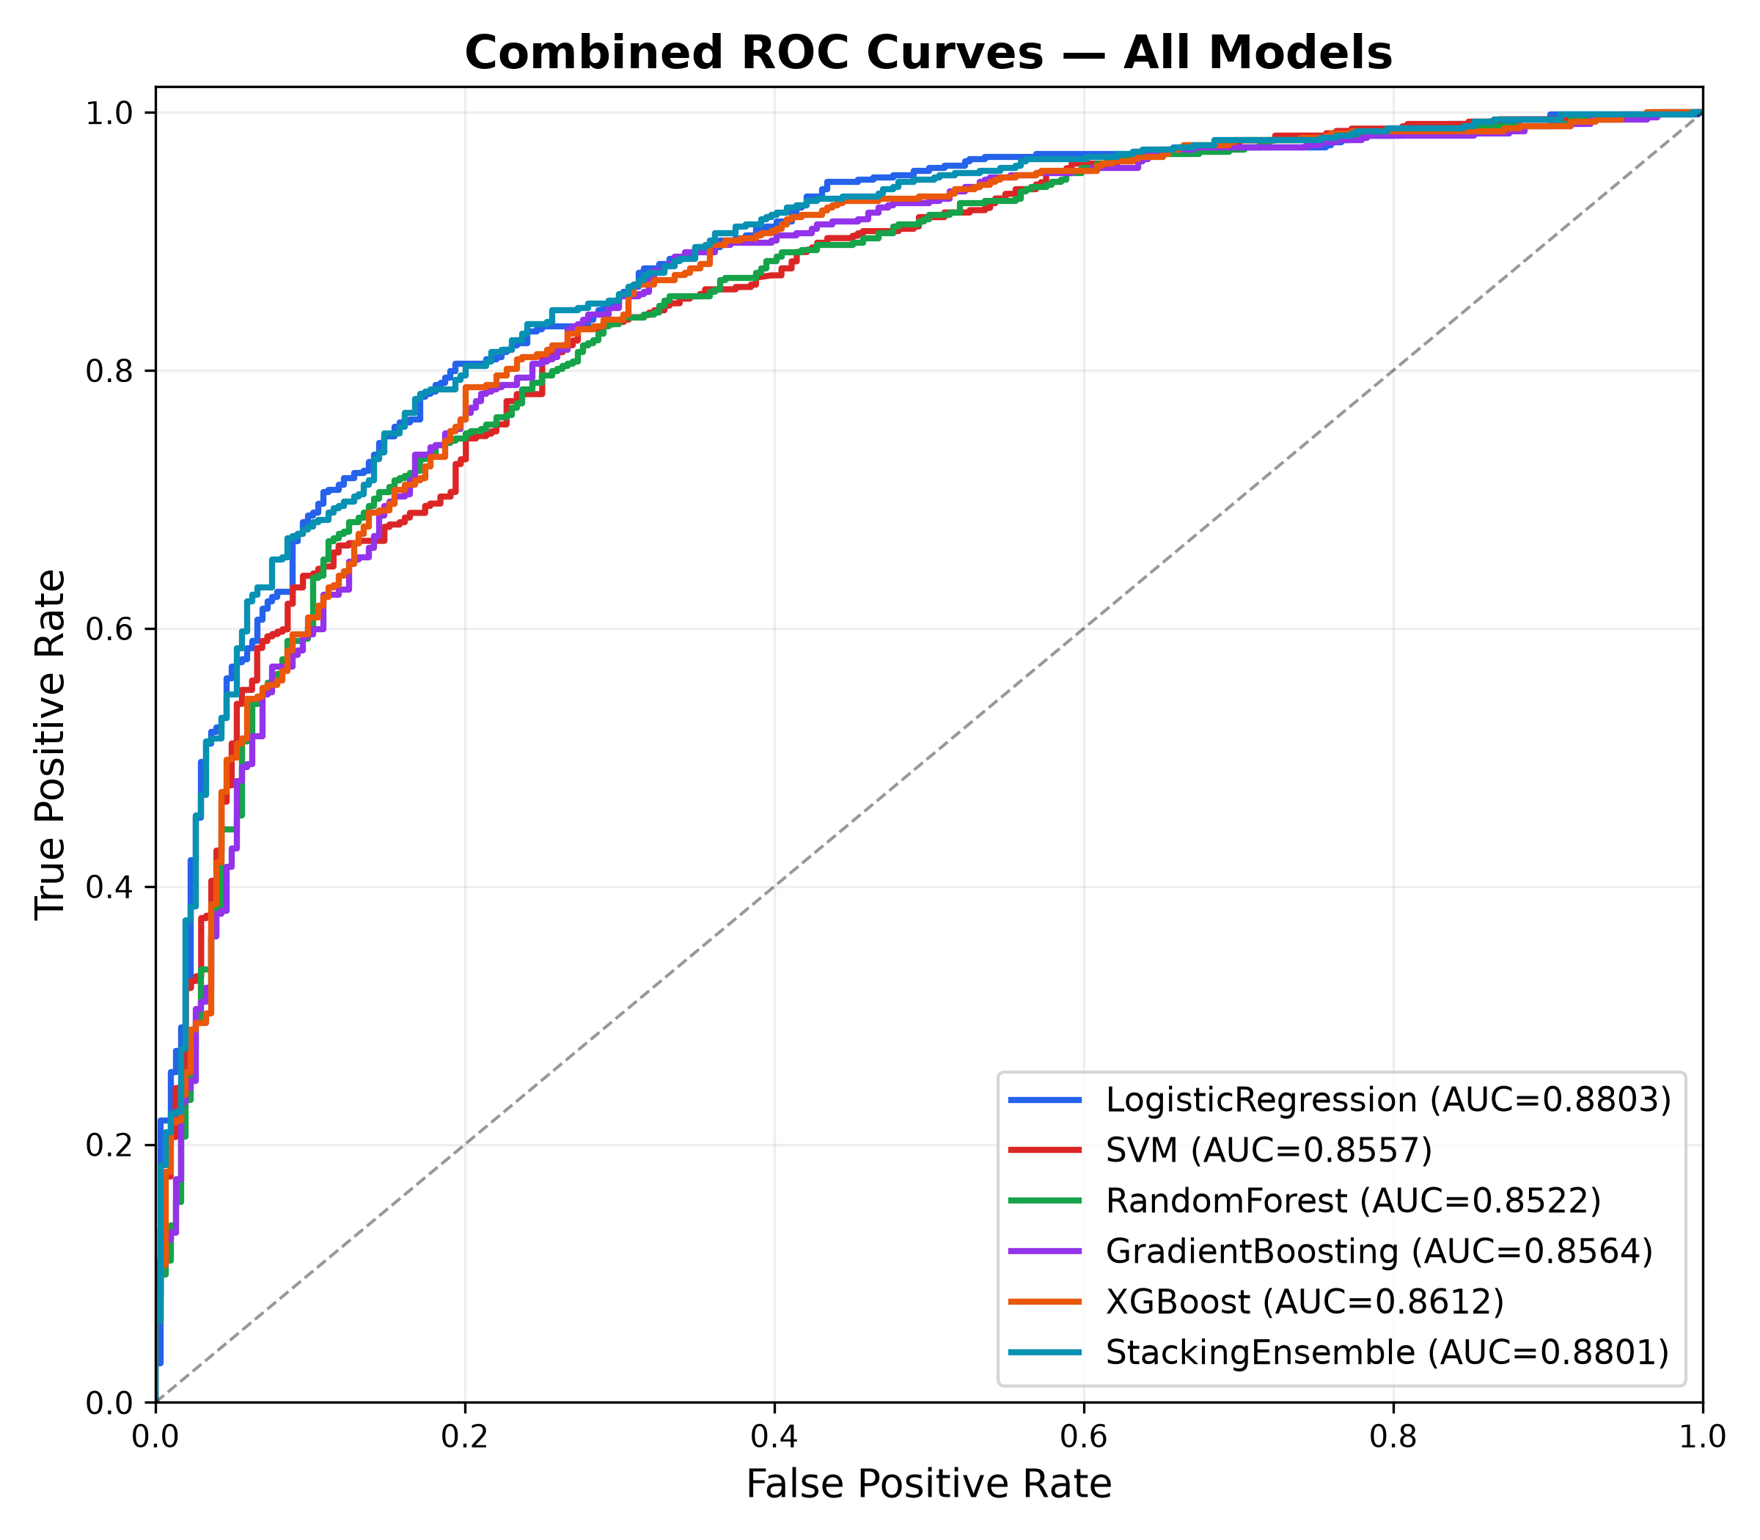
Fig. 7. Receiver Operating Characteristic (ROC) curves comparing all architectures.
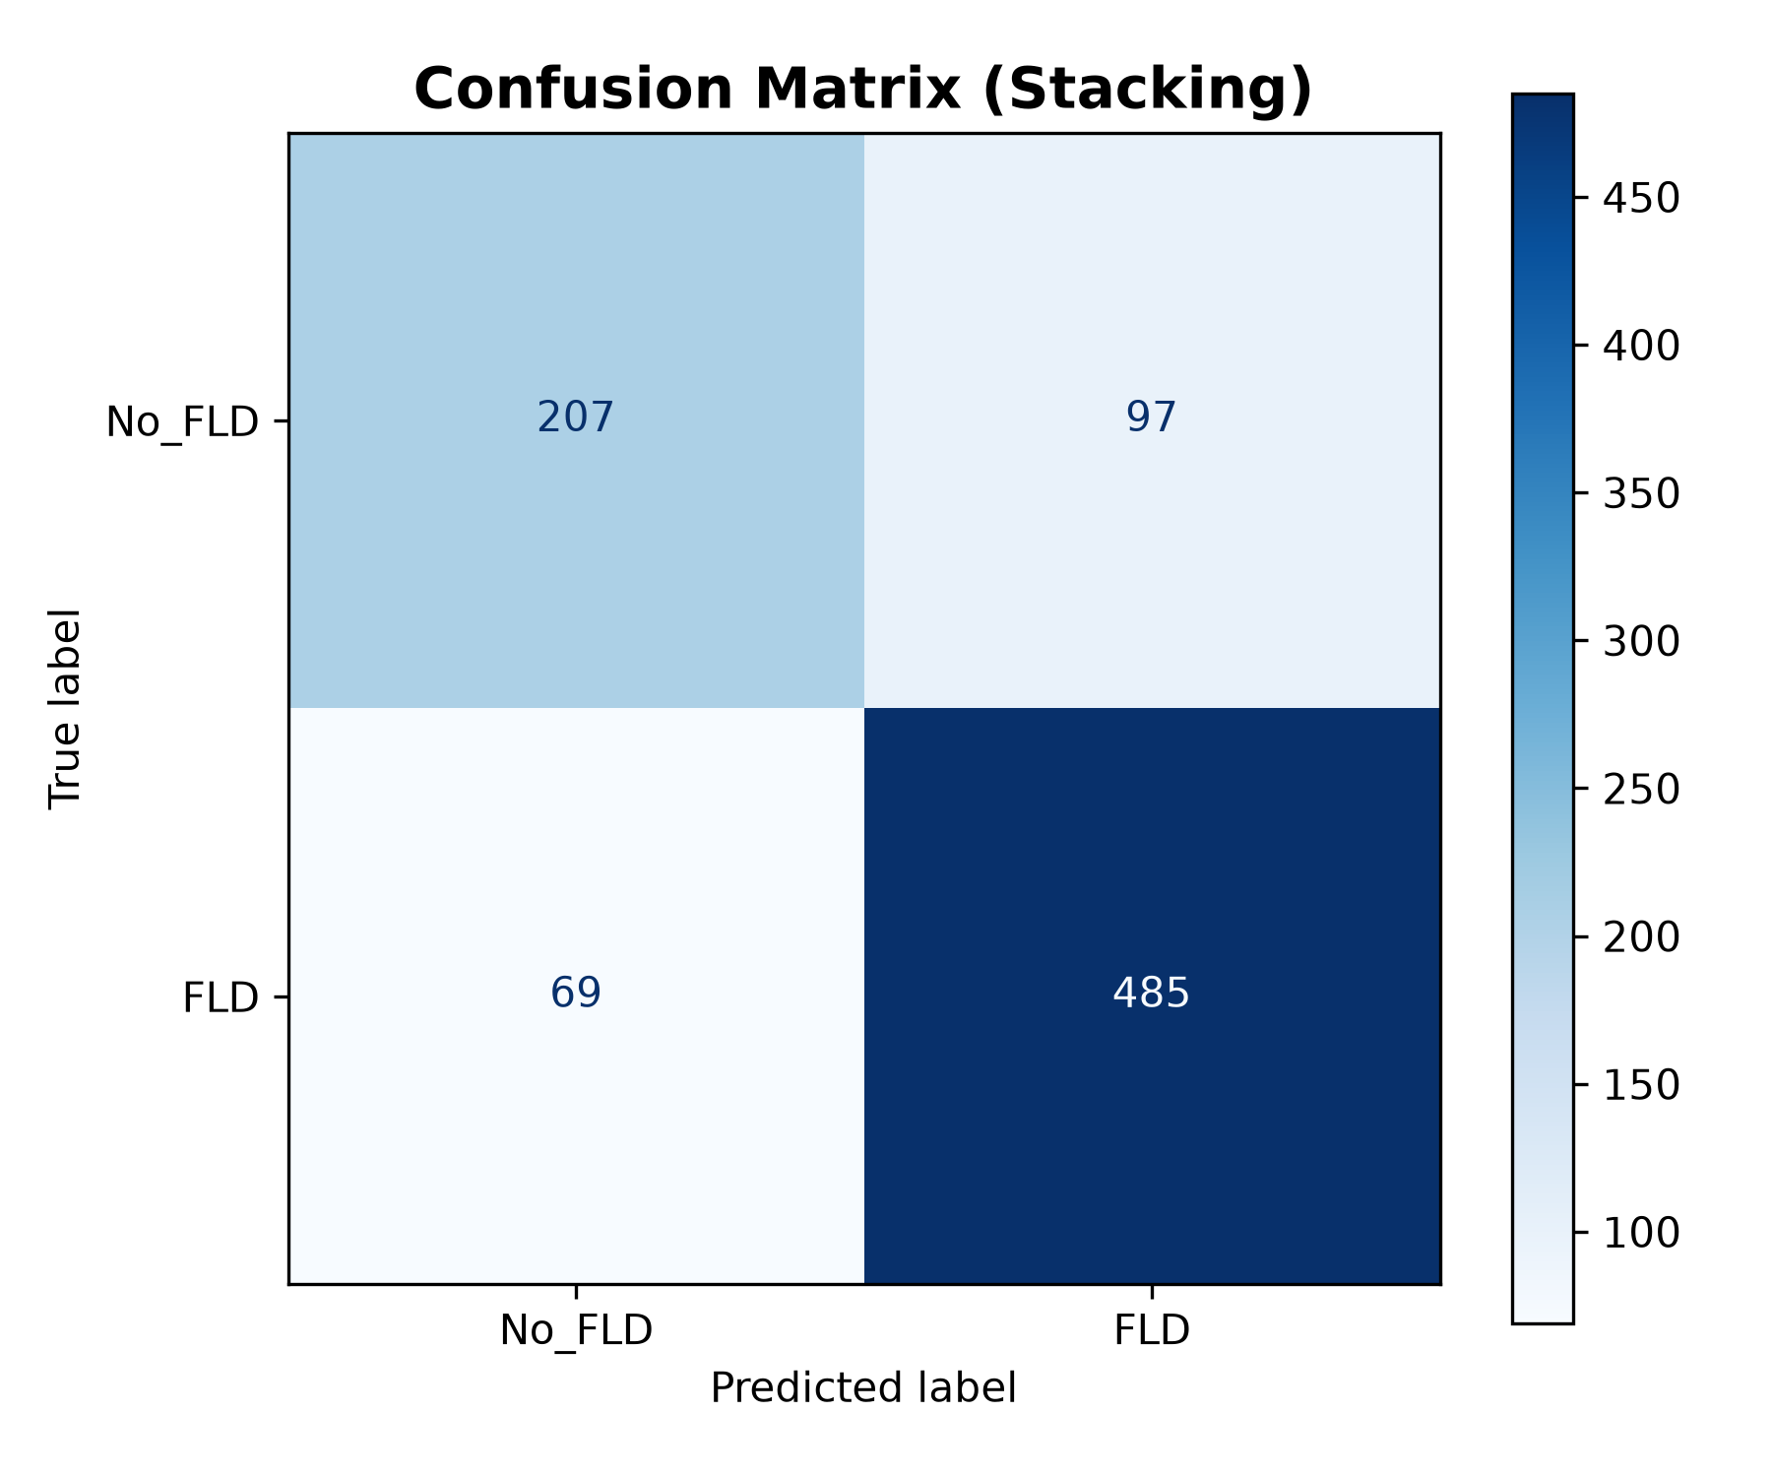
Fig. 8. Confusion matrix of the proposed Stacking Ensemble on the test cohort.
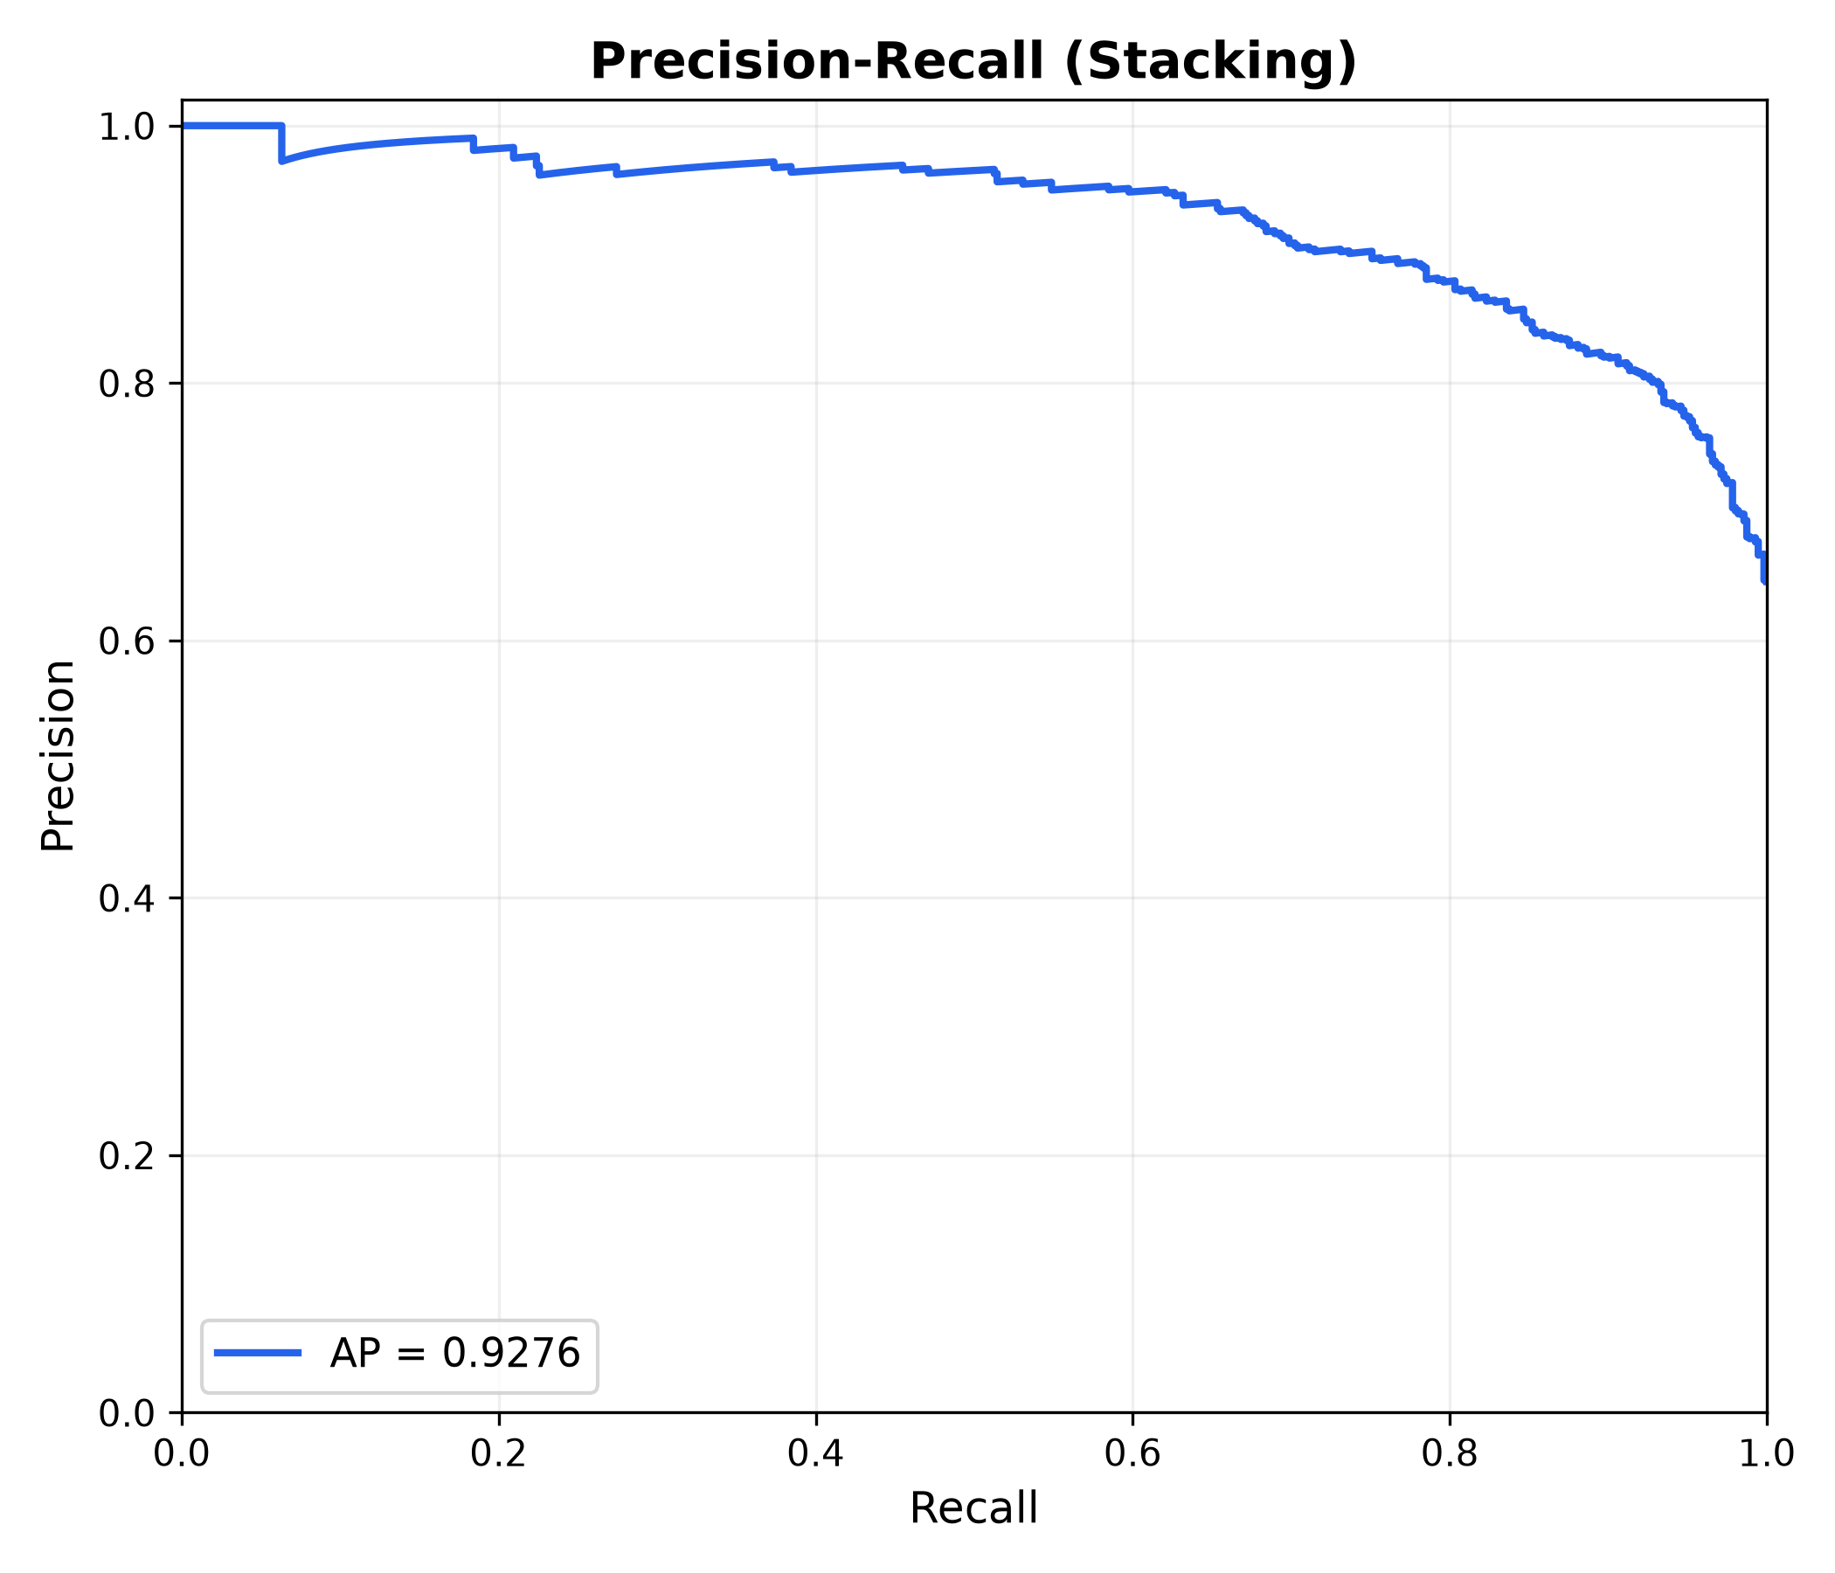
Fig. 9. Precision-Recall curve of the proposed Stacking Ensemble model.
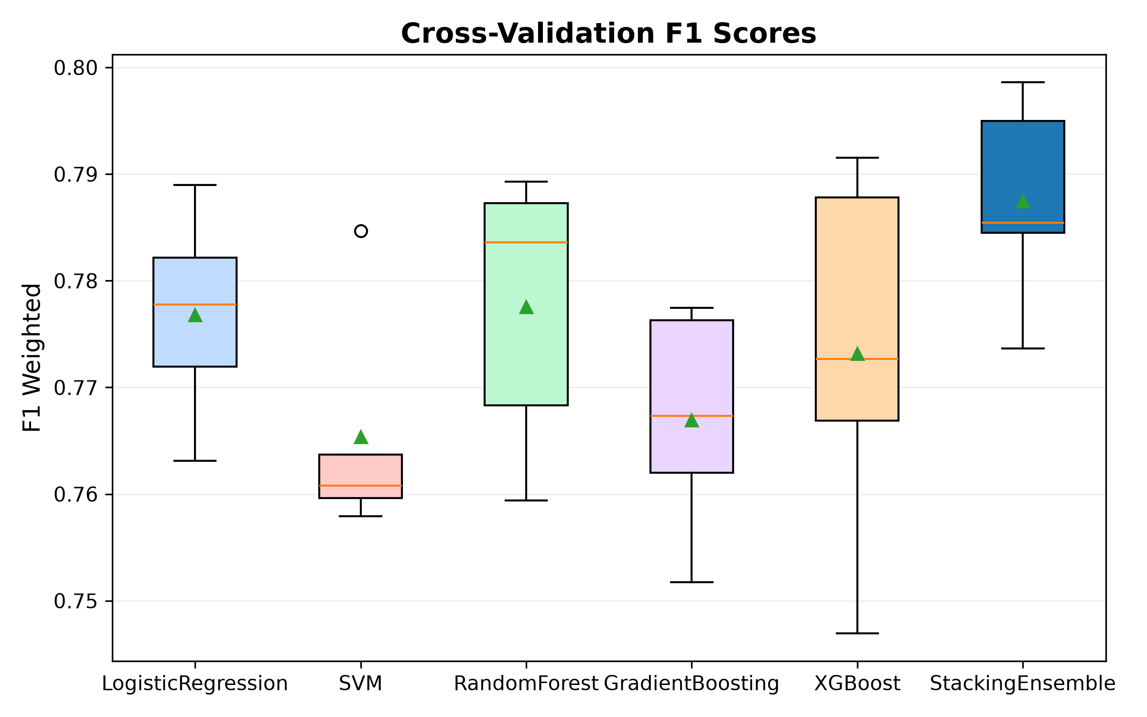
Fig. 10. Five-fold cross-validation F1-score stability distribution across models.
VI. ABLATION STUDY & MODEL EXPLAINABILITY
A. Feature Group Ablation Analysis
To rigorously examine the individual and collective diagnostic value of the extracted biomarker modalities, we executed an ablation study across nine distinct feature configurations. Table II and Fig. 11 summarize the findings.
TABLE II
FEATURE MODALITY ABLATION STUDY RESULTS (TEST SET)
Modality Subset | Dim | Accuracy | F1-Score
All Features (Fusion) | 174 | 80.65% | 80.42%
Physiological Only | 7 | 78.21% | 78.35%
All Tongue Features | 167 | 64.10% | 64.15%
Image + Blood Pressure | 169 | 72.49% | 72.63%
Image + Anthropometrics | 171 | 76.92% | 77.01%
Color Features Only | 72 | 61.89% | 61.92%
Texture Descriptors Only | 64 | 59.44% | 59.50%
Coating Indices Only | 16 | 58.16% | 58.21%
Hu Shape Moments Only | 15 | 54.78% | 54.82%
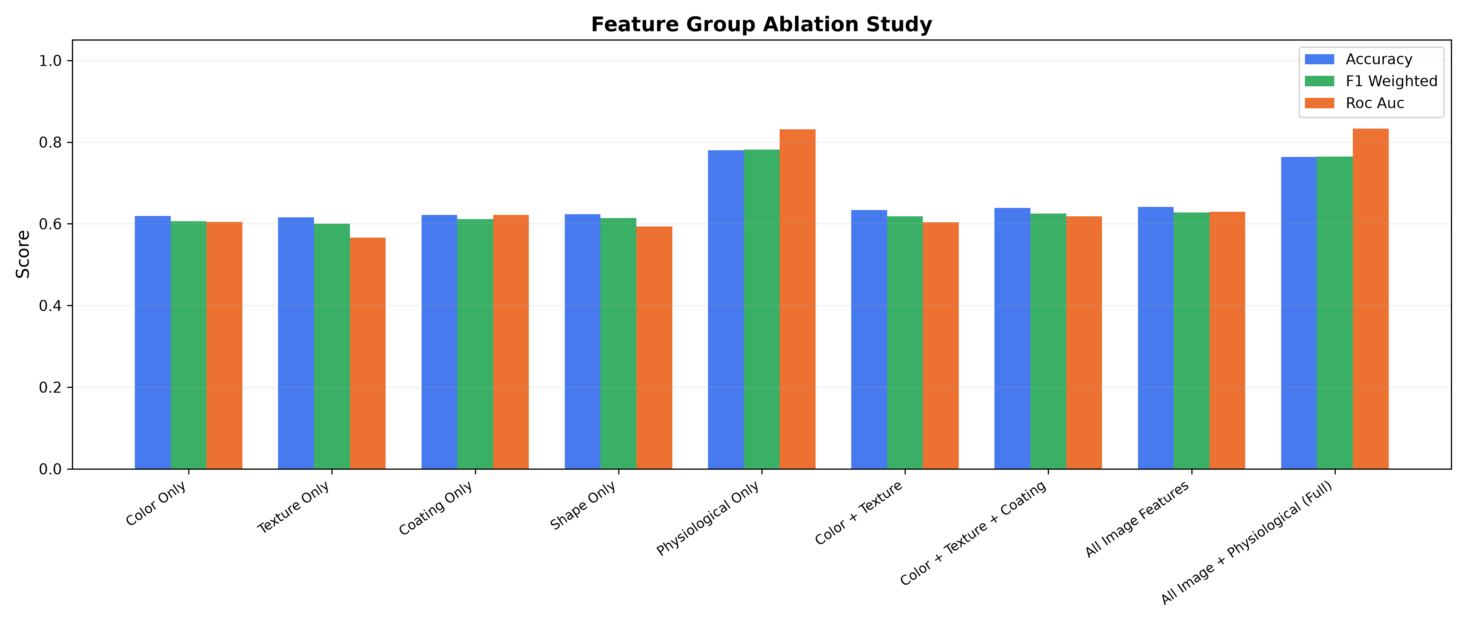
Fig. 11. Empirical feature modality ablation study comparing multimodal fusion against isolated feature subsets.
Critical Analysis of Ablation Results: The ablation data reveals a fundamental clinical insight: physiological biomarkers alone achieve 78.21% accuracy, whereas tongue image features alone achieve 64.10% accuracy. This indicates that systemic metabolic dysfunction (elevated BMI, waist circumference, and hypertension) serves as the primary driver of fatty liver pathology. However, integrating tongue morphological features with physiological indicators elevates test accuracy to 80.65% (+2.44% absolute increase) and expands the ROC-AUC from 0.842 to 0.8801. Tongue biomarkers provide vital non-linear phenotypic evidence of microvascular congestion and lingual mucosal inflammation that physiological parameters alone cannot capture.
B. Explainable AI: SHAP & Permutation Importance
To establish clinical trust and satisfy regulatory transparency standards for medical AI, we computed Shapley Additive exPlanations (SHAP) using TreeSHAP on our best gradient boosted models. Fig. 12 illustrates the global SHAP summary plot.
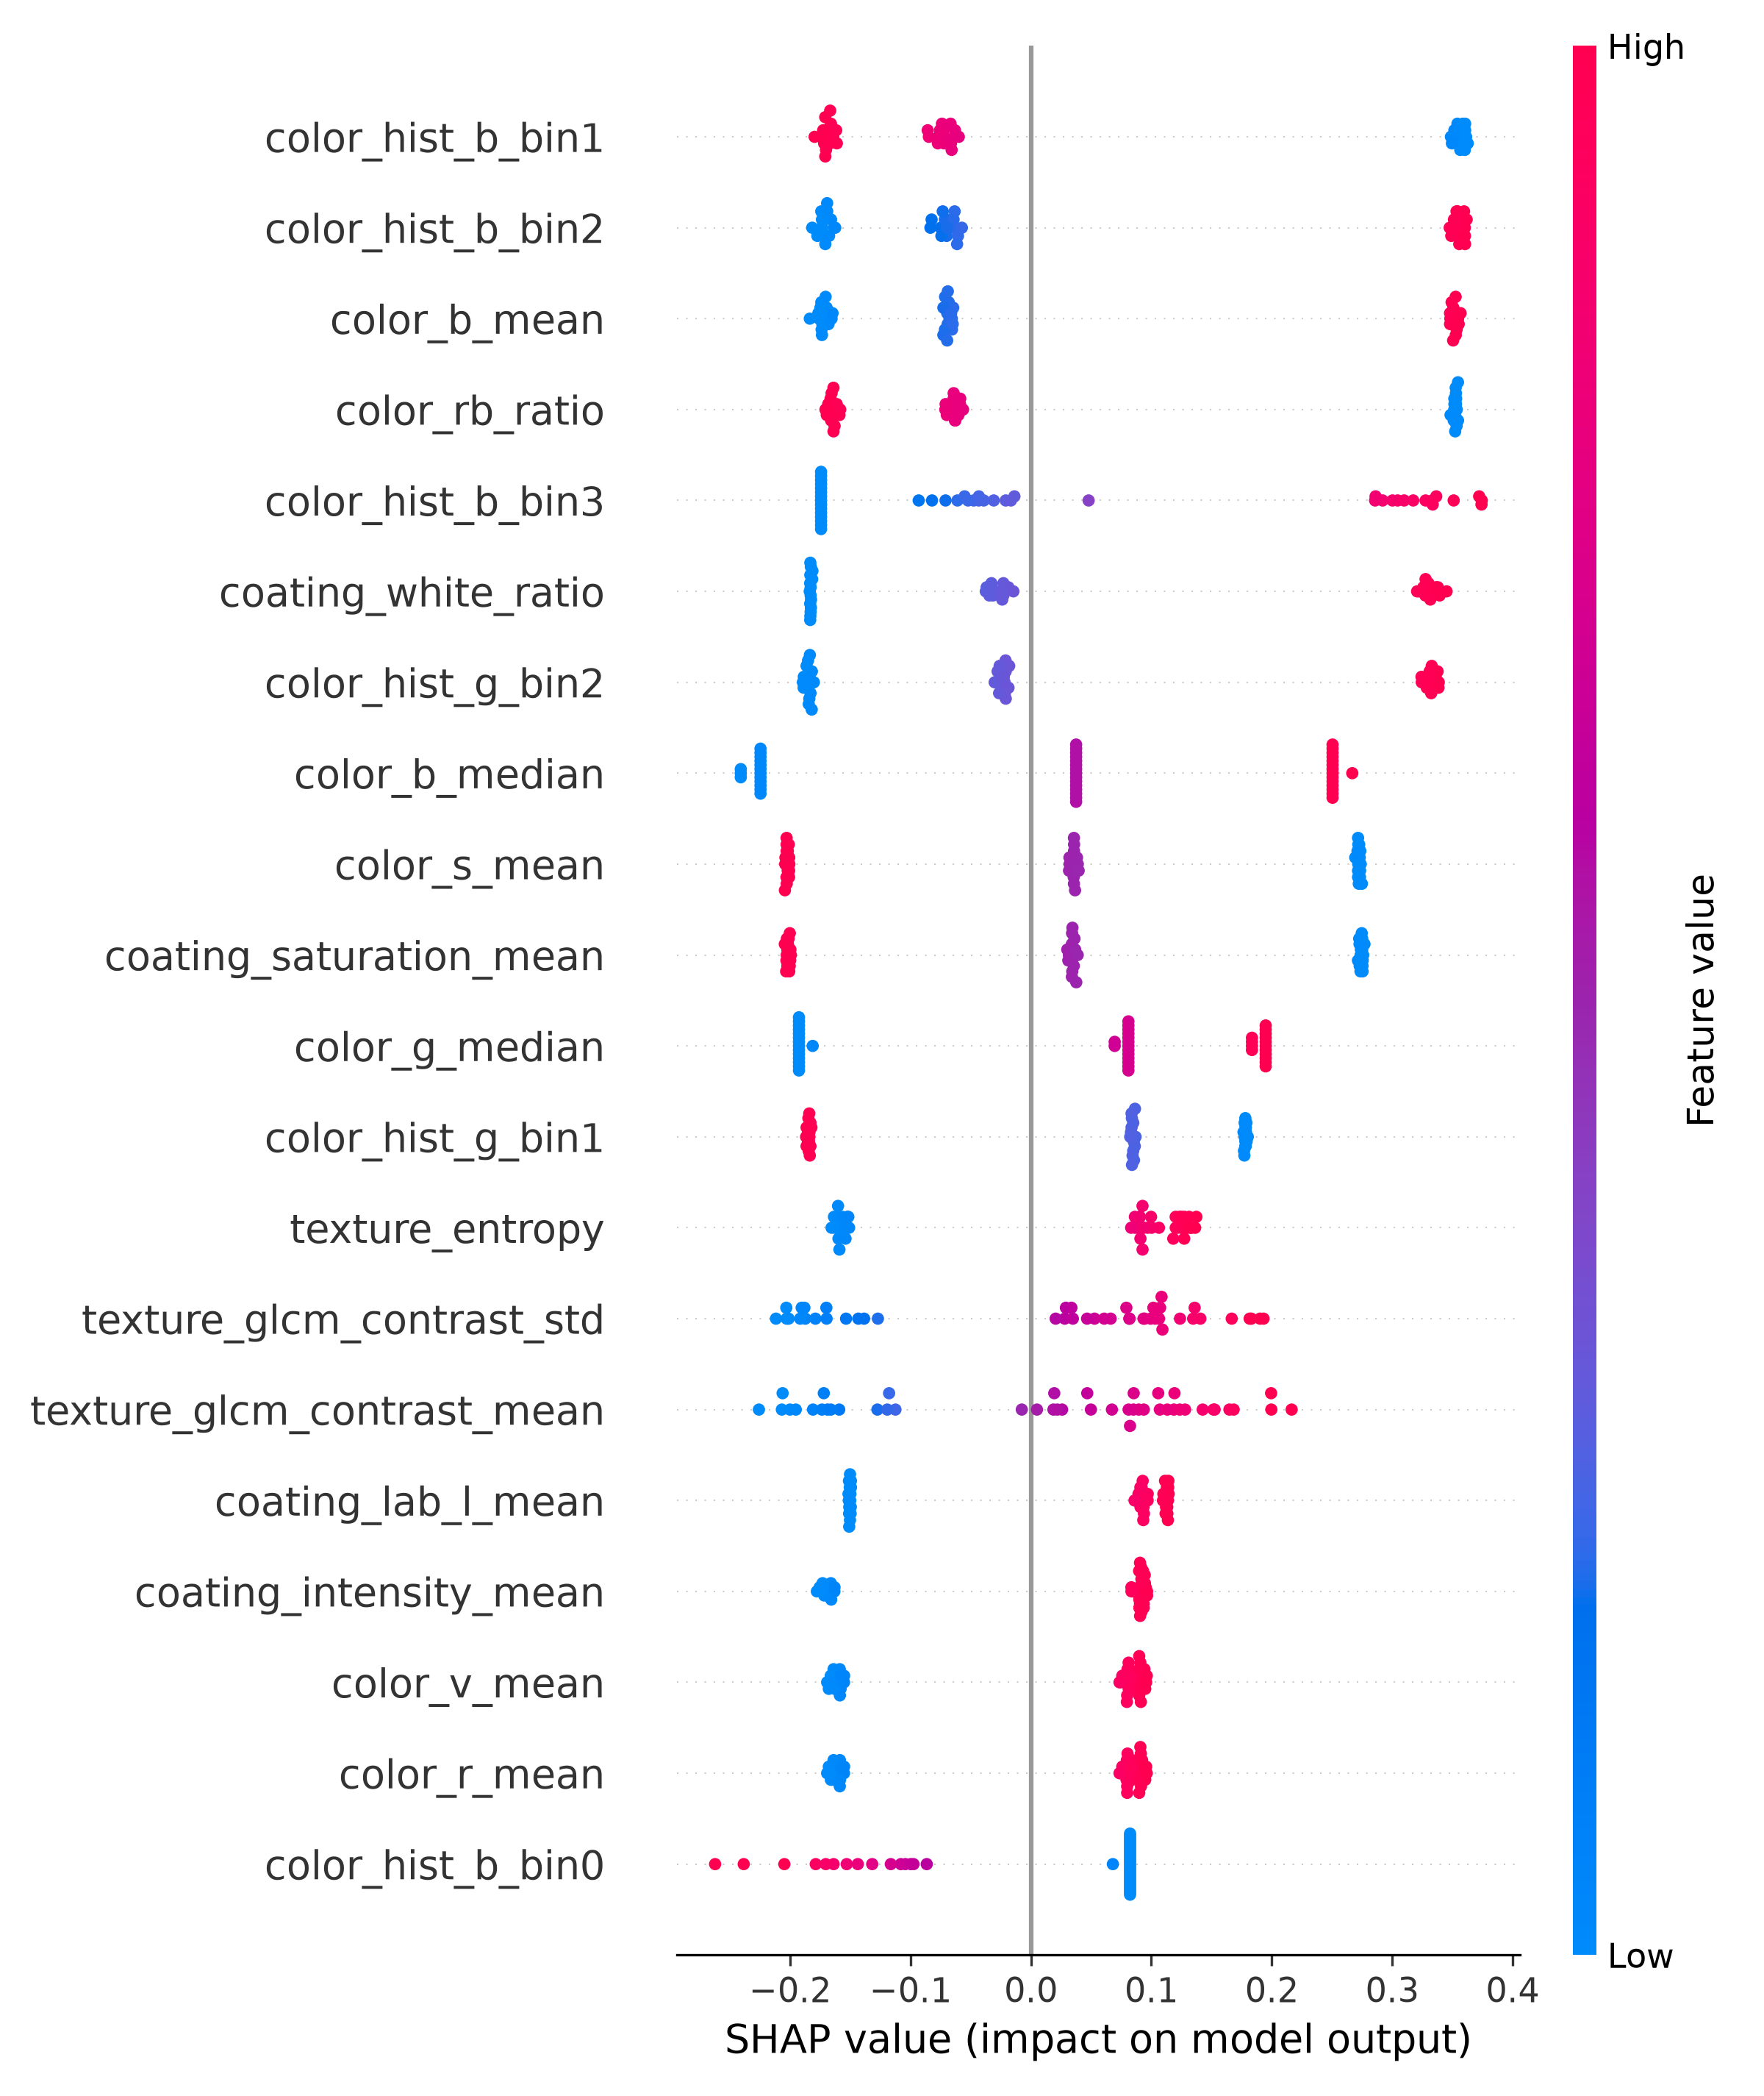
Fig. 12. TreeSHAP global feature attribution summary revealing the top predictive biomarkers driving fatty liver risk.
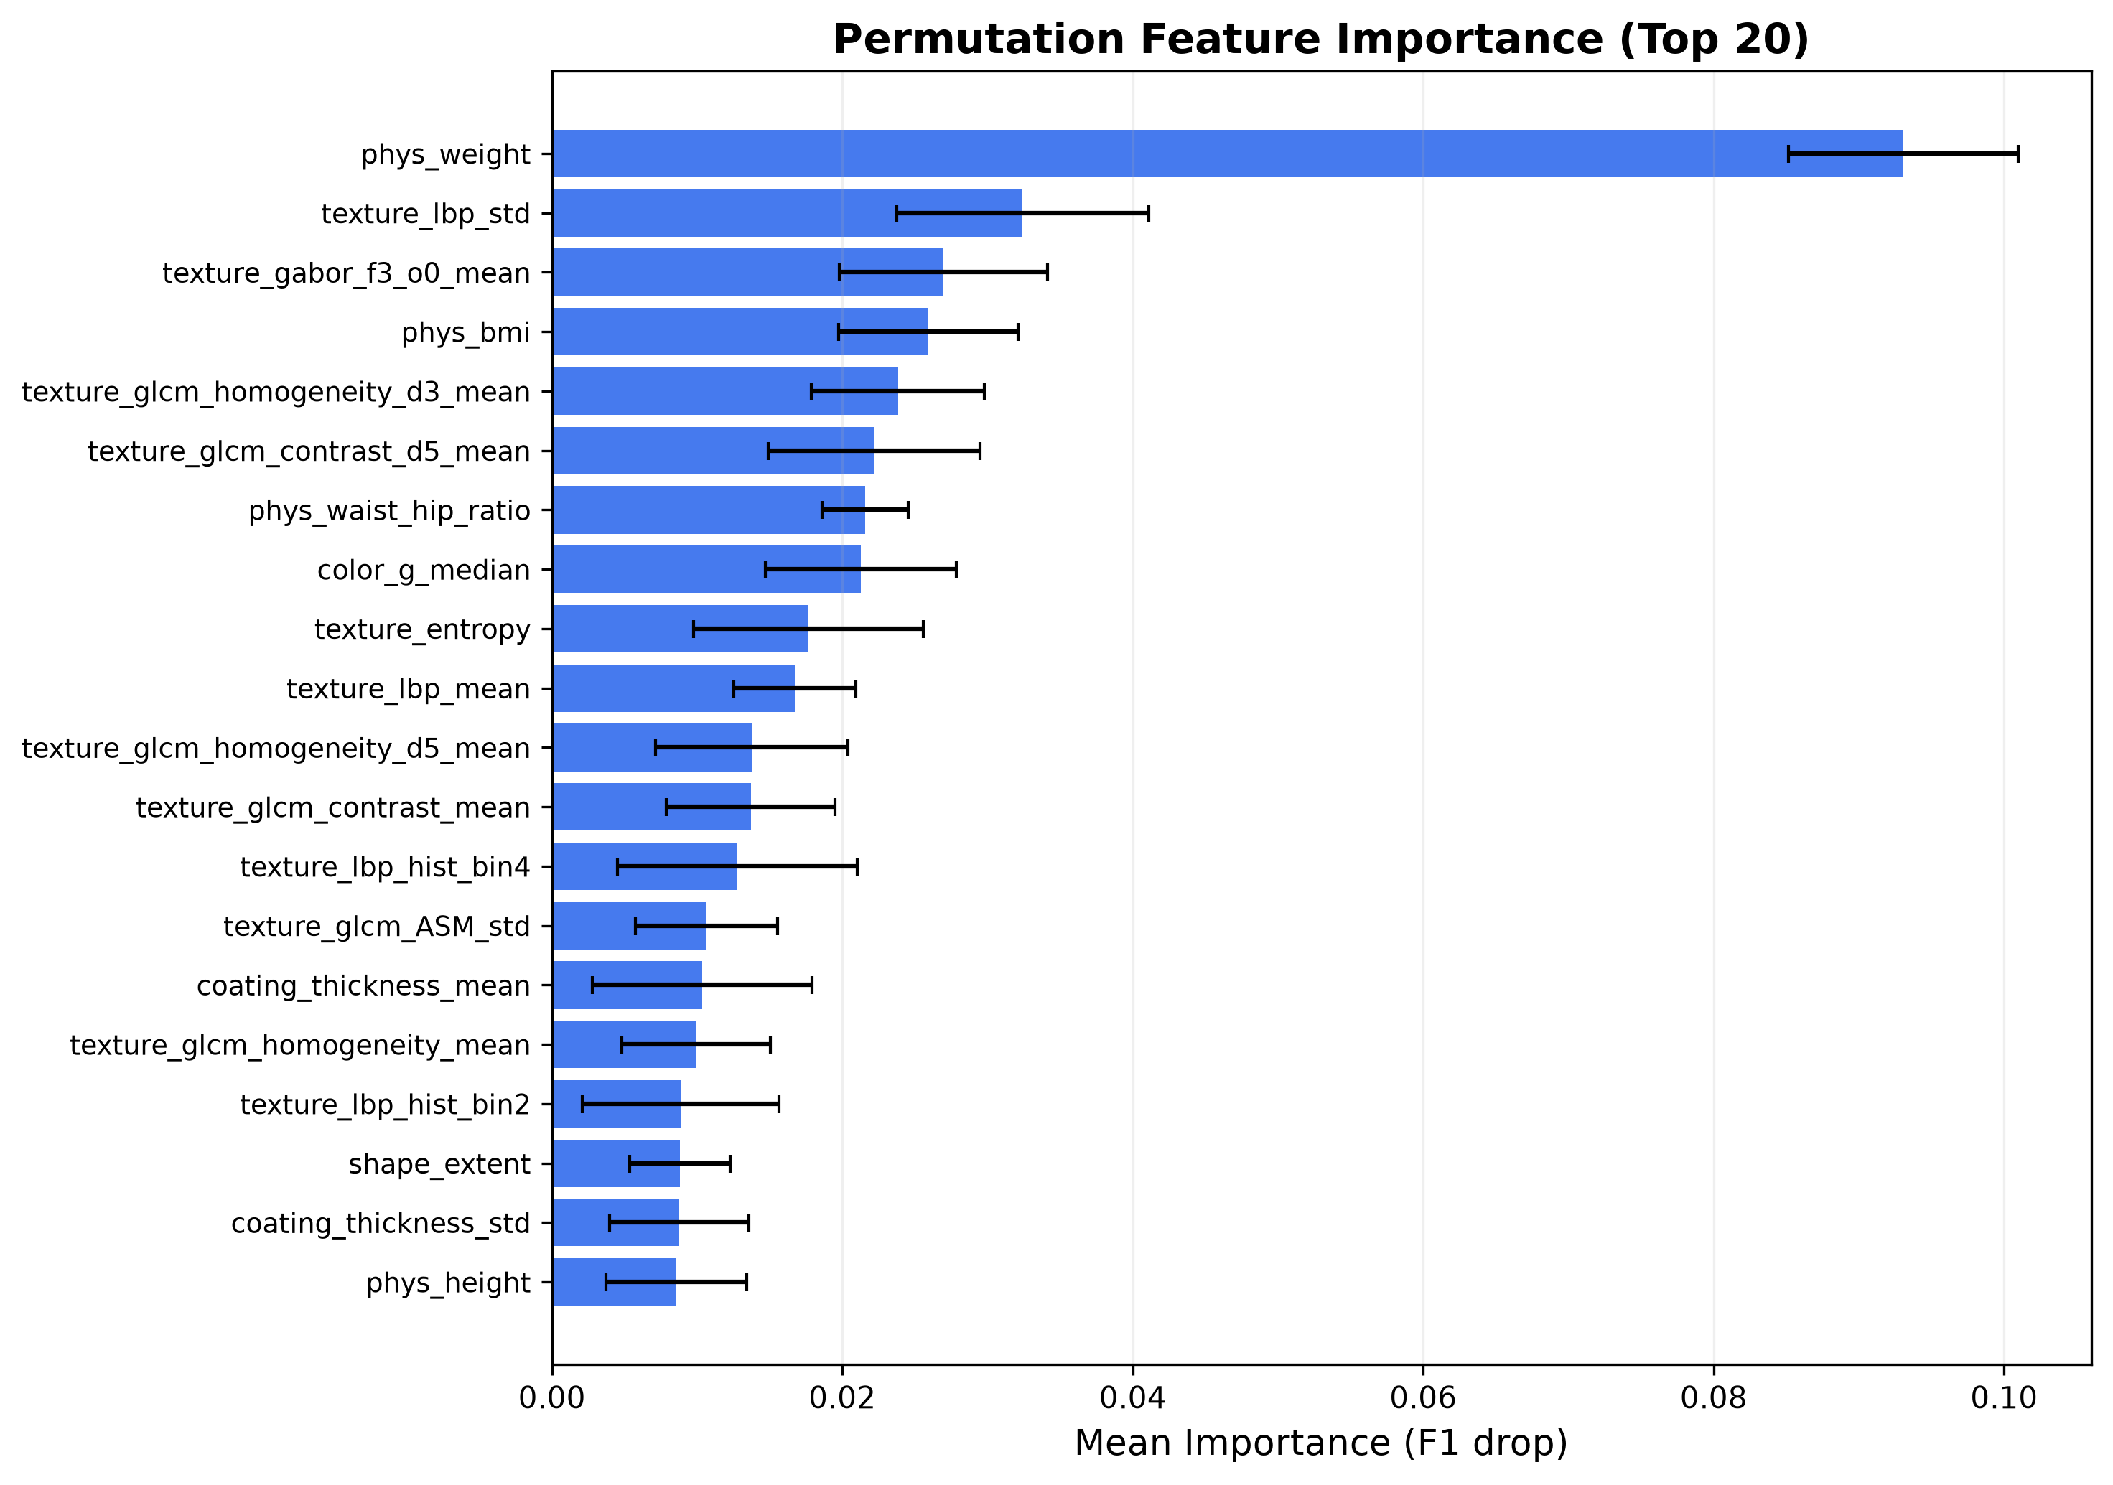
Fig. 13. Permutation feature importance analysis confirming feature stability under random feature shuffling.
Clinical Pathophysiological Alignment: The SHAP analysis confirms that Body Mass Index (BMI), Waist Circumference, and Systolic Blood Pressure (SBP) exhibit the largest positive Shapley values, directly reflecting visceral adiposity and insulin resistance. Crucially, among lingual biomarkers, the CIE-b* channel mean (yellow coating hue), tongue coating thickness index, and GLCM contrast were ranked within the top 15 most influential predictors. Elevated yellow coating values strongly correlate with higher FLD risk, corroborating clinical observations that metabolic dysbiosis and hepatic lipid accumulation promote oral microbial colonization and mucosal epithelial cornification.
VII. CONCLUSION AND FUTURE SCOPE
In this investigation, we developed and validated FLD-Screen, an automated multimodal screening framework for non-invasive detection of Fatty Liver Disease. By bridging computerized lingual image analysis with standard physiological indicators across 5,717 patients, our Stacking Ensemble achieved 80.65% diagnostic accuracy and 0.8801 ROC-AUC. Rigorous ablation and SHAP analyses confirmed that tongue morphology provides meaningful, clinically grounded complementary markers of hepatic metabolic dysfunction. Future research will explore prospective multi-center clinical validation, smartphone-based point-of-care mobile acquisition with on-device color calibration, and longitudinal tracking of steatosis regression following lifestyle interventions.
REFERENCES
[1] Z. M. Younossi, A. B. Koenig, D. Abdelatif, Y. Fazel, L. Henry, and M. Wymer, 'Global epidemiology of nonalcoholic fatty liver disease—Meta-analytic assessment of prevalence, incidence, and outcomes,' Hepatology, vol. 64, no. 1, pp. 73–84, 2016.
[2] E. E. Powell, V. W. Wong, and M. Rinella, 'Non-alcoholic fatty liver disease,' The Lancet, vol. 397, no. 10290, pp. 2212–2224, 2021.
[3] D. C. Rockey, S. H. Caldwell, Z. D. Goodman, R. C. Nelson, and A. D. Smith, 'Liver biopsy,' Hepatology, vol. 49, no. 3, pp. 1017–1044, 2009.
[4] M. F. Cusi, K. Cusi, 'Role of obesity and lipotoxicity in the development of nonalcoholic steatohepatitis,' Endocrine Practice, vol. 20, no. 9, pp. 936–943, 2014.
[5] G. Bedogni, S. Bellentani, L. Miglioli, F. Masutti, M. Passador, G. Castiglione, and C. Tiribelli, 'The Fatty Liver Index: A simple and accurate predictor of hepatic steatosis in the general population,' BMC Gastroenterol., vol. 6, no. 1, p. 33, 2006.
[6] D. Zhang, Z. Guo, G. Lu, and N. M. B. J. Z. Zhang, 'Computerized Tongue Analysis for Medical Diagnosis,' IEEE Trans. Comput. Biol. Bioinform., vol. 14, no. 5, pp. 1120–1132, 2017.
[7] J. Tang, W. Zhang, and C. Sun, 'Tongue image analysis for clinical disease diagnosis: A comprehensive review,' IEEE Access, vol. 8, pp. 118420–118434, 2020.
[8] X. Wang, B. Zhang, and Z. Liu, 'Investigation of tongue coating characteristics in patients with non-alcoholic fatty liver disease based on computerized chromatic analysis,' Evid.-Based Complement. Altern. Med., vol. 2019, Art. no. 4819273, 2019.
[9] D. Zhang, H. Peng, and B. Huang, 'Computerized tongue image feature extraction and analysis,' in Proc. IEEE Int. Conf. Bioinform. Biomed. (BIBM), 2015, pp. 450–456.
[10] B. Huang, J. Wu, and D. Zhang, 'Tongue shape classification using geometric features and active contours,' in Proc. IEEE EMBC, 2018, pp. 2489–2492.
[11] Y. Li, J. Chen, and K. Wang, 'Diagnostic significance of tongue texture features using multi-scale Gabor wavelets and GLCM,' Comput. Biol. Med., vol. 112, p. 103362, 2019.
[12] R. Wang, Y. Zhang, and H. Xu, 'Correlation between metabolic syndrome and tongue diagnosis features in community health screening,' J. Tradit. Chin. Med. Sci., vol. 7, no. 2, pp. 145–152, 2020.
[13] Q. Liu, L. Zhao, and T. Hu, 'A deep learning approach for tongue color and coating segmentation,' IEEE J. Biomed. Health Inform., vol. 24, no. 8, pp. 2351–2360, 2020.
[14] M. E. Rinella, J. V. Lazarus, V. Ratziu, et al., 'A multi-society Delphi consensus statement on new fatty liver disease nomenclature,' Hepatology, vol. 78, no. 6, pp. 1966–1986, 2023.
[15] D. H. Wolpert, 'Stacked generalization,' Neural Networks, vol. 5, no. 2, pp. 241–259, 1992.
[16] MLDMXM2017, 'MFF-TDF: Multimodal Feature Fusion for Tongue-based Fatty Liver Diagnosis Dataset,' GitHub repository, 2024. [Online]. Available: https://github.com/MLDMXM2017/MFF-TDF
[17] T. Chen and C. Guestrin, 'XGBoost: A scalable tree boosting system,' in Proc. 22nd ACM SIGKDD Int. Conf. Knowl. Discov. Data Min., 2016, pp. 785–794.
[18] S. M. Lundberg and S.-I. Lee, 'A unified approach to interpreting model predictions,' in Adv. Neural Inf. Process. Syst. (NeurIPS), 2017, pp. 4765–4774.
[19] F. Pedregosa et al., 'Scikit-learn: Machine learning in Python,' J. Mach. Learn. Res., vol. 12, pp. 2825–2830, 2011.
[20] R. M. Haralick, K. Shanmugam, and I. Dinstein, 'Textural features for image classification,' IEEE Trans. Syst., Man, Cybern., vol. SMC-3, no. 6, pp. 610–621, 1973.
[21] M. K. Hu, 'Visual pattern recognition by moment invariants,' IRE Trans. Inf. Theory, vol. 8, no. 2, pp. 179–187, 1962.
[22] K. Zuiderveld, 'Contrast limited adaptive histogram equalization,' in Graphics Gems IV, P. S. Heckbert, Ed. Academic Press, 1994, pp. 474–485.
[23] C. Cortes and V. Vapnik, 'Support-vector networks,' Machine Learning, vol. 20, no. 3, pp. 273–297, 1995.
[24] L. Breiman, 'Random forests,' Machine Learning, vol. 45, no. 1, pp. 5–32, 2001.
[25] J. H. Friedman, 'Greedy function approximation: A gradient boosting machine,' Ann. Statist., vol. 29, no. 5, pp. 1189–1232, 2001.

