Fetching data from Twitter using Apache Nifi:

<http://localhost:8080/nifi/>

Nifi Version: 1.9.2

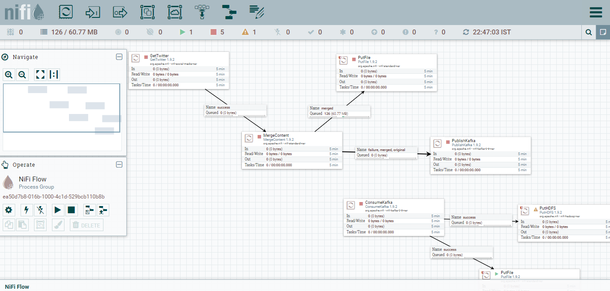

Apache Nifi is continuously loading the data into Kafka Topics (mytopics) .

Processor used to fetch the data into kafka

1. GetTwitter processor to get data from Twitter website. Currently I am using the raw data

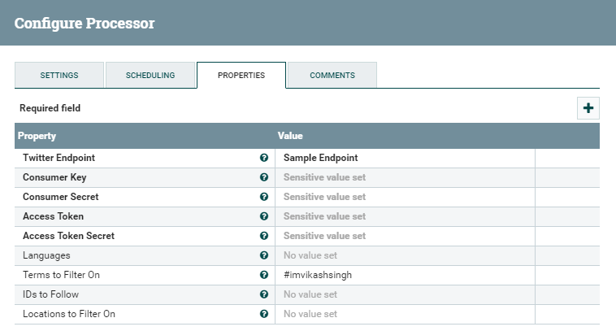

1. MergeContent processor to merge the files received based on the file size

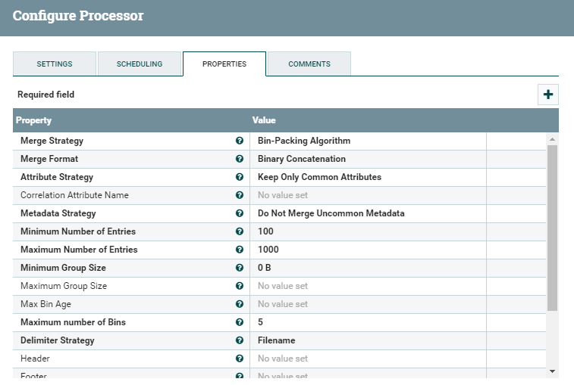

1. PublishKafka processor : This processor is publishing the data to kafka topics(mytopics)

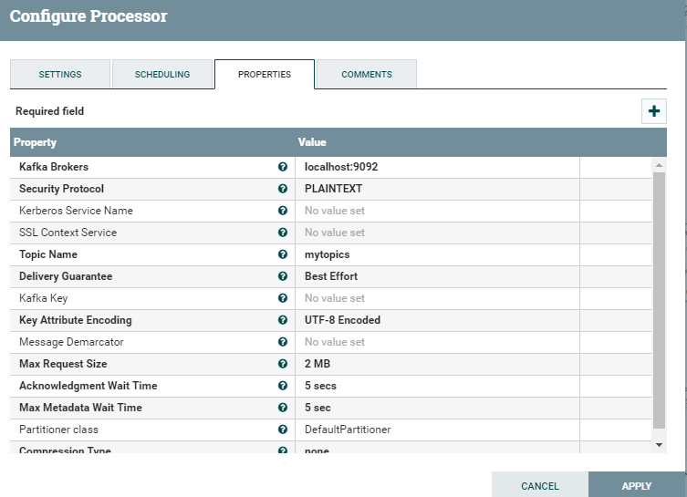

Apache Kafka:

Version: 2.10-0.8.2.0

1. Zookeeper server Start

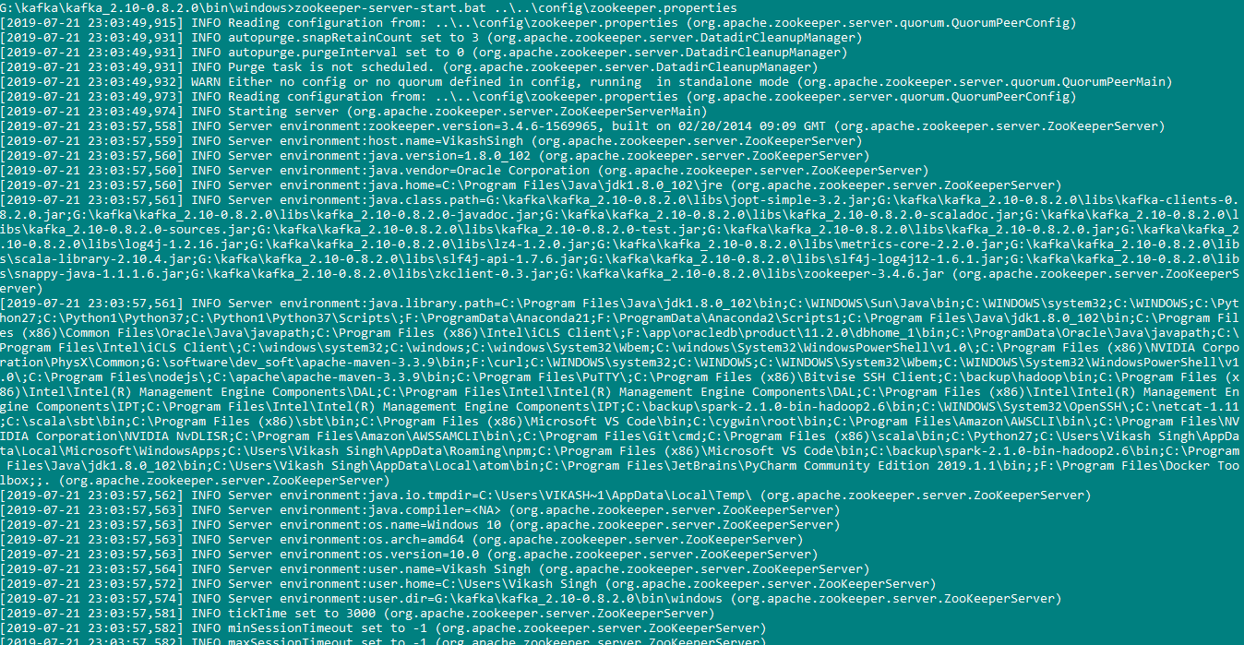

1. Kafka Server Start

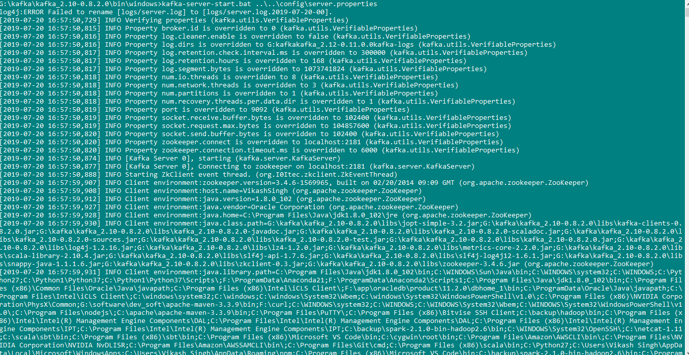

1. Kafka Topics: For Demo purpose I have created my topics with one partition with one replication facor.

<kafka_dir>\bin\windows\kafka-topics.bat --create --zookeeper localhost:2181 --replication-factor 1 --partitions 1 --topic mytopics

Data Received from twitter to kafka Topics

{"created_at":"Sat Jul 13 10:07:40 +0000 2019","id":1149983726245482496,"id_str":"1149983726245482496","text":"@realFFK Hmmmmm","display_text_range":[9,15],"source":"\u003ca href=\"http:\/\/twitter.com\/download\/iphone\" rel=\"nofollow\"\u003eTwitter for iPhone\u003c\/a\u003e","truncated":false,"in_reply_to_status_id":1149748835104804869,"in_reply_to_status_id_str":"1149748835104804869","in_reply_to_user_id":597224882,"in_reply_to_user_id_str":"597224882","in_reply_to_screen_name":"realFFK","user":{"id":848964040361725953,"id_str":"848964040361725953","name":"Rashidabkd","screen_name":"cuterashhhh","location":"Kaduna, Nigeria","url":null,"description":null,"translator_type":"none","protected":false,"verified":false,"followers_count":283,"friends_count":152,"listed_count":0,"favourites_count":3486,"statuses_count":2182,"created_at":"Mon Apr 03 18:22:55 +0000 2017","utc_offset":null,"time_zone":null,"geo_enabled":false,"lang":null,"contributors_enabled":false,"is_translator":false,"profile_background_color":"F5F8FA","profile_background_image_url":"","profile_background_image_url_https":"","profile_background_tile":false,"profile_link_color":"1DA1F2","profile_sidebar_border_color":"C0DEED","profile_sidebar_fill_color":"DDEEF6","profile_text_color":"333333","profile_use_background_image":true,"profile_image_url":"http:\/\/pbs.twimg.com\/profile_images\/1149979796027453440\/MGmorHI-_normal.jpg","profile_image_url_https":"https:\/\/pbs.twimg.com\/profile_images\/1149979796027453440\/MGmorHI-_normal.jpg","profile_banner_url":"https:\/\/pbs.twimg.com\/profile_banners\/848964040361725953\/1561452032","default_profile":true,"default_profile_image":false,"following":null,"follow_request_sent":null,"notifications":null},"geo":null,"coordinates":null,"place":null,"contributors":null,"is_quote_status":false,"quote_count":0,"reply_count":0,"retweet_count":0,"favorite_count":0,"entities":{"hashtags":[],"urls":[],"user_mentions":[{"screen_name":"realFFK","name":"Femi Fani-Kayode","id":597224882,"id_str":"597224882","indices":[0,8]}],"symbols":[]},"favorited":false,"retweeted":false,"filter_level":"low","lang":"und","timestamp_ms":"1563012460658"}

Apache Spark:

Version: 2.10

1. **First Transformation** (SparkStreamingFromKafka.scala): Retrieve the all twitter data based on the condition apply on the data in json ( used spark sql and apply query)

2> **Second Transformation** (TwitterDataAnalysis.scala): Search the provided hash code from twitter and save to Cassandra on every window time frame of 10 second.

Cassandra Version: -3.11.4

Query Need to create in Cassandra:

1. For keySpace

CREATE KEYSPACE vkspace WITH REPLICATION = {'class': 'SimpleStrategy', 'replication_factor': 1 };

1. For table 1

CREATE TABLE vkspace.twitterdata (id VARCHAR PRIMARY KEY, created_at VARCHAR , favorite_count VARCHAR );

1. For table 2

CREATE TABLE vkspace.toptentag (count int PRIMARY KEY, tags VARCHAR);

