1. **First Transformation** (SparkStreamingFromKafka.scala): Retrieve the all twitter data based on the condition apply on the data in json ( used spark sql and apply query)

In This code we are reading the data from Kafka topics in as row format which is Json format and apply the transformation to get the information of the twit bases on the provided search value given to system per and save to Cassandra. Below is the Cassandra output.

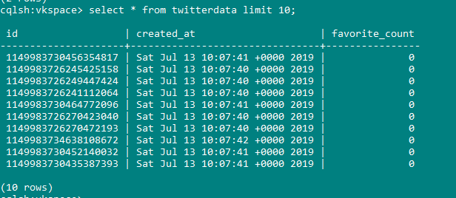

1. **Second Transformation** (TwitterDataAnalysis.scala): Search the provided hash code from twitter and save to Cassandra on every window time frame of 10 second. The below are the output which is saved into Cassandra.

