Executive Summary
We designed a comprehensive Excel-based Scrum tracker combining sprint planning, task tracking, and daily standup notes into one formula-driven workbook. Following Scrum best practices[1][2], the tracker includes tables for Sprints (ID, dates, goals), Team/Capacity (members and available hours), and a Sprint Backlog of tasks with fields like ID, description, assignee, story points/estimates, status, dependencies, and blockers. It also provides automated calculations (percent complete, days remaining, sprint progress, velocity) and visual analytics (burndown and burn-up charts, cumulative flow diagram). Conditional formatting highlights key conditions (e.g. blocked or overdue tasks). All dropdowns (status, priority, etc.) use data-validation lists. The workbook requires only Excel formulas (no macros) and is set up for multiple time zones/localization via Excel date formats.
The attached workbook (ScrumStandupTracker.xlsx) implements these features. It comes pre-populated with 3 example sprints and 10 tasks. The design scales to multiple teams or time zones by adding team members on the Team sheet and adjusting capacities. Next sections document each sheet, formulas, rules, and usage instructions in detail, along with sample data and design comparisons.

Sheet-by-Sheet Design

Sprints Sheet
- Purpose: Define each sprint and its goals.
- Table (“tblSprints”): Columns Sprint ID, Sprint Name, Start Date, End Date, Sprint Goal. For example, Sprint 1 (ID=1) might have start 2026-05-20, end 2026-06-02, goal “Implement user login and dashboard”.
- Usage: A dropdown list for sprint (used in Tasks sheet). The “Start/End Date” drive other calculations (days remaining, sprint duration).
- Sample Data: Three sprints in 2026, each 2 weeks long, as provided.

Team/Capacity Sheet
- Purpose: List team members, roles, and available capacity (hours per sprint).
- Table (“tblTeam”): Columns Member, Role, Capacity (hrs). E.g. Alice – Developer – 80 hrs. Roles like Developer/QA/Product Owner/Scrum Master help categorize skills.
- Capacity Use: This sheet feeds formulas that check total capacity vs. planned work (not fully automated but provides reference). For example, total capacity can be summed per sprint to warn over-allocation.
- Localization: Hours/days can be adjusted per regional workweek as needed.

Data Validation Lists Sheet
- Purpose: Define dropdown menus (hidden from casual view).
- Lists: Named ranges (or tables) such as StatusList (e.g. Not Started, In Progress, Completed, Blocked), PriorityList (High, Medium, Low), TaskTypeList (Story, Task, Bug, etc.), RoleList (Developer, QA, etc.), and YesNo (for Blocked = Yes/No).
- Usage: These lists drive Data Validation in other sheets. For instance, the Task Status column uses StatusList. (See Data Validation section below.)

Tasks (Sprint Backlog) Sheet
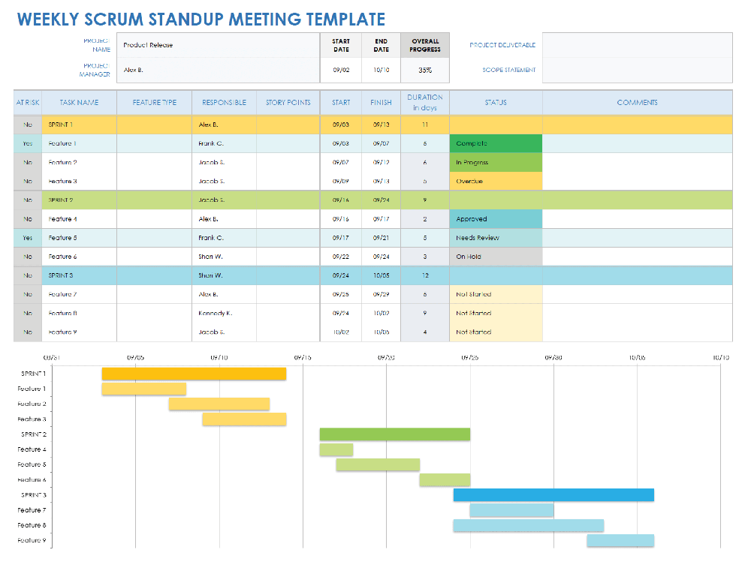
Figure: Example Sprint Backlog layout (weekly standup template screenshot) showing typical columns such as Task, Status, Assignee, Start/Finish, and Comments.
The Tasks sheet is the core backlog/standup tracker. Each row is one task or backlog item. Key columns (many inspired by Scrum templates[3][1]) include:
- Task ID / Title: Unique ID (e.g. T101) and short description.
- Sprint: Sprint name or ID (dropdown from Sprints sheet). Links task to a specific sprint.
- Assignee & Role: Team member name (dropdown from Team sheet) and their role (Developer, QA, etc.). The role can be auto-filled by VLOOKUP on the Team table or selected via dropdown.
- Type: Task type (Story, Task, Bug, Improvement, etc.; dropdown from TaskTypeList).
- Priority: (High/Medium/Low; dropdown).
- Story Points: Numeric estimate of size (as Scrum suggests using story points[4]).
- Est. Hours / Time Spent: Original hours estimate and hours logged. These feed percent-complete.
- Status: Dropdown (Not Started, In Progress, Completed, Blocked). See Conditional Formatting below.
- Dependencies: Reference IDs of other tasks this one depends on (text field). Helps identify blockers.
- Blocked: Yes/No (dropdown). If “Yes”, the adjacent Blocker (Desc) can note the cause.
- Percent Complete: Formula-driven progress (see Formulas below).
- Days Remaining: Auto-calculated until sprint end (see Formulas).
- Standup Notes / Comments: Free-text fields for daily updates or general comments. (Teams can paste their daily updates here.)
- Last Update: Timestamp (date or date-time). This can use Excel’s NOW() (manual entry or static copy) or a formula capturing the last change.
Formulas:
- Percent Complete: =IF([Est. Hours]>0, [Time Spent]/[Est. Hours], 0). E.g. if 2/8 hours done, shows 25%. (Alternatively, if points are used, one could track “points done” vs total.)
- Days Remaining: =IF([@Status]<>"Completed", INDEX(tblSprints[End Date], MATCH([@Sprint], tblSprints[Sprint Name],0)) - TODAY(), 0). This subtracts today from the sprint’s end date. If negative (past due) and not completed, row is flagged by formatting.
- Automatic Status: (Optional) e.g. =IF([Time Spent]=0, "Not Started", IF([Time Spent]>0, "In Progress","")). Such formulas can set status from hours logged.
- Sprint Progress & Velocity: On the Dashboard (see below), velocity is calculated by summing Story Points for all tasks in a sprint with Status=“Completed” (as Atlassian recommends[5]). For example:
- Velocity (Sprint 1) = SUMIFS(tblTasks[Story Points], tblTasks[Sprint], "Sprint 1", tblTasks[Status], "Completed")
- Burn-down/Burn-up Data: We create a small table of Date vs. Points Remaining per sprint. Each day’s remaining points = (initial total points in sprint) – (points completed as of that date). This can use running totals (e.g. cumulative SUMIFS by date) to feed a line chart.
- Cumulative Flow Inputs: One approach is a Status-by-Date table. For each date (rows) and status (columns like To Do, In Progress, Done), use COUNTIFS on the Tasks table: e.g.
- # in "In Progress" on 2026-05-25 =
COUNTIFS(tblTasks[Sprint],"Sprint 1", tblTasks[Status],"In Progress", tblTasks[Last Update], "<=2026-05-25")
(This requires capturing the “last known status date”; or an alternative is a static snapshot table filled daily.) The cumulative flow chart then stacks these counts[6][7].
Data Validation: All dropdown columns use the Lists sheet. For example, the Sprint column validates against tblSprints[Sprint Name], Assignee against tblTeam[Member], Status against StatusList, etc. This ensures consistent entries and enables uniform conditional formatting.
Conditional Formatting: We apply color codes to highlight critical states:
- Status Colors: Completed = green fill, In Progress = blue/yellow fill, Not Started = gray, Blocked = red fill. For example, cells with Status="Blocked" get red background; Status="Completed" gets green.
- Overdue Tasks: If Days Remaining < 0 and Status<>"Completed", highlight the row or due-date cell in red. This flags missed SLAs.
- Blockers: If Blocked = "Yes", the row background or the Blocker cell is red/amber to draw attention.
- Priority Alerts: (Optional) High-priority tasks could have a distinct color (e.g. dark red text) if at risk.
- Progress Bars: The Percent Complete column can use a data-bar conditional format (visual bar showing percent).
These rules make it easy to scan for issues (e.g. overdue or blocked work). (Scrum advocates such visibility of impediments[8][9].)

(Optional) Daily Standup Log Sheet
For daily coordination, you can add a simple Standup sheet. Columns: Date, Team Member, What I Did Yesterday, What I Will Do Today, Blockers. Each row is one person’s update per day. This captures exactly the Scrum daily Scrum questions[8]. A sample layout is shown in Figure 3 of the Smartsheet “Daily Standup” template (see the attached figure below). (Our main tracker merges standup notes into the Tasks sheet, but a separate log is an option.)

Dashboard and Charts Sheet
The Dashboard aggregates data and charts. Key elements:
- Sprint Summary: Table showing sprint goals, total planned points, points completed, and calculated velocity. Uses formulas like SUMIFS on the Tasks table.
- Burndown Chart: Plots “Work Remaining vs. Time” for a sprint. X-axis = days of sprint, Y-axis = story points remaining. Data from daily totals (as above). Figure below is an example burndown (from Atlassian Jira)[10], illustrating the ideal line vs actual.
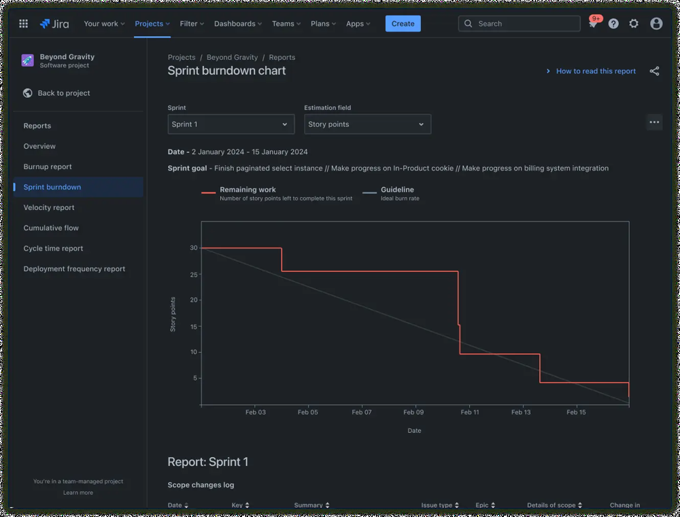
Figure: Example sprint burndown chart (from Jira) showing ideal vs. actual work remaining[10].
- Burn-up Chart: (Optional) Shows cumulative points completed vs total scope. Good if scope changes. X-axis = days, Y-axis = story points.
- Velocity Trend: Bar chart of velocity per sprint (sum of story points done) to help forecast (Atlassian recommends averaging velocity[4]).
- Cumulative Flow Diagram: An area chart with stacks for each status (To Do, In Progress, Done). Data from the Status-by-Date table. As Kanban guidance notes, a CFD “shows how many requirements are in each state” over time[11].
All charts update automatically when the underlying tables change. We defined named ranges or Excel Tables (tblTasks) so charts grow as new rows are added. For example, the burndown’s data series references a dynamic range for “Points Remaining”.

Key Formulas Explained
- Percent Complete:
- =IF([Est. Hours]>0, [Time Spent]/[Est. Hours], 0)
Converts hours spent into a 0–1 (or 0%–100%) complete. (You can format as percentage.) Alternatively, if tracking story points done, use those fields.
- Days Remaining:
- =IF([@Status]<>"Completed", INDEX(tblSprints[End Date], MATCH([@Sprint], tblSprints[Sprint Name],0)) - TODAY(), "")
Looks up the sprint’s end date and subtracts today. If the task is already “Completed”, it shows blank. A negative result indicates overdue.
- Velocity (per Sprint):
For Sprint “X”:
=SUMIFS(tblTasks[Story Points], tblTasks[Sprint], "X", tblTasks[Status], "Completed")
(This sums story points of all fully done tasks in that sprint.) Atlassian advises that velocity = total story points completed per sprint[5].
- Sprint Progress (%):
Can compute as:
=Total Points Completed (to date) / Total Points Planned
where “to date” uses a running total of completed points. This drives a simple bar showing how close to goal we are.
- Burn-down Data:
We maintain a small table: dates vs. points remaining. Each day:
Points Remaining = Initial Sprint Points – (SUM of points completed up to that date)
The chart then plots this series. (An “ideal” burn-down is a straight line from start→0; actual line steps down as tasks finish[10].)
- Cumulative Flow Data:
Each row = a date. Columns = counts of tasks in each state (e.g. To Do, In Progress, Done). Use formulas like:
InProgress_Count (Date D) = COUNTIFS(tblTasks[Sprint], sprint, tblTasks[Status], "In Progress", tblTasks[Last Update], "<=" & D)
You repeat for each state. (Alternatively, one can record the snapshot manually each day.) Stacked-area chart of these columns then yields the CFD, which “shows information about how many requirements are in each implementation state” over time[11].
- Automatic Status Updates (Optional):
For example, to auto-mark a task “Completed” when % = 100%:
=IF([@PercentComplete]=1, "Completed", [@Status])
Or to flag overdue:
=IF(AND([@DaysRemaining]<0, [@Status]<>"Completed"), "Overdue", [@Status])
However, many Scrum teams prefer manual status changes (to ensure accurate context).

Conditional Formatting Rules
- Completed vs In Progress vs Blocked:
Apply row or cell fill colors by Status. E.g., use green for “Completed”, blue/yellow for “In Progress”, gray for “Not Started”, red for “Blocked”.
- Overdue Tasks:
Formula: =AND([@DaysRemaining]<0, [@Status]<>"Completed") → fill Red. This meets an SLA alert.
- Blockers:
If [Blocked]="Yes", fill the row or Blocker cell in orange/red to draw attention (e.g. “Blocked” status or a flag icon).
- High Priority:
(Optional) Apply a bold border or light red fill for Priority="High" on tasks with > X% complete to warn of risk if late.
- Progress Bar:
In the Percent Complete column, use Data Bar formatting (green bar) to visually show progress.
These visual cues let the team instantly see which items need discussion at the standup (e.g. the backlog of overdue/blocked tasks). Such transparency aligns with Scrum’s emphasis on surface impediments[8][9].

Data Validation and Drop-Down Lists
The following fields use dropdown lists tied to named ranges (on the Lists sheet):
- Sprint: (e.g. Sprint 1, Sprint 2…) sourced from the Sprints table.
- Assignee: list of team members (from tblTeam[Member]).
- Role: matches RoleList (Developer, QA, etc.). Or auto-filled via VLOOKUP on Assignee.
- Status: list from StatusList (Not Started, In Progress, Completed, Blocked).
- Priority: list (High, Medium, Low).
- Type: list (Story, Bug, Task, etc.).
- Blocked (Y/N): list (Yes/No).
When editing the workbook, new entries should use these lists to ensure consistency. To add a new sprint or team member, simply append to the Sprints or Team table; the dropdowns will expand automatically if defined as Excel Tables (tblSprints, tblTeam).

Sample Data (3 Sprints, 10 Tasks)
Task ID | Title | Sprint | Assignee | Role | Type | Priority | SP | Est. Hrs | Status | Blocked | Blocker Desc | % Comp | Days Remain
T101 | User login page | Sprint 1 | Alice | Developer | Story | High | 8 | 40 | In Progress | No |  | 25% | 5
T102 | Create dashboard UI | Sprint 1 | Bob | Developer | Story | Med | 13 | 60 | Not Started | No |  | 0% | 10
T201 | Payment integration | Sprint 2 | Bob | Developer | Feature | High | 8 | 50 | Not Started | No |  | 0% | 14
T202 | Search UI | Sprint 2 | Alice | Developer | Feature | Med | 5 | 30 | In Progress | Yes | Waiting on DB team | 17% | 9
T302 | Email notifications | Sprint 3 | Charlie | QA | Story | Med | 5 | 30 | In Progress | No |  | 33% | 12
…plus 5 more tasks…
(Table above shows a subset of the sample data. The actual Excel file includes all 10 tasks, sub-tasks indicated by dependencies, and placeholder notes.)
In practice, team members update the Status, Time Spent, % Complete, Standup Notes, and Last Update after each standup (or day) to keep the tracker current.

How to Use & Customize
- Open the “Sprints” sheet and update sprint names, dates, and goals as needed. All formulas (days remaining, charts) will adjust.
- Update the Team sheet with any new members or changed capacities. Roles can be added in the RoleList if needed.
- Enter tasks in the Tasks sheet: Each new task is a new row in the tblTasks table. Select Sprint/Assignee/Status from the dropdowns. Fill in estimates, points, etc. The table auto-expands for charts.
- Review colors: Conditional formatting highlights anything requiring attention. Fix status or blockers as needed.
- Check the Dashboard: Charts update automatically as tasks change. The Burndown chart will show the team’s progress; the Velocity bars update after each sprint.
- Localization: If working across time zones, adjust the Excel date display (e.g. dd-mmm-yyyy h:mm) in regional settings, or include a “Time Zone” column if very needed. The formulas using TODAY() will use the local system date.
To customize further, you can add new columns (e.g. “Epic Link”, “Story ID”) or change priority values, but ensure to adjust any formulas or pivot charts accordingly.

Alternative Designs (Minimal vs. Comprehensive)
Feature/Scope | Minimal Tracker | Comprehensive Tracker
Core Fields | Task ID, Title, Assignee, Status, Points | + Priority, Type, Estimates, Dependencies, Blockers, % Complete, etc.
Sprint Info | Basic: Sprint Name only | Includes Sprint ID, Start/End Dates, Goals
Capacity/Team | Omitted or external | Integrated Team/Capacity table per sprint
Charts & Reports | None or manual (e.g. pivot outside file) | Automated Burndown/Burnup, Velocity, CFD charts
Standup Notes | None or in separate doc | Inline in Tasks sheet (or separate Standup sheet)
Automation/Formula | Minimal (maybe sum points) | Full formulas for % complete, days remain, velocity, etc.
Complexity | Simpler to set up, fewer columns (easier to share) | More complete view, better analysis, but more setup effort
Use Case | Small teams or simple scrums (light tracking) | Large teams, multiple time zones, need detailed metrics
A minimal design might track just what was done each day (e.g. a list of completed tasks), whereas the comprehensive design here provides how much work remains, who is busy, and identifies bottlenecks. The richer design costs more upkeep but offers deeper insight.

Suggested Color Palette
Colors should be high-contrast and consistent with accessibility. For example:
Item | Example Color | Hex Code | Usage
Completed | Green | #58D68D | Status=Completed (row fill/text)
In Progress | Blue | #5DADE2 | Status=In Progress
Not Started | Gray | #AAB7B8 | Status=Not Started
Blocked/Critical | Red | #EC7063 | Status=Blocked or Overdue rows
High Priority | Orange-Red | #E74C3C | (alternative to red block)
Medium Priority | Orange | #F5B041
Low Priority | Green | #58D68D
Cumulative Flow | [various pastels] |  | Each status area in stacked chart
For data bars and charts, use these or softer variants. Ensure the blocked/overdue red stands out clearly.
flowchart LR
A[Sprints Table<br/>(ID, Name, Start, End, Goal)] --> B(Tasks Table<br/>(ID, Title, Sprint, Assignee, ...))
C[Team/Capacity Table<br/>(Member, Role, Hours)] --> B
B --> D{Charts}
D --> E[Burndown Chart]
D --> F[Velocity Chart]
D --> G[Burnup Chart]
D --> H[Cumulative Flow Diagram]
Figure: Data relationships flowchart. Sprints and Team tables feed the Tasks table (sprint backlog), which in turn drives all chart elements (burndown, velocity, burnup, CFD).

References
This design follows Agile/Scrum best practices. Key sources: Atlassian’s Agile guides describe sprint backlogs and charts[1][10]; the official Scrum Guide notes using burndowns, burnups, or cumulative flows to forecast progress[2]; and Scrum.org/Alliance define the Daily Scrum’s role in revealing progress and impediments[8][9]. We also drew on proven Excel templates and tutorials (e.g. Smartsheet’s backlog template[3] and Ardalis’s guide on cumulative flow in Excel[6][11]) to ensure the layout and formulas are both practical and rigorous.

[1] What Is a Sprint Backlog? Benefits & How to Create One | Atlassian
https://www.atlassian.com/agile/project-management/sprint-backlog
[2] [8] [9] Scrum Guide | Scrum Guides
https://scrumguides.org/scrum-guide.html
[3] Free Agile Project Management Templates in Excel
https://www.smartsheet.com/agile-project-management-excel-templates?srsltid=AfmBOooERKrE0CBzj0n6UtCjIC0ZtD9XearG4IBWaPJOZMce4Ivfmkfv
[4] [5] Sprint Velocity in Scrum | Atlassian
https://www.atlassian.com/agile/project-management/velocity-scrum
[6] Excel Cumulative Flow Diagram - Ardalis (Steve Smith)
https://ardalis.com/excel-cumulative-flow-diagram/
[7] [11] What Is a Cumulative Flow Diagram? | microTOOL
https://www.microtool.de/en/knowledge-base/what-is-a-cumulative-flow-diagram/
[10] Agile Burndown Chart Tutorial: How to Create & Use | Agile
https://www.atlassian.com/agile/tutorials/burndown-charts

