Contents

AgroForestry

The proof of concept demonstrated in this article has been developed as part of the Indo Data Week Hackathon for Good Challenge, an initiative by the DAV Data Solutions in collaboration with WorldStartup, CITTAMAP, Ambee, and the Emerging Technologies Wing, Government of Telangana for fostering innovation through the use of Data Science and AI for accelerating the achievement of the Sustainable Development Goals.

This proof of concept was built by Team Dreamers consisting of Abhinaya, Ashwija Jagadish, Kavana Tilak S.K., Prajwal Shetty and Thilak V S.

---

Climate change has a major impact on soil, and changes in land use and soil can either accelerate or slow down climate change. Without healthier soils and a sustainable land and soil management, we cannot tackle the climate crisis, ensure food security and adapt to a changing climate.

The Problem:

Widespread conversion of forests to other land uses, may increase food security of farmers and communities that depend on their products in the short or medium term but may also have negative long-term environmental, livelihood and food-security impacts on people; these impacts will primarily affect forest communities but also affect national and global populations. Furthermore, the aggregate long-term impact of the loss of biodiversity and ecosystem services resulting from loss of forest is likely to result in reduced agricultural productivity. Contributing to this problem, agriculture remains the most significant driver of global deforestation.

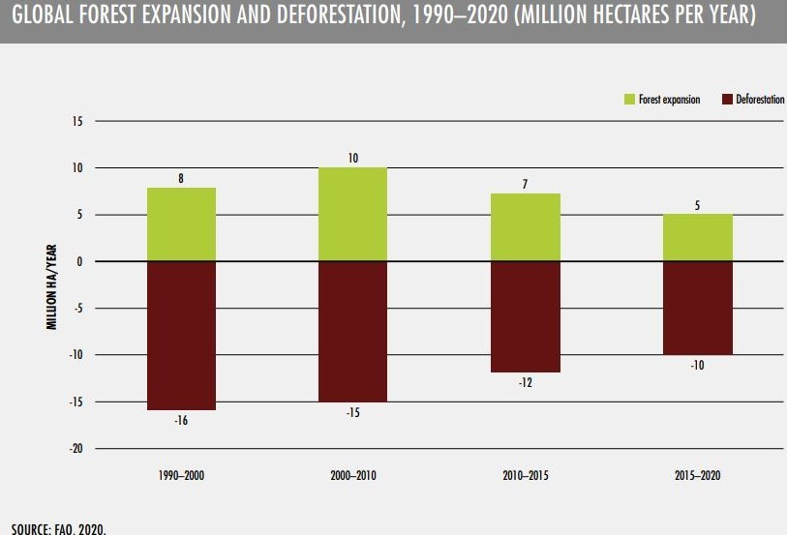

Understanding the Problem:

According to The State of World's Forests(SOFO), commercial agriculture accounts for about 40 per cent of deforestation in the tropics and subtropics, local subsistence agriculture for 33 per cent, infrastructure for 10 per cent, urban expansion for 10 per cent and mining for 7 per cent. Commercial agriculture, contributing majorly to the widespread clearing of forest cover, is not sustainable for the climate. Farmers and landowners select this option as forests take a longer time to fetch revenue and crops generate profits at a faster rate.

Forests play a major role in sustainable agricultural development through a host of channels, including the water cycle, soil conservation, carbon sequestration, natural pest control, influencing local climates and providing habitat protection for pollinators and other species and conversion of the forest land to agricultural use disrupts the entire ecosystem.

Our Solution:

We intend to promote positive interactions between agriculture and forestry to build sustainable agricultural systems and improve food security.

The 2030 Agenda for Sustainable Development, as well as the Paris Agreement on climate change, recognizes that we can no longer look at food security and the management of natural resources separately and to overcome the stated problems forestry should be tied with agriculture for socio-economic development.

Agroforestry is a land use management system in which trees or shrubs are grown around or among crops or pastureland. This diversification of the farming system initiates an agroecological succession, like that in natural ecosystems, and so starts a chain of events that enhance the functionality and sustainability of the farming system.

Agroforestry addresses the needs of the stakeholders and our solution acts as a decision support system by collecting data of agricultural land and predicting the optimum technique for adoption of Agroforestry Methodology.

Forests support sustainable agriculture by stabilising soils and climate, regulating water flow, providing shade and shelter and providing a habitat for pollinators and natural predators of agricultural pests. When integrated judiciously into agricultural landscapes, trees can increase agricultural productivity. Forests ensure the food security of millions of people worldwide, as they are important sources of food, energy and income.

The SOFO report shows that some countries have successfully increased agricultural productivity while also halting and reversing deforestation. The SOFO report says that since 1990, over 20 countries have succeeded in improving food security while maintaining or increasing forest cover.