**PROJECT REPORT**

**“AK-BLOG”**

By

ASHWIN YADAV

ENROLLOMENT NO: - 202326900131

Under the Supervision of

Honey Ma’am

A Report Submitted to

Gujarat University

In Partial Fulfilment of the Requirements for the Degree of B.Sc. IT in

DATA MANAGEMENT & VISUAL INSIGHT



Center for Professional Courses Gujarat University,

Navrangpura, Ahmedabad - 380009, Gujarat

* **CERTIFICATE**

This is to certify that research work embodied in this report entitled **“AK-BLOG”** was carried out by **YADAV ASHWIN** (**202326900131**) at Centre for Professional Course for partial fulfilment of B.Sc. IT degree to be awarded by Gujarat University. This research work has been carried out under my supervision and is to the satisfaction of department.

Date:

Place:

Guide Name Coordinator Name

Honey Ma’am SAURABH DAS SIR

CPC, Gujarat University CPC, Gujarat University

Director Name

**Dr. Paavan Pandit**

CPC, Gujarat University

Seal of Institute

* **DECLARATION OF ORIGINALITY**

I hereby certify that I am the sole author of this Project report and that neither any part of this Project report nor the whole of the Project report has been submitted for a degree to any other University or Institution.

I certify that, to the best of my knowledge, my Project report does not infringe up on any one’s copyright nor violate any proprietary rights and that any ideas, techniques, quotations, or any other material from the work of other people included in my Project report, published or otherwise, are fully acknowledged in accordance with the standard referencing practices.

I declare that this is a true copy of my Project report, including any final revisions, as approved by my Project report review committee.

Date:

Place:

YADAV ASHWIN

202326900131

* **PROJECT REPORT APPROVAL**

This is to certify that research work embodied in this Project report entitled **“AK-BLOG”** was carried out by **YADAV ASHWIN** (**202326900131**) at Center for Professional Course for partial fulfilment of B.Sc. IT degree in Cloud and Application Development to be awarded by Gujarat University.

Date:

Place:

Examiner(s):

**__________________________ ________________________ _________________________**

**( ) ( ) ( )**

* **ACKNOWLEDGEMENT**

We are sincerely thankful to our guide **Honey Ma’am** for their constant support, stimulating suggestions, and encouragement, which greatly assisted us in successfully completing our project work. Their close supervision over the past few months and helpful insights have been invaluable. Despite their busy schedule, their valuable advice and unwavering support have been an inspiration and a driving force for us. Their experience and knowledge have continuously helped shape our initial ideas into a comprehensive form.

We, hereby, take an opportunity to convey my gratitude for the generous assistance and cooperation, that I received from the **Coordinator Sourabh Sir** and to all those who helped me directly and indirectly. We also thank **“Dr. Paavan Pandit”, Director, CPC, GU** for extending all the help and cooperation during our training period.

We are deeply indebted & thankful to our Department Faculties who helped and rendered their valuable time, knowledge and information and whose suggestion and guidance has enlightened on the subject.

Finally, I am also indebted to my friends without whose help I would have had a hard time managing everything on my own.

YADAV ASHWIN

202326900131

* **TABLE OF CONTENT**

|  |  |  |
| --- | --- | --- |
| SR NO. | CONTENTS | Page No |
| 1 | Introduction |  |
| 2 | Project Description |  |
| 3 | System Architecture |  |
| 4 | Implementation |  |
| 4.1 | Setting Up Flask |  |
| 4.2 | User Authentication |  |
| 4.3 | Login & Registration |  |
| 5 | User Interface and Experience |  |
| 6 | Deployment |  |
| 7 | Benefit of this Project |  |
| 8 | Future Enhancement |  |
| 9 | Conclusion |  |

* **INTRODUCTION**
* **Project Title:** AK-Blog (Blog Website)
* **Technologies Used: -**
* **Frontend:** HTML & CSS, JavaScript, Bootstrap
* **Backend:** Python (Flask), GitHub
* **Deployment:** Render
* **DATABASE:** SQLITE

In today's digital age, content creation and sharing have become integral parts of our daily lives. Blogging serves as a powerful tool for individuals and organizations to express their thoughts, share knowledge, and engage with a global audience.

The primary objective of this project is to design and develop a modern blogging website that offers intuitive navigation, secure user authentication, efficient content management, and an engaging user interface. This project aims to bridge the gap between simplicity and functionality, ensuring that users with varying technical expertise can leverage the platform to its fullest potential.

Additionally, the project has been successfully pushed to GitHub for version control and deployed on Render, demonstrating a complete lifecycle management from development to deployment.

* **Project Description**

The AK-Blog project is a modern and dynamic blogging platform designed to cater to the needs of both individual bloggers and organizations. Utilizing a robust tech stack including Flask for the backend, SQL Alchemy for database management, and a combination of HTML, CSS, JavaScript, and Bootstrap for the frontend, this project ensures a seamless and engaging user experience.

* **Objective:**

The primary goal of AK-Blog is to create a user-friendly and intuitive platform that bridges the gap between simplicity and functionality. The project aims to provide users with an easy-to-navigate interface, secure user authentication, and efficient content management tools, ensuring that users of varying technical expertise can effectively utilize the platform to share their thoughts, ideas, and knowledge.

* **Key Features:**
* **User Registration and Login:** Secure user authentication allows individuals to create accounts and log in to the platform.
* **Content Creation and Editing Tools:** Although content editing and addition will be included in future enhancements, the existing tools ensure a smooth user experience.
* **Dynamic Database:** A structured SQLite database setup ensures smooth storage and retrieval of blog posts.
* **Responsive Design:** The website adapts seamlessly across various devices, providing a consistent and accessible user experience, and is fully responsive, ensuring ease of viewing on mobile devices.
* **Scalability and Maintainability:** By leveraging the capabilities of the Flask framework and integrating a robust database architecture, the project ensures that the website can efficiently handle growth and is easy to maintain.
* **Deployment and Version Control:**

The AK-Blog project has been pushed to GitHub for version control, showcasing the developer's proficiency in managing and collaborating on code. Furthermore, the project is deployed on Render, demonstrating a complete lifecycle management from development to deployment.

* **Conclusion:**

In today's digital landscape, AK-Blog stands out as a versatile and scalable solution for content creators looking to share their voices with a global audience. By combining modern web technologies with a focus on user experience, this project exemplifies the balance between technical sophistication and user-friendly design.

* The code is available on my GitHub account, and the project is deployed on Render.

**GITHUB ACC: -** [**https://github.com/Ashwin-1718**](https://github.com/Ashwin-1718)

**DEPLOYMENT: -**[**https://ak-blog-dxkk.onrender.com**](https://ak-blog-dxkk.onrender.com)

* **System Architecture**
* Frontend:
* Technologies Used: HTML, CSS, JavaScript, Bootstrap
* Components:
  + User Interface (UI): Provides an intuitive and responsive interface for users to interact with the platform, including blog viewing, user registration, and login pages.
* Backend:
* Technologies Used: Python (Flask)
* Components:
  + Web Server: Handles HTTP requests, manages routing, and serves HTML templates and static files.
  + Business Logic Layer: Contains the core logic for user authentication, session management, blog post handling, and other backend functionalities.
  + API Endpoints: Provides RESTful APIs for frontend interactions and ensures secure communication between frontend and backend.
* Database:
* Technology Used: SQLite
* Components:
  + Database Schema: Structured to store user information, and metadata.
* Version Control:
* Technology Used: GitHub
* Components:
  + Repository Management: Version control for the project codebase, allowing for collaborative development and tracking changes.
* Deployment:
* Technology Used: Render
* Components:
  + Deployment Pipeline: Automates the deployment process, ensuring the latest code changes are reflected on the live website.
  + Hosting: Provides a reliable and scalable environment for the application to run.
* Security:
* Components:
  + User Authentication: Secure login and registration system to protect user accounts.
* Responsiveness:
* Components:
  + Responsive Design: Ensures the website is fully accessible and user-friendly across different devices, including mobile phones, tablets, and desktops.
* **Implementation**
* DIAGRAM  
  User Authentication

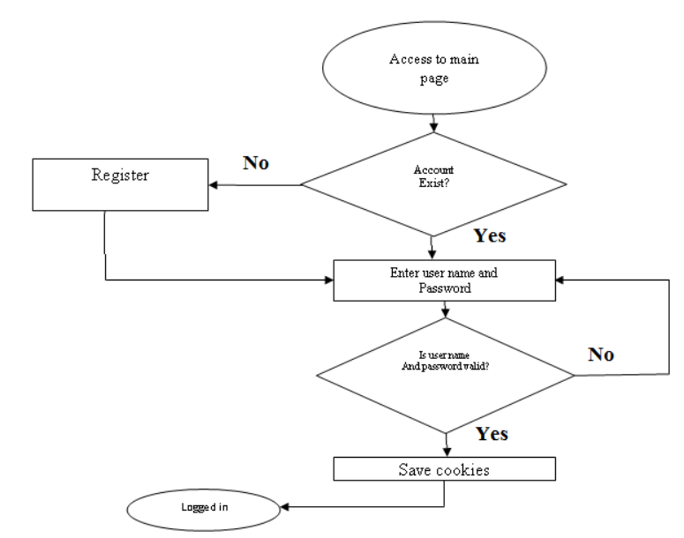

* The user authentication process in the AK-Blog project ensures secure access and management of user accounts.
* The Flask framework is used to create the web application, while SQL Alchemy is used to handle database interactions.

A SQLite database is configured to store user information.

###### **Activity diagram**

**Home Page**

**Register**

**Login**

**Yes**

**No**

**Have an**

**Account?**

**Login**

* **LOGIN (CODE)**

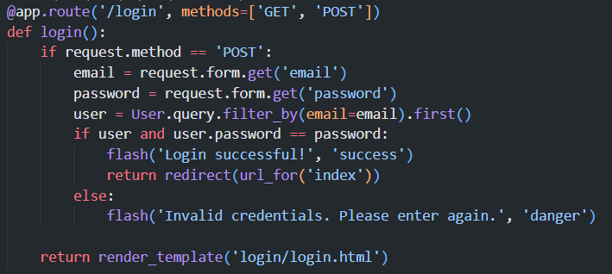

* **LOGIN(OUTPUT)**

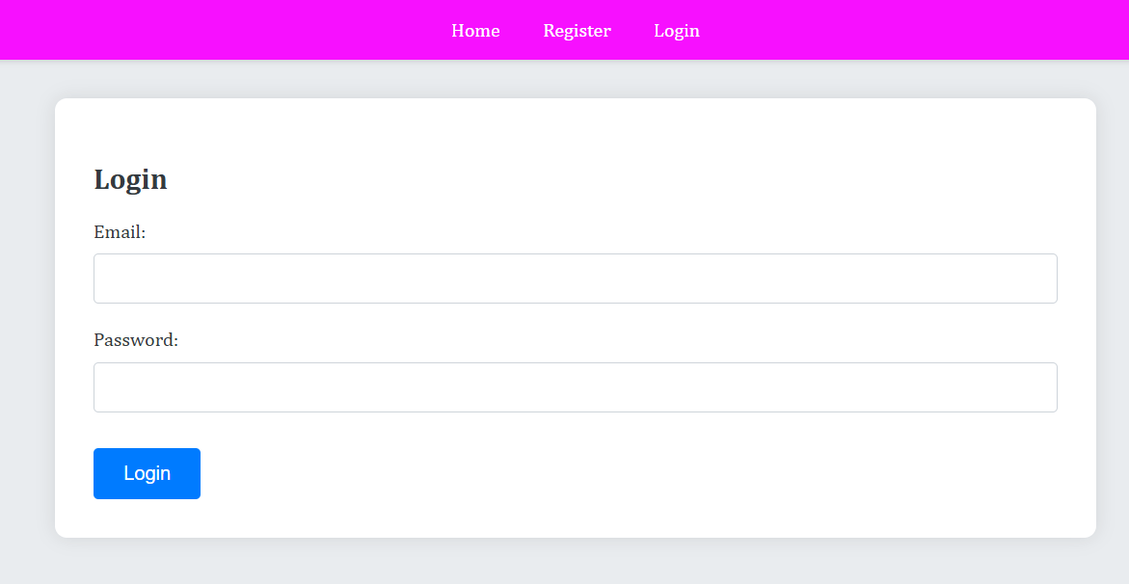

* **REGISTER (CODE)**

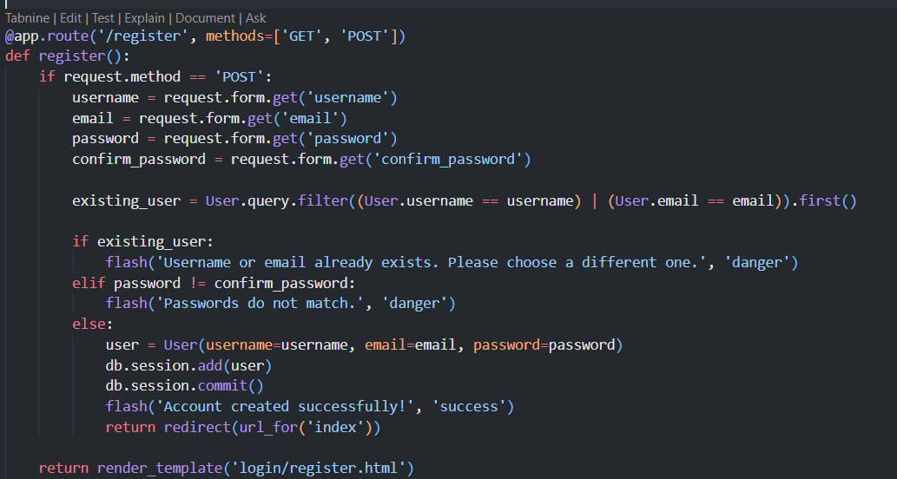

* **REGISTER(OUTPUT)**

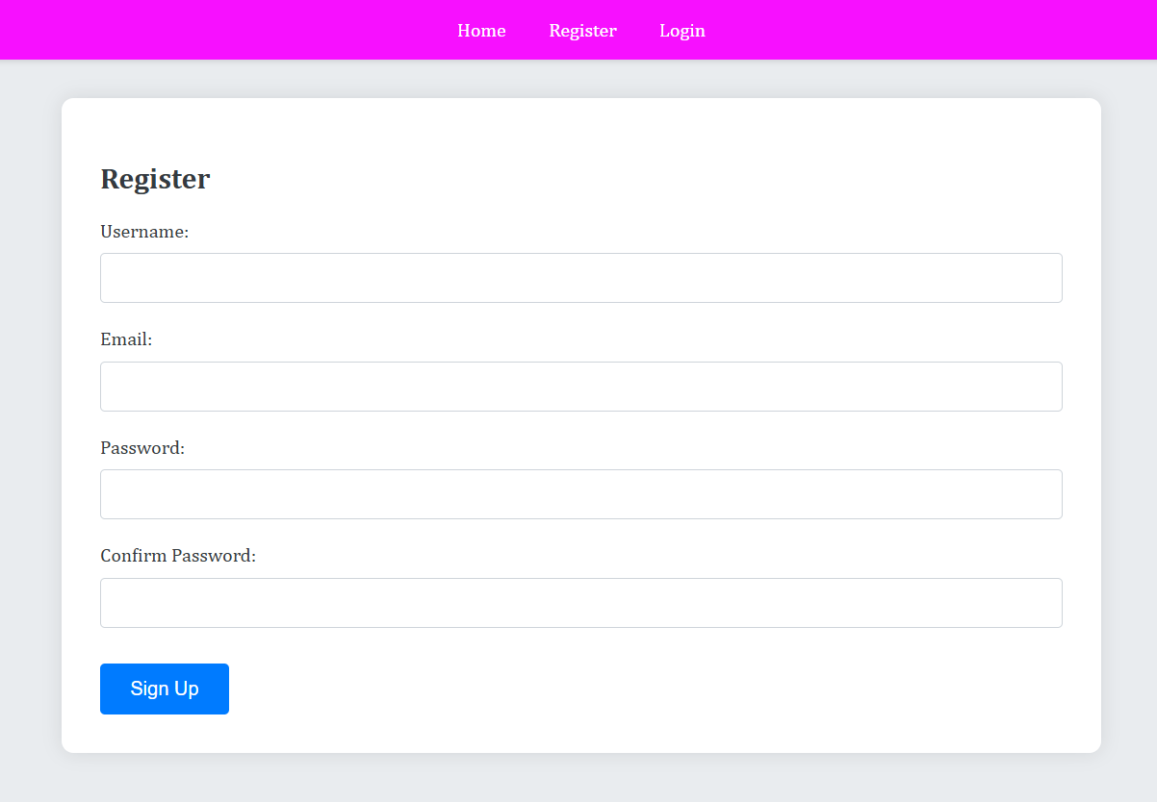

* **User Interface (UI) and Experience (UX)**
* **Desktop View**

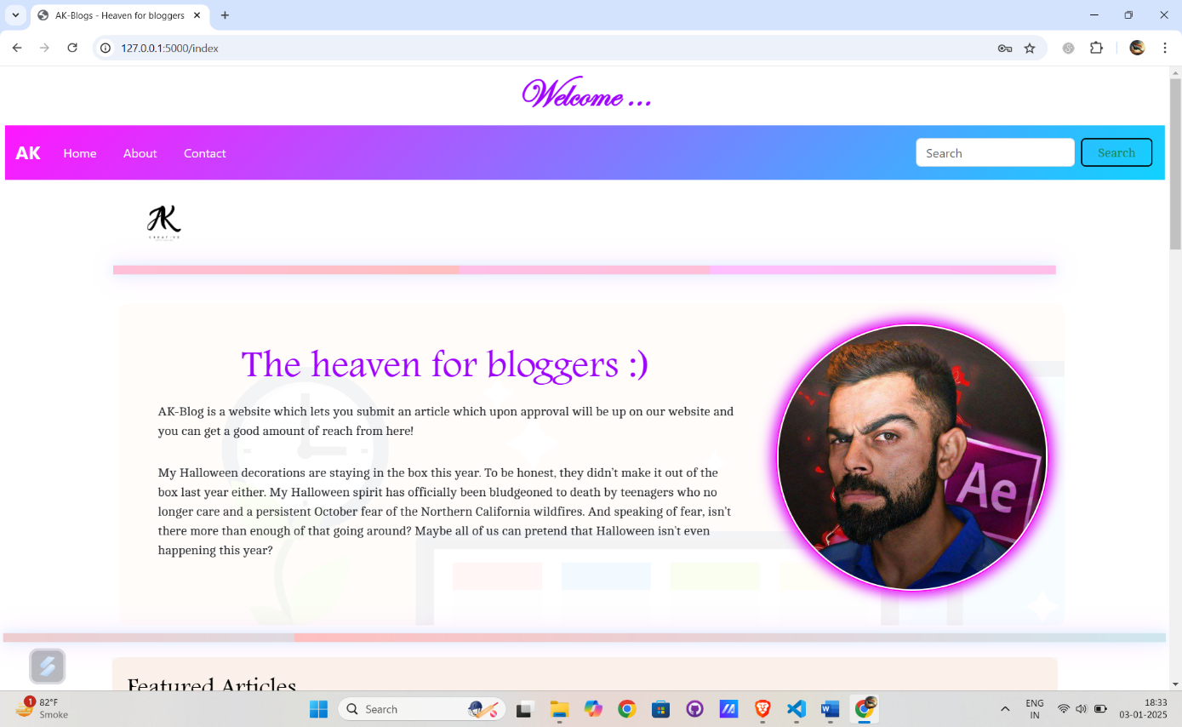

* A well-designed User Interface (UI) and User Experience (UX) are crucial for ensuring that users find your blog website intuitive, engaging, and enjoyable. Here's a detailed overview
* **Mobile View**  **Tablet View**

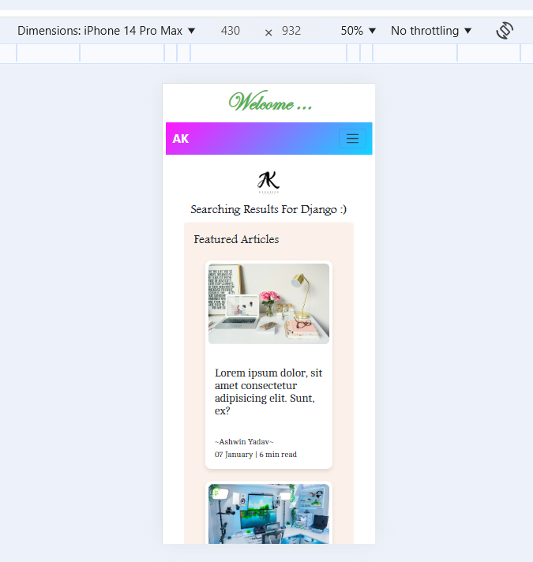 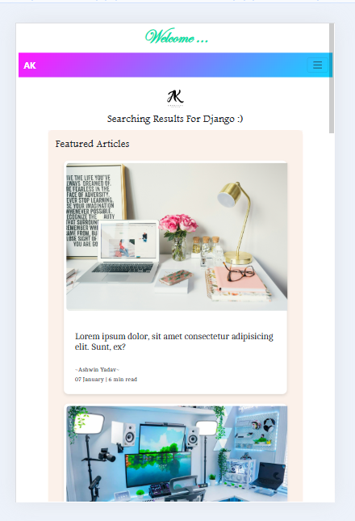

* **ARTICLE POST VIEW**

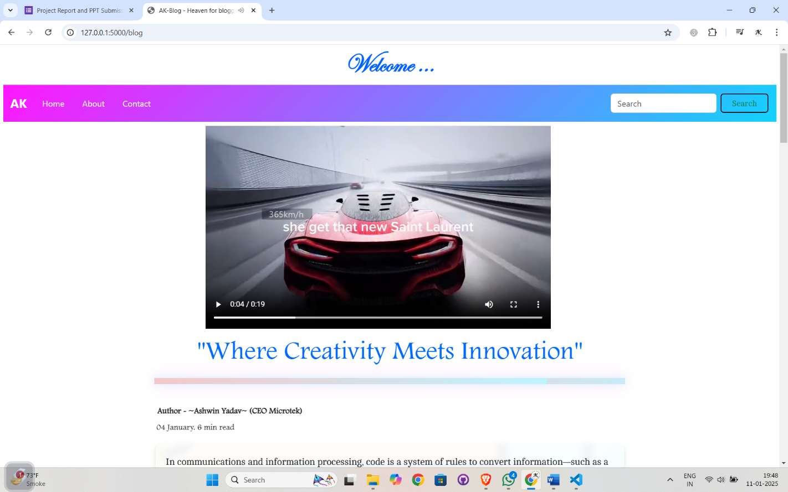

* **MOBILE VIEW TABLET VIEW**

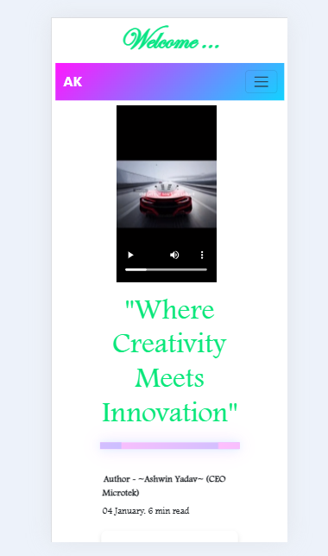 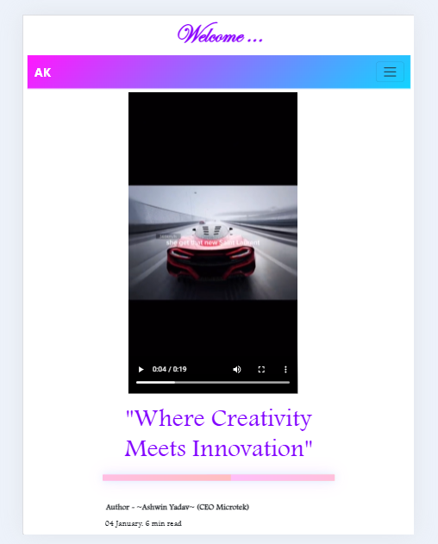

* **Article View**

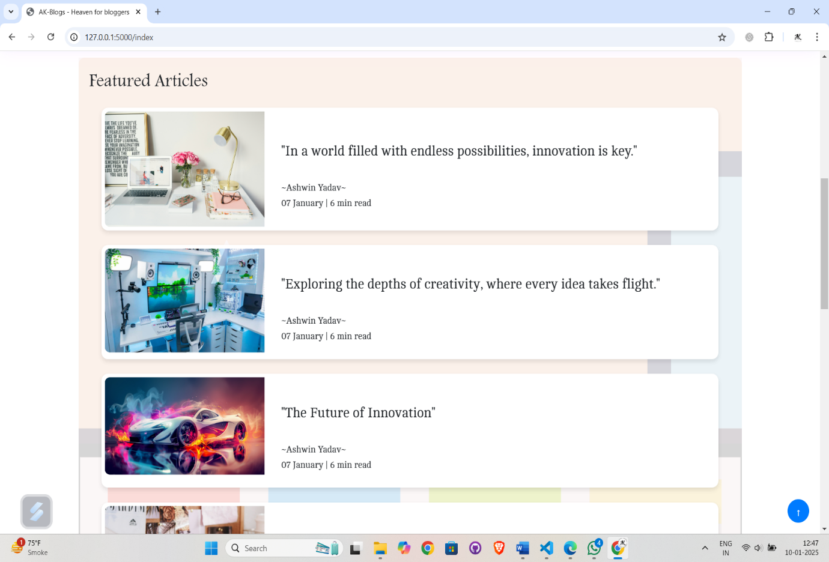

* **ABOUT VIEW**

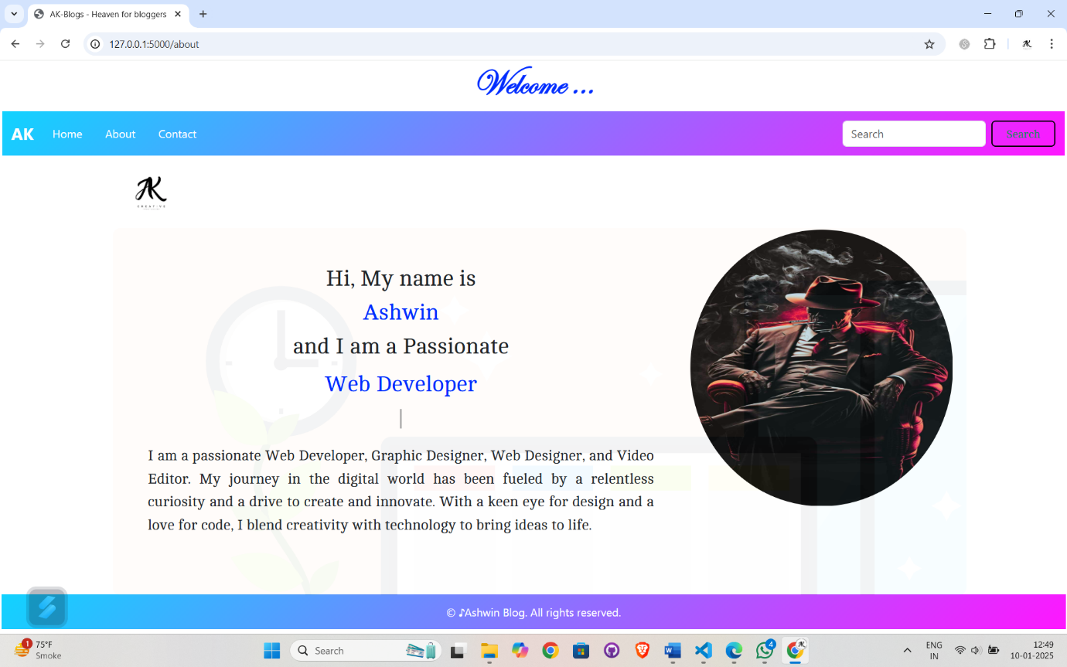

* **SEARCH PAGE**

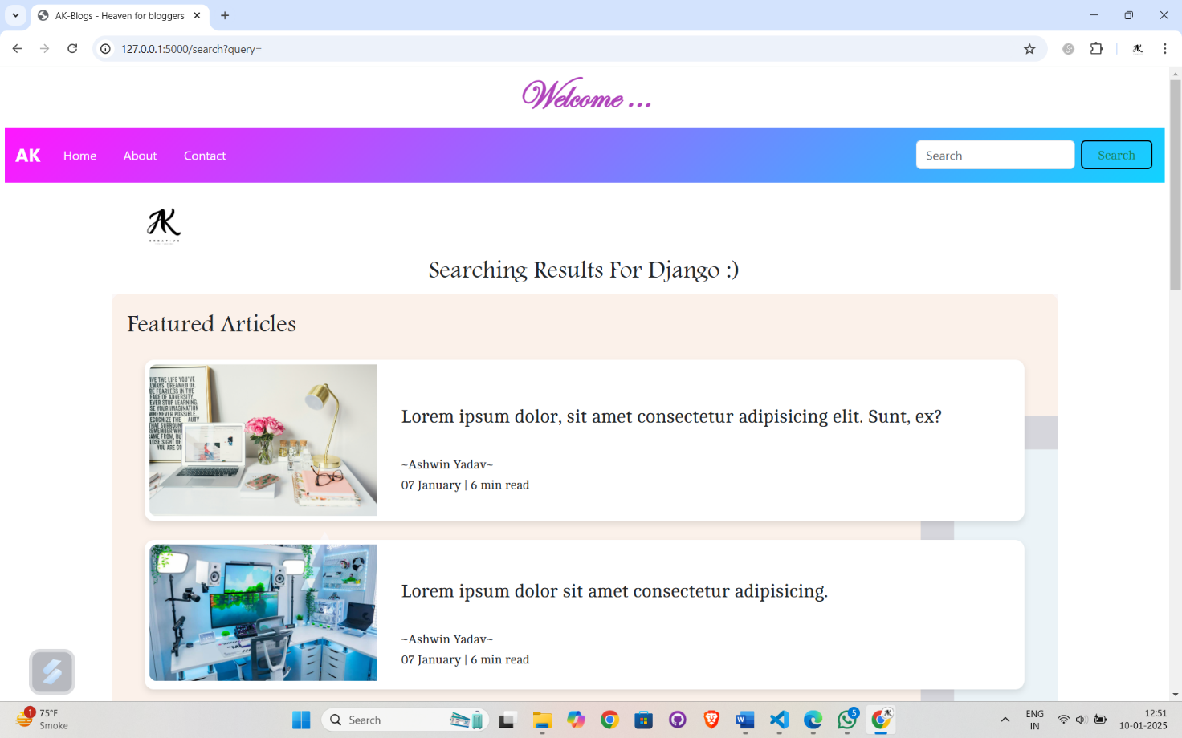

* **CONTACT US**

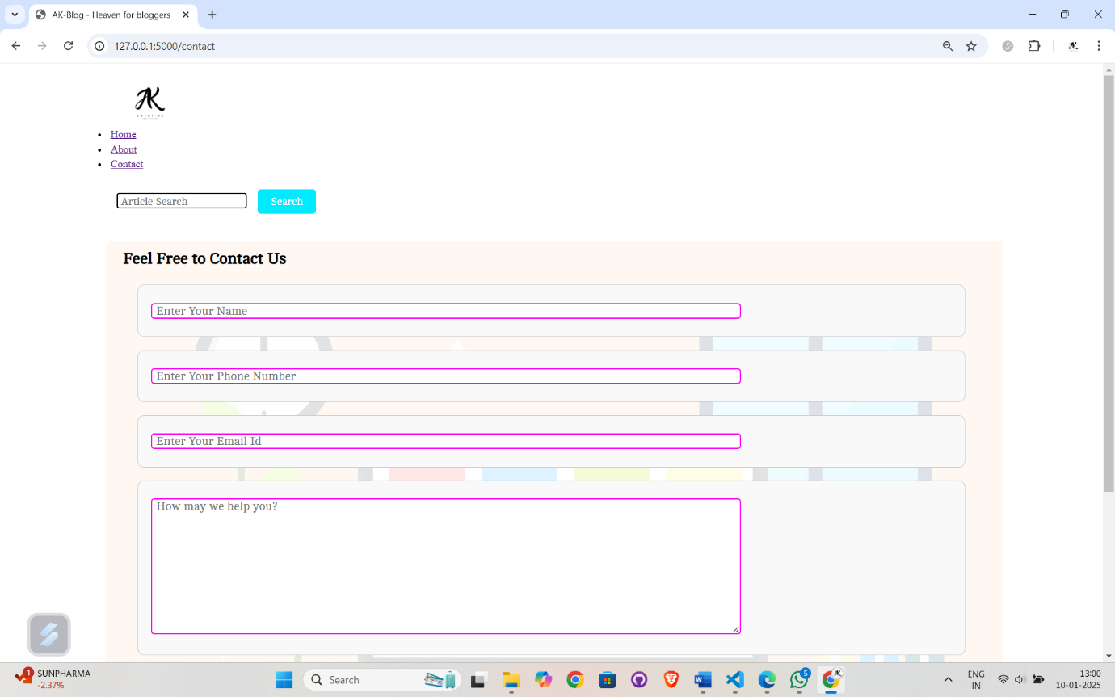

* **DEPLOYMENT**

**1.Prerequisites:**

* **Render Account**: Create an account on Render.
* **Git Repository**: Ensure your project is in a Git repository (GitHub, GitLab, etc.).

**2. Initial Setup:**

* **Create a New Service**: Log in to Render and click on "New" -> "Web Service".
* **Connect Repository**: Choose the Git repository where your project is stored.
* **Benefits of Using Render:**
* **Simplified Deployment**: Render handles much of the complexity, allowing you to focus on your code.
* **Scalability**: Easily scale your application as your user base grows.
* **Automatic SSL**: Render provides automatic SSL for your applications, ensuring secure connections.
* The code is available on my GitHub account, and the project is deployed on Render.

**GITHUB ACC: -** [**https://github.com/Ashwin-1718**](https://github.com/Ashwin-1718)

**DEPLOY: -**[**https://project-external.onrender.com**](https://project-external.onrender.com)

* **BENEFITS OF THIS PROJECT**
* **User Engagement:**
* The blog website encourages user interaction and engagement through a rich reading experience, offering high-quality, curated content that keeps readers coming back for more.
* Readers can easily browse through various blog posts, discover new topics, and enjoy a seamless reading experience.
* **Learning Opportunity:**
* Developing the project helps in learning and applying web development skills, including Flask, SQL Alchemy, and front-end technologies.
* Working with databases, user authentication, and deployment provides hands-on experience with essential aspects of web development.
* **Responsive Design:**
* The website is fully responsive and can be easily viewed on any device, including desktops, tablets, and smartphones. This ensures a seamless and consistent user experience across different platforms.
* The use of Bootstrap and other front-end technologies ensures that the layout and functionality of the website adapt to various screen sizes and resolutions.
* **FUTURE ENHANCEMENT**
* **User-Generated Content:**
* Enable users to register as contributors, allowing them to create and submit their own blog posts for publication.
* Implement an approval workflow for submitted content to ensure quality and relevance.
* **Commenting and Interaction:**
* Introduce a commenting system to allow readers to engage in discussions and share their thoughts on blog posts.
* Implement features like comment moderation, threaded comments, and upvoting to enhance the quality of interactions.
* **Likes and Bookmarks:**
* Enable readers to like blog posts, providing feedback and increasing engagement.
* Allow users to bookmark their favourite posts for easy access and future reference.
* Implement a user dashboard where users can view and manage their liked and bookmarked posts.
* **Personalization and Recommendations:**
* Implement personalized content recommendations based on user preferences, reading history, and behaviour.
* Use machine learning algorithms to suggest relevant blog posts and enhance user engagement.
* **Conclusion**
* **Summary**

AK-Blog is a modern and fully responsive blogging platform designed to provide a seamless and engaging reading experience. Leveraging cutting-edge web technologies such as Flask, SQL Alchemy, HTML, CSS, JavaScript, and Bootstrap, the project offers a reliable, secure, and scalable solution for content consumption. The application is deployed on Render, showcasing a complete lifecycle management from development to deployment.

* **Lessons Learned**

Throughout the development process, various challenges were encountered, including implementing responsive design, ensuring secure user authentication, and managing deployment pipelines. These challenges provided valuable learning experiences in web development, project management, and problem-solving. The project also highlighted the importance of modular architecture and scalability, which allows for future enhancements and continuous improvement.

**Thank you.**