

INTERNSHIP REPORT
ACADEMIC YEAR 2025-2026

Submitted to:
Namita Doshi
Under the guidance of:
Parthrajsinh Jadeja

By
Name: Ashwin Yadav
Enrolment No: 202326900131
Stream: Data Management & Visual Insight
Semester: 6
Date: 27/03/2026
Centre for Professional Courses,
Maharishi Aryabhatta Building Gujarat University


Self Declaration

I, Ashwin Yadav, hereby declare that the internship report, submitted in partial fulfilment of the requirement for the completion of my academic
credits of Semester 6 of Data Management & Visual Insights Sem-6, at Centre for Professional Courses, Gujarat University, is my original Work.

I further declare that:
- The work presented in this report has been carried out by me during my internship at
Grass IT Solutions from 16th February 2026 to 13th March 2026.

- This report has not been submitted previously to any other university or institution for the reward of any degree, diploma, or certification.

- The data, observations & conclusions presented in this report are true to the best of my knowledge.

- I take full responsibility for the authenticity & accuracy of the content presented in this internship report.

Student Name: Ashwin Yadav

Enrollment No: 202326900131

Stream & Semester: Data Management & Visual Insights, Sem-6

Signature:

Date:



ACKNOWLEDGEMENT

I would like to express my sincere and heartfelt gratitude to Grras IT Solutions for
providing me with the invaluable opportunity to undertake my internship in the field
of Data Analytics. This experience has significantly enhanced my practical knowledge
and provided me with meaningful exposure to real-world data analysis.

I am deeply thankful to my mentor, Mr. Darshan Patel, for his constant guidance,
encouragement, and support throughout the internship period. His expert insights and
constructive feedback played a crucial role in the successful completion of my Project
and in strengthening my technical and analytical skills.

I would also like to extend my sincere appreciation to the Programme In-charge and
esteemed faculty members of the Centre for Professional Courses, Gujarat University,
for their continuous motivation and academic support.

Furthermore, I express my gratitude to my family and friends for their unwavering
encouragement and moral support, which helped me stay focused and dedicated
throughout the internship.

Ashwin Yadav
202326900131



TABLE OF CONTENT

- Title Page .................................................................................1
- Self Declaration ................................................................. 2
- Acknowledgement ............................................................ 3
- Table of Contents ............................................................. 4
- Resume .................................................................................... 5
- Offer Letter ............................................................................. 6
- Completion Certificate .................................................... 7
- Evaluation Certificate ...................................................... 8
- Daily Log .................................................................................. 9
- Report ……………………………………………… 11
  - Introduction of the Company & Domain ……………11
  - Company Overview (Grras IT Solutions) ................... 11
  - Training Objectives .................................................... 12
  - Training Experience ............................................. 12
    - Figure 1: Power BI Dashboard ……….……13
    - Figure 2: Excel Dashboard ………………. 13
  - Skills Developed .................................................. 14
  - Achievements & Contributions .................................. 14
  - Challenges Faced ............................................... 15
  - Lessons Learned ............................................... 15



DAILY LOG

Name of the Student: Ashwin Yadav
Enrollment No: 202326900131
Name of the Company/organization: Grras IT Solutions.

Day | Date | Working hours | Work done  /Activities performed | Key learnings/  Remarks
1 | 16/02/2026 | 6 | Introduction to Data Analytics, its importance and real-world applications. | Understood basics of Data Analytics and tools like Python, SQL, Power BI.
2 | 17/02/2026 | 6 | Performed exploratory data analysis and handled data cleaning tasks. | Learned importance of preprocessing and dealing with missing values.
3 | 18/02/2026 | 6 | Studied regression concepts and model basics. | Understood how variables are related and analyzed.
4 | 19/02/2026 | 6 | Created charts and graphs for data visualization. | Learned how visual representation helps in understanding data.
5 | 20/02/2026 | 6 | Learned basics of hypothesis testing techniques. | Understood statistical concepts for decision-making.
6 | 23/02/2026 | 6 | Introduction to SQL and basic query writing. | Learned fundamentals of database querying.
7 | 24/02/2026 | 6 | Worked on JOIN operations to combine tables. | Understood how to merge data from multiple tables.
8 | 25/02/2026 | 6 | Used GROUP BY and aggregate functions. | Learned data summarization techniques.
9 | 26/02/2026 | 6 | Practiced complex SQL queries and problems. | Improved logical thinking in SQL queries.
10 | 27/02/2026 | 6 | Completed a mini project using SQL. | Understood basic database design concepts.
11 | 02/03/2026 | 6 | Worked with APIs and extracted data in JSON format. | Learned how to fetch and handle data from APIs.
12 | 03/03/2026 | 6 | Converted API data into DataFrames using Python. | Understood structuring of raw data for analysis.
13 | 04/03/2026 | 6 | Performed data cleaning and transformation tasks. | Learned preparing data for accurate analysis.
14 | 05/03/2026 | 6 | Created dashboards using Power BI. | Learned effective data visualization techniques.
15 | 06/03/2026 | 6 | Developed final project using Power BI. | Understood data integration and storytelling.
16 | 09/03/2026 | 6 | Worked with datasets in Microsoft Excel. | Learned basic data handling in Excel.
17 | 10/03/2026 | 6 | Applied formulas and performed data cleaning. | Improved data manipulation skills in Excel.
18 | 11/03/2026 | 6 | Created pivot tables and charts. | Learned summarizing data using Excel tools.
19 | 12/03/2026 | 6 | Built an interactive dashboard in Excel. | Understood visual analytics using Excel.
20 | 13/03/2026 | 6 | Final review of work and preparation of report. | Learned documentation and presentation skills.

Sign of the student:
Date:

Sign of the authorized person of the Company/Organization: Stamp of the Company:


REPORT

Introduction of the Company & Domain
- The internship at Grras IT Solutions provided me with an opportunity to gain practical exposure in the field of Data Analytics. This experience helped me understand how theoretical concepts are applied in real-world scenarios and enhanced my technical and analytical skills.
- Grras IT Solutions is a recognized IT training and development organization that offers industry-oriented programs in domains such as Data Analytics, Cloud Computing, and Software Development. The company focuses on delivering practical knowledge through real-time projects and hands-on learning. It aims to bridge the gap between academic education and industry requirements by equipping students with relevant technical skills.
- The domain I worked in during my internship was Data Analytics, which involves collecting, processing, and analyzing data to extract meaningful insights. It plays a crucial role in decision-making across various industries. During the training, I was introduced to tools and technologies such as Python, SQL, Power BI, and Excel, which are widely used in the data analytics process.
- Overall, the internship provided a strong foundation in understanding how data is transformed into actionable insights, preparing me for future roles in the field of data analytics.

Company Overview – Grras IT Solutions
- Grras IT Solutions is a well-established IT training and development organization known for providing industry-oriented education in various domains such as Data Analytics, Cloud Computing, Cyber Security, and Software Development. The company focuses on bridging the gap between academic learning and industry requirements by offering practical training programs designed to enhance technical skills and employability.
- The organization provides hands-on experience through real-time projects, enabling students to gain exposure to practical scenarios. Grras IT Solutions emphasizes a learning approach that combines theoretical concepts with implementation, ensuring that learners understand not only the “what” but also the “how” of technology.
- In the field of Data Analytics, Grras offers comprehensive training that includes tools and technologies such as Python, SQL, Power BI, and Excel. The training is structured to help students understand the complete data analysis lifecycle, from data collection and cleaning to visualization and interpretation.
- During my internship at Grras IT Solutions, I had the opportunity to work in a professional learning environment where I could apply my academic knowledge to real-world datasets. The company’s focus on practical exposure and mentorship played a crucial role in enhancing my understanding of data analytics and preparing me for industry challenges.
- Overall, Grras IT Solutions provides a strong platform for students to develop technical expertise and gain confidence in applying their skills in real-world situations.

Training Objectives
- The primary objective of this internship was to gain practical exposure to the field of Data Analytics and understand how data-driven techniques are applied in real-world scenarios. The training aimed to bridge the gap between theoretical knowledge acquired during academic studies and its practical implementation in the industry.
- One of the key objectives was to develop a strong foundation in data handling and analysis using tools such as Python, SQL, Power BI, and Excel. The internship focused on enabling me to perform essential tasks such as data cleaning, data transformation, and data visualization, which are crucial steps in the data analytics process.
- Another important objective was to enhance my ability to work with structured and unstructured datasets. This included learning how to extract data from various sources, process it efficiently, and generate meaningful insights that support decision-making.
- The training also aimed to improve my problem-solving and analytical thinking skills by working on real-world datasets and projects. Additionally, I was encouraged to understand the complete data analysis lifecycle, from data collection to interpretation and presentation of results.
- Overall, the objective of this internship was not only to build technical skills but also to develop a practical mindset required to solve real-world data-related problems effectively.

Training Experience
- During my internship at Grras IT Solutions, I gained hands-on experience in the field of Data Analytics through a well-structured training program. The training began with the fundamentals of data analytics, where I was introduced to basic concepts such as types of data, data processing, and the importance of analytics in decision-making.
- As the training progressed, I worked with various tools and technologies including Python, SQL, Power BI, and Excel. I performed tasks such as exploratory data analysis (EDA), data cleaning, and transformation to prepare datasets for further analysis. I also learned how to write SQL queries to extract and manipulate data from databases efficiently.
- One of the most valuable parts of my training was working with real-world datasets and APIs. I learned how to fetch data in JSON format, convert it into structured DataFrames, and analyze it using Python. Additionally, I created interactive dashboards using Power BI and Excel to represent data in a visually appealing and meaningful way.
- Towards the end of the internship, I worked on a final project where I applied all the concepts I had learned. This included integrating data from multiple sources, performing analysis, and presenting insights through dashboards.
- Overall, the training experience was highly practical and helped me build confidence in applying data analytics concepts to real-world problems.

Figure 1: Power BI Dashboard showing World Indicators Analysis including GDP, Health Expenditure, Trade Value, and Country-wise comparisons:
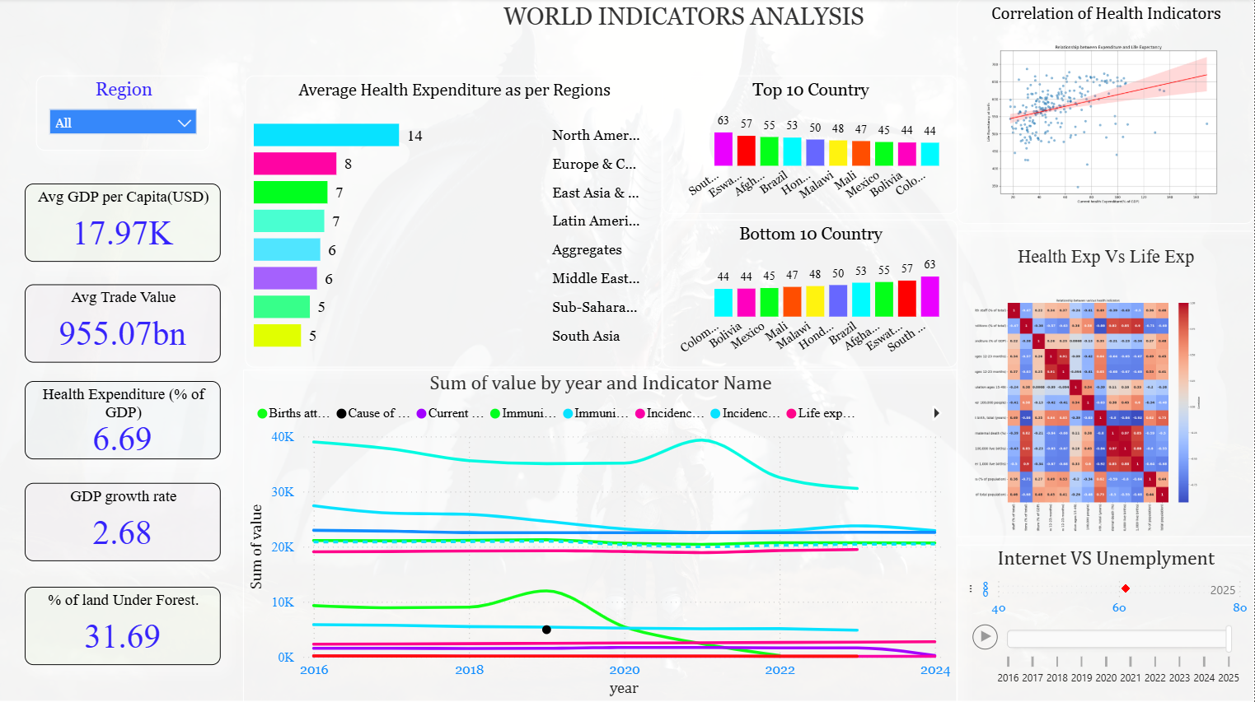

Figure 2: Excel Dashboard representing company performance with sales, profit, customer distribution, and category-wise analysis
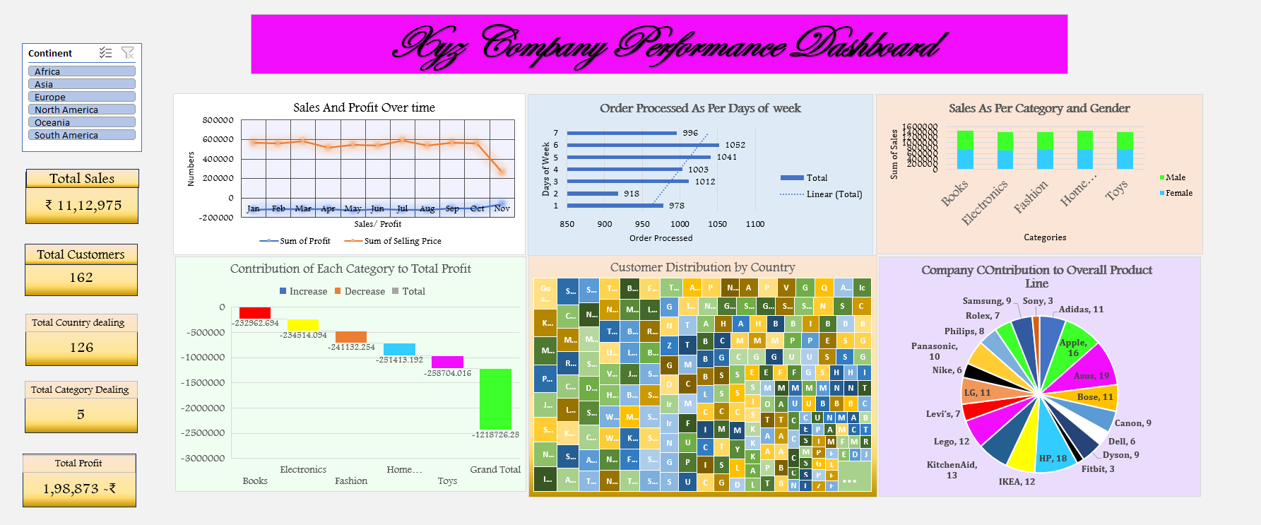

Skills Developed
- During my internship at Grras IT Solutions, I developed a combination of technical and soft skills that are essential in the field of Data Analytics. The training provided me with hands-on experience in working with various tools and technologies, which helped strengthen my technical foundation.
- From a technical perspective, I gained proficiency in Python for data analysis, including libraries used for data manipulation and visualization. I also developed strong SQL skills, which enabled me to write queries for data extraction, filtering, and aggregation. Additionally, I learned to use Power BI and Excel for creating interactive dashboards and visual representations of data, which improved my ability to present insights effectively.
- I also developed skills in data cleaning, preprocessing, and transformation, which are crucial steps in preparing raw data for analysis. Working with real-world datasets helped me understand how to handle missing values, inconsistencies, and large volumes of data efficiently.
- Along with technical skills, I improved several soft skills such as problem-solving, analytical thinking, and attention to detail. I also enhanced my ability to work independently, manage time effectively, and approach tasks in a structured manner.
- Overall, this internship played a significant role in improving both my technical expertise and professional skills, preparing me for future opportunities in the field of Data Analytics.

Achievements & Contributions
- During my internship at Grras IT Solutions, I actively contributed to various tasks and projects that enhanced my practical understanding of Data Analytics. One of my key achievements was successfully working on data analysis tasks involving real-world datasets, where I applied techniques such as data cleaning, transformation, and visualization.
- I contributed to building interactive dashboards using Power BI and Excel, which helped in presenting complex data in a clear and understandable manner. These dashboards included visual representations such as charts, graphs, and key performance indicators, making it easier to interpret trends and patterns.
- Another significant contribution was working with SQL queries to extract, filter, and analyze data from multiple tables. This helped me improve my logical thinking and efficiency in handling structured data. I also worked with API data, where I extracted information in JSON format and converted it into structured datasets for analysis using Python.
- Additionally, I successfully completed a final project that involved integrating data from different sources and presenting meaningful insights through dashboards. This project reflected my ability to apply the concepts learned during the training in a practical scenario.
- Overall, my contributions during the internship demonstrated my ability to work with data effectively and deliver results through proper analysis and visualization techniques.

Challenges Faced
- During my internship at Grras IT Solutions, I encountered several challenges that helped me improve my technical and problem-solving skills. One of the major challenges was working with large and complex datasets consisting of multiple tables. Understanding the relationships between these tables and ensuring accurate data extraction required careful analysis and attention to detail.
- Another challenge I faced was handling missing and inconsistent data during the data cleaning process. Identifying appropriate methods to deal with such issues without affecting the overall analysis was sometimes difficult and required a deeper understanding of data preprocessing techniques.
- While working with SQL, writing complex queries involving multiple joins and aggregations was initially challenging. It required logical thinking and practice to ensure correct results. Similarly, working with APIs and converting JSON data into structured formats also posed some difficulties in the beginning.
- Creating effective dashboards in Power BI and Excel was another area where I faced challenges, particularly in selecting the right type of visualization to represent the data clearly.
- However, with continuous practice, guidance from my mentor, and consistent effort, I was able to overcome these challenges and improve my overall performance throughout the internship.

Lessons Learned
- The internship at Grras IT Solutions provided me with valuable learning experiences that extended beyond technical knowledge. One of the key lessons I learned was the importance of data preprocessing, as clean and well-structured data is essential for accurate analysis and meaningful results.
- I also understood the significance of choosing appropriate tools and techniques based on the type of data and the problem being addressed. Working with tools like Python, SQL, Power BI, and Excel helped me realize how each tool plays a unique role in the data analysis process.
- Another important lesson was the value of logical thinking and a step-by-step approach while solving data-related problems. Whether it was writing SQL queries, cleaning data, or building dashboards, a structured method was necessary to achieve accurate outcomes.
- Additionally, I learned the importance of effective data visualization and how it helps in communicating insights clearly to users. Presenting data in a simple and understandable format is as important as analyzing it.
- This internship also taught me the importance of consistency, patience, and continuous learning. Overall, the experience has strengthened my interest in Data Analytics and prepared me to handle real-world challenges with confidence.

