**PROJECT REPORT**

**“HIRE-HORIZON”**

By

ASHWIN YADAV

ENROLLOMENT NO: - 202326900131

Under the Supervision of

Honey Ma’am

A Report Submitted to

Gujarat University

In Partial Fulfilment of the Requirements for the Degree of B.Sc. IT in

DATA MANAGEMENT & VISUAL INSIGHT



Center for Professional Courses Gujarat University,

Navrangpura, Ahmedabad - 380009, Gujarat

* **CERTIFICATE**

This is to certify that research work embodied in this report entitled **“HIRE-HORIZON”** was carried out by **YADAV ASHWIN** (**202326900131**) at Centre for Professional Course for partial fulfilment of B.Sc. IT degree to be awarded by Gujarat University. This research work has been carried out under my supervision and is to the satisfaction of department.

Date:

Place:

Guide Name Coordinator Name

Honey Ma’am SAURABH DAS SIR

CPC, Gujarat University CPC, Gujarat University

Director Name

**Dr. Paavan Pandit**

CPC, Gujarat University

Seal of Institute

* **DECLARATION OF ORIGINALITY**

I hereby certify that I am the sole author of this Project report and that neither any part of this Project report nor the whole of the Project report has been submitted for a degree to any other University or Institution.

I certify that, to the best of my knowledge, my Project report does not infringe up on any one’s copyright nor violate any proprietary rights and that any ideas, techniques, quotations, or any other material from the work of other people included in my Project report, published or otherwise, are fully acknowledged in accordance with the standard referencing practices.

I declare that this is a true copy of my Project report, including any final revisions, as approved by my Project report review committee.

Date:

Place:

YADAV ASHWIN

202326900131

* **PROJECT REPORT APPROVAL**

This is to certify that research work embodied in this Project report entitled **“HIRE-HORIZON”** was carried out by **YADAV ASHWIN** (**202326900131**) at Center for Professional Course for partial fulfilment of B.Sc. IT degree in Cloud and Application Development to be awarded by Gujarat University.

Date:

Place:

Examiner(s):

**__________________________ ________________________ _________________________**

**( ) ( ) ( )**

* **ACKNOWLEDGEMENT**

We are sincerely thankful to our guide **Honey Ma’am** for their constant support, stimulating suggestions, and encouragement, which greatly assisted us in successfully completing our project work. Their close supervision over the past few months and helpful insights have been invaluable. Despite their busy schedule, their valuable advice and unwavering support have been an inspiration and a driving force for us. Their experience and knowledge have continuously helped shape our initial ideas into a comprehensive form.

We, hereby, take an opportunity to convey my gratitude for the generous assistance and cooperation, that I received from the **Sourabh Sir** and to all those who helped me directly and indirectly. We also thank **“Dr. Paavan Pandit”, Director, CPC, GU** for extending all the help and cooperation during our training period.

We are deeply indebted & thankful to our Department Faculties who helped and rendered their valuable time, knowledge and information and whose suggestion and guidance has enlightened on the subject.

Finally, I am also indebted to my friends without whose help I would have had a hard time managing everything on my own.

YADAV ASHWIN

202326900131

* **Abstract**

In the rapidly evolving digital landscape, the need for efficient and accessible job application platforms has become increasingly critical. Traditional hiring practices are often manual, time-consuming, and lack the efficiency required to meet modern recruitment demands. To address these limitations, **HIRE-HORIZON** has been developed as a comprehensive, technology-driven solution aimed at streamlining the job application and hiring process.

**HIRE-HORIZON** is a responsive web-based application built using the **MERN stack**—MongoDB, Express.js, React.js, and Node.js. It enables job seekers to register, browse job opportunities, and apply seamlessly, while also providing administrators with powerful tools to post jobs, manage applications, update user statuses (Hired/Denied), and maintain control via a dedicated admin panel.

The system integrates modern features such as JWT-based authentication, role-based authorization, and responsive design to ensure security, scalability, and cross-device compatibility. With user-friendly interfaces and structured backend logic, the application delivers a smooth and secure experience to both job seekers and administrators.

This solo project, developed by **Ashwin Ashok Yadav** under the guidance of **Honey Ma’am**, showcases practical knowledge in full-stack development, API handling, database integration, and system design. It serves not only as an academic endeavour but also as a potential blueprint for real-world recruitment platforms.

* **TABLE OF CONTENT**

|  |  |  |
| --- | --- | --- |
| SR NO. | CONTENTS | Page No |
| 1 | Certificate |  |
| 2 | Project Acknowledgment |  |
| 3 | Preface |  |
| 4 | |  | | --- | |  |  |  | | --- | | Introduction | |  |
| 5 | Objective of the Project |  |
| 6 | Scope of the Project |  |
| 7 | |  | | --- | |  |  |  | | --- | | System Analysis | |  |
| 7.1 | • Existing System |  |
| 7.2 | |  | | --- | |  |  |  | | --- | | • Proposed System | |  |
| 7.3 | |  | | --- | |  |  |  | | --- | | • System Requirements | |  |
| 8 | |  | | --- | |  |  |  | | --- | | System Design | |  |
| 8.1 | |  | | --- | |  |  |  | | --- | | • Architecture Diagram | |  |
| 8.2 | |  | | --- | |  |  |  | | --- | | • Data Flow Diagram | |  |
| 8.3 | |  | | --- | |  |  |  | | --- | | • ER Diagram | |  |
| 9 | |  | | --- | |  |  |  | | --- | | Implementation | |  |
| 9.1 | |  | | --- | |  |  |  | | --- | | • Frontend | |  |
| 9.2 | |  | | --- | |  |  |  | | --- | | • Backend | |  |
| 9.3 | |  | | --- | |  |  |  | | --- | | • Database | |  |
| 10 | |  | | --- | |  |  |  | | --- | | Modules of the Application | |  |
| 11 | |  | | --- | |  |  |  | | --- | | Testing | |  |
| 12 | |  | | --- | |  |  |  | | --- | | Conclusion | |  |
| 13 | |  | | --- | |  |  |  | | --- | | Future Scope | |  |

* **CHAPTER 1**
* **INTRODUCTION**
* **Project Title: HIRE-HORIZON** (A Comprehensive Job Application Platform)
* **Technologies Used: -**
* Backend Development: - Node. Js
* Web-Framework: - Express. Js
* Frontend Development: - React. Js
* Authentication: - JWT (JSON Web Token)
* HTTP Request: - Axios
* Styling: - CSS, Bootstrap

In today’s digital era, finding jobs or hiring the right talent has become increasingly dependent on technology-driven platforms. Traditional hiring methods are often time-consuming, inefficient, and unable to meet the fast-paced needs of modern organizations and job seekers. To overcome these challenges, digital job portals have emerged as essential tools to streamline the hiring process and connect employers with potential candidates more effectively.

**HIRE-HORIZON** is a responsive and efficient **Job Portal Application** built using the **MERN stack (MongoDB, Express.js, React.js, Node.js)**.

The platform is designed to simplify the recruitment process by enabling users to register, search and apply for jobs, while allowing administrators to post job listings, manage applications, and track user activity via a dedicated admin panel.

The application provides an intuitive user interface and ensures seamless functionality across various devices. Its responsive design ensures accessibility from mobile phones, tablets, and desktops. The platform also includes authentication, authorization, and secure data handling mechanisms to protect user information and ensure reliability.

Being a **solo project** undertaken in the **4th semester** by **Ashwin Ashok Yadav** under the guidance of **Honey Ma’am**, this application showcases a practical implementation of full-stack development knowledge. It integrates front-end design, back-end logic, RESTful API handling, database management, and admin control in a unified system.

In summary, HIRE-HORIZON is a scalable, modern, and user-friendly job portal that meets the demands of both employers and job seekers in a rapidly evolving digital world.

* **CHAPTER 2**
* **Project Description**
* **OBJECTIVE OF THE PROJECT**
* The primary objective of HIRE-HORIZON is to design and develop a comprehensive job portal application that bridges the gap between job seekers and employers by offering a modern, intuitive, and responsive platform.
  + Facilitate seamless job hunting for users by allowing them to search, view, and apply for available job listings across various industries and roles.
  + Empower employers or administrators to post job vacancies, manage job applications, and track user activity through a dedicated admin dashboard.
  + Ensure secure and efficient user management using authentication and authorization features implemented through JWT (JSON Web Token).
  + Provide a fully responsive user interface that offers an optimal experience across multiple devices, including smartphones, tablets, and desktops.
  + Implement a modular and scalable full-stack architecture using the MERN stack (MongoDB, Express.js, React.js, Node.js) to support the growing needs of a modern recruitment platform.
  + Demonstrate practical skills in frontend development, backend logic, database integration, and RESTful API usage.
  + Support real-time updates such as application submission, deletion, and status tracking, enhancing user engagement and admin oversight.
  + Maintain user-friendly UI/UX design practices to ensure that both technical and non-technical users can easily navigate and operate the system.
* **KEY FEATURES**
* The HIRE-HORIZON platform offers a robust set of features tailored to meet the needs of job seekers, recruiters, and administrators. Some of the key highlights include:
  + **User Authentication & Authorization**  
    Secure login and registration using JWT-based authentication for both users and administrators.
  + **Responsive Design**  
    Fully responsive layout compatible with smartphones, tablets, and desktops to enhance usability across devices.
  + **Job Listings & Search Functionality**  
    Users can browse through job listings, view job details, and apply with a single click.
* **Admin Panel**  
  A dedicated dashboard for administrators to:
  + Post new job openings
  + View and manage all submitted applications
  + Monitor registered users
  + Delete users and update user application statuses (e.g., "Hired", "Denied"
    - * **Application Management**Users can track job applications while admins can delete applications or mark their status.
      * **Secure API Integration**Efficient and secure communication between frontend and backend via Axios
* **Technology Stack  
  Built using the MERN Stack:**
* MongoDB for database management
* Express.js for backend server handling
* React.js for building interactive UI
* Node.js as the runtime environment
* The Project is available on my GitHub Account:

**GITHUB ACC: -** [**https://github.com/Ashwin-1718**](https://github.com/Ashwin-1718)

* **CHAPTER 3**
* **Scope of the Project**
* The primary scope of HIRE-HORIZON is to streamline and enhance the recruitment process for both employers and job seekers by providing an all-in-one digital job application platform. The application is designed to be scalable, responsive, and user-friendly, catering to the growing need for online job portals in today's digital age**.**

**This project covers the following key scopes:**

* **User-Centric Job Portal:** Job seekers can create accounts, browse job listings, and apply directly through the platform. The interface is designed to provide a smooth user experience across devices.
* **Employer/Administrator Tools:** Administrators are empowered with tools to post new job openings, manage submitted applications, and update user statuses (e.g., Hired, Denied). They also have the authority to delete users or applications when necessary.
* **Authentication and Role-Based Access:** The system features secure login functionality using JWT tokens. It distinguishes between regular users and administrators to ensure appropriate access control.
* **Responsive Frontend and Secure Backend:** Built using the MERN stack (MongoDB, Express.js, React.js, Node.js), the platform ensures smooth performance, secure data handling, and an engaging user interface.
* **CHAPTER 4**

|  |
| --- |
| * **System Analysis** |

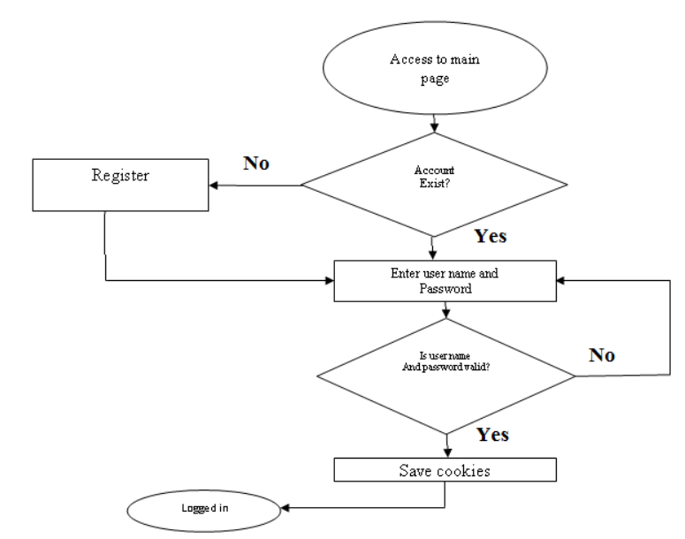

* The user authentication process in the HIRE-HORIZON project ensures secure access and management of user accounts.

1. Existing System

* Traditional job application processes often involve manual resume submissions, offline interviews, and inefficient communication between employers and applicants. These systems are time-consuming and offer limited transparency for tracking job application status or managing applicant data. Even with some digital job portals, many lack administrative control, real-time updates, and effective data handling
* **Challenges in the Existing System:**
* Manual and repetitive data handling.
* Lack of centralized platform for job seekers and recruiters.
* No real-time updates or status tracking of applications.
* Limited admin control and backend data analytics.
* Inaccessible on mobile devices due to non-responsive designs.

**2. Proposed System**

* HIRE-HORIZON is developed to overcome the shortcomings of traditional and existing digital systems. It provides a centralized and automated platform for job seekers to explore and apply for jobs and for administrators to manage postings, applications, and users.
* **Highlights of the Proposed System:**
* **Role-Based Access Control:** Admin and User dashboards with dedicated functionalities.
* **Secure Authentication:** JWT-based authentication to ensure secure login sessions.
* **Responsive Interface:** Accessible from any device—desktop, tablet, or smartphone.
* **Admin Panel:** View all users, delete users, manage application status (hired or denied), and monitor activity.
* **User-Friendly UI:** Clean, modern interface built with React and styled using CSS/Bootstrap.
* **RESTful API Integration:** Smooth interaction between frontend and backend using Express.js and Axios.

###### **CHAPTER 5**

###### **SYSTEM DESIGN**

The system design of HIRE-HORIZON is structured to ensure seamless interaction between the user interface, server logic, and database. It focuses on building a modular, scalable, and responsive architecture to meet the needs of both users and administrators.

###### **Activity diagram (User Side)**

###### 

**Home Page**

**Register**

**Login**

**Yes**

**No**

**Have an**

**Account?**

**Login**

***Data Flow Diagram:***

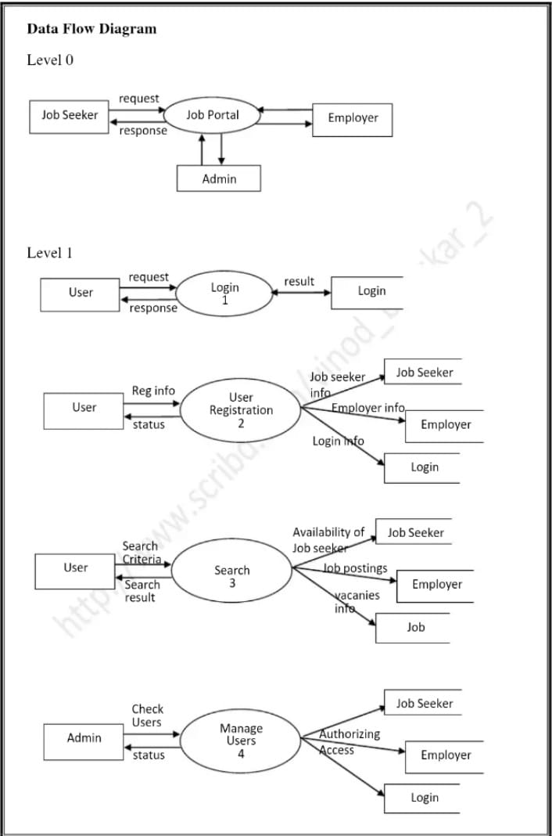

***Admin Side Login***

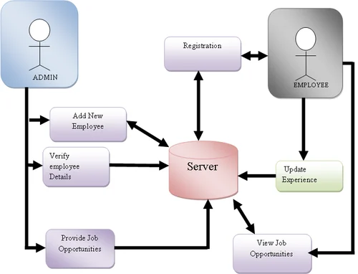

***ER Diagram***

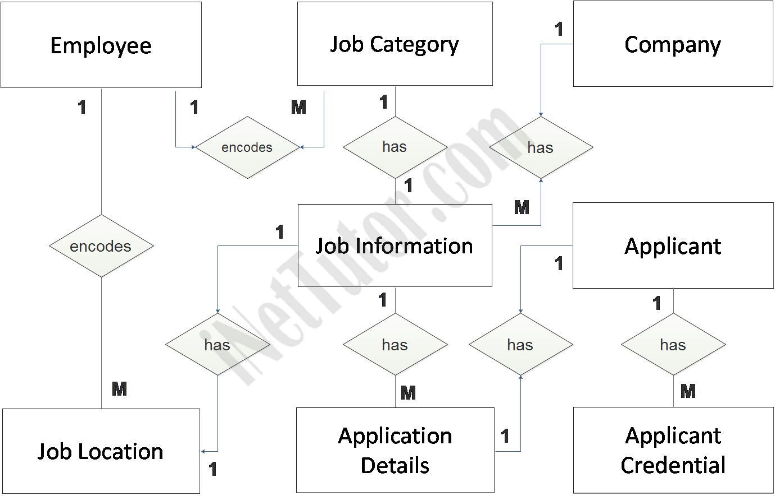

* 1. **System Architecture**

The project follows a MERN Stack Architecture, which includes:

* Frontend: Built with React.js
* Backend: Node.js with Express.js
* Database: MongoDB
* Communication: HTTP requests using Axios
* Authentication: JSON Web Tokens (JWT)
* This architecture ensures that the frontend and backend communicate efficiently using RESTful APIs, and data is securely stored and retrieved from the database.

**2. Modules and Components**

**a. User Module**

* User Registration and Login
* Job Listings View
* Job Application Form
* Application History View

**b. Admin Module**

* Login Authentication
* View All Users
* Delete Users
* Update User Status (Hired / Denied)
* View All Job Applications
* Delete Applications

**c. Authentication Module**

* Token-based login system
* Authorization middleware for protected routes
* Role-based redirection (admin/user)

**d. Job Application Module**

* Users can apply to job listings
* Applications are stored with timestamps
* Admins can view and manage these applications

**2. Modules and Components**

**a. User Module**

* User Registration and Login
* Job Listings View
* Job Application Form
* Application History View

**b. Admin Module**

* Login Authentication
* View All Users
* Delete Users
* Update User Status (Hired / Denied)
* View All Job Applications
* Delete Applications

**c. Authentication Module**

* Token-based login system
* Authorization middleware for protected routes
* Role-based redirection (admin/user)

**d. Job Application Module**

* Users can apply to job listings
* Applications are stored with timestamps
* Admins can view and manage these applications

**3. Database Design**

The application uses **MongoDB**, a NoSQL database. Key collections include:

* **Users**: Stores user data (name, email, password, role, status)
* **Jobs**: Stores job listing details
* **Applications**: Links users to jobs they’ve applied for, including application status and date

Each collection is structured to allow efficient querying and updates.

###### **CHAPTER 6**

###### **SYSTEM IMPLEMENTATION**

**1. Frontend Implementation (React.js)**

React Components: The UI was broken into reusable components such as Navbar, Job Card, Application Form, and AdminDashboard.

Routing: Implemented using React Router to handle navigation across different pages like Home, Login, Dashboard, and Admin Panel.

State Management: useContext and useState hooks were used to manage user data, application states, and global authentication context.

Responsive Design: Applied using CSS and Bootstrap to ensure the app is mobile and desktop friendly.

**2. Backend Implementation (Node.js + Express.js)**

* **API Structure**: RESTful API endpoints were developed for user authentication, job applications, user management, and admin actions.
* **Security**: Passwords are encrypted using **bcryptjs** and route access is secured with **JWT authentication**.
* **Middleware**:
  + Auth Middleware: Protects routes from unauthorized access.
  + Role Middleware: Differentiates access levels for Admin and User.
* ***User Interface (UI) and Experience (UX)***

***Home Page View:***

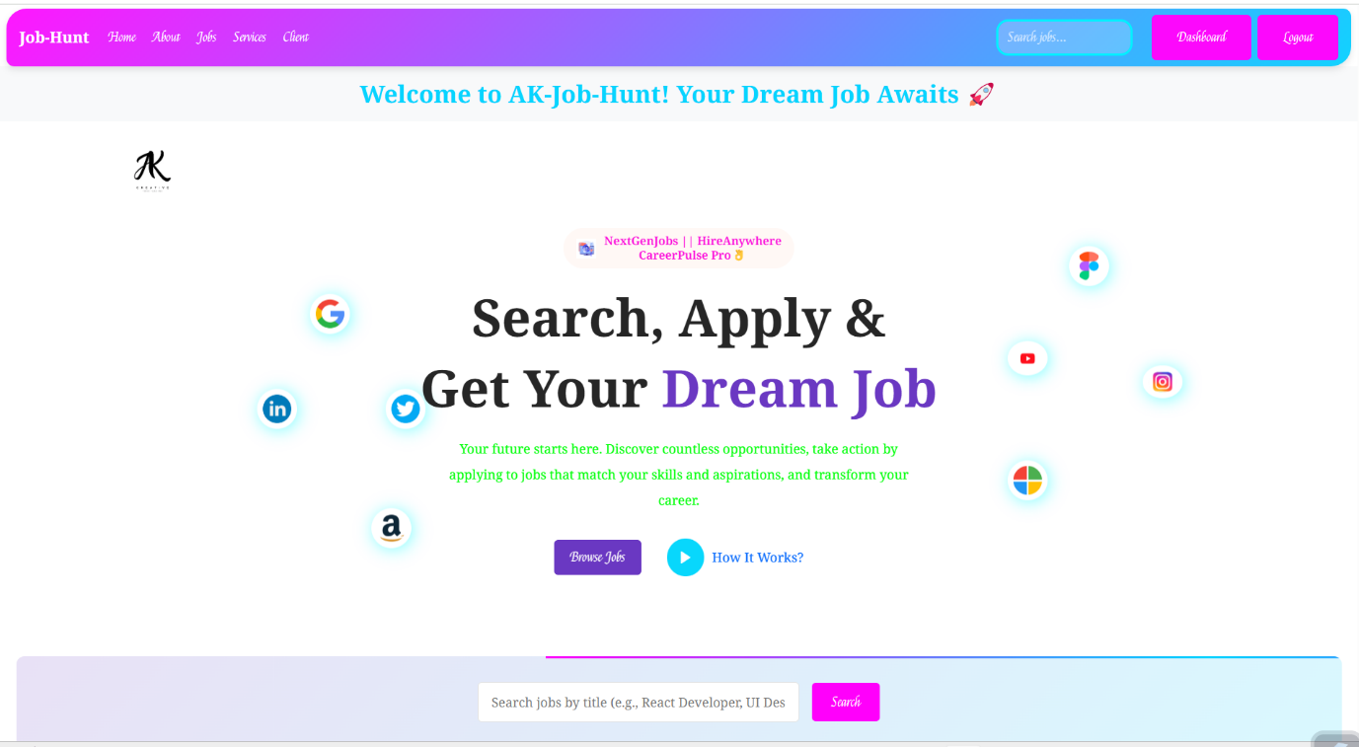

***INTERSHIP SECTION:***

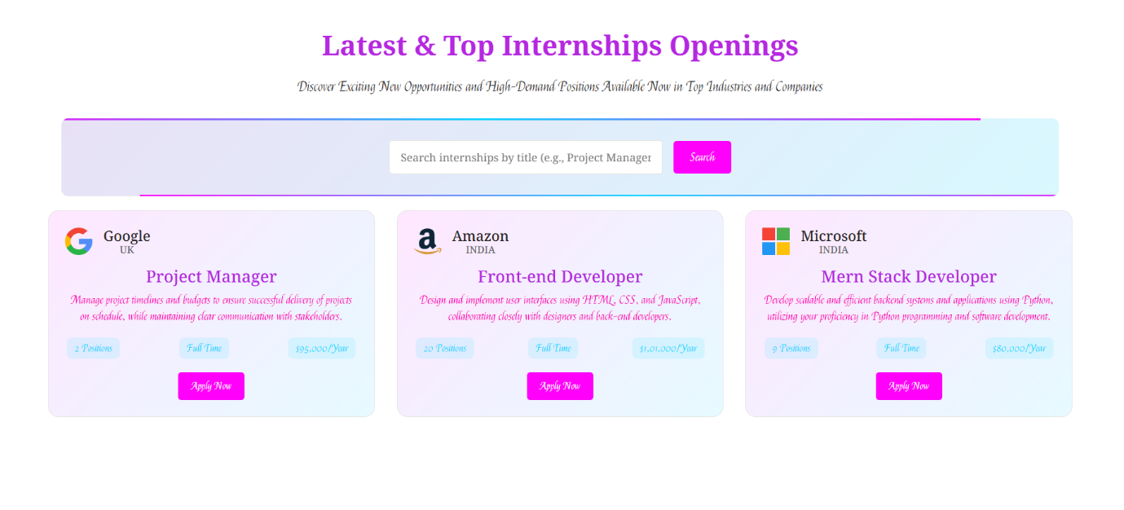

***LATEST JOB SECTION:***

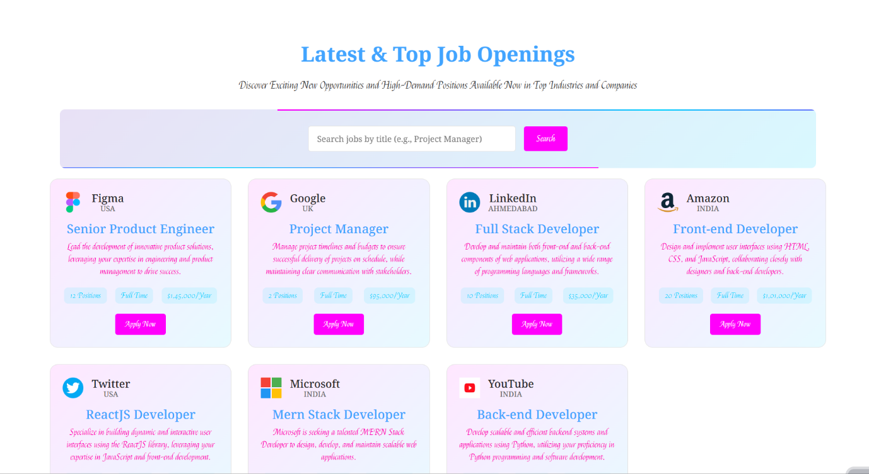

***JOB APPLICATION:***

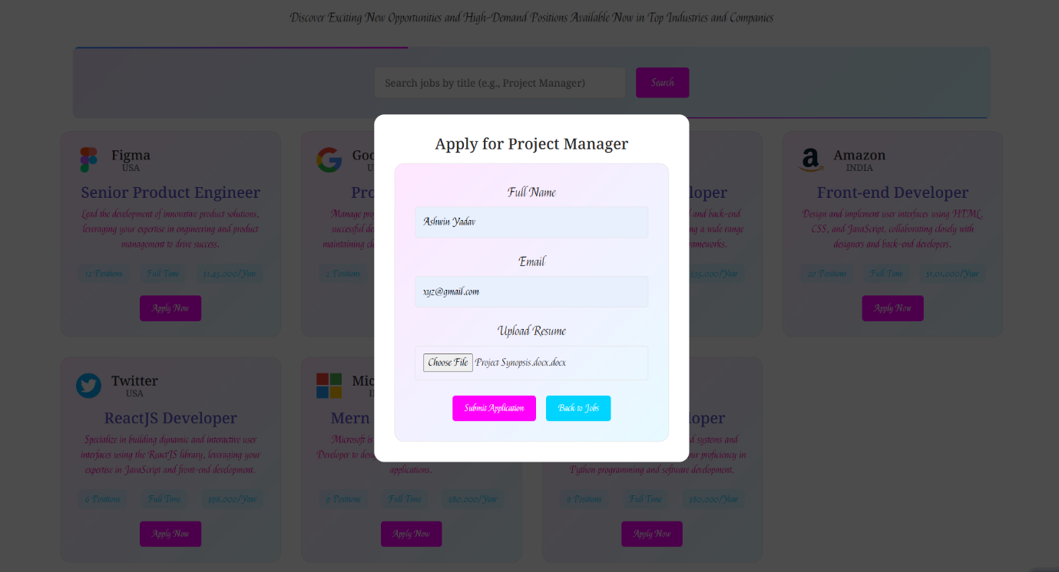

***User Side Dashboard:***

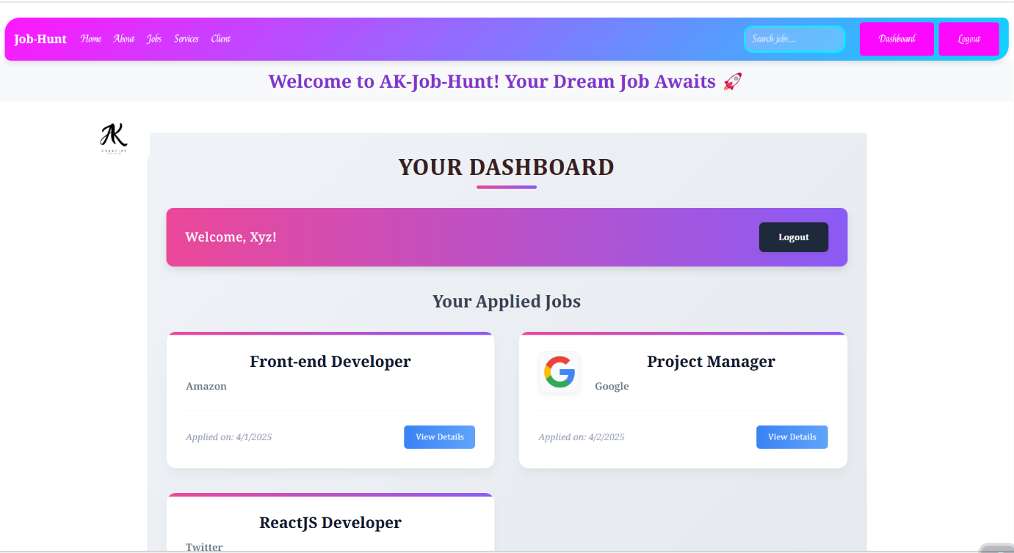

***Admin Dashboard:***

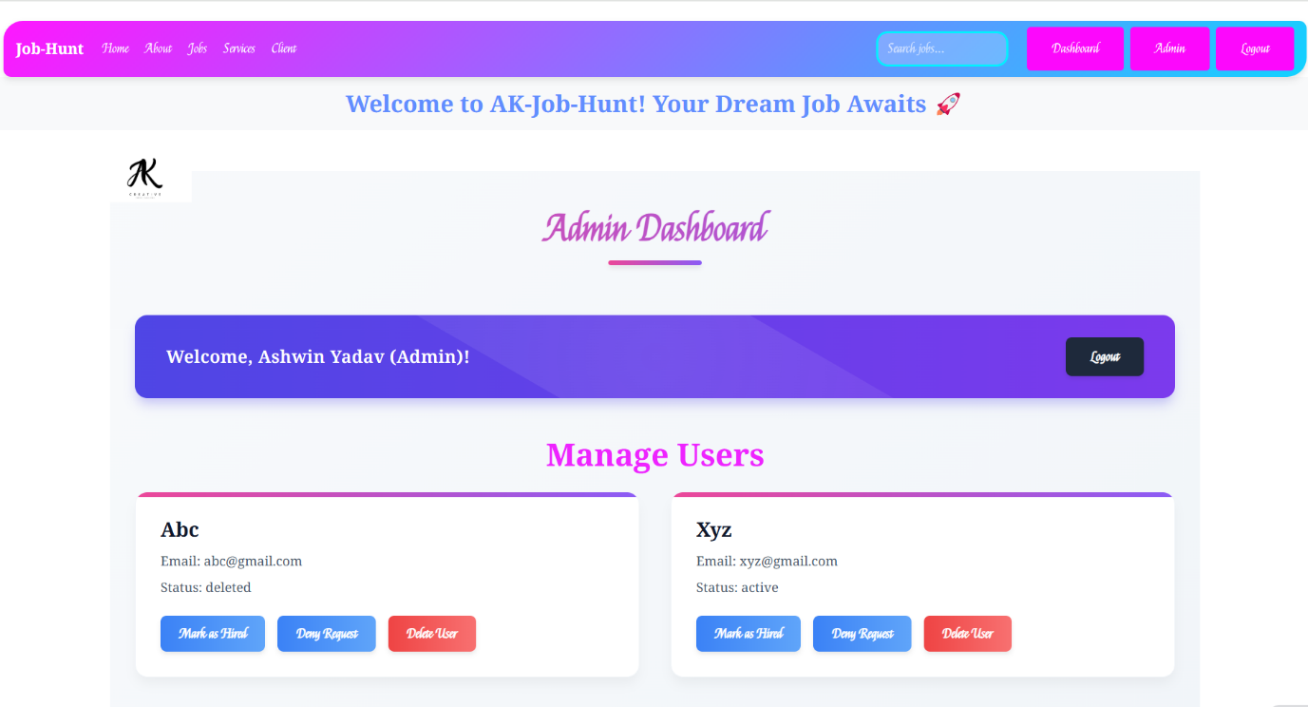

###### **CHAPTER 7**

* ***SYSTEM TESTING***

***Test Cases and Results***

| * ***Test Case*** | ***Expected Result*** | ***Actual Result*** | ***Status*** |
| --- | --- | --- | --- |
| * ***User Registration*** | ***New user account should be created*** | ***Successfully created*** | ***Pass*** |
| * ***User Login*** | ***Authenticated and redirected to dashboard*** | ***Login successful*** | ***Pass*** |
| * ***Job Application Submission*** | ***Application should be stored and listed in admin panel*** | ***Application submitted*** | ***Pass*** |
| * ***Admin View All Users*** | ***Admin should see all users except themselves*** | ***Admin view working*** | ***Pass*** |
| * ***Admin Update User Status*** | ***Status should update to 'hired' or 'denied'*** | ***Updated successfully*** | ***Pass*** |
| * ***Admin Delete User*** | ***User should be removed from the database*** | ***User deleted*** | ***Pass*** |
| * ***Unauthorized Admin Panel Access*** | ***User should be redirected or blocked*** | ***Access denied to non-admins*** | ***Pass*** |

* ***Bug Fixes***
* *Admin panel was showing admin account — Fixed by filtering out current user.*
* *User status not updating properly — Backend route was corrected to handle status update requests.*
* *Application logo fallback — Handled broken image URLs with a default placeholder.*
* ***Tools Used for Testing***
* *Postman – For API testing and validation.*
* *Browser Developer Tools – To inspect UI elements and responsiveness.*
* *Console Logs & Network Tab – To debug data flows and API errors*

###### **CHAPTER 8**

###### **Future Scope of the Project**

* *While HIRE-HORIZON in its current state offers a complete and functional job portal system, there is ample scope for enhancement and scaling. The following are some of the key areas identified for future development:*
* ***1. Resume Builder Integration***
* *Incorporate an intelligent resume builder tool that helps users create professional resumes directly on the platform.*
* ***2. Advanced Search & Filters***
* *Implement advanced job search filters based on experience, salary range, job type (remote, full-time, part-time), and location for improved user experience.*
* ***3. Real-time Notifications***
* *Enable real-time notifications and alerts using WebSockets or Firebase for job status updates, interview calls, and admin responses.*
* ***4. Chat System***
* *Add a built-in chat feature for direct communication between applicants and recruiters to streamline interaction.*
* ***5. AI-based Job Recommendations***
* *Integrate AI algorithms to suggest job listings to users based on their skills, interests, and application history.*

###### **CHAPTER 9**

* **Conclusion**
* *The HIRE-HORIZON project successfully demonstrates the development and implementation of a full-stack job application platform using the MERN stack (MongoDB, Express.js, React.js, Node.js). The application was designed with the objective of bridging the gap between job seekers and employers through a responsive, secure, and intuitive platform.*
* *Throughout the project, essential features such as user authentication, job listing, application tracking, and an admin management panel were integrated to ensure both functional robustness and user convenience. The admin panel plays a pivotal role in enabling real-time user management, application review, and status updates — ensuring an efficient recruitment workflow.*
* *This solo project allowed the developer to apply a wide range of skills, including frontend design, backend logic, REST API integration, state management, and secure authentication with JWT. The use of modern libraries like Axios, Bootstrap, and React Hooks further enriched the development process.*
* *Overall, HIRE-HORIZON reflects a scalable and user-friendly solution aligned with current industry needs, showcasing how technology can be effectively leveraged to simplify and accelerate the hiring process. The project also exemplifies a strong grasp of full-stack development concepts and real-world application building, making it a valuable addition to the developer’s portfolio*.