1. A write a query to display ename and sal of employees whose salary is greater than or equal to 2200

Query->

SELECT ename,sal from employee_schema.employee_details where sal>=2200;

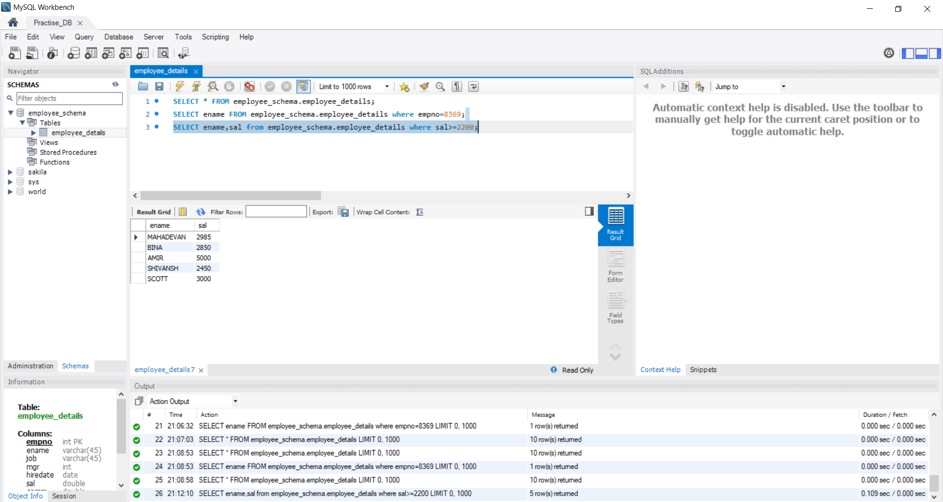

1. B Write a query to diplay details of employees who are not getting commission

Query->

SELECT *

FROM employee_schema.employee_details

WHERE comm IS NULL OR comm = 0;

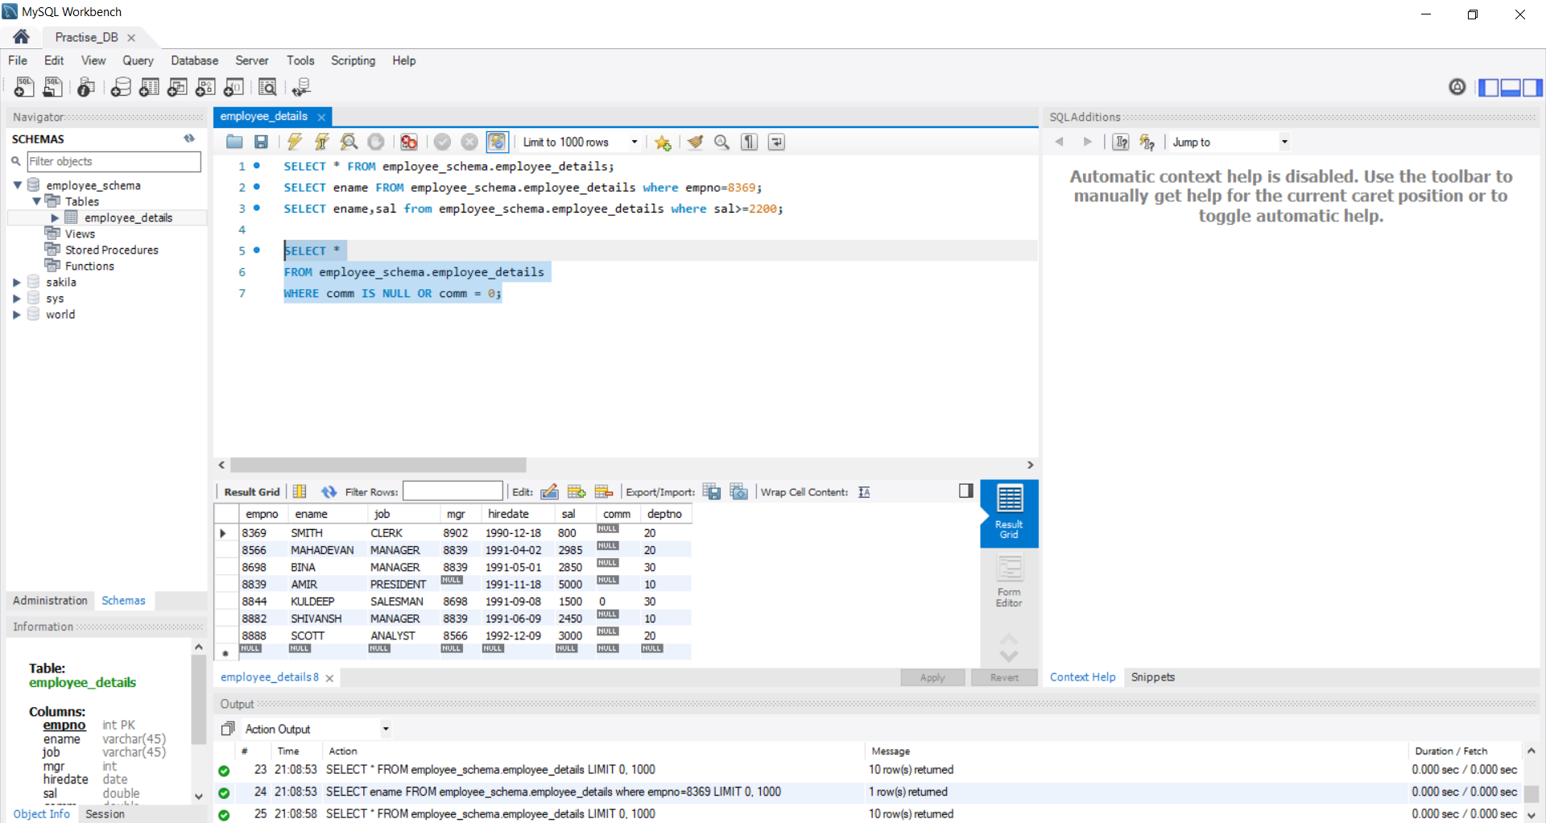

1. C. write a query to display ename and sal of those employees who don't have salary in range of 2500 to 4000

Query->

SELECT ename, sal

FROM employee_schema.employee_details

WHERE sal NOT BETWEEN 2500 AND 4000;

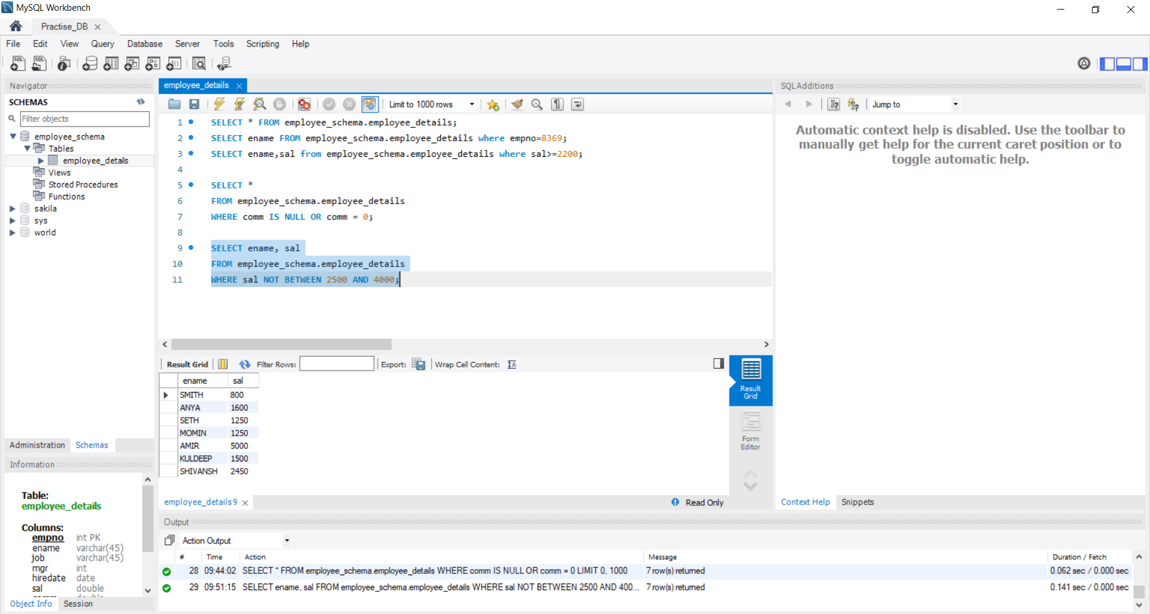

1. D. write a query to display ename, job and sal of those employees who don't have manager

Query->

SELECT ename,job,sal

FROM employee_schema.employee_details

WHERE mgr IS NULL;

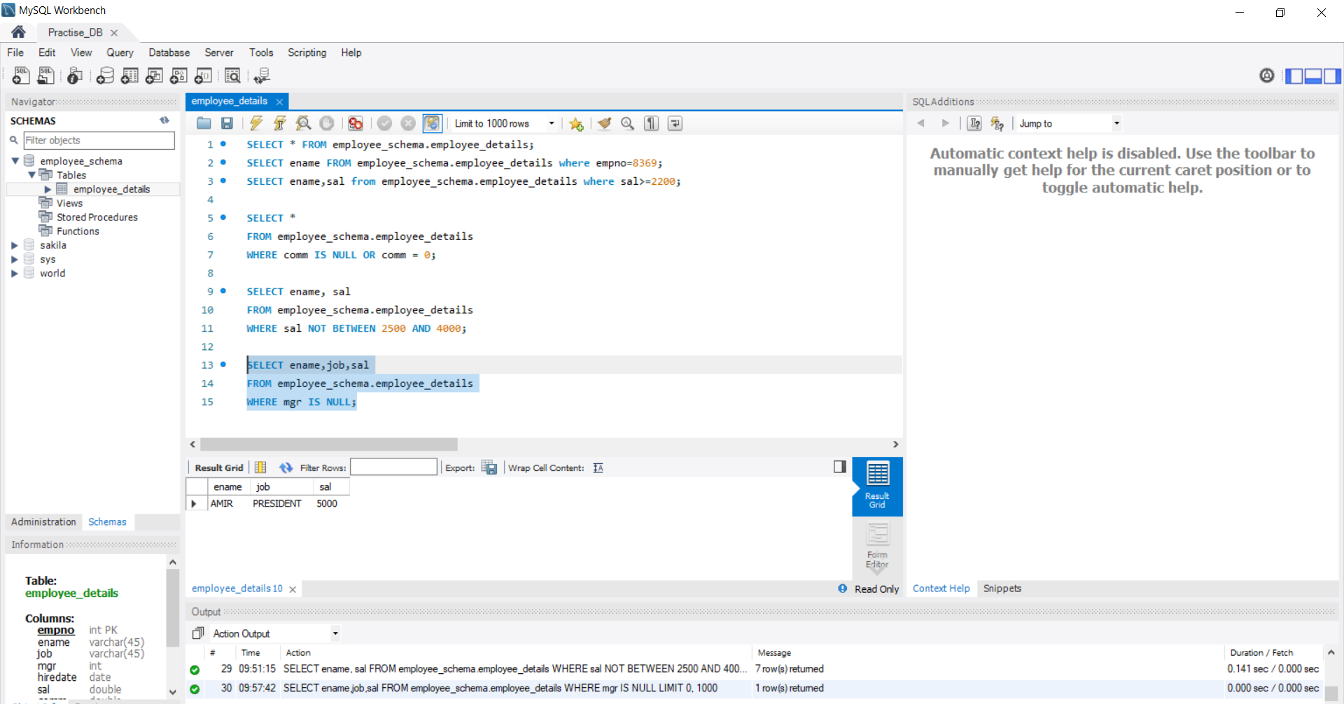

1) E. write a query to display ename of employee whose name contains "A" as the third alpabet

Query->

SELECT ename

FROM employee_schema.employee_details

WHERE SUBSTRING(ename, 3, 1) = 'A';

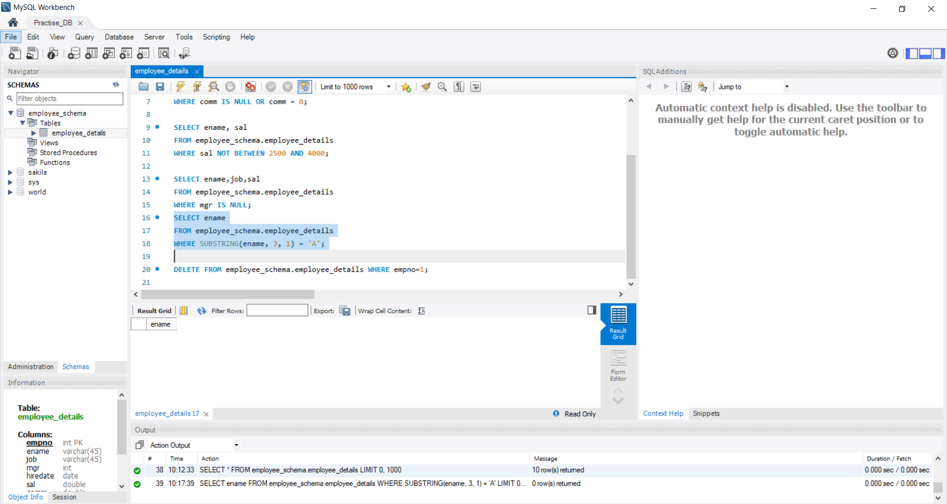

1) F. write a query to display ename of employee whose name contains "I" as the last alpabet

Query->

SELECT ename

FROM employee_schema.employee_details

WHERE RIGHT(ename, 1) = 'I';

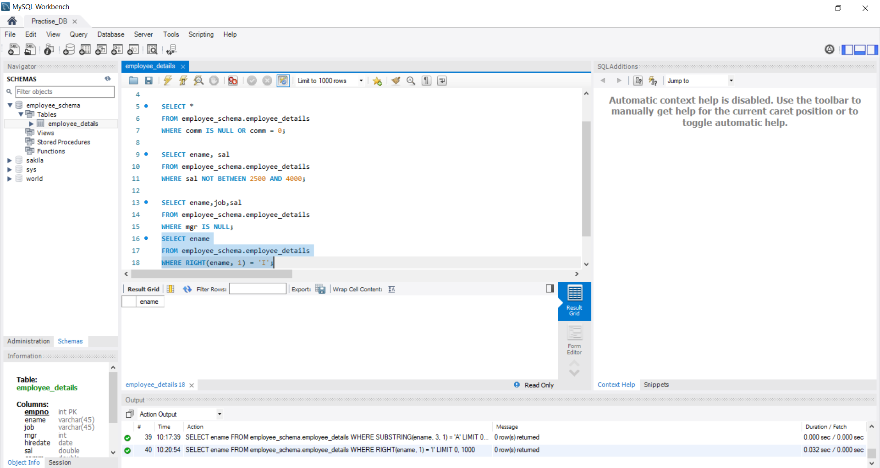

Employee_Details(Table)

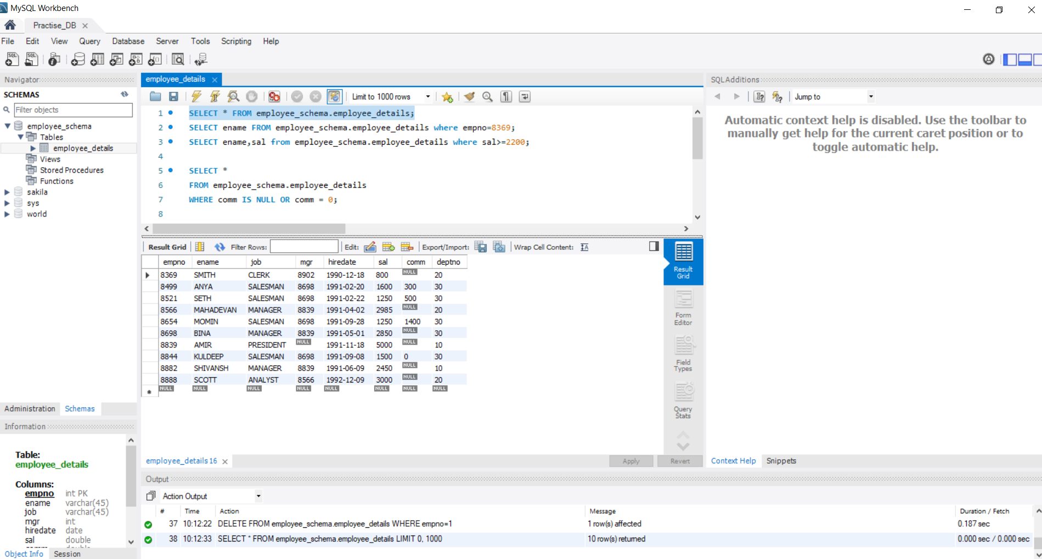

2)Write a program for JDBC connectivity and insert the below data

