Task_01

Solution_01

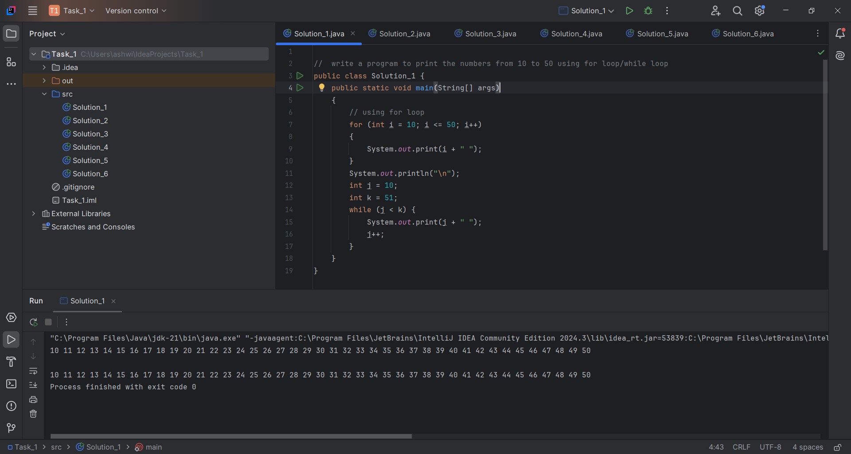

Output:

10 11 12 13 14 15 16 17 18 19 20 21 22 23 24 25 26 27 28 29 30 31 32 33 34 35 36 37 38 39 40 41 42 43 44 45 46 47 48 49 50

10 11 12 13 14 15 16 17 18 19 20 21 22 23 24 25 26 27 28 29 30 31 32 33 34 35 36 37 38 39 40 41 42 43 44 45 46 47 48 49 50

Process finished with exit code 0

Solution_02

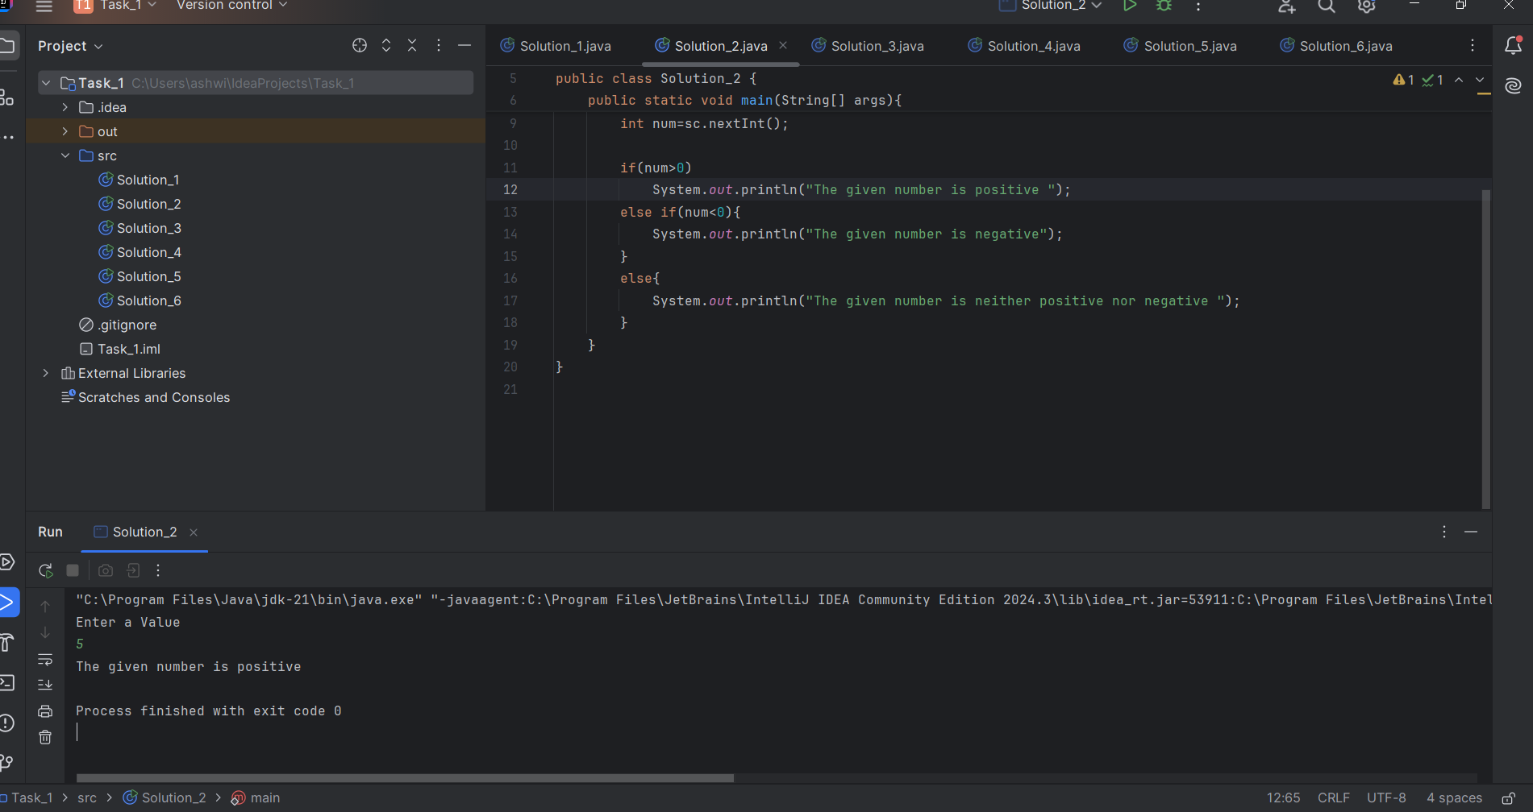

Output:

Enter a Value

5

The given number is positive

Process finished with exit code 0

Solution_03

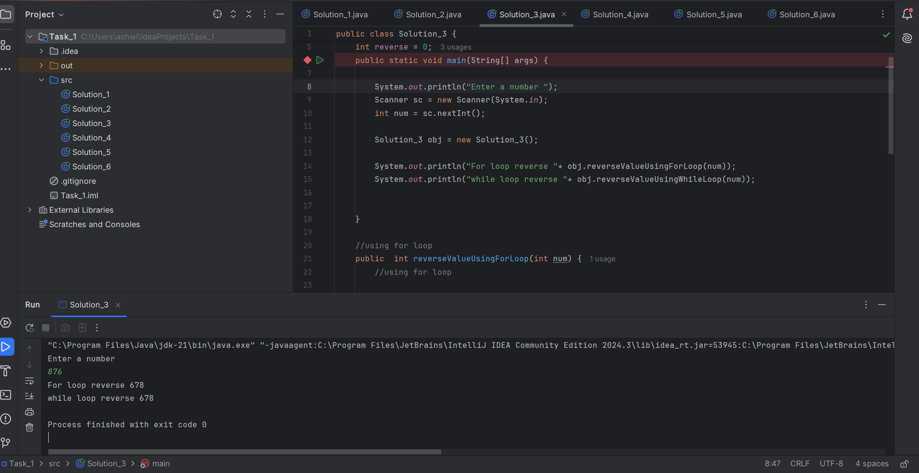

Output:

Enter a number

876

For loop reverse 678

while loop reverse 678

Process finished with exit code 0

Solution_04

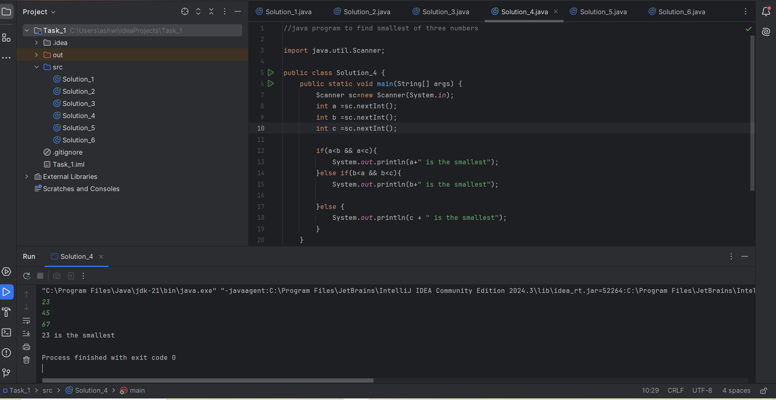

Output:

23

45

67

23 is the smallest

Process finished with exit code 0

Solution_05

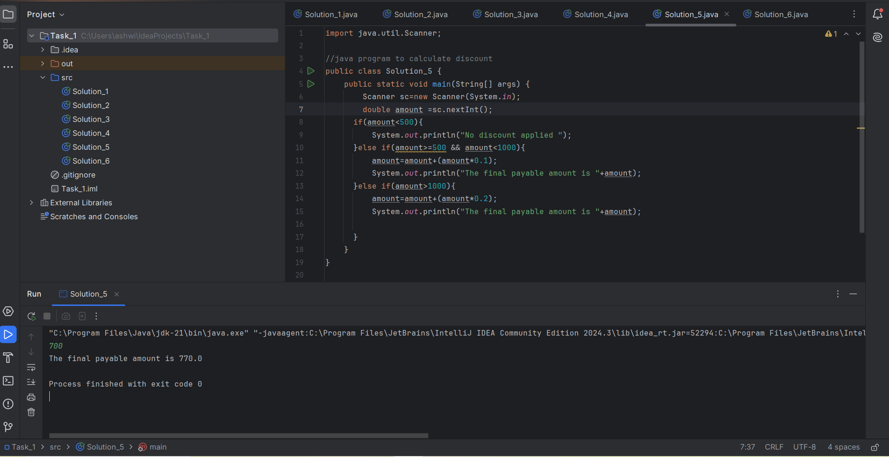

Output:

700

The final payable amount is 770.0

Process finished with exit code 0

Solution_06

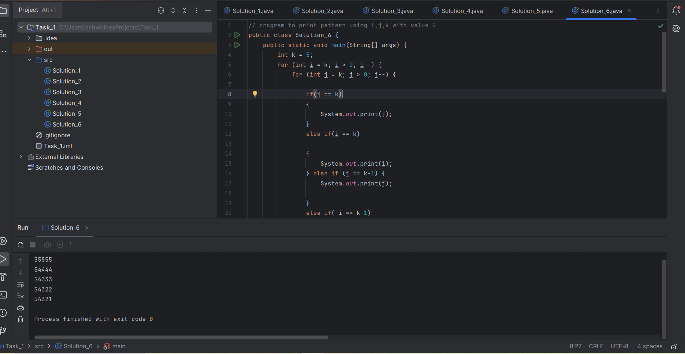

Output:

55555

54444

54333

54322

54321

Process finished with exit code 0