1.1)create a class person

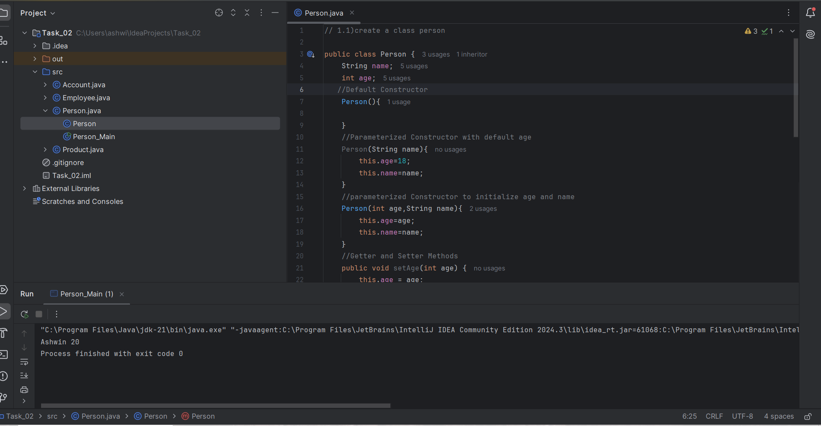

Output:

Ashwin 20

Process finished with exit code 0

1.3)Create a class Account

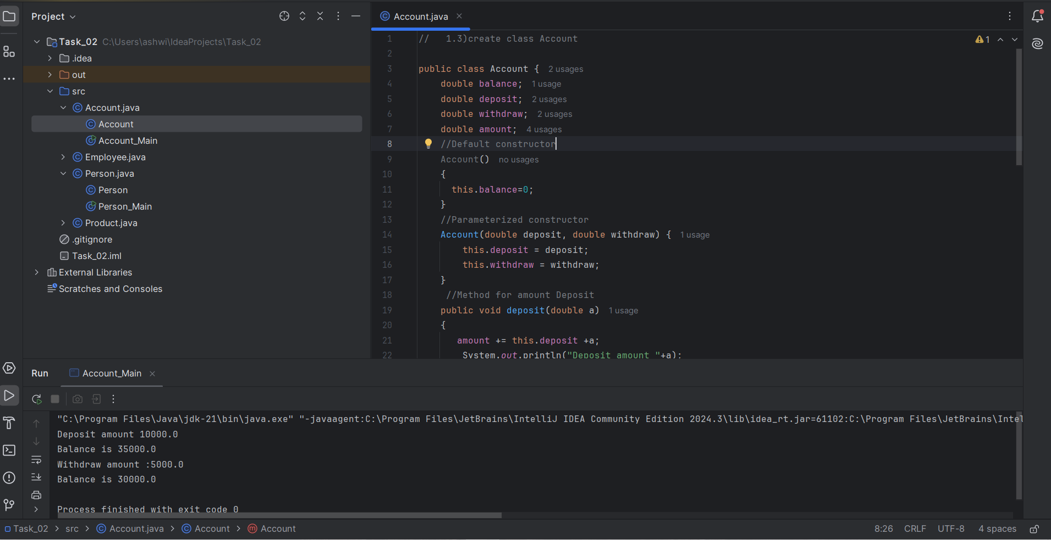

Output:

Deposit amount 10000.0

Balance is 35000.0

Withdraw amount :5000.0

Balance is 30000.0

Process finished with exit code 0

1.4)define base class Person and sub class Employee

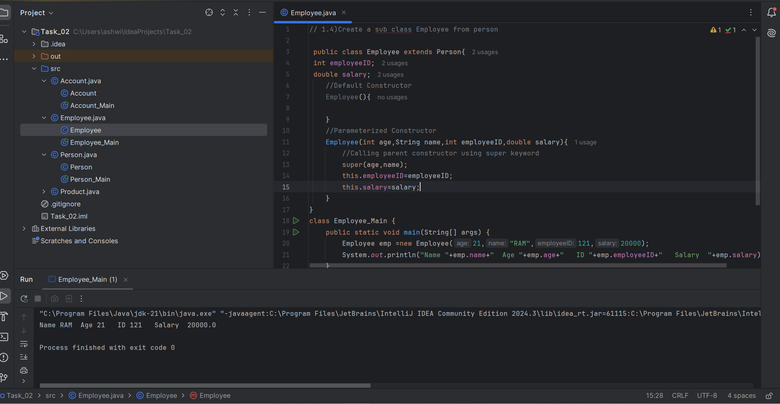

Output:

Name RAM Age 21 ID 121 Salary 20000.0

Process finished with exit code 0