1.2)Create a class Product(pid,price,Quantity)

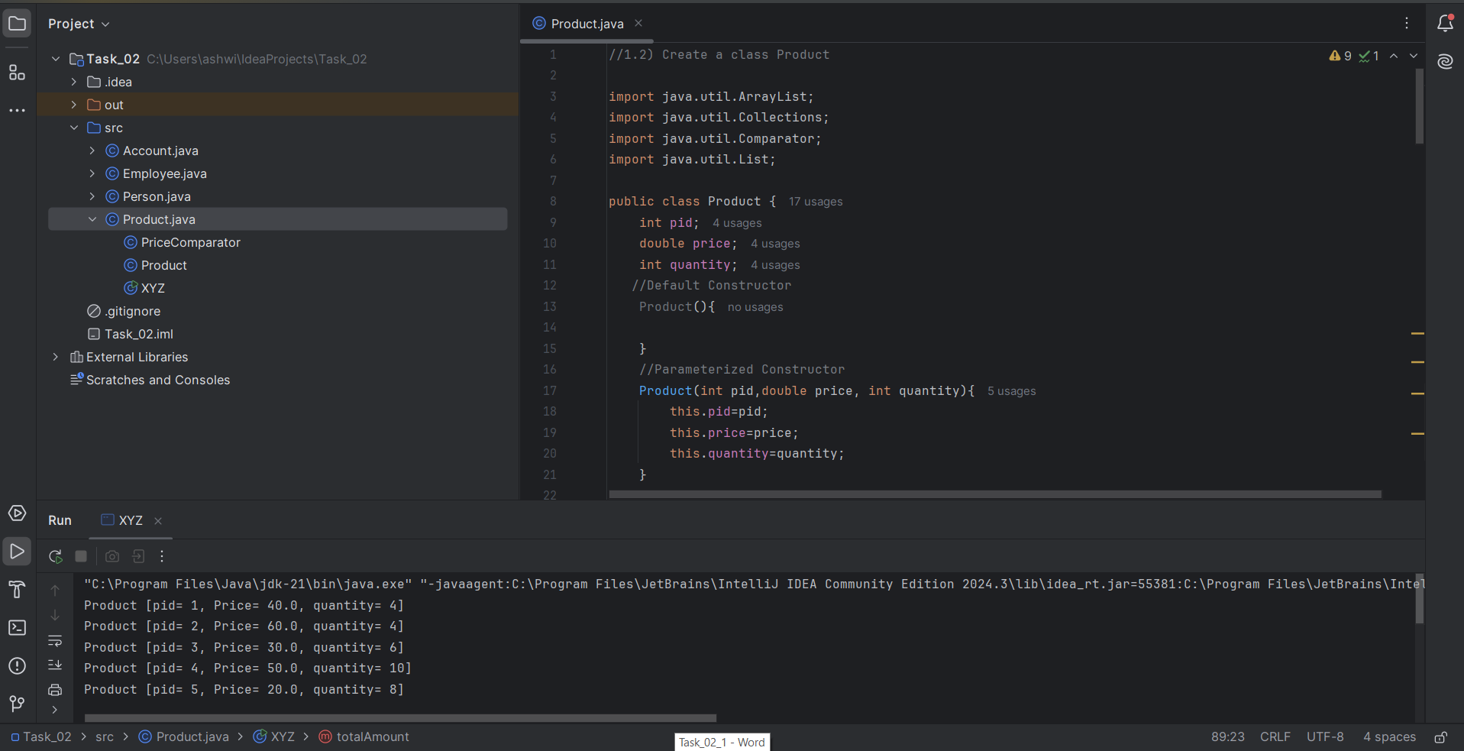

Output:

Product [pid= 1, Price= 40.0, quantity= 4]

Product [pid= 2, Price= 60.0, quantity= 4]

Product [pid= 3, Price= 30.0, quantity= 6]

Product [pid= 4, Price= 50.0, quantity= 10]

Product [pid= 5, Price= 20.0, quantity= 8]

Products sorted by price:

Product [pid= 5, Price= 20.0, quantity= 8]

Product [pid= 3, Price= 30.0, quantity= 6]

Product [pid= 1, Price= 40.0, quantity= 4]

Product [pid= 4, Price= 50.0, quantity= 10]

Product [pid= 2, Price= 60.0, quantity= 4]

The Product id with the highest price is 2

The total amount of all product is 1240.0

Process finished with exit code 0