Library Management System

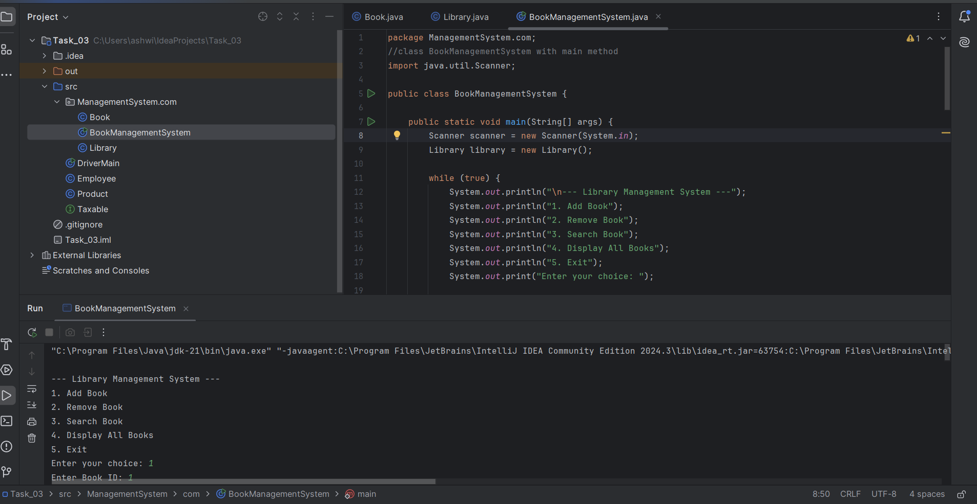

Output:

--- Library Management System ---

1. Add Book

2. Remove Book

3. Search Book

4. Display All Books

5. Exit

Enter your choice: 1

Enter Book ID: 1

Enter Book Title: The Pragmatic Programmer

Enter Book Author: Andrew Hunt

Book added successfully.

--- Library Management System ---

1. Add Book

2. Remove Book

3. Search Book

4. Display All Books

5. Exit

Enter your choice: 1

Enter Book ID: 2

Enter Book Title: Artificial Intelligence

Enter Book Author: Stuart Russell

Book added successfully.

--- Library Management System ---

1. Add Book

2. Remove Book

3. Search Book

4. Display All Books

5. Exit

Enter your choice: 1

Enter Book ID: 3

Enter Book Title: Clean Code

Enter Book Author: Robert C

Book added successfully.

--- Library Management System ---

1. Add Book

2. Remove Book

3. Search Book

4. Display All Books

5. Exit

Enter your choice: 2

Enter Book ID to remove: 1

Book with ID 1 has been removed.

--- Library Management System ---

1. Add Book

2. Remove Book

3. Search Book

4. Display All Books

5. Exit

Enter your choice: 3

Enter Book ID to search: 2

Book found:

BookID: 2, Title: Stuart Russell, Author: Artificial Intelligence, Available: Yes

--- Library Management System ---

1. Add Book

2. Remove Book

3. Search Book

4. Display All Books

5. Exit

Enter your choice: 4

BookID: 2, Title: Stuart Russell, Author: Artificial Intelligence, Available: Yes

BookID: 3, Title: Robert C, Author: Clean Code, Available: Yes

--- Library Management System ---

1. Add Book

2. Remove Book

3. Search Book

4. Display All Books

5. Exit

Enter your choice: 5

Exiting the system.

Process finished with exit code 0

Tax Calculation

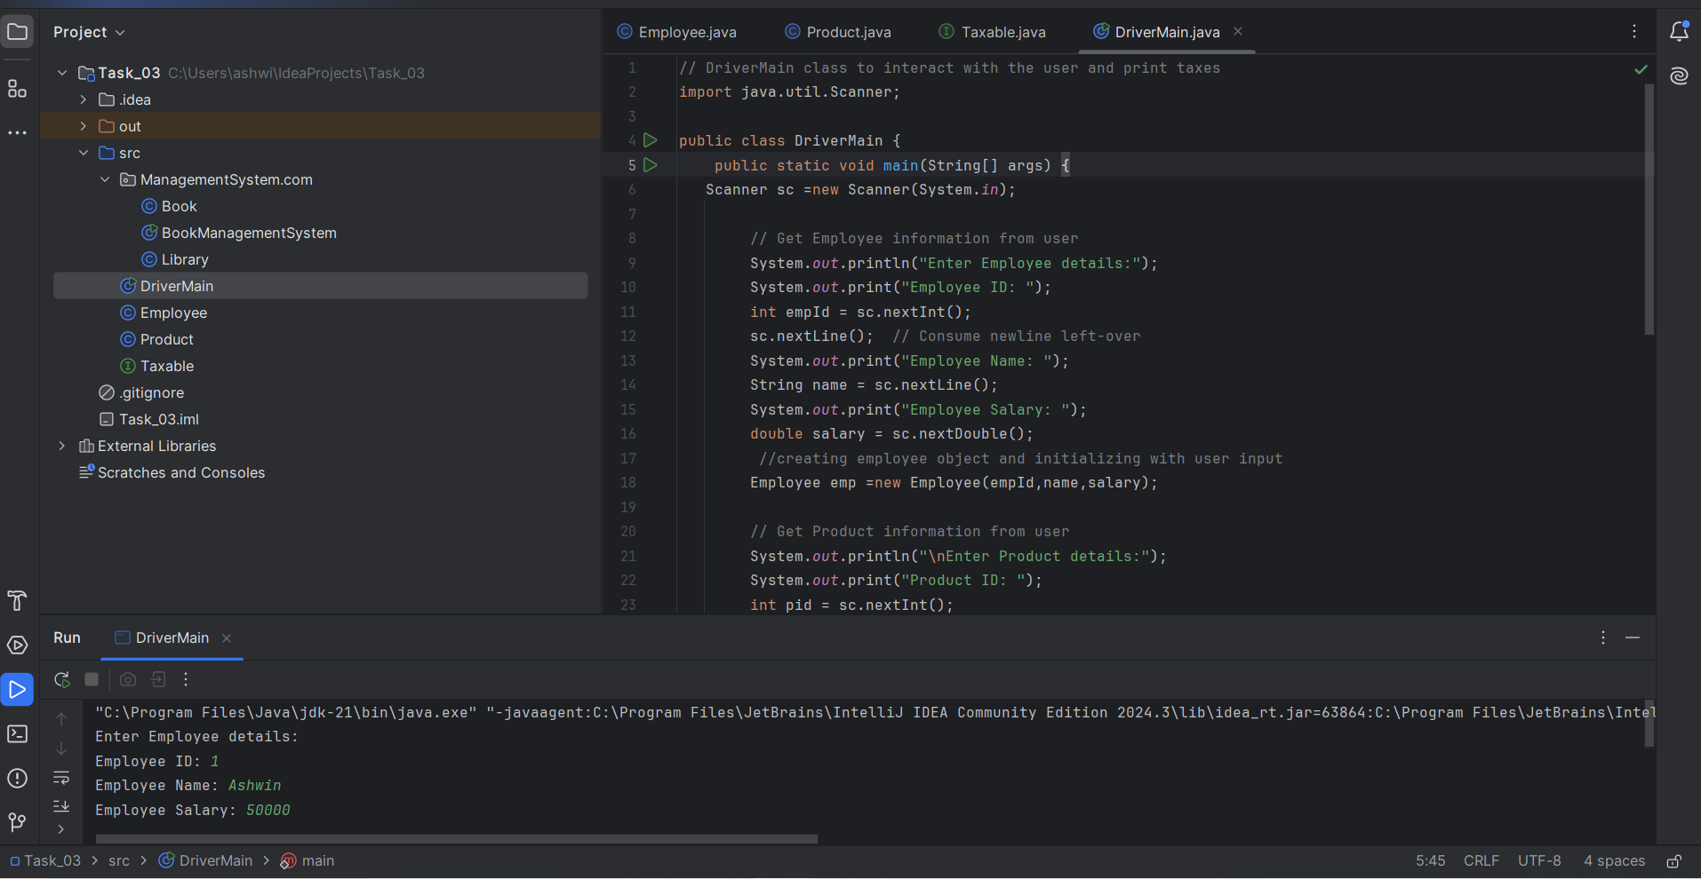

Output:

Enter Employee details:

Employee ID: 1

Employee Name: Ashwin

Employee Salary: 50000

Enter Product details:

Product ID: 1

Product Price: 200

Product Quantity: 20

Tax Calculation Results:

Income Tax for Employee (Ashwin): $5250.0

Sales Tax for Product ID 1: $280.00000000000006

Process finished with exit code 0