Solution_1 Student Management System

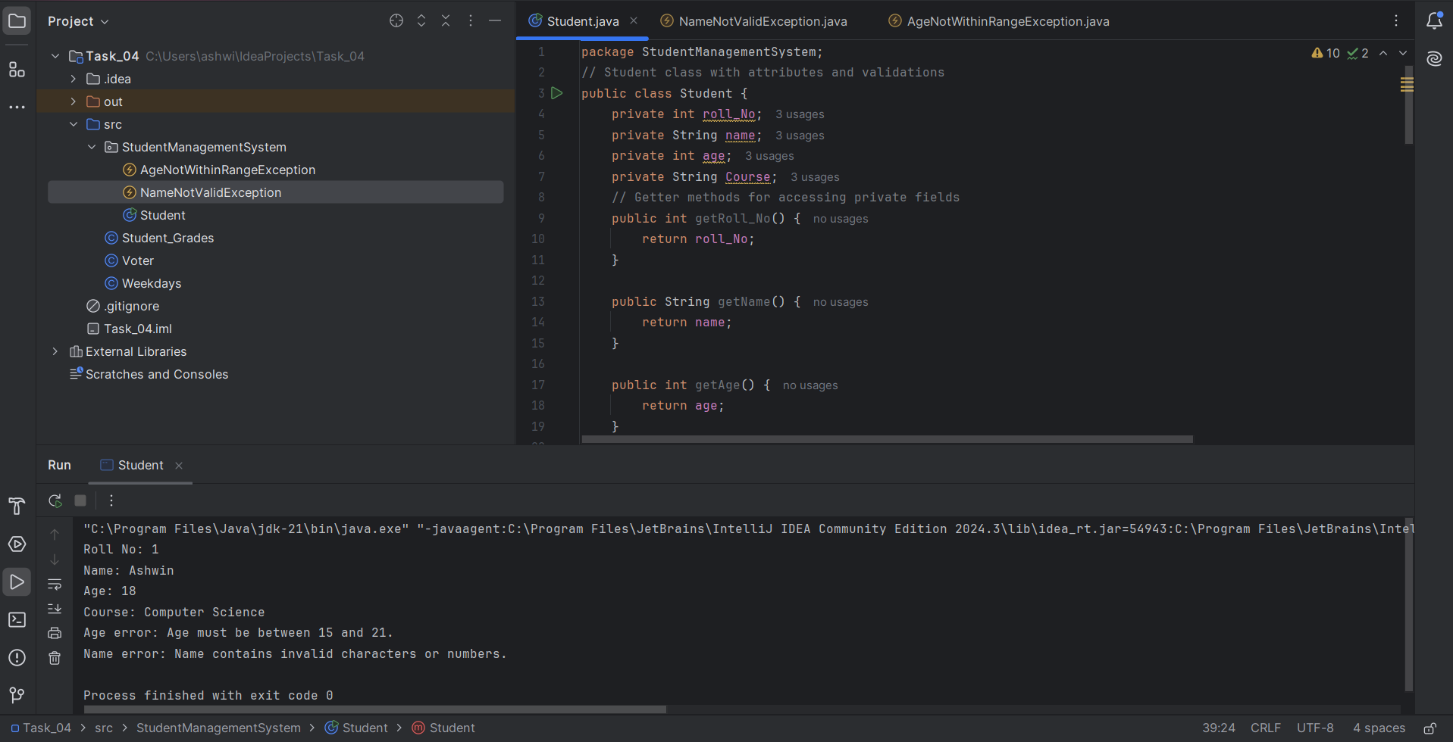

Output:

Roll No: 1

Name: Ashwin

Age: 18

Course: Computer Science

Age error: Age must be between 15 and 21.

Name error: Name contains invalid characters or numbers.

Process finished with exit code 0

Solution_2 Voter class

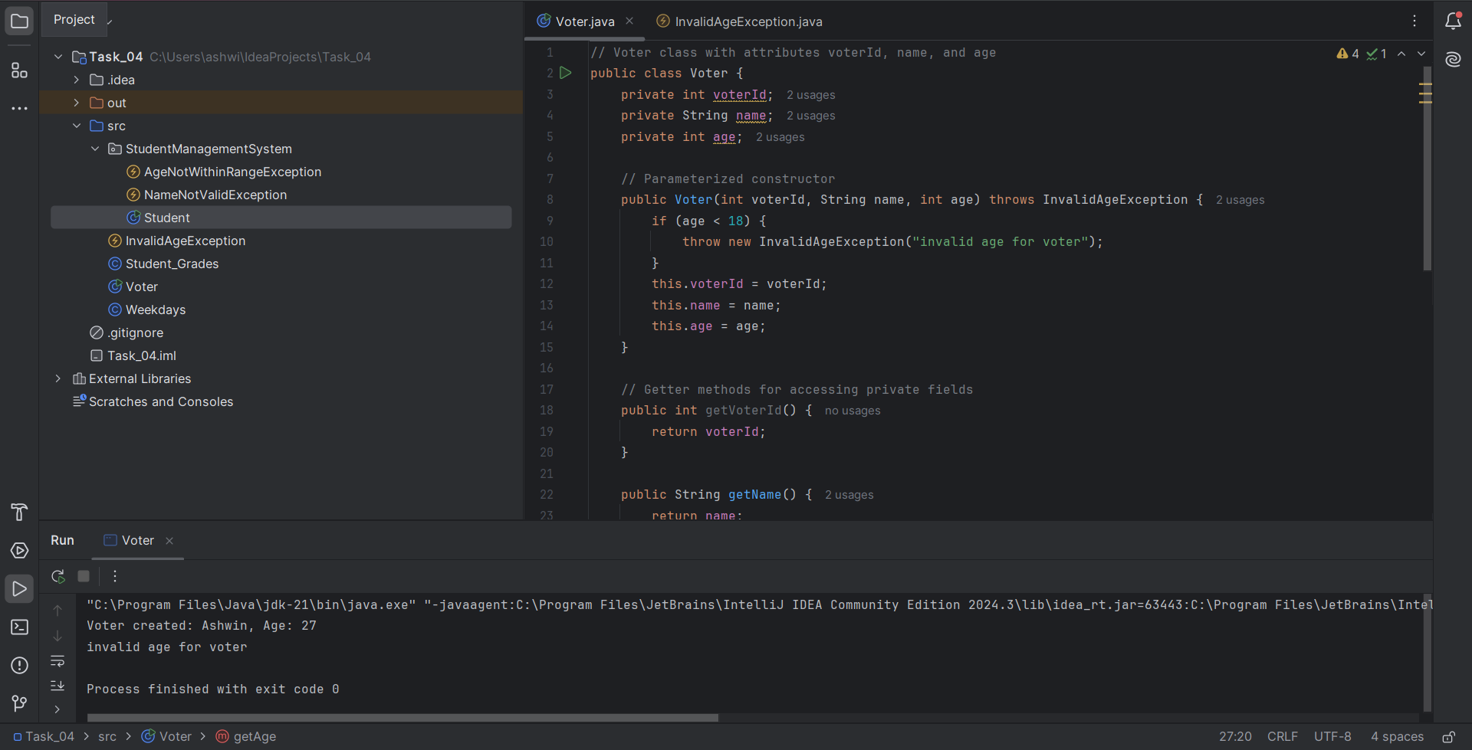

Output:

Voter created: Ashwin, Age: 27

invalid age for voter

Process finished with exit code 0

Solution_3 weekdays Class

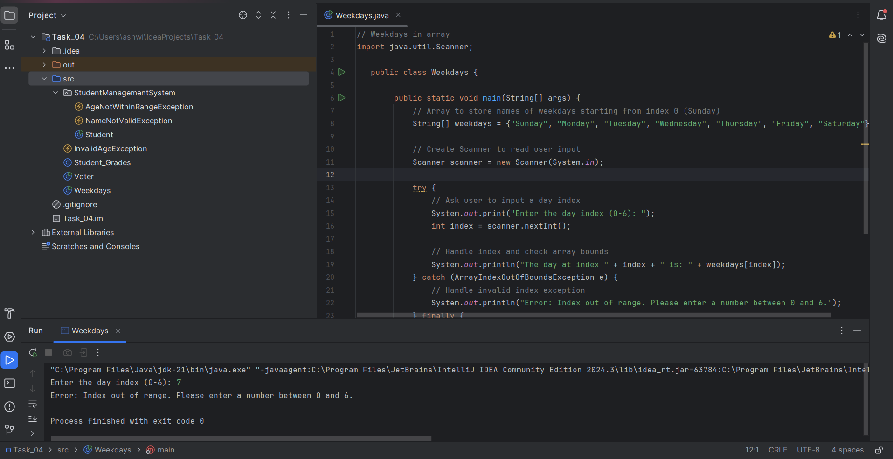

Output:1

Enter the day index (0-6): 7

Error: Index out of range. Please enter a number between 0 and 6.

Process finished with exit code 0

Output:2

Enter the day index (0-6): 6

The day at index 6 is: Saturday

Process finished with exit code 0

Solution_4 Student_Grades using hashmap

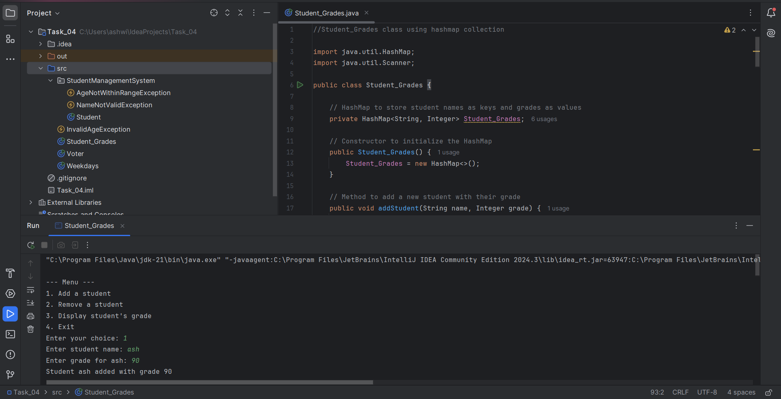

Output:

--- Menu ---

1. Add a student

2. Remove a student

3. Display student's grade

4. Exit

Enter your choice: 1

Enter student name: ash

Enter grade for ash: 90

Student ash added with grade 90

--- Menu ---

1. Add a student

2. Remove a student

3. Display student's grade

4. Exit

Enter your choice: 1

Enter student name: win

Enter grade for win: 80

Student win added with grade 80

--- Menu ---

1. Add a student

2. Remove a student

3. Display student's grade

4. Exit

Enter your choice: 3

Enter student name to display grade: ash

Grade of ash: 90

--- Menu ---

1. Add a student

2. Remove a student

3. Display student's grade

4. Exit

Enter your choice: 3

Enter student name to display grade: win

Grade of win: 80

--- Menu ---

1. Add a student

2. Remove a student

3. Display student's grade

4. Exit

Enter your choice: 2

Enter student name to remove: ash

Student ash has been removed.

--- Menu ---

1. Add a student

2. Remove a student

3. Display student's grade

4. Exit

Enter your choice: 3

Enter student name to display grade: ash

Student ash not found.

--- Menu ---

1. Add a student

2. Remove a student

3. Display student's grade

4. Exit

Enter your choice: 4

Exiting...

Process finished with exit code 0

Solution_5 IntegerStackCollection

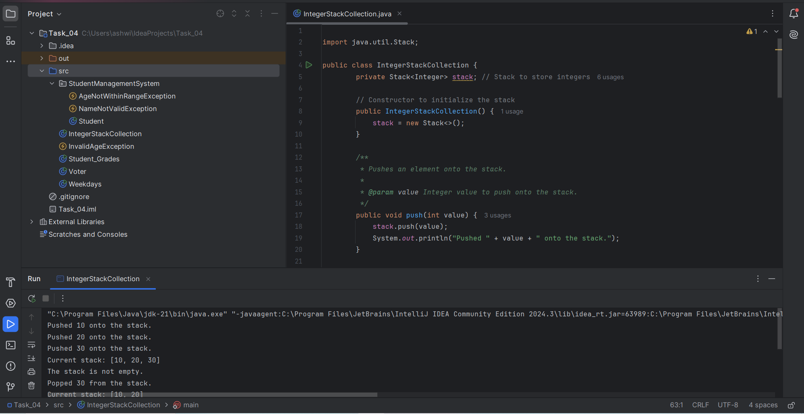

Output:

Pushed 10 onto the stack.

Pushed 20 onto the stack.

Pushed 30 onto the stack.

Current stack: [10, 20, 30]

The stack is not empty.

Popped 30 from the stack.

Current stack: [10, 20]

Popped 20 from the stack.

Popped 10 from the stack.

The stack is empty.

Current stack: []

Stack is empty. Nothing to pop.

Process finished with exit code 0