1.1) program to map string into uppercase

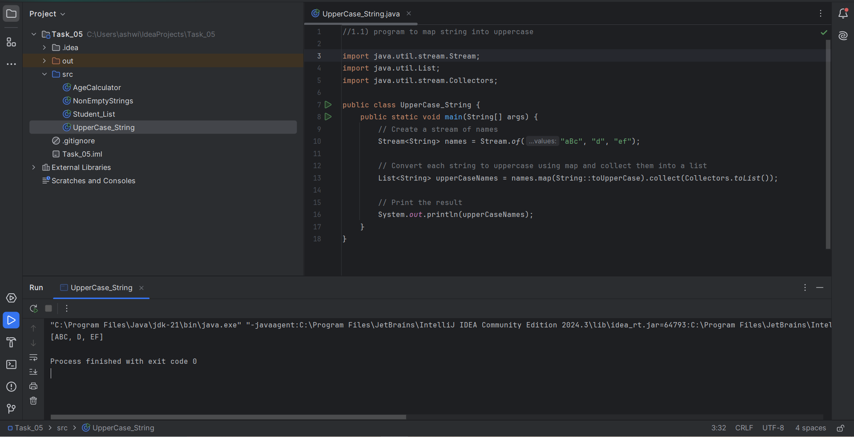

Output:

[ABC, D, EF]

Process finished with exit code 0

1.2) program to check the string is empty or not in the list

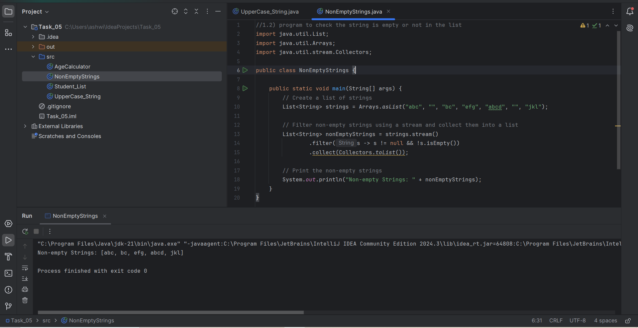

Output:

Non-empty Strings: [abc, bc, efg, abcd, jkl]

Process finished with exit code 0

1.3)List interface, lambda expression and stream API

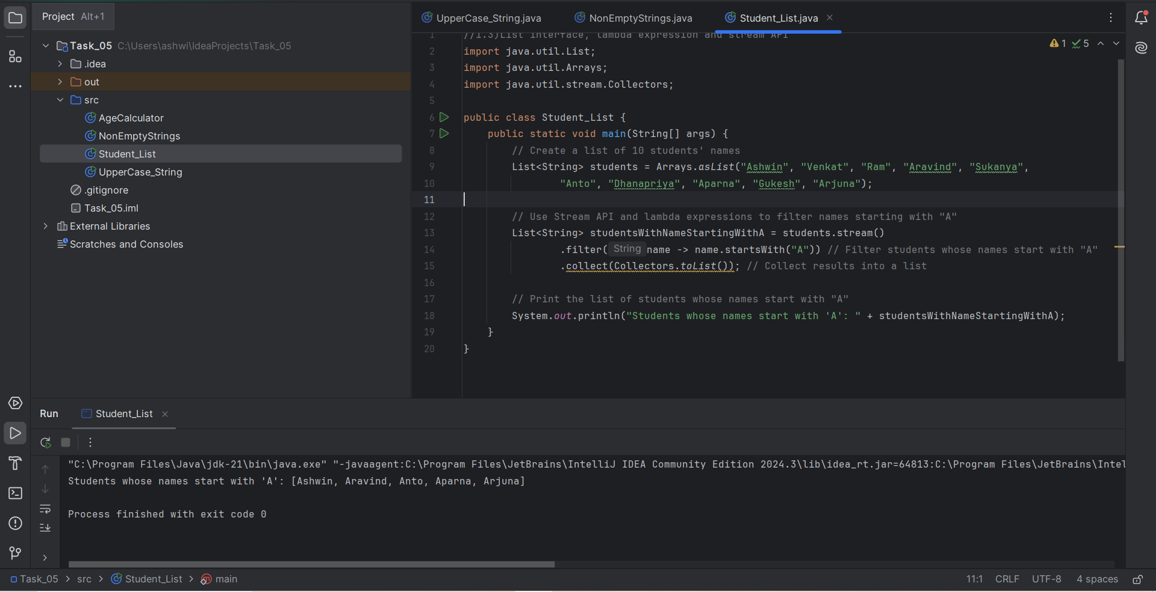

Output:

Students whose names start with 'A': [Ashwin, Aravind, Anto, Aparna, Arjuna]

Process finished with exit code 0

1.4)java.time.LocalDate class for age calculation

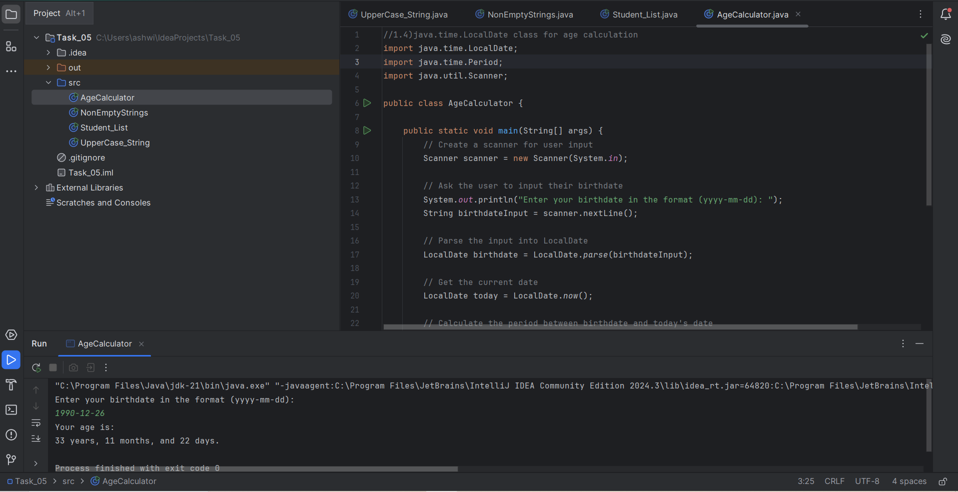

Output:

Enter your birthdate in the format (yyyy-mm-dd):

1990-12-26

Your age is:

33 years, 11 months, and 22 days.

Process finished with exit code 0