1.Fix the bugs in below snippet

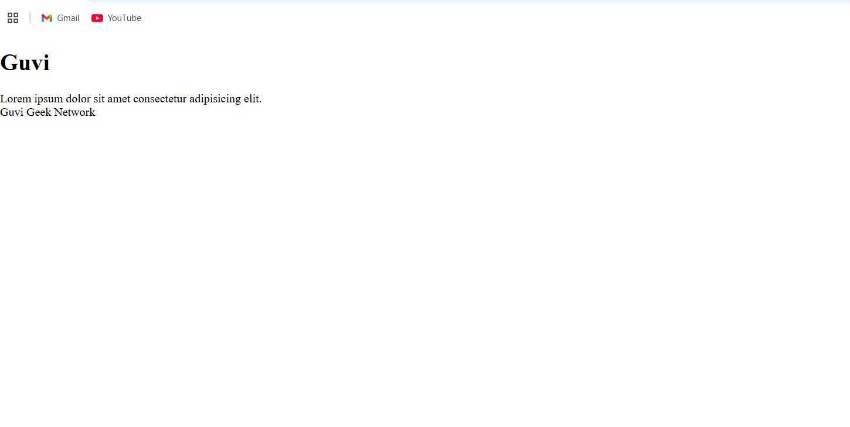

2. Fix the bugs in below snippet



1. Design a contact us form with all fields as required.

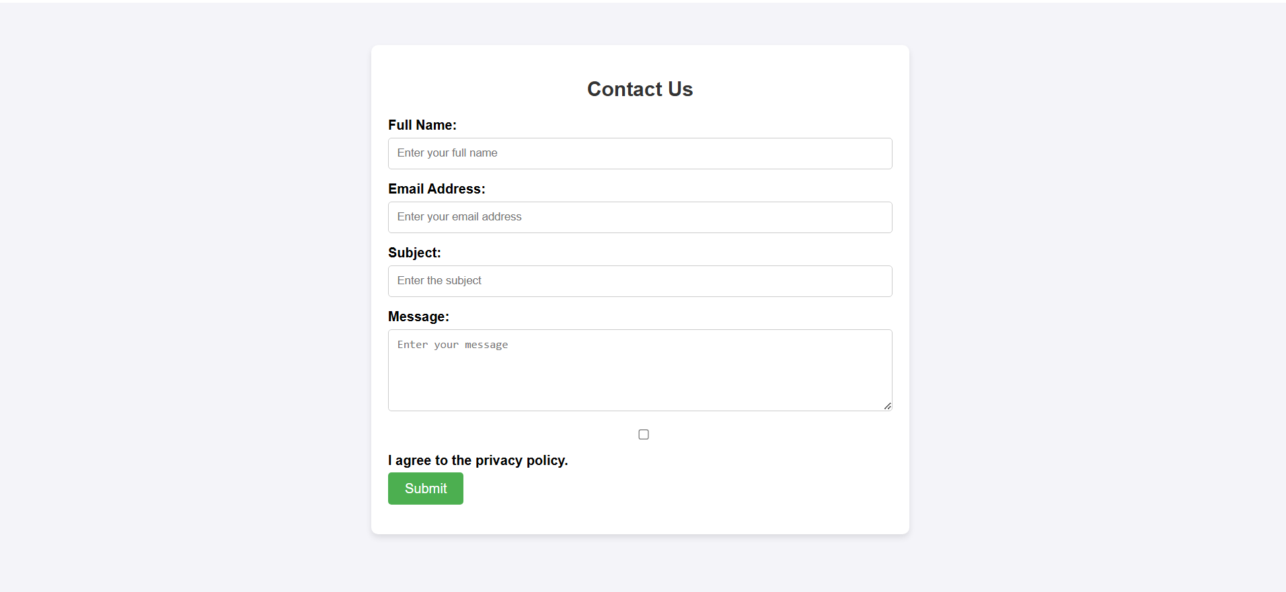

1. 4. Use certain HTML elements to display the following in a HTML page.

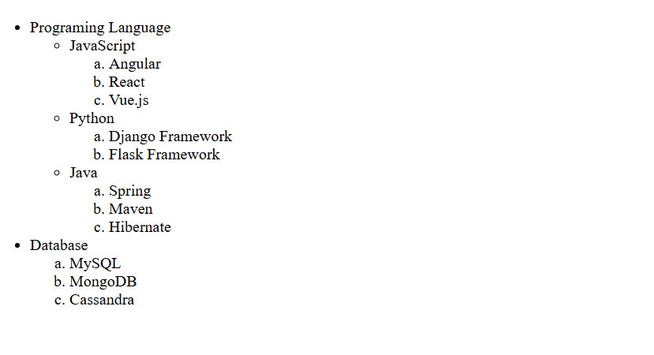

1. Create an element that helps you to open the [https://google.com](https://google.com/) in separate new tab.

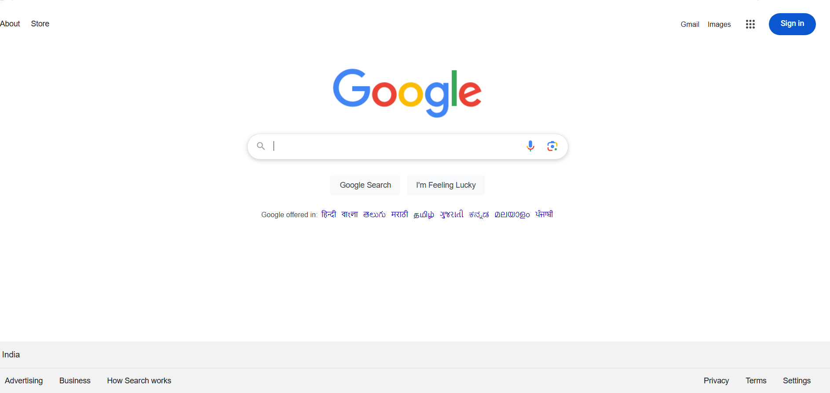

1. 6. In the form, add two radio buttons with grouping them for employee type(Salaried and own business)

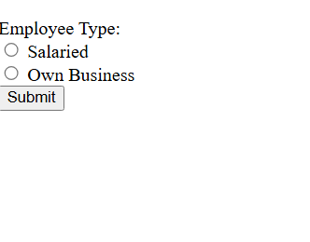

9.Write HTML input tags snippet to show default values for all Form elements.

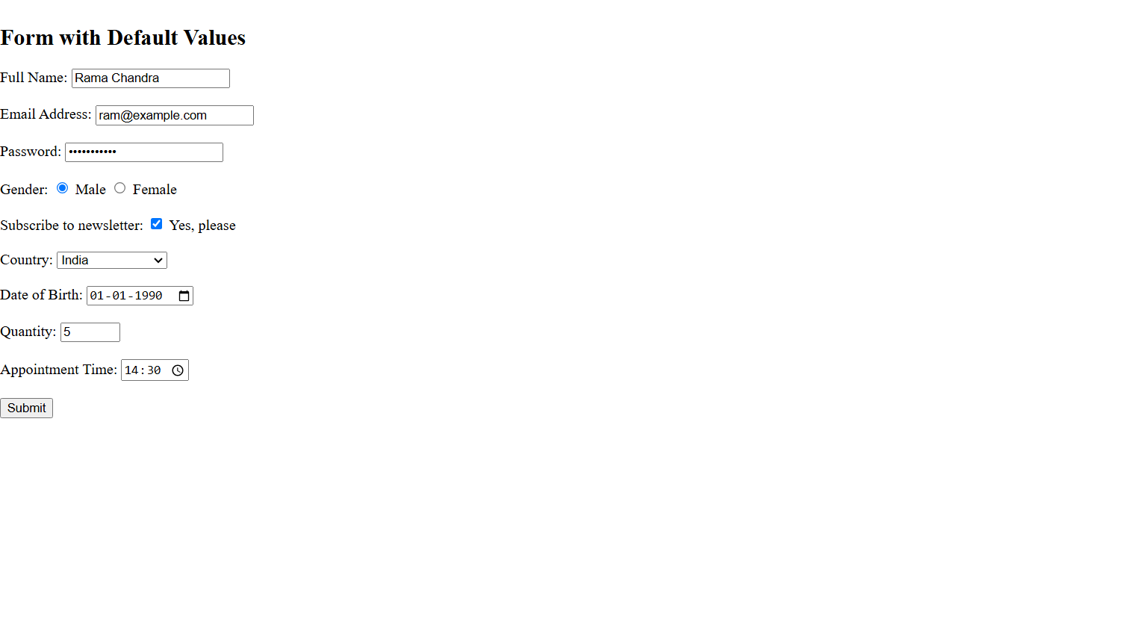

1. In your, HTML page add the below line and Highlight it without using any CSS.

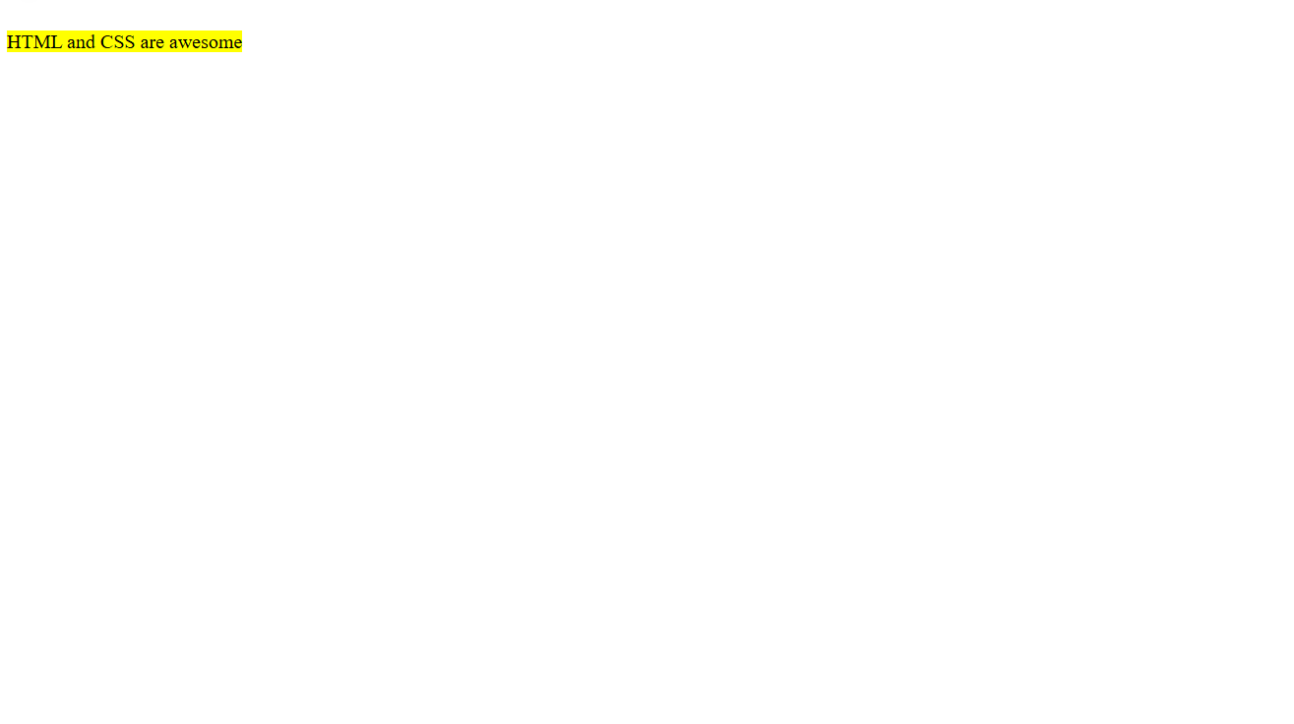

1. Create an HTML page, which should contain all types of input elements.

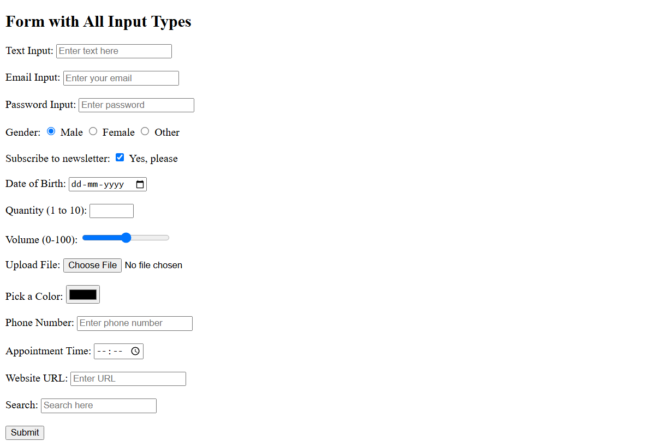

3.Write a media rule to change only the font size of web page when it's resized.

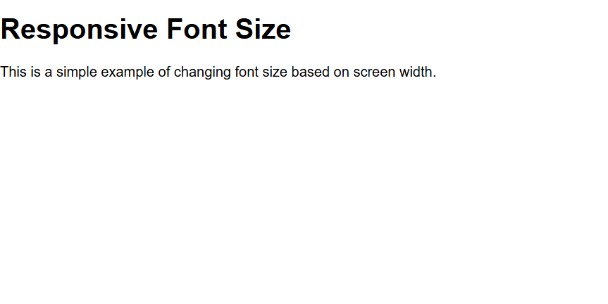

4.Use HTML & CSS to display different types of cursors.

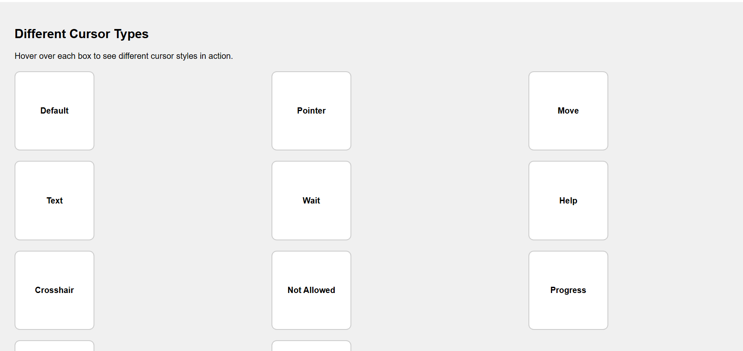

5.Write a CSS class that meets the **Box Model** requirement for all the div tags in your page.

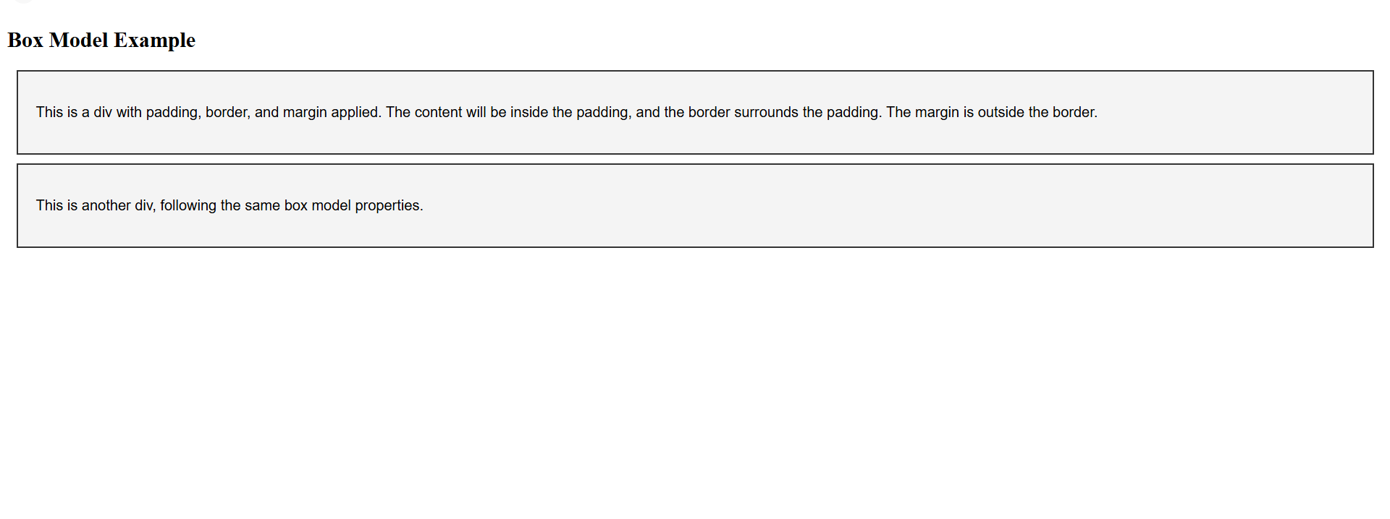

6. Write a CSS class to change size of font, color font family when mouse moves over of span tag in your webpage.

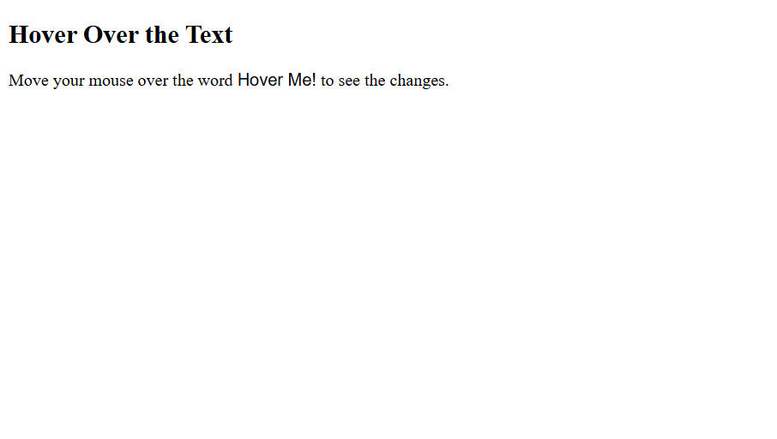7.Write a CSS 2D rule with translate() property to move an element.

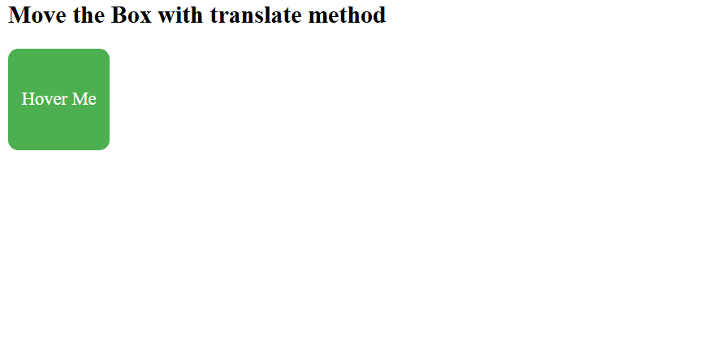

8.Define a CSS class to show tooltip when mouse moved over the elements.

