Autonomous RAG Planner Prompts & Architecture Guide

Phase 1 – Query Classification & Decomposition

Objective
This phase introduces structured thinking before retrieval. Instead of directly sending the query to the retriever, the system first classifies the query type and determines whether it needs decomposition. This improves retrieval precision and prepares the system for multi-step reasoning.

Optimized Planner Prompt
You are the planning engine of an advanced Retrieval-Augmented Generation (RAG) system.
Your task is to analyze the user's query and generate a structured retrieval plan.
Do NOT answer the question.
Return ONLY valid JSON with the following fields:
{
"query_type": "factual | comparative | multi_step | analytical | definition | unknown",
"complexity": "low | medium | high",
"sub_queries": ["..."],
"retrieval_strategy": "single_query | multi_query"
}
Rules:
- If the question involves comparison, break into separate sub-queries.
- If multi-step reasoning is required, decompose clearly.
- If simple definition, keep single sub-query.
- Always return at least one sub_query.
User Query:
{user_query}

Phase 2 – Tool Routing

Objective
In this phase, the planner selects which tools should be used to solve the query. This transforms the system from a simple retriever into a multi-tool AI agent. Tool selection ensures the right mechanism is used for the right task.

Optimized Planner Prompt
You are the planning engine of an autonomous AI system.
Available tools:
- vector_search: semantic retrieval from internal database
- keyword_search: exact keyword-based retrieval
- web_search: retrieve current or external information
- calculator: perform numerical calculations
Return ONLY valid JSON:
{
"query_type": "...",
"complexity": "...",
"sub_queries": ["..."],
"tools_needed": ["..."],
"retrieval_strategy": "single_query | multi_query",
"requires_reasoning": true | false
}
Tool Selection Rules:
- Conceptual or semantic → vector_search
- Exact names, codes → keyword_search
- Recent/time-sensitive → web_search
- Math operations → calculator
User Query:
{user_query}

Phase 3 – Dynamic Retrieval Control

Objective
This phase allows the planner to dynamically control retrieval parameters. Instead of fixed top_k values, retrieval becomes adaptive based on query complexity. This improves recall for complex queries and precision for simple ones.

Optimized Planner Prompt
You are the planning module of an autonomous retrieval system.
Available tools:
- vector_search
- keyword_search
- web_search
- calculator
Return ONLY valid JSON:
{
"query_type": "...",
"complexity": "...",
"sub_queries": ["..."],
"tools_needed": ["..."],
"retrieval_strategy": "...",
"requires_reasoning": true | false,
"retrieval_parameters": {
"top_k": 2-10,
"similarity_threshold": 0.5-0.9
}
}
Rules:
- High complexity → increase top_k.
- Simple factual → lower top_k.
- Analytical/comparative → multi_query.
- If uncertain → increase recall slightly.
User Query:
{user_query}

Phase 4 – Self-Reflection & Validation Planning

Objective
This phase introduces a verification layer. The planner decides whether the final answer should undergo self-reflection. High complexity or analytical queries trigger validation loops to reduce hallucinations.

Optimized Planner Prompt
You are the strategic planning module of an autonomous AI system.
Return ONLY valid JSON:
{
"query_type": "...",
"complexity": "...",
"sub_queries": ["..."],
"tools_needed": ["..."],
"retrieval_strategy": "...",
"requires_reasoning": true | false,
"requires_self_reflection": true | false,
"confidence_requirement": "low | medium | high"
}
Rules:
- Multi-step or analytical → requires_self_reflection = true
- High complexity → high confidence_requirement
- Simple definition → no reflection needed
User Query:
{user_query}

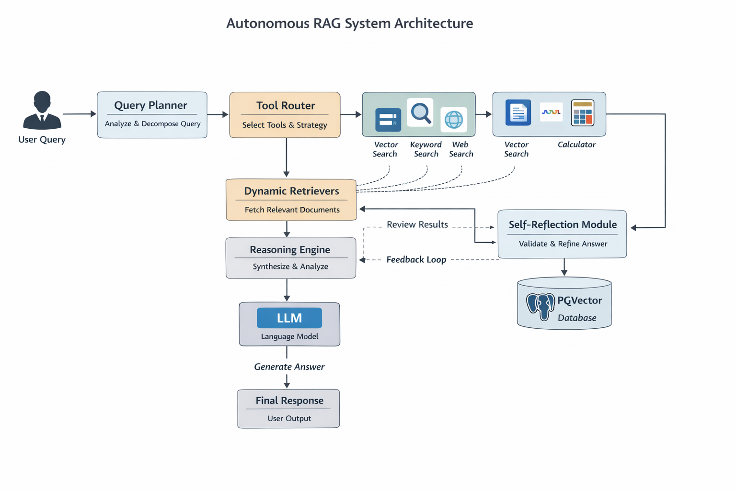

Autonomous RAG System – Beginner-Friendly Architecture Explanation

1. User Query
This is the input from the user. Instead of immediately answering it, the system first analyzes how to handle it properly. This is the starting point of the intelligent workflow.

2. Query Planner
The planner acts as the brain of the system. It classifies the question, determines its complexity, decides whether it should be broken into smaller parts, selects the strategy, and prepares a structured plan. This prevents inefficient or shallow retrieval.

3. Tool Router
The router selects the correct tools based on the planner’s output. For example, it may choose vector search for semantic retrieval, keyword search for exact matches, web search for current information, or a calculator for mathematical operations. This makes the system flexible and task-aware.

4. Dynamic Retrievers
This module retrieves documents based on adaptive parameters like top_k and similarity threshold. Complex questions retrieve more documents; simple ones retrieve fewer. This improves both accuracy and efficiency.

5. PGVector Database
This is the knowledge storage system. It stores document chunks, embeddings, and metadata. The system retrieves relevant information from here using similarity search. Without retrieval, the language model would not have access to private or domain-specific knowledge.

6. Reasoning Engine
The reasoning engine processes the retrieved documents. It extracts relevant facts, compares information when needed, performs structured thinking, and prepares organized content before final answer generation.

7. LLM (Language Model)
The language model generates the natural language response. Unlike a normal chatbot, it operates inside a controlled pipeline. It receives structured inputs and contextual documents rather than answering freely.

8. Self-Reflection Module
After generating an answer, the system evaluates its own response. It checks for hallucinations, unsupported claims, or low confidence. If issues are detected, it can trigger additional retrieval or refinement.

9. Feedback Loop
If the reflection module determines improvements are needed, the system loops back to adjust retrieval parameters or gather more context. This creates an adaptive and self-improving workflow.

10. Final Response
After planning, routing, retrieval, reasoning, and validation, the system delivers a refined and more reliable answer to the user. The complexity of the internal process remains invisible to the user.

