# **Software Requirements Specification**

# **PRJ566 – Winter 2025**

**PRJ566 – Team No:** 3

**Name of Project:** Easy Explore

**Project Leader:**

**Last updated:** 25-01-2025

**Team Members:**

1. Harsh Pahurkar

2. Ruslan Gofman

3. Alex Leung

4. Ashwin B N

# **TABLE OF CONTENTS**

1. **Introduction/Overview - Document Information**
   1. **Document Authors**
   2. **Revision History**
   3. **Document Conventions**
   4. **Document Purpose**
   5. **Intended Audience**
   6. **Group Agreement**
2. **Project Overview**
   1. **Project Proposal**
   2. **Stakeholders and Users**
   3. **Project Scope**
   4. **System risks**
   5. **Operating Environment**
   6. **Functional Requirements**
   7. **Nonfunctional Requirements**
   8. **UI/UXD Interface Mockups**
3. **Process & Data Modeling**
   1. **UML Modeling: DFDs & Activity Diagrams**
   2. **Use Case Specification** 
      1. **Business Rules**
      2. **System Use Case Diagrams**
      3. **Use Case Description Tables**
4. **Domain Class Diagram**
5. **Database (Select either 5.1 or 5.2)**
   1. **RDBMS Artifacts**
      1. Scripts to create, populate, delete tables
      2. Data Dictionary
   2. **NoSQL Artifacts**
6. **Work breakdown Structure (WBS)**
7. **Milestones & Acceptance Criteria**
8. **Implementation Schedule (Agile/Waterfall)**
9. **Client / Faculty Sign-off**

# **1 - Introduction/Overview - Document Information**

## 1.1 Document Authors

Harsh Pahurkar

Ruslan Gofman

Alex Leung

Ashwin B N

## 1.2 Revision History

|  |  |
| --- | --- |
| Week 03 | Sections of this document that were completed/updated this week, example: completed/updated  1. Introduction/Overview  1.1 Document Authors (completed)  1.2 Revision History (ongoing)  1.4 Document Purpose (completed)  1.5 Intended Audience (completed)  1.6 Group Agreement (completed)  2. Project Overview  2.1 Project Proposal (completed)  2.2 Stakeholders and Users (completed)  2.6 Functional Requirements (completed)  2.7 Operating Environments (completed) |
| Week 04 | 2.2 Stakeholders and Users (completed)  2.3 Project Scope (completed) 2.4 System Risks (completed) 2.5 Operating Environment (completed) |
| Week 05 | 2.6 Functional Requirements (completed) 2.7 Nonfunctional Requirements (completed) 2.8 Data Flow Diagrams (DFDs) (completed) |
| Week 06 | 2.8 UI/UXD Interface Mockups (completed)  3.1 UML Modeling: DFDs & Activity Diagrams (completed) |
| Week 07 | 3.2. Use Case Specification (completed)  3.2.1. Business Rules (completed)  3.2.2. System Use Case Diagrams (completed)  3.2.3 Use Case Description Tables (completed) |
| Week 08 | 4. Domain Class Diagram (completed) |
| Week 09 | 5.2 Database (completed) |
| Week 10 | 6. Work breakdown Structure (WBS) (completed)  7. Milestones & Acceptance Criteria (completed) |
| Week 11 | 8. Implementation Schedule (Agile/Waterfall) (completed) |
| Final | Final presentation |

## 1.3 Document Conventions

For example:

Any text in red indicates an exception or error.

Any text in blue is in-progress.

Any text highlighted in yellow is an important point.

Any text in green was recently added.

Any text *italicized* represents definitions.

Any text with ~~strike-through~~ is deleted.

## 1.4 Document Purpose

The SRS is a formal document that outlines the scope, requirements, features, plan, visuals, functionality, and constraints of Easy Explore. It serves as a reference for the stakeholders responsible for the development and deployment of the application.

The Introduction of the SRS provides basic information such as authors, revision history, and group agreement. The Project Overview section documents Easy Explore's system and foundation. It details key aspects such as objective and operating environment. The Process and Data Modeling section documents the functionality and behavior of Easy Explore. This includes different use cases such as searching for attractions or building a schedule. The Domain Class Diagram section displays the different classes, attributes, methods, and relationships that will be used during the development of Easy Explore.

The Database section of the SRS dictates which database design will be implemented for Easy Explore. The WBS section divides Easy Explore into smaller, more manageable components. The Milestone and Acceptance Criteria section lists all the future milestones and their corresponding acceptance criteria during the development phase. The Implementation Schedule section describes the project management methodology that will be used. The Client/Faculty Sign Off section records the client’s/professor's approval of this document.

## 1.5 Intended Audience

This document is intended for the following groups:

1. **Project Stakeholders:**

* **CEO:** To ensure the project aligns with organizational goals and financial feasibility.
* **Construction Manager and Scheduler:** To gain accurate information for scheduling and project management.
* **Administrative Assistant:** To facilitate communication and documentation needs.

1. **Development Team:**

* **Project Leader:** To oversee the development, manage deliverables, and ensure timely progress.
* **Developers:** To understand system requirements, architecture, and implementation plans.

1. **End Users:**

* **Tourists and Locals:** Individuals seeking an efficient, personalized, and user-friendly travel planning solution.
* **Business Owners:** To provide accurate, real-time data for attractions and services listed on the platform.

1. **Academics and Evaluators:**

* **Faculty Members/Professors:** To assess the project for academic purposes and verify adherence to guidelines and quality standards.

## 1.6 Group Agreement

**TEAM AGREEMENT**

**Team #: 3**

**Project Title:** Easy Explore

**Project Time Frame:** January 2025 – End of PRJ666 (Next Semester)

**Team Members:** Harsh Pahurkar, Ruslan Gofman, Alex Leung, Ashwin B N

**Team Leadership**: The team will practice shared leadership, where responsibilities are delegated based on expertise and availability.

**Team Functions:**

* ***Communication Tools:*** *Information will be shared through MS Teams, OneDrive, WhatsApp, email, and scheduled meetings.*
* ***Collaboration:*** *All members will contribute equally to discussions, decision-making, and deliverables.*

**Team Meetings:**

* Regular team meetings will be held weekly or as required.
* Meeting agendas and outcomes will be documented to track progress.

**Team Problems:**

* Conflicts will be resolved through open communication and consensus.
* If unresolved, issues will be escalated to the instructor for mediation.

**Team Commitment**

**The undersigned members agree to work together on the project until the end of the PRJ666 next Semester. They recognize that as a team and individually they are responsible for the quality of all deliverables.**

**Name**  **Date**

|  |  |
| --- | --- |
| Harsh Pahurkar | 23-01-2025 |
| Ruslan Gofman | 23-01-2025 |
| Alex Leung | 23-01-2025 |
| Ashwin B N | 23-01-2025 |

ShapeShapeShapeShapeShapeShapeShape

# **2 - Project Overview**

## 2.1 Project Proposal

**Project Background**

Easy Explore is a travel planning app/website for tourists and locals. It consolidates key details like pricing, reviews, and proximity, offering personalized recommendations based on user preferences such as budget, interests, and transportation. Key features include filters and an optimized schedule planner to streamline trip planning.

The idea for Easy Explore arose from simplifying the overwhelming travel planning process, particularly identifying attractions and activities. Existing platforms like TripAdvisor or Yelp provide basic details but lack advanced customization and planning features. Easy Explore addresses this gap with personalized, efficient solutions for avid travelers and local explorers alike.

**Problem Statement**

|  |  |
| --- | --- |
| The Problem of: | Inefficient and scattered travel planning tools make itinerary creation time-consuming and frustrating. |
| Affects: | * Domestic and international travelers. * Locals exploring nearby attractions. * Businesses attract tourists and customers. |
| The impact of which is: | * Wasted time on research and planning. * Missed opportunities to discover attractions. * Reduced enjoyment of travel experiences. |
| A successful solution would: | * Provide a consolidated, user-friendly platform. * Offer personalized, optimized recommendations. * Save time and enhance travel satisfaction. |

**Product Vision**

|  |  |
| --- | --- |
| For | Tourists and locals seeking efficient and personalized travel planning. |
| Who | Need an intuitive way to discover and organize activities. |
| The Product Name | Easy Explore. It is a travel planning app/website. |
| That | Delivers personalized recommendations, optimized itineraries, and key attraction details. |
| Unlike | Traditional platforms that lack customization and planning features. |
| Our product | Combines advanced filters, real-time updates, and a planner in a user-friendly design to simplify travel planning. |

## 2.2 Stakeholders and Users

The stakeholders and users of the Easy Explore project are categorized based on their roles, responsibilities, and how they interact with the system. Below is the updated and reorganized list of stakeholders and users:

Project Stakeholders

|  |  |  |
| --- | --- | --- |
| **Stakeholder** | **Role** | **Responsibilities** |
| **Developers** | Developer | Responsible for understanding system requirements, architecture, and implementation plans. |
| **UI/UX Designers** | Design Team | Develops an intuitive, user-friendly interface to enhance user experience. |
| **Marketing Team** | Business & Promotion | Promotes the platform, gathers user feedback, and analyzes market trends. |
| **Investors** | Financial Stakeholders | Provide funding and expect return on investment through platform success. |
| **Academic Evaluators** | Faculty, Professors | Assess project quality, adherence to academic standards, and overall feasibility. |

Users

|  |  |  |
| --- | --- | --- |
| **Username/Identifier** | **Category** | **Description** |
| **Tourists** | End User | Domestic and international travelers seeking efficient and personalized travel planning. |
| **Locals** | End User | Individuals exploring nearby attractions and activities. |
| **Business Owners** | End User | Businesses that rely on the platform to attract tourists and customers by listing their services or attractions. |

## 2.3 Functional Requirements

|  |  |  |  |  |
| --- | --- | --- | --- | --- |
| **Requirement ID** | **Priority** | **Description** | **Input(s)** | **Output(s)** |
| FR-001 | High | The system shall allow users to search for attractions based on keywords, location, and date. | Search query, location, date | List of matching attractions with relevant details (name, description, rating, price, location, images). |
| FR-002 | High | The system shall allow users to filter search results based on budget, transportation methods, activity types, and rating. | Budget range, transportation methods, activity types, minimum rating | Filtered list of attractions matching the specified criteria. |
| FR-003 | Medium | The system shall provide personalized recommendations based on user preferences and past behavior. | User profile data, past searches, saved attractions, user reviews | List of recommended attractions with a relevance score. |
| FR-004 | High | The system shall allow users to create and save personalized itineraries. | User-selected attractions, dates, times, transportation methods, notes | Saved itinerary with a schedule, map, and estimated costs. |
| FR-005 | Medium | The system shall display real-time updates on attraction availability, operating hours, or transportation options. | External data sources (APIs) providing real-time information on attraction status, schedules, and routes | Notifications and updates on the user interface. |
| FR-006 | High | The system shall allow users to create and manage their profiles. | User details (name, contact info, preferences, past trips, payment methods, profile picture). | Saved user profile with personal details, preferences, past trips, and payment methods. |
| FR-007 | Low | The system shall allow users to sync itinerary with their calendar. | Calendar details, user access | Itinerary saved to user calendar |
| FR-008 | Medium | The system shall allow users to share an itinerary with their friends. | User access, friend list | Itinerary shared to user list, and permission for friends to view itinerary |

## 2.4 Nonfunctional Requirements

|  |  |  |  |  |
| --- | --- | --- | --- | --- |
| **Requirement ID** | **Category** | **Priority** | **Description** | **Measurement** |
| NFR-001 | Performance | High | The system should load search results within 2 seconds. | Average response time ≤ 2 seconds for 95% of search queries. |
| NFR-002 | Performance | High | The system should support at least 500 concurrent users. | The system should maintain acceptable performance levels (e.g., response time, error rate) with 500 concurrent users. |
| NFR-003 | Security | High | User authentication must follow OAuth 2.0 standards. | Compliance with OAuth 2.0 specifications. |
| NFR-004 | Security | High | User data should be encrypted for storage. | Verification of encryption algorithms and protocols used. |
| NFR-005 | Scalability | Medium | The system should be deployed on a cloud-based architecture to handle increasing traffic demands. | Cloud-based infrastructure with autoscaling capabilities. |
| NFR-006 | Scalability | Medium | The system should be designed to support future expansion to include more geographic locations. | Modular design with well-defined interfaces for integrating new data sources and services. |
| NFR-007 | Usability | High | The interface should be intuitive and user-friendly, requiring minimal learning effort. | User satisfaction rating ≥ 4.0 on a 5-point scale based on usability testing. |
| NFR-008 | Usability | Medium | The system should be accessible and compliant with WCAG 2.1 AA guidelines. | Compliance with WCAG 2.1 AA guidelines based on accessibility audits. |
| NFR-009 | Usability | Medium | The system should support multiple languages (initially English and French). | Support for English and French language options in the user interface. |
| NFR-010 | Availability | High | The system should maintain 99.5% uptime to ensure system reliability. | Uptime ≥ 99.5% based on system monitoring. |
| NFR-011 | Availability | High | The system should be accessible on modern web browsers (Chrome, Firefox, Safari) with responsive design for mobile and desktop. | Compatibility and responsive design verified on supported browsers and devices. |

## 2.5 Project Scope

#### Project Goal and Objectives

The **Easy Explore** project will deliver a comprehensive travel planning platform that consolidates attractions, schedules, reviews, and real-time updates into a seamless user experience for both tourists and locals. The goal is to simplify travel planning by providing personalized, data-driven recommendations based on individual preferences and behaviors.

**Key objectives:**

* Deliver a cross-platform web and mobile app for personalized travel planning.
* Allow users to create optimized itineraries based on budget, interests, transportation, and time.
* Implement advanced filters and intelligent search for discovering attractions.
* Provide real-time updates on attraction availability and transportation.
* Achieve ≥ 90% user satisfaction rating for ease of use and recommendations.
* Maintain ≤ 2-second average load time for 95% of user queries.
* Reach a user base of 10,000+ within the first six months post-launch.

#### Project Boundaries

**Within Scope:**

* Develop core modules: search, filters, itinerary planner, and user profiles.
* Integrate external APIs for real-time attraction data and maps.
* Design intuitive UI/UX interfaces for web and mobile versions.
* Build a scalable cloud-based backend using modular architecture.
* Provide support for English and French languages.
* Ensure system security and compliance with OAuth 2.0 standards.
* Conduct usability testing and meet WCAG 2.1 AA accessibility standards.

**Out of Scope:**

* Booking and payment functionalities for travel or accommodation.
* Third-party ad or affiliate network integration during the initial release.
* Offline functionality or downloadable itineraries in Phase 1.

#### Project Deliverables

* Fully functional Easy Explore platform (web + mobile responsive)
* User registration, profile management, and personalized recommendations
* Search and filtering interface with dynamic attraction results
* Custom itinerary creation and calendar sync option
* Real-time updates on availability, hours, and routes
* Admin dashboard for business owners to manage listings
* Domain class and database design documentation
* WBS (Work Breakdown Structure) and milestone schedule
* System and process documentation
* Training material and user guide for onboarding
* Final sign-off from project stakeholders and academic evaluators

## 2.6 System Risks

|  |  |
| --- | --- |
| **Risk** | **Response** |
| Tight deadlines may lead to poor code quality which may lead to bugs, errors, and glitches. | Create a comprehensive testing plan to test code frequently and adopt proper coding practices. |
| Poor security implementations may lead to data breaches and compromise user data. | Enforce protocols such as OAuth, OpenID Connect, and JWT for API endpoints. Utilize MFA for user authentication. |
| Compatibility issues may arise when using the app/website on different operating systems or browsers. | Perform cross-platform and cross-browser testing. Utilize cross-platform frameworks and monitor external dependencies to ensure they are regularly updated. |
| Possibility of new features or requirements being added to the project scope after project execution. | Clearly define all project requirements, establish a scope management plan, utilize a change management plan, and verify project scope with stakeholders. |
| Possibility of outdated or inaccurate data being returned to the user. | Utilize API validation, data syncs, and caching. |
| Weak Wi-Fi connection may lead to slow data return. | Optimize data requests by requesting necessary data only, implement background data fetching, and utilize caching mechanisms. |

## 2.7 Operating Environment

To maximize the availability of the service, the platform will be accessible through any internet browser such as Chrome, Firefox or Safari running the latest update. It will be optimized to support mobile and desktop screens to ensure ease of use on any device. The only user requirement will be to have a stable internet connection.

## 2.8 UI/UXD Interface Mock-ups

## 

# **3- Process and Data Modeling**

## 3.1 UML/DFD Modeling and Data Modeling

Data Flow Diagram

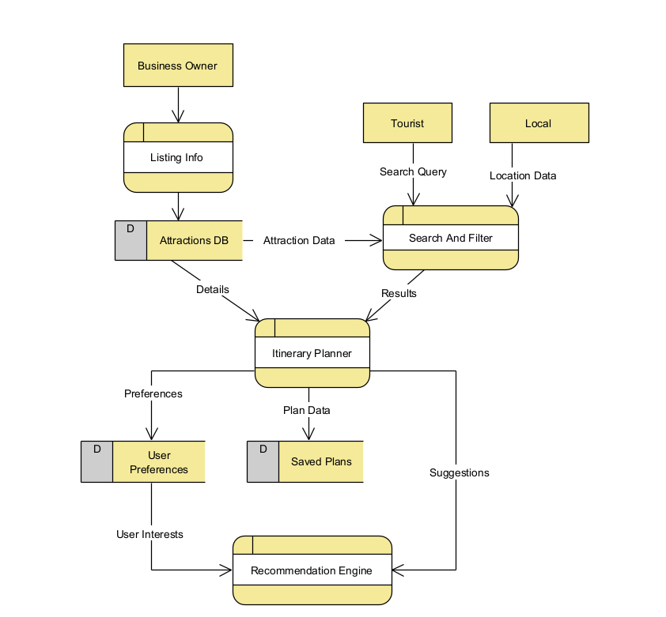

**Activity Diagrams:**

Attraction Listings

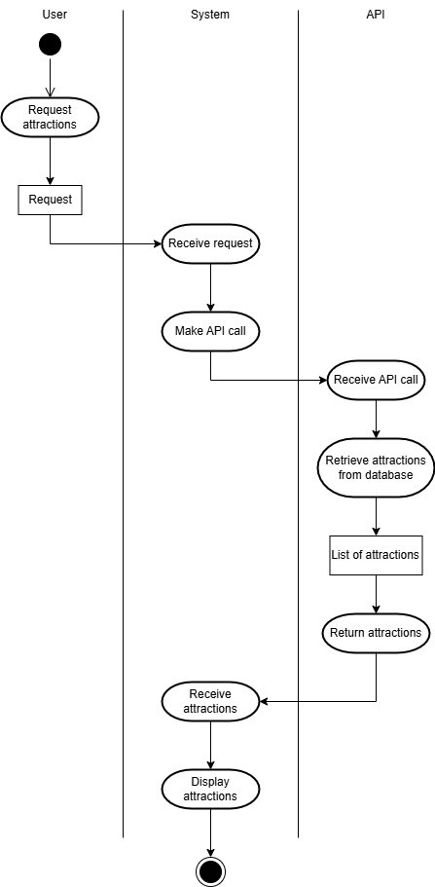

Filters

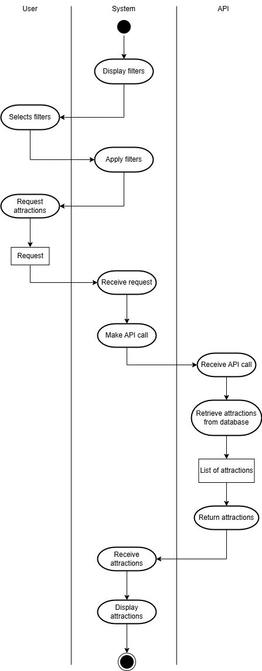

Planner

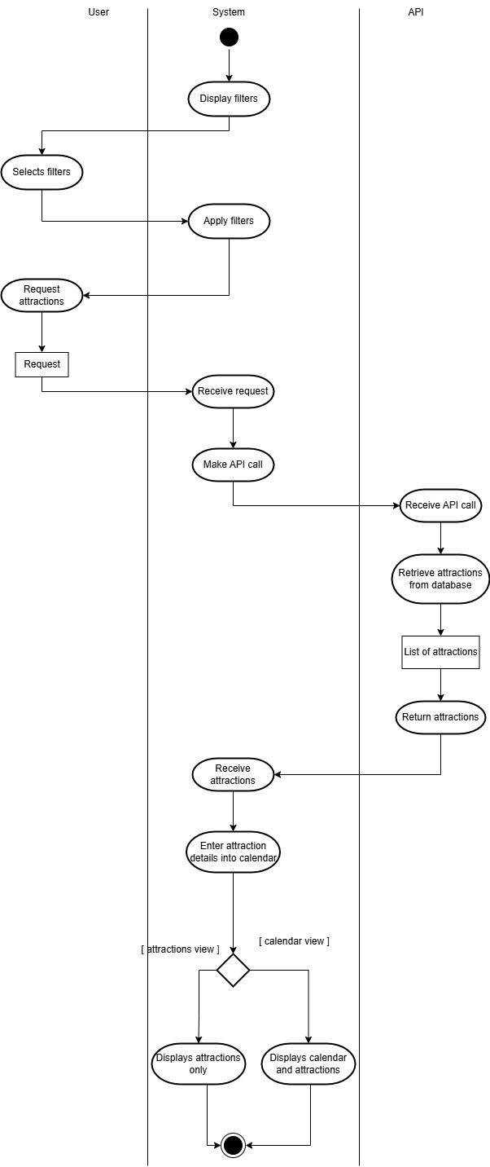

Personalized Recommendations

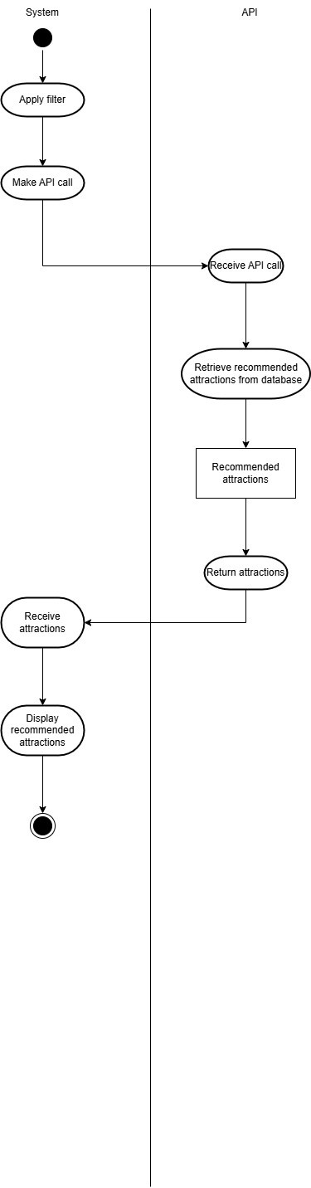

Real-Time Updates

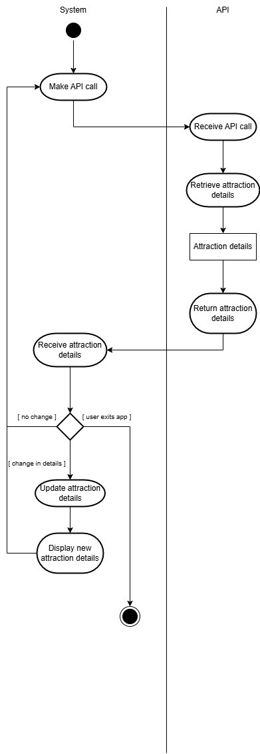

User Profiles

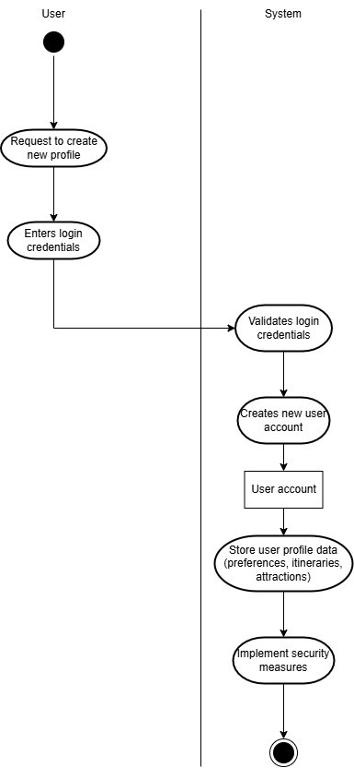

## 3.2 Business Rules

|  |  |  |
| --- | --- | --- |
| **Business Rule Number** | **Business Rule Description** | **Related UC** |
| BR01 | User's device is connected to a stable internet connection | UC01 |
| BR02 | User grant's permission to share device location | UC01 |
| BR03 | Users select valid date, keyword, budget and transportation mode | UC01 |
| BR04 | Activity listings must include name, image, description, location, hours of operation | UC02 |
| BR05 | Recommendation must be based on user preferences | UC03 |
| BR06 | Itineraries must include selected attractions with time and date | UC04 |
| BR07 | System will utilize external API to fetch live data | UC05 |
| BR08 | Notifications must notify user of any updates regarding itineraries | UC05 |
| BR09 | Profile must include name, preferences, payment methods and saved itineraries | UC06 |
| BR09 | All user data must be validated before being saved | UC06 |
| BR10 | Users must be able to modify their personal details and preferences | UC06 |
| BR11 | Syncing with calendar requires user permission | UC07 |
| B012 | Syncing with calendar will copy exact itinerary name, time, date, location | UC07 |
| B013 | To share itineraries, both parties need to have an account | UC08 |
| B014 | User must selection permission status to share itineraries | UC08 |

3.3 Use Case Specifications with corresponding interface mockups:

Each use case needs to have the following:

#### Use Case 1: Search for Attractions

* Use Case Name: Search for Attractions
* ID: UC-001
* Importance Level: High
* Primary Actor: Tourist, Local
* Use Case Type: Detail, Essential
* Stakeholders and Interests:
  + Tourists/Locals - Want to find attractions quickly and easily.
  + Business Owners - Want their attractions to be easily found by potential customers.
* Brief Description: This use case describes how users search for attractions based on keywords, location, and date.
* Trigger: User enters search criteria and initiates a search.
* Type: External
* Relationships:
  + Association: Tourist, Local
* Normal Flow of Events:
  + The user enters keywords, location, and date into the search fields.
  + The system validates the input.
  + The system queries the database for matching attractions.
  + The system retrieves a list of attractions with relevant details (name, description, rating, price, location, images).
  + The system displays the list of matching attractions to the user.
* Alternate/Exceptional Flows:
  + A1: No attractions match the search criteria. The system displays a message indicating no results were found.
  + A2: The user enters invalid search criteria. The system displays an error message.

#### Use Case 2: Filter Search Results

* Use Case Name: Filter Search Results
* ID: UC-002
* Importance Level: High
* Primary Actor: Tourist, Local
* Use Case Type: Detail, Essential
* Stakeholders and Interests:
  + Tourists/Locals - Want to refine search results to find attractions that meet specific needs.
* Brief Description: This use case describes how users filter search results based on budget, transportation methods, activity types, and rating.
* Trigger: User applies filter criteria to an existing search result.
* Type: External
* Relationships:
  + Association: Tourist, Local
  + Include: Search for Attractions
* Normal Flow of Events:
  + The user has already performed a search and has a list of attractions displayed.
  + The user selects filter criteria (budget range, transportation methods, activity types, minimum rating).
  + The system applies the filters to the existing search results.
  + The system displays the filtered list of attractions matching the specified criteria.
* Alternate/Exceptional Flows:
  + A1: No attractions match the filter criteria. The system displays a message indicating no results were found.

#### Use Case 3: Get Personalized Recommendations

* Use Case Name: Get Personalized Recommendations
* ID: UC-003
* Importance Level: Medium
* Primary Actor: Tourist, Local
* Use Case Type: Detail, Essential
* Stakeholders and Interests:
  + Tourists/Locals - Want to discover attractions tailored to their interests.
* Brief Description: This use case describes how the system provides personalized recommendations based on user preferences and past behavior.
* Trigger: User logs in or accesses the recommendation section.
* Type: Internal
* Relationships:
  + Association: Tourist, Local
* Normal Flow of Events:
  + The system retrieves user profile data, past searches, saved attractions, and user reviews.
  + The system analyzes the data to identify user preferences.
  + The system generates a list of recommended attractions with a relevance score.
  + The system displays the list of recommended attractions to the user.
* Alternate/Exceptional Flows:
  + A1: Insufficient user data is available. The system displays generic recommendations or prompts the user to update their profile.

#### Use Case 4: Create and Save Itineraries

* Use Case Name: Create and Save Itinerary
* ID: UC-004
* Importance Level: High
* Primary Actor: Tourist, Local
* Use Case Type: Detail, Essential
* Stakeholders and Interests:
  + Tourists/Locals - Want to plan and save their travel itineraries.
* Brief Description: This use case describes how users create and save personalized itineraries.
* Trigger: User initiates the creation of a new itinerary.
* Type: External
* Relationships:
  + Association: Tourist, Local
* Normal Flow of Events:
  + The user selects attractions, dates, times, transportation methods, and adds notes to the itinerary.
  + The system allows the user to arrange the attractions in a specific order.
  + The user saves the itinerary.
  + The system saves the itinerary with a schedule, map, and estimated costs.
  + The user can access the saved itinerary later.
* Alternate/Exceptional Flows:
  + A1: The user tries to save an itinerary without selecting any attractions. The system displays an error message.

#### Use Case 5: Display Real-Time Updates

* Use Case Name: Display Real-Time Updates
* ID: UC-005
* Importance Level: Medium
* Primary Actor: System
* Use Case Type: Detail, Essential
* Stakeholders and Interests:
  + Tourists/Locals - Want to have up-to-date information about attraction availability and transportation.
* Brief Description: This use case describes how the system displays real-time updates on attraction availability, operating hours, and transportation options.
* Trigger: Real-time data changes from external sources.
* Type: Internal
* Relationships:
  + Association: Tourist, Local
* Normal Flow of Events:
  + The system receives real-time data from external APIs (attraction status, schedules, routes).
  + The system updates the user interface with the latest information.
  + The system displays notifications and updates to the user.
* Alternate/Exceptional Flows:
  + A1: The connection to the external data source is lost. The system displays a message indicating that real-time updates are unavailable.
  + A2: The external data source provides invalid data. The system logs the error and attempts to use the last known good data.

#### Use Case 6: Create and Manage User Profiles

* Use Case Name: Create and Manage User Profiles
* ID: UC-006
* Importance Level: High
* Primary Actor: Tourist, Local
* Use Case Type: Detail, Essential
* Stakeholders and Interests:
  + Tourists/Locals - Want to manage and customize their user profiles.
* Brief Description: This use case describes how users create and manage their profiles.
* Trigger: User initiates profile creation or management.
* Type: External
* Relationships:
  + Association: Tourist, Local
* Normal Flow of Events:
  + The user enters personal details (name, contact info, preferences, past trips, payment methods, profile picture).
  + The system validates the input.
  + The system saves the user profile with personal details, preferences, past trips, and payment methods.
  + The user can update their profile information later.
* Alternate/Exceptional Flows:
  + A1: The user enters invalid profile information. The system displays an error message.

#### Use Case 7: Sync Itinerary with Calendar

* Use Case Name: Sync Itinerary with Calendar
* ID: UC-007
* Importance Level: Low
* Primary Actor: Tourist, Local
* Use Case Type: Detail, Essential
* Stakeholders and Interests:
  + Tourists/Locals - Want to manage and customize their user profiles.
* Brief Description: This use case describes how users sync Itinerary with Calendar.
* Trigger: User initiates the sync.
* Type: External
* Relationships:
  + Association: Tourist, Local
* Normal Flow of Events:
  + The user enters/allows calendar user access.
  + The system validates the input.
  + The itinerary will be exported to user calendar.
* Alternate/Exceptional Flows:
  + A1: The user doesn't allow calendar user access. The system displays an error message.

#### Use Case 8: Share Itinerary with Friends

1. Use Case Name: Share Itinerary with Friends
2. ID: UC-008
3. Importance Level: Medium
4. Primary Actor: Tourist, Local
5. Use Case Type: Detail, Essential
6. Stakeholders and Interests:
   1. Tourists/Locals - Want to share itinerary with their friends.
7. Brief Description: This use case describes how users share Itinerary with Friends.
8. Trigger: User initiates the share.
9. Type: External
10. Relationships:
    1. Association: Tourist, Local
11. Normal Flow of Events:
    1. The user selects friend to share their itinerary with.
    2. The system validates the access to friends.
    3. The system will provide user list to select and give permission.
12. Alternate/Exceptional Flows:
    1. A1: The user doesn't allow friend user access. The system displays an error message.

4- Corresponding Mockups

**System Use Case Diagram**

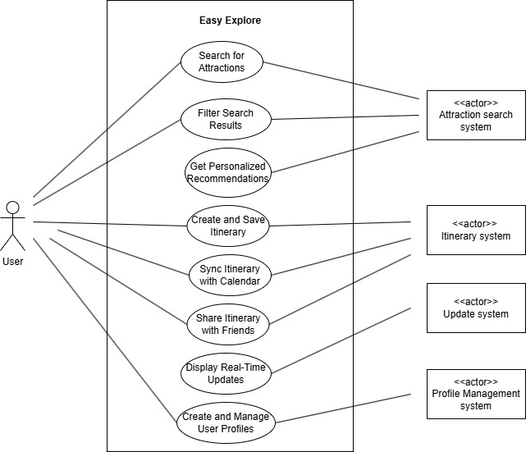

# **4- Domain Class Diagram**

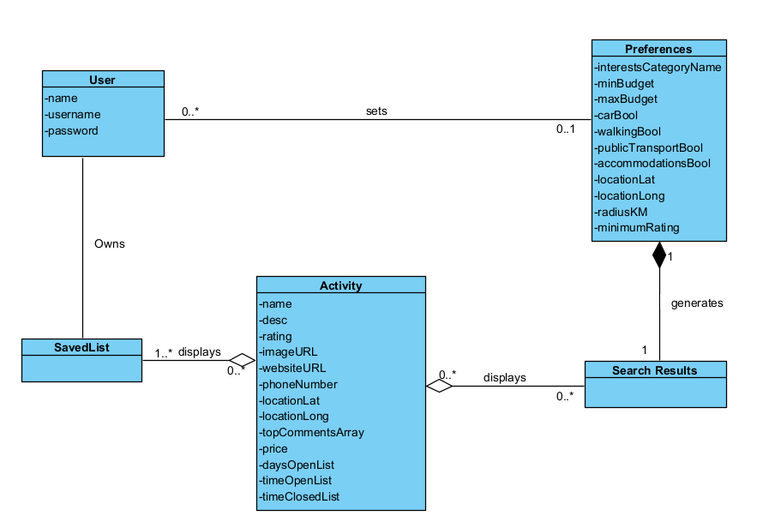

# **5- Database**

## 5.2 NoSQL Artifacts

#### 1. User Model

Collection: Users

{  
 "_id": "user_001",  
 "name": "John Doe",  
 "email": "[john.doe@example.com](mailto:john.doe@example.com)",  
 "saved_attractions": ["attraction_id_001", "attraction_id_002"],  
 "trip_history": ["trip_id_1001", "trip_id_1002"]  
}

#### 2. Activity Recommendation Model

Collection: ActivityRecommendations

{  
 "_id": "activity_001",  
 "name": "Royal Ontario Museum Tour",  
 "price": 25.00,  
 "distance_km": 10,  
 "address": "100 Queens Park, Toronto, ON M5S 2C6",  
 "rating": 3.5,  
 "genre": ["Park"]  
}

#### 3. Activity Details Model

Collection: ActivityDetails

{  
 "_id": "activity_001",  
 "name": "Royal Ontario Museum Tour",  
 "description": "A guided tour at the Royal Ontario Museum",  
 "available_time": { "start": "08:00", "end": "20:00" },  
 "price": 25.00,  
 "contact": "(123) 456-7890",  
 "website": "https://example.com/rom",  
 "location": {  
 "address": "100 Queens Park, Toronto, ON M5S 2C6",  
 "latitude": 45.3456,  
 "longitude": -45.3542  
 },  
 "travel_details": "Ferry rides available from Battery Park...",  
 "rating": 3.5,  
 "reviews": [  
 {  
 "user": "John Doe",  
 "comment": "Amazing experience!",  
 "rating": 5  
 },  
 {  
 "user": "Jane Smith",  
 "comment": "Crowded but worth it.",  
 "rating": 4  
 }  
 ],  
 "image_url": "https://example.com/rom.jpg"  
}

#### 4. User Preferences Model

Collection: UserPreferences

{  
 "_id": "user_pref_001",  
 "user_id": "user_001",  
 "interests": ["Museums", "Landmarks", "Parks"],  
 "preferred_date_time": "2024-03-25",  
 "budget": { "min": 0, "max": 500 },  
 "transportation": {  
 "car": true,  
 "public_transport": true,  
 "accessibility_required": true  
 },  
 "travel_distance": { "min_km": 5, "max_km": 50 },  
 "location": {  
 "latitude": 50.5234,  
 "longitude": 61.5423,  
 "city": "Toronto",  
 "country": "Canada"  
 }  
}

#### 5. Search Model

Collection: Searches

{  
 "search_query": "Toronto attractions",  
 "activity_type": "all",  
 "minimum_rating": 3,  
 "transportation": ["public transport"],  
 "price": 100,  
 "results": [  
 {  
 "_id": "activity_001",  
 "image": "https://example.com/rom.jpg",  
 "name": "Royal Ontario Museum Tour",  
 "price": 25.00,  
 "distance_km": 10,  
 "address": "100 Queens Park, Toronto, ON M5S 2C6",  
 "rating": 3.5,  
 "genre": ["Park"]  
 },  
 {  
 "_id": "activity_002",  
 "image": "https://example.com/images/ripley’s_aquarium.jpg",  
 "name": "Ripley's Aquarium of Canada",  
 "price": 50.00,  
 "distance_km": 20,  
 "address": "288 Bremner Blvd, Toronto, ON M5V 3L9",  
 "rating": 4.6,  
 "genre": ["Wildlife", "Educational"]  
 }  
 ]  
}

#### 6. Itinerary Model

Collection: Itineraries

{  
 "itinerary": [  
 {  
 "date": "2025-01-04",  
 "event": [  
 {  
 "name": "Royal Alexandra Theatre",  
 "time": "8:00 PM"  
 }  
 ]  
 },  
 {  
 "date": "2025-01-07",  
 "event": [  
 {  
 "name": "Scarborough Bluffs",  
 "time": "10:00 AM"  
 }  
 ]  
 }  
 ]  
}

#### 7. Trips Model

Collection: Trips

{  
 "trips": [  
 {  
 "name": "Paris Trip Itinerary",  
 "sync_with_calendar": "off",  
 "shared": ["Friend1", "Friend2"],  
 "permissions": "View_only"  
 },  
 {  
 "name": "London Trip Itinerary",  
 "sync_with_calendar": "off",  
 "shared": ["Friend1"],  
 "permissions": "View_only"  
 }  
 ]  
}

#### 8. Real-Time Update Model

Collection: RealTimeUpdates

{  
 "_id": "activity_002",  
 "name": "Ripley's Aquarium of Canada",  
 "message": "Ripley's Aquarium of Canada is now fully booked!",  
 "availability": "Full",  
 "operating_hours": [  
 "Monday: 9:00 AM-9:00 PM",  
 "Tuesday: 9:00 AM-9:00 PM",  
 "Wednesday: 9:00 AM-9:00 PM",  
 "Thursday: 9:00 AM-9:00 PM",  
 "Friday: 9:00 AM-9:00 PM",  
 "Saturday: 9:00 AM-9:00 PM",  
 "Sunday: 9:00 AM-9:00 PM"  
 ],  
 "transportation": ["Walk", "Car", "Bus"]  
}

#### 9. Search Collections Model

Collection: SearchCollections

{  
 "_id": "search_001",  
 "search_query": "Toronto attractions",  
 "activity_type": "all",  
 "minimum_rating": 3,  
 "transportation": ["public transport"],  
 "results": [/* array of activity references */]  
}

# **6- Work Breakdown Structure (WBS)**

The Work Breakdown Structure (WBS) outlines the project's hierarchical decomposition into manageable sections that define the scope of work. It enables better planning, resource allocation, monitoring, and control of the development process.

The detailed WBS for the project is provided in the attached document:

[WBSEasyExplore.pdf](https://seneca.sharepoint.com/:b:/s/2025-01-06PRJ566NCC-Team03/EeHqOxKQxtJAt_awgPNCT2sB1JCZ7Jy-A6NENVN964fUTw?e=3qje19)

The WBS includes the following key components:

* **Planning**
  + Determine Objectives
  + Determine Functional Requirements
  + Determine Nonfunction Requirements
  + Determine Risks
  + Determine Constraints
  + Design Database
* **Development**
  + Frontend
  + Backend
* **Testing**
  + Unit Testing
  + Integration Testing
  + System Testing
  + User Acceptance Testing (UAT)
* **Deployment**
  + Production Setup
  + Push Code to Github
  + Link Github Repo to Vercel
  + Deploy

This structure ensures that all components are properly scoped and accounted for throughout the software development lifecycle.

# **7- Milestones and Acceptance Criteria**

Each milestone outlined below represents a key deliverable that contributes to the successful development and deployment of the *Easy Explore* platform. These milestones align with the project’s functional and non-functional requirements and include clearly defined acceptance criteria to validate completion. The criteria reflect specific outcomes that stakeholders and end users can verify through testing and review.

Milestone M-001: Search Feature Implemented  
 **Estimated Completion:** Week 2  
 **Description:** Development of the core search functionality enabling users to explore attractions based on keywords, location, and date. *(FR-001)*  
 **Acceptance Criteria:**

* Users can input search terms and receive relevant results based on attraction name, location, and date.
* Search results are dynamically updated and presented in a structured, visually accessible layout.

Milestone M-002: Filter Functionality Completed  
 **Estimated Completion:** Week 3  
 **Description:** Implementation of advanced filters such as budget, transport method, activity types, and user ratings. *(FR-002)*  
 **Acceptance Criteria:**

* Users can apply and combine multiple filters.
* The system reflects changes in real time and displays only results matching the selected filter combinations.

Milestone M-003: Personalized Recommendations Engine Developed  
 **Estimated Completion:** Week 4  
 **Description:** AI-driven module to provide personalized attraction suggestions based on user profiles and historical behavior. *(FR-003)*  
 **Acceptance Criteria:**

* Personalized recommendations are displayed in a distinct “Top Picks” section.
* Results vary between users and adapt based on engagement patterns over time.

Milestone M-004: Itinerary Planner Functional  
 **Estimated Completion:** Week 5  
 **Description:** Development of a customizable itinerary planner with scheduling and mapping capabilities. *(FR-004)*  
 **Acceptance Criteria:**

* Users can build itineraries by selecting attractions, organizing them by date/time, and viewing mapped routes.
* Itineraries are saved persistently and can be edited or deleted.

Milestone M-005: User Authentication and Profile Management Implemented  
 **Estimated Completion:** Week 6  
 **Description:** Integration of secure OAuth 2.0 login along with user profile creation and management. *(FR-006, NFR-003, NFR-004)*  
 **Acceptance Criteria:**

* Users can sign up or log in using third-party providers.
* User data is stored securely and profile updates are reflected instantly.

Milestone M-006: Real-Time Data Integration Live  
 **Estimated Completion:** Week 7  
 **Description:** Connection with external APIs for real-time updates on availability, opening hours, and transportation routes. *(FR-005)*  
 **Acceptance Criteria:**

* Real-time information is visible on each attraction page and updates dynamically upon user request or reload.
* API failures are handled gracefully with fallback messaging.

Milestone M-007: Itinerary Sharing and Calendar Sync Enabled  
 **Estimated Completion:** Week 8  
 **Description:** Implementation of features that allow users to share itineraries and sync them with digital calendars. *(FR-007, FR-008)*  
 **Acceptance Criteria:**

* Users can export itineraries to Google Calendar or iCal.
* Public shareable links allow view-only access without authentication.

Milestone M-008: Cross-Platform UI/UX Finalized  
 **Estimated Completion:** Week 9  
 **Description:** Completion of a fully responsive, accessible user interface compliant with WCAG 2.1 AA standards. *(NFR-007, NFR-008, NFR-011)*  
 **Acceptance Criteria:**

* The platform renders correctly across major browsers and devices.
* Accessibility audit tools confirm compliance with accessibility standards.

Milestone M-009: Multi-Language Support Added  
 **Estimated Completion:** Week 10  
 **Description:** Enabling bilingual support in English and French across the platform. *(NFR-009)*  
 **Acceptance Criteria:**

* Users can switch languages at any time.
* All text-based content updates according to the selected language without page reload.

Milestone M-010: Performance and Load Testing Passed  
 **Estimated Completion:** Week 11  
 **Description:** Validation of system performance under load to ensure speed and stability. *(NFR-001, NFR-002)*  
 **Acceptance Criteria:**

* Platform supports at least 500 concurrent users with a maximum average response time of 2 seconds.
* No critical errors or downtime occur during peak-load simulation.

Milestone M-011: System Documentation and Admin Dashboard Delivered  
 **Estimated Completion:** Week 12  
 **Description:** Delivery of full system documentation and development of an administrative backend.  
 **Acceptance Criteria:**

* Documentation includes setup guides, API references, and architecture overview.
* Admins can add, edit, or delete listings and manage user feedback from a secure interface.

Milestone M-012: Final Demo and Stakeholder Sign-Off  
 **Estimated Completion:** Week 13  
 **Description:** Presentation of the completed platform and confirmation of readiness for production deployment.  
 **Acceptance Criteria:**

* A full end-to-end walkthrough of features is conducted during the demo.
* All stakeholders formally approve the platform for launch, confirming that project objectives have been met.

# **8- Implementation Schedule**

The *Easy Explore* development follows an Agile-Scrum methodology, ensuring flexibility, continuous delivery, and iterative progress. Tasks are organized into a Product Backlog, and development is tracked through GitHub milestones and issues, with regular sprints allowing for prioritized implementation and team collaboration.

The product backlog for this project is actively maintained and can be accessed here:

[Product Backlog - GitHub Milestone 12](https://github.com/jimmyJimmyYay/PRJ566NCC-Team3/milestone/12)

* **Search Functionality**  
   *“As a user, I want to search for attractions based on location and type so I can find what fits my interest.”*  
   This story represents a core feature allowing users to explore attractions tailored to their preferences.
* **Profile Management**  
   *“As a user, I want to be able to edit my profile information so I can keep it up to date.”*  
   Enables users to manage and update personal details through an intuitive interface.
* **View Reviews**  
   *“As a user, I want to view reviews from other travelers so I can make informed decisions.”*  
   Essential for providing social proof and helping users evaluate destinations.
* **Leave Reviews & Ratings**  
   *“As a user, I want to leave reviews and ratings for attractions so that I can share my experience with others.”*  
   This facilitates community-driven content and engagement within the platform.
* **Real-Time Updates**  
   *“As a user, I want real-time updates on attractions so I know whether or not I should go.”*  
   Integrates live data for opening hours, availability, and potential disruptions.
* **Calendar Synchronization**  
   *“As a user, I want to sync my itineraries with my calendar so I can track what activities I have on which day.”*  
   Supports integration with Google Calendar or iCal for personalized scheduling.
* **Search Filters**  
   *“As a user, I want to filter my searches to get more customized results.”*  
   Enhances the search experience by refining results based on specific criteria.
* **Profile Page Viewing**  
   *“As a user, I want to view my profile page to verify the information.”*  
   Aims to provide a centralized view of user-related data and preferences.
* **Attraction Details Page**  
   *“As a user, I want to see attraction details so I can get more information about it.”*  
   Displays in-depth attraction info including photos, ratings, hours, and map location.
* **Save Attractions**  
   *“As a user, I want to save attractions so that I can access them later.”*  
   Allows users to bookmark favorites for easy access during planning.
* **Share Itineraries**  
   *“As a user, I want to share my itineraries with my friends so they know what I have planned.”*  
   Enables users to generate shareable links or collaborative itinerary views.
* **User Registration**  
   *“As a new user, I want to register an account so I can save my preferences.”*  
   Introduces account creation to enable personalization and secure access.
* **User Login**  
   *“As a user, I want to log into my account so that I can access my profile.”*  
   Secure authentication process ensuring access to personalized content.

# **9- Client / Faculty Sign-off**

**Date: ______________________**

X .

Name of Client/Rep/Professor