## NIRAJ NANDISH

## 191IT234 | IT252 | 27/02/2021

# IT252

# Database Management System

## Assignment V

## Hospital Schema

1. Write a query in SQL to obtain the name of the physician and the departments they are affiliated with.

> SELECT P.Name "Physician", D.Name "Department" FROM PhysicianE P, Department D, Affiliated_With A WHERE P.EmployeeID = A.Physician AND D.DepartmentID = A.Department;

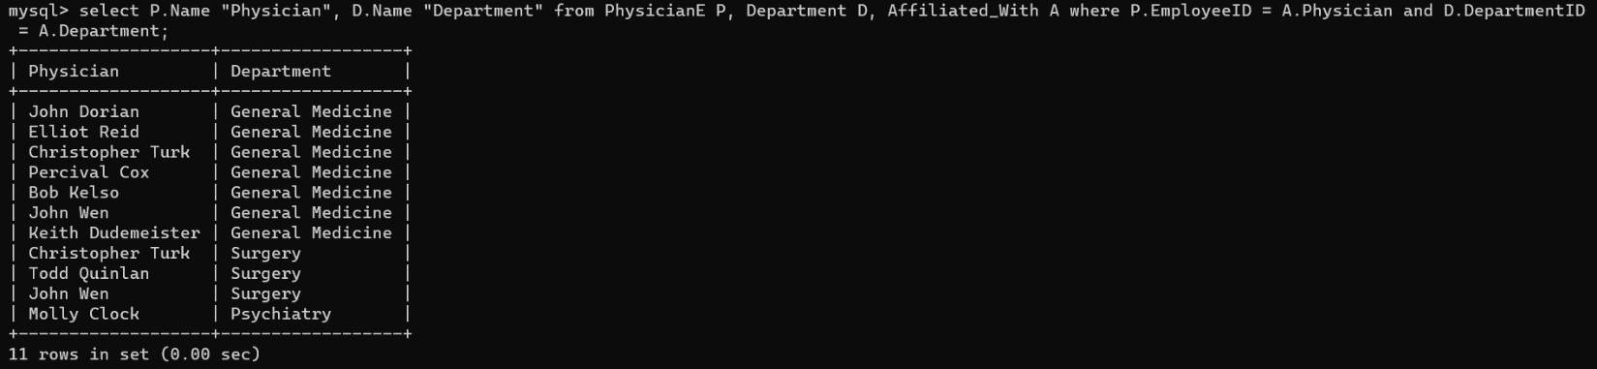

1. Write a query in SQL to find the name of patients and their physicians who does not require any assistance of a nurse.

> SELECT P.Name "Patient", Ph.Name "Physician" FROM Patient P, PhysicianE Ph, Appointment A WHERE P.SSN = A.Patient AND Ph.EmployeeID = A.Physician AND A.PrepNurse IS NULL;

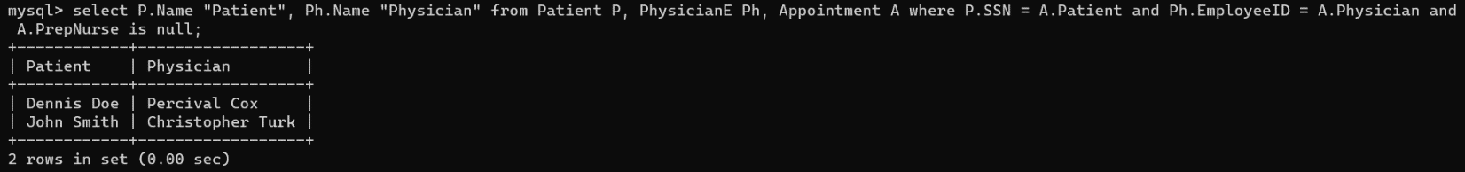

1. Write a query in SQL to find the name of the patients, their treating physicians and medication.

> SELECT P.Name "Patient", Ph.Name "Physician", M.Name "Medicine" FROM Patient P, PhysicianE Ph, Medication M, Prescribes Pr WHERE Pr.Patient = P.SSN AND Pr.Physician = Ph.EmployeeID AND Pr.Medication = M.Code;

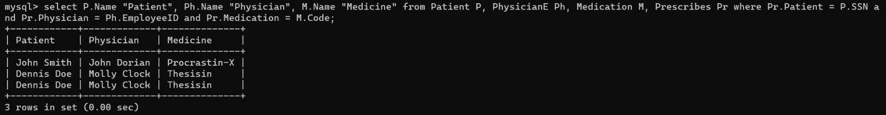

1. Write a query in SQL to find the name of the patients who taken an advanced appointment, and also display their physicians and medication.

> SELECT P.Name "Patient", Ph.Name "Physician", M.Name "Medicine" FROM Patient P, PhysicianE Ph, Medication M, Prescribes Pr WHERE Pr.Patient = P.SSN AND Pr.Physician = Ph.EmployeeID AND Pr.Medication = M.Code AND Pr.Appointment IS NOT NULL;

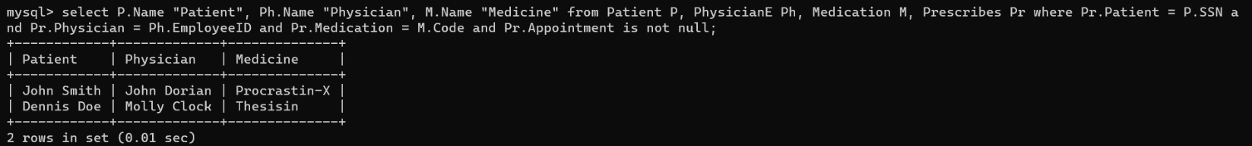

1. Write a query in SQL to obtain the name of the patients, their block, floor, and room number where they are admitted.

> SELECT P.Name "Patient", R.BlockCode "Block", R.BlockFloor "Floor", S.Room "Room Number" FROM Patient P, Stay S, Room R WHERE S.Patient = P.SSN AND S.Room = R.RoomNumber;

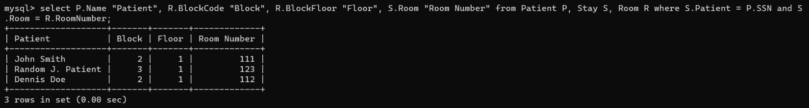

1. Write a query in SQL to make a report which will show - a) name of the patient, b) name of the physician who is treating him or her, c) name of the nurse who is attending him or her, d) which treatment is going on to the patient, e) the date of release, f) in which room the patient has admitted and which floor and block the room belongs to respectively.

> SELECT P.Name "Patient", Ph.Name "Physician", N.Name "Nurse", Pr.Name "Treatment", S.StayEnd "Date of Release", S.Room "Room", R.BlockFloor "Floor", R.BlockCode "Block" FROM Undergoes U JOIN Patient P ON U.Patient = P.SSN JOIN PhysicianE Ph ON U.Physician = Ph.EmployeeID LEFT JOIN Nurse N ON U.AssistingNurse = N.EmployeeID JOIN Procedures Pr ON U.Procedures = Pr.Code JOIN Stay S ON U.Stay = S.StayID JOIN Room R ON S.Room = R.RoomNumber;

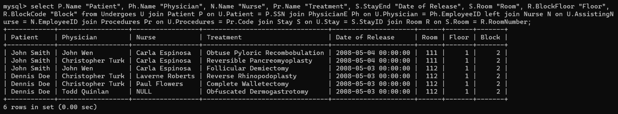

1. Write a query in SQL to obtain the name and position of all physicians who completed a medical procedure with certification after the date of expiration of their certificate.

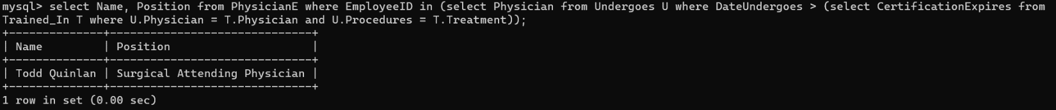> SELECT Name, Position FROM PhysicianE WHERE EmployeeID IN (SELECT Physician FROM Undergoes U WHERE DateUndergoes > (SELECT CertificationExpires FROM Trained_In T WHERE U.Physician = T.Physician AND U.Procedures = T.Treatment));

1. Write a query in SQL to Obtain the names of all patients who had at least two appointment where the nurse who prepped the appointment was a registered nurse and the physician who has carried out primary care.

> SELECT P.Name FROM Appointment A JOIN Patient P ON A.Patient = P.SSN JOIN Nurse N ON A.PrepNurse = N.EmployeeID JOIN PhysicianE Ph ON P.PCP = Ph.EmployeeID WHERE A.Patient IN (SELECT a.Patient FROM Appointment a GROUP BY a.Patient HAVING COUNT(*) >= 2) AND N.Registered = 1;

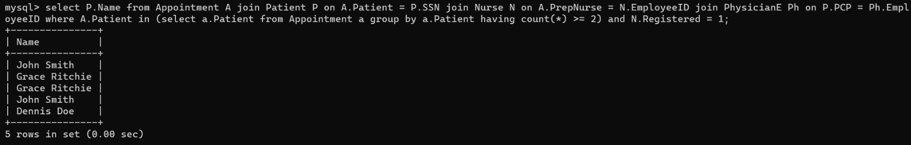

1. Write a query in SQL to obtain the names of all patients who has been undergone a procedure costing more than $5000 and the name of that physician who has carried out primary care.

> SELECT P.Name "Patient", Ph.Name "Physician" FROM Patient P, PhysicianE Ph, Undergoes U, Procedures Pr WHERE P.PCP = Ph.EmployeeID AND P.SSN = U.Patient AND U.Procedures = Pr.Code AND Pr.Cost > 5000;

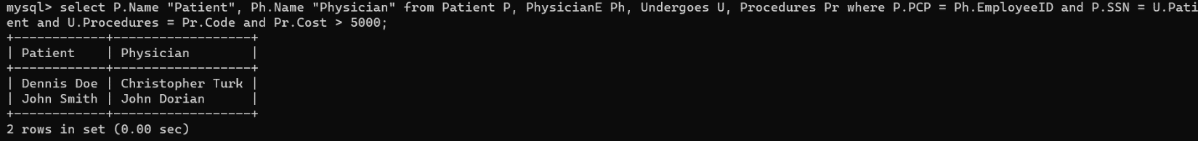

1. Write a query in SQL to Obtain the names of all patients who has been prescribed some medication by his/her physician who has carried out primary care and the name of that physician.

> SELECT P.Name "Patient", Ph.Name "Physician" FROM Patient P, PhysicianE Ph, Prescribes Pr WHERE P.PCP = Ph.EmployeeID AND P.SSN = Pr.Patient AND P.PCP = Pr.Physician;

