**IT253 Operating System Assignment**

**Name:** Niraj Nandish

**Roll No:** 191IT234

First Come First Serve

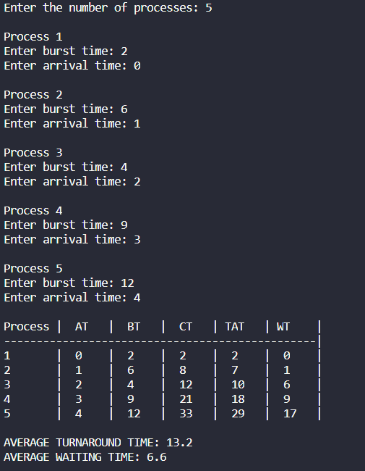

Shortest Job First Non-Preemptive

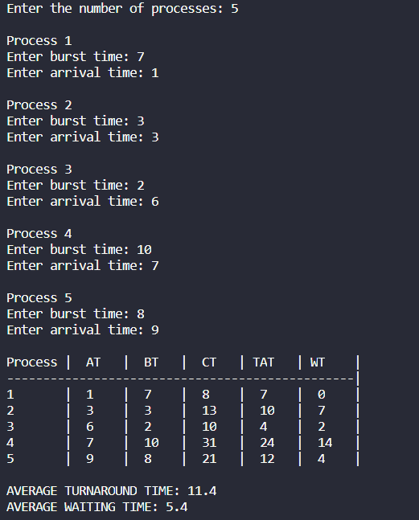

Shortest Job First Preemptive

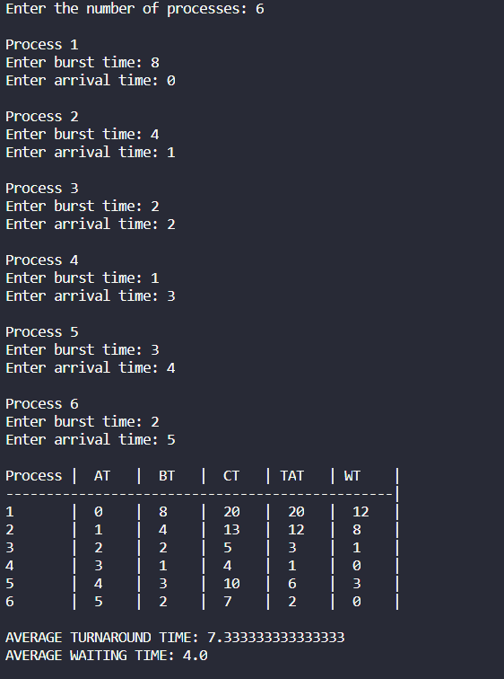

Round Robin

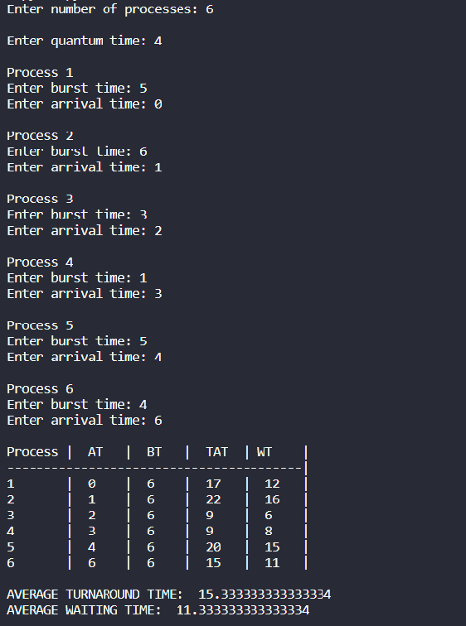

Producer Consumer using Semaphores

