JavaScript Assignment 10

1. Are Higher Order functions and Call back functions the same? If not,

briefly explain about both functions.

**Ans**. No, higher order functions and call-back functions are not the same.

**Higher order functions** **-** A Function which takes a function as an argument or return a function is called a higher order function

**Call-back function –** A call back is a function that is passed on to another function as an argument

2. Is filter a Higher Order function in JavaScript? If yes, why?

**Ans.** Yes, Filter is a Higher order function because it takes a function as an argument and do the necessary operation and returns an array.

3. Give an example of a Higher Order function and a call back function

used in the same program.

**Ans.** 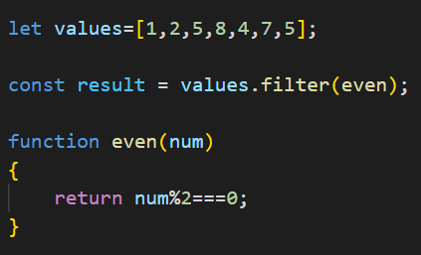

**Higher order function – Filter()**

**Call back function – even()**

4. Carefully check the example below:

a) What will be the output of this program ?

b) Which function is a Higher Order function here ?

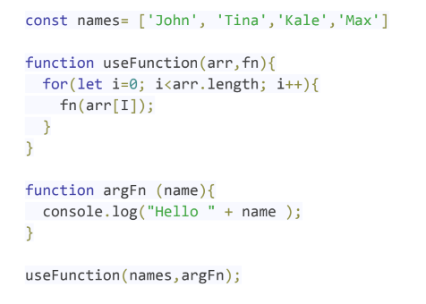

**Ans. a.)** Output of the program: (if **fn(arr[i])** is used)

Hello John

Hello Tina

Hello Kale

Hello Max

**b.)** Higher order function - **useFunction**