HeatScope: An Explainable, Spatially Validated and Equity-Aware Framework for Mapping Urban Heat Exposure and Prioritising Mitigation Interventions
October 2026

Abstract
Urban heat exposure mapping is increasingly operational: municipalities need cell-level estimates of where heat is intense, who is exposed, how much confidence to place in the estimate, and which interventions to deploy first under a fixed budget. Most published pipelines deliver only part of this chain, and reported accuracy figures are frequently optimistic because model selection uses random rather than spatially structured cross-validation. This paper presents HeatScope, an end-to-end framework for Bengaluru, India that couples four elements which the urban-climate and geospatial machine-learning literatures generally treat separately. First, a 250 m analysis grid is built over a 0.33° × 0.34° study region enclosing the metropolitan area, and within-cell upper-tail (p95) land-surface temperature is predicted from nine spectral, built-form, demographic and neighbourhood-mean predictors using gradient-boosted regression trees. Second, all model assessment uses five-fold cross-validation grouped by 240 spatially contiguous ~2.5 km blocks, with an explicit assertion that no block is shared between training and test partitions. Third, attribution is made operational rather than diagnostic: TreeSHAP values for four neighbourhood-mean features account for 45.42% of total model attribution, which is then propagated into a priority score and into intervention benefit weights. Fourth, distributional objectives enter the allocation problem itself, as a mixed-integer program that maximises scenario benefit subject to a budget, per-type capacity limits, and a floor on the share of benefit accruing to equity-priority cells. Out-of-fold performance is MAE 1.174 °C, RMSE 1.548 °C and R² 0.655, a 3.62% RMSE reduction over a five-feature baseline, and cross-fitted prediction intervals achieve 94.94% empirical coverage at a mean width of 6.14 °C. Requiring that 70% of benefit accrue to equity-priority cells costs 18.76% of total benefit, while a 60% floor costs 5.22%. A 500-run Monte Carlo analysis of cost, effect and capacity uncertainty returns a certified-optimal solution in 475 runs. We report each of these results with its disqualifying caveats made explicit: the target is a single-date spatial percentile and not a temporal heat extreme; attribution is associational, not causal; surface temperature is not air temperature; benefit and cost are dimensionless scenario units; and the reported intervals are empirically calibrated but carry no formal coverage guarantee.
Index Terms—urban heat island, surface temperature, remote sensing, explainable AI, spatial cross-validation, equity-aware optimisation, urban heat vulnerability.

I. Introduction
Urban heat is not distributed uniformly within a city, and the people who live in its hottest neighbourhoods are frequently those with the least capacity to adapt [1], [2]. This coupling of hazard and social context is what motivates the development of heat vulnerability mapping rather than heat-hazard mapping alone [11], [14]. Satellite land-surface temperature (LST) has become the workhorse measurement for such mapping at city scale, because thermal-infrared sensors such as those aboard Landsat 8 and 9 provide 30 m observations with a validated processing chain [1]–[4] and a long, stable record [6].
The decision problem, however, is not merely to produce a map. A municipality must also decide where its measurements are uncertain, which places to treat as high priority, and what mix of interventions to buy with a fixed budget, ideally without systematically disadvantaging the populations already most exposed. Each of these steps has its own methodological literature, and the most serious errors observed in published urban-heat machine-learning work are methodological rather than algorithmic. Three recur.
The first is optimistic validation. Random k-fold cross-validation on spatially autocorrelated data places near neighbours of a test cell in the training set, so reported error understates true spatial error; this bias has been quantified for large-scale environmental mapping [26], [27]. The second is over-reading of attribution. Shapley-based explanations describe how a fitted model uses its inputs; they do not establish that the input causes the outcome [28], [29]. The third is silent conflation of two quantities that look alike: a percentile computed across spatial pixels within one cell on one date is not a temporal extreme, and surface temperature is not air temperature [5], [11].
Against this background we designed HeatScope to be auditable end to end. Every reported number in this paper is reproducible from a committed artifact by a fixed script order, and where an artifact does not support an intended claim we report the narrower claim that it does support rather than omitting the discrepancy. Section VIII enumerates the cases where this forced a change of framing; we regard that enumeration as a contribution in its own right, because the affected quantities are precisely those that decision-makers would otherwise rely on.
The contributions of this work are as follows.
- A complete 250 m pipeline for Bengaluru producing within-cell upper-tail LST, spectral indices, built-form metrics and gridded population, from a single pinned Landsat 8 acquisition through to intervention siting, with every intermediate artifact retained.
- A spatially structured evaluation protocol — five folds over 240 contiguous ~2.5 km blocks, with a programmatic leakage assertion — applied not only at final evaluation but to every model and every uncertainty estimate in the chain (Section V-B).
- Demonstration that neighbourhood-mean context features measurably improve both accuracy and, more importantly, error balance across the temperature distribution, reducing hottest-quintile bias by 8.08% (Section VI-C).
- A cross-fitted prediction-interval scheme with reported coverage by temperature quintile, which exposes a 7-point coverage deficit in the hottest quintile that a single pooled number conceals (Section VI-D).
- An equity-constrained mixed-integer allocation model, with an explicit account of what each constraint costs in benefit and of where its inputs come from (Section VI-E).
- A documented negative result: under the implementation’s index-based benefit formulation, cell-invariant per-intervention effect coefficients cannot influence any ranking (Section VI-E.3).
Section II positions this work. Section III gives the methodology, Section IV the study area and data, Section V the experimental design, Section VI results, Section VII discussion, Section VIII limitations, and Section IX concludes.

II. Related Work
Urban heat island remote sensing. Thermal remote sensing of urban climates [5] established the physical basis for retrieving surface temperature and, critically, the distinction between surface and air temperature that bounds what any LST product can claim. Subsequent reviews catalogue retrieval methods, scaling problems, and open challenges [6], [7], and connect mitigation effectiveness to vulnerability and health outcomes [8], [9]. The magnitude of urban heat islands has been shown to depend substantially on population and climate rather than urban form alone [10], which supports including demographic covariates alongside spectral ones.
Exposure, vulnerability, and human thermal comfort. Using LST as a proxy for human thermal exposure is standard practice but carries systematic caveats, most importantly that surface and near-surface air temperature diverge with time of day, season, and surface moisture [5], [11]. Exposure time and acclimatization further separate what a thermal index measures from what a person experiences [12]. Recent multi-city work on India documents how urbanisation alters heat exposure risk across Indian cities [13].
Equity in heat exposure. Exposure is not merely an environmental quantity but a distributional one: a detailed analysis of major US cities found systematically disproportionate exposure to urban heat island intensity [14]. Normative frameworks for justice criteria in urban climate adaptation [33] and operationalised adaptation justice indices [34] exist but, in the cases we verified, equity is evaluated on a finished hazard map rather than embedded in the allocation decision. The modifiable-areal-unit sensitivity of environmental-justice findings [35] further motivates fixing and justifying an analysis resolution.
Spectral indices. NDVI originates with Rouse et al. [17]; the normalised difference moisture index with Gao [15]; NDBI with Zha et al. [16]. We note in Section VI-B that NDBI and NDMI as defined for Landsat are algebraic negatives of one another, which is a property of the definitions rather than of the data.
Gridded population and built form. WorldPop provides 100 m gridded population denominators via random-forest dasymetric redistribution of census counts [18], [19], [20]. Building footprints from conflated open sources [21] supply built-form coverage. For Bengaluru specifically, studies have related LST to urban growth [36], land cover by concentric ring [37], and the controlling biophysical factors [38]; tropical Indian-city work supports the vegetation and urbanisation feature set used here [39].
Modelling method. Gradient-boosted decision trees [22] and their scalable variants [23] are the workhorses of tabular environmental prediction; extremely randomised trees [24] and random forests [25] provide standard tree-ensemble baselines.
Spatially structured validation. Roberts et al. [26] provide the definitive treatment of cross-validation under spatial, temporal, hierarchical and phylogenetic structure. Ploton et al. [27] quantify the resulting optimism for spatial prediction problems.
Explainability. TreeSHAP [28] and the original Shapley formulation [29] provide exact additive attributions for tree ensembles, which is what permits attribution to be propagated into downstream scenario weights rather than merely displayed.
Predictive uncertainty. Split conformal prediction [30] and its exposition [31] define the conditions under which a nominal 95% interval actually carries 95% coverage. We use these as the benchmark our intervals are measured against, and we state explicitly where they fall short.
Sensitivity analysis. Design-based Monte Carlo practice and its reporting requirements are set out by Saltelli et al. [32].
Optimisation. The allocation stage solves a mixed-integer program through the HiGHS solver [40], [41]. We were unable to verify a peer-reviewed formulation that allocates urban heat mitigation under budget and equity constraints, and we note this gap rather than cite a loosely related study.

III. Methodology

A. Overview
Fig. 1 gives the pipeline as implemented. Four data layers — Landsat Collection 2 Level-2 surface reflectance and surface temperature, conflated building footprints, and gridded population — are reduced to a common 250 m grid. Spectral indices and zonal statistics form a feature table. Neighbour context features are derived from that table. Models are trained and assessed under block-grouped spatial cross-validation; attribution is computed and propagated into a priority score and intervention benefit weights; a mixed-integer program allocates interventions; a Monte Carlo analysis perturbs the scenario parameters.
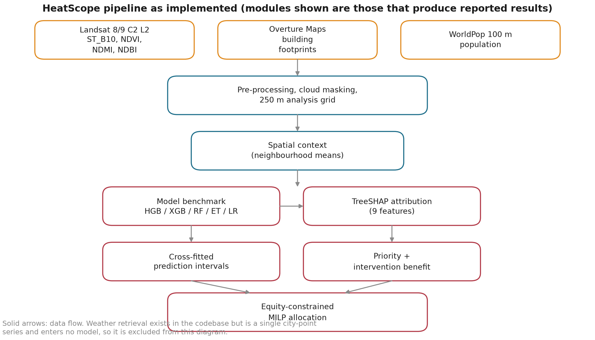
Fig. 1. HeatScope as implemented. Modules shown are those that produce reported results. Weather retrieval exists in the codebase but yields a single city-point series and enters no model, so it is excluded.

B. Pre-processing and grid construction
A single Landsat 8 Collection 2 Level-2 scene is retrieved from STAC: collection landsat-c2-l2, path 144, row 051, acquisition 2026-04-01 05:10:29 UTC, reported cloud cover 0.23% (LC08_L2SP_144051_20260401_02_T1). Assets red, nir08, swir16, lwir11 and qa_pixel are used. Radiometric scaling follows the Collection 2 conventions [1], [2]: surface reflectance is computed as $ρ=0.0000275×DN−0.2$, and land-surface temperature as $T_{C}=0.00341802×DN+149.0−273.15$.
Quality screening is applied per pixel. Pixels are masked where the QA_PIXEL band flags fill, dilated cloud, cirrus, cloud, cloud shadow, or snow; where any band’s digital number is non-positive; where scaled reflectance falls outside $[0,1]$; where LST falls outside $[−50,80] ^{∘}C$; or where any computed index falls outside $[−1,1]$. The resulting masked scene contains 39,624,101 valid 30 m pixels over a 7541 × 7701 window in UTM zone 43N (EPSG:32643).
Three normalised indices are computed per pixel:
$$NDVI=\frac{NIR−RED}{NIR+RED}$$
$$NDBI=\frac{SWIR−NIR}{SWIR+NIR}$$
$$NDMI=\frac{NIR−SWIR}{NIR+SWIR}$$
The analysis grid is a regular 250 m lattice in EPSG:32643 whose extent is derived from the temperature raster, clipped to the study-region polygon, and renumbered. It contains 21,845 cells totalling 1,348.25 km². Because cells are clipped to the study-region polygon, boundary cells have reduced area; 30 cells have an area below 25% of nominal, the smallest being 10.54 m². These are retained but flagged, and Section VIII discusses their influence.

C. Feature construction
Eleven predictors are used in the base model. Spectral features are the per-cell mean and median of NDVI, NDBI and NDMI, six statistics in total. Demographic and built-form features are population count, population density, building count, building area and building coverage percentage, five more. The within-cell 95th percentile of LST is the target and is never supplied to the model.
Two implementation properties are consequential and are reported as findings rather than hidden. First, the denominators in (2) and (3) are the same expression with the numerator sign reversed, so $NDBI≡−NDMI$ exactly for every pixel. We verified this numerically: $max|NDBI+NDMI|=0.0$ over all 39,624,101 valid pixels, and the Spearman correlation between the two per-cell means is exactly $−1.0000$. The eleven-feature set therefore contains one redundant pair, and the reduced five-feature set used in the ablation removes NDBI. Second, population is aggregated from the 100 m population raster by centre-in-cell selection with no proportional-area weighting, so cells straddling raster edges can be miscounted by up to one raster pixel.

D. Neighbourhood context features
For each of four features — NDVI, NDMI, population density and building coverage — the mean over queen-contiguous neighbours is computed, excluding the focal cell itself. Queen adjacency is established by a spatial-index candidate query followed by an exact touches-or-intersects test. Excluding the focal cell guarantees that no feature value can enter the feature vector that describes it. Four context columns are carried forward; local-contrast and neighbourhood-standard-deviation columns are computed by the same routine but are not consumed downstream.

E. Heat vulnerability layer
A composite index is computed to support descriptive mapping and, more importantly, to supply the structural-vulnerability term used downstream. Each component is normalised by clipping to its 1st and 99th percentiles and rescaling to $[0,1]$. An exposure score combines normalised mean LST (0.50), normalised p95 LST (0.30) and normalised mean NDBI (0.20). A capacity score combines normalised mean NDVI (0.45), normalised mean NDMI (0.35) and a normalised built-form deficit (0.20). A sensitivity score is the normalised log population density. The index is the product $exposure×sensitivity×(1−capacity)$, rescaled, ranked, and cut into quintile categories. These weights are expert-elicited and are not validated; Section VIII states the consequences.

F. Attribution
TreeSHAP [28], [29] is computed for the nine-feature context model over 5,000 cells stratified by target quantile. Because the explainer uses interventional perturbation estimated from a 100-row background sample, additivity is approximate; the measured discrepancy between base+j​ϕj and the model prediction is reported in Section VI-C. Attribution values are used twice: as a diagnostic of which predictors the model relies on, and as input to the priority construction described next.

G. Priority and intervention benefit
The priority construction is deliberately retrospective-free. Exposure enters only through out-of-fold predicted LST; the observed temperature is never used. A risk term combines the prediction with an uncertainty half-width, and a structural-vulnerability term combines normalised log population density with the built-form capacity score. The operational priority is a weighted blend of the normalised risk term and the structural-vulnerability term, with cells in the top 30% of structural vulnerability flagged as equity-priority cells.
For each cell and each of four intervention types — urban tree, shade structure, cool roof and cooling centre — an opportunity term expresses physical or demographic suitability, computed exclusively from remotely sensed and demographic quantities so that the benefit model does not circularly consume the target. A need term combines the risk and structural-vulnerability terms. The per-cell benefit for intervention type $t$ is
$$\begin{aligned}{benefit}_{i,t}&={need}_{i}×{opportunity}_{i,t} \\ & ×{effect}_{t}×{populationFactor}_{i}\end{aligned}$$
with scenario parameters ${effect}_{t}$ and unit costs given in Table V. One property of (4) deserves emphasis because it constrains what can be claimed: ${effect}_{t}$ is a cell-invariant constant per intervention type, so it multiplies every cell identically and therefore cannot alter any per-cell ranking. Its only influence is through the cost–benefit trade-off inside the allocation model. Any statement that one intervention is preferable to another because of its effect coefficient would be circular; Section VI-E.3 confirms this empirically.
Eligibility gates restrict which cells each intervention may serve. Each gate is a conjunction of in-sample median or quartile thresholds on NDVI, NDMI, building coverage, population density, risk and structural vulnerability. Section VI-F discusses what this implies for the resulting eligibility rate.

H. Equity-constrained allocation
Let $x_{i,t}∈\{0,1\}$ indicate that intervention type $t$ is assigned to cell $i$. The allocation model maximises total benefit subject to a per-cell single-intervention constraint, a budget constraint, per-type capacity limits, and an equity floor:
maxi​t​benefiti,t xi,t
s.t. t​xi,t≤1 ∀i
i​t​costt xi,t≤B
t​xi,t≤Ct ∀t
(1−α)i∈E​benefiti,txi,t−αi∉E​benefiti,txi,t≥0
where $E$ is the equity-priority set and constraint (9) is equivalent to a floor $α$ on the share of benefit accruing to $E$. Solutions are obtained with HiGHS [40], [41] via scipy.optimize.milp with a relative MIP gap of ${10}^{−4}$.
Two configurations are reported. In the capacity-bound configuration the budget is $n_{cells}\overset{‾}{c}f$ with $\overset{‾}{c}$ the mean unit cost and $f=0.5$; capacities bind and the budget does not. In the budget-bound configuration the budget is ft​ctCt with $f∈\{0.25,0.5,0.75,1.0\}$; the budget binds at utilisation 0.9999–1.0000 and capacities are slack. Section VI-E reports both and states which constraint is active in each.

I. Monte Carlo sensitivity
Cost and effect coefficients are perturbed by uniform multiplicative factors on $[0.7,1.3]$ and capacities by factors on $[0.8,1.2]$, with capacity ceilings rounded to integers and floored at one. 500 runs are executed: 100 selection-pipeline runs and 50 equity-pipeline runs, each evaluated across multiple budget and equity settings. The random seed is fixed at 42.

IV. Study Area and Data
The study region is a 0.33° × 0.34° bounding box (12.82–13.16° N, 77.45–77.78° E) enclosing the Bengaluru metropolitan area in the Indian state of Karnataka, analysed on a 250 m grid of 21,845 cells covering 1,348.25 km². Of these, 21,815 carry a valid temperature target. The region contains a gridded population of 7,458,314 persons, a mean density of 5,533 persons per km$​^{2}$.
Bengaluru is an appropriate case for three reasons. It is among the larger and faster-growing Indian metropolitan areas; LST–urban-growth relationships there are already documented [36], [37] and the controlling biophysical factors identified [38]; and the tropical semi-arid setting means that vegetation and moisture contrasts are strong, which is the regime in which the vegetation and moisture indices carry the most signal.
Table I. Data sources and characteristics.
Layer | Source | Native resolution | Role
Surface temperature, surface reflectance | Landsat 8 C2 L2, path 144 / row 051, 2026-04-01, cloud 0.23% | 30 m | Target and spectral predictors
Building footprints | Overture Maps Buildings theme, snapshot 2026-08-13, quadkey 123303312, ODbL | Vector | Count, area, coverage
Population | WorldPop 100 m gridded denominators [20] | ~100 m | Count, density
Derived grid | This work | 250 m | Analysis unit
Note that the study region is a bounding box rather than an administrative boundary, and that the building layer is a single quadkey tile of a global conflation product rather than a complete extract.
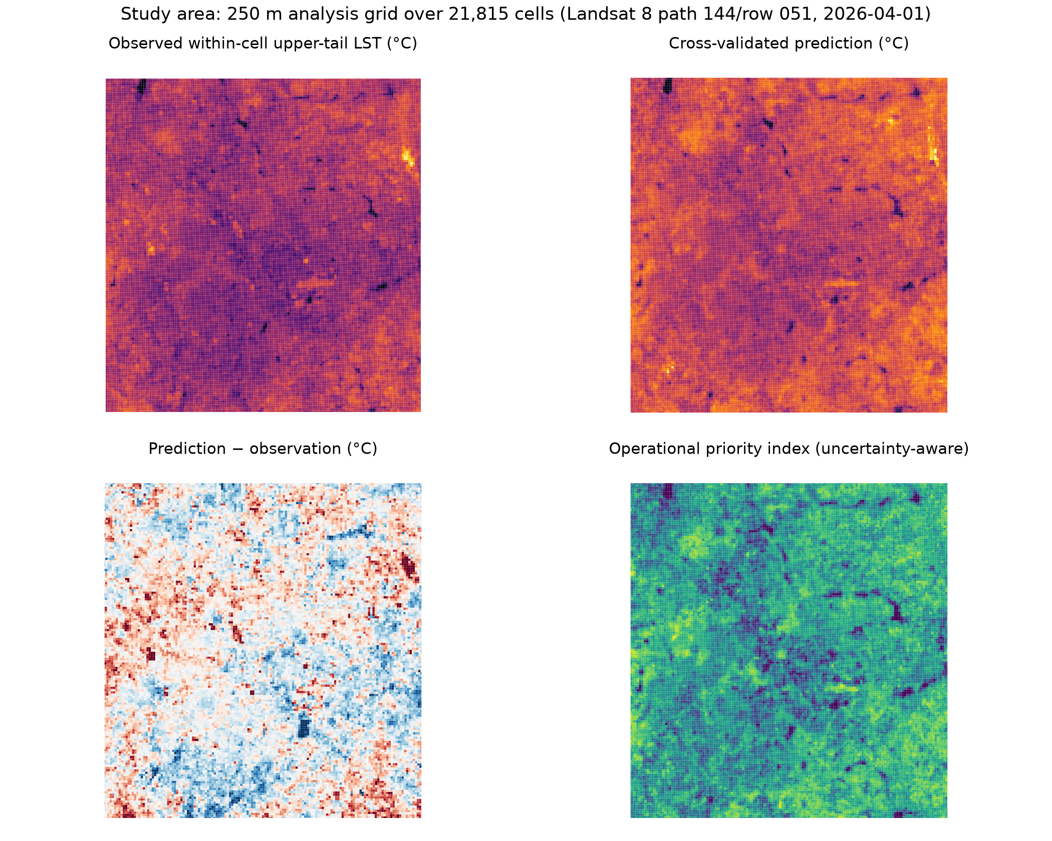
Fig. 2. Observed within-cell upper-tail LST, cross-validated prediction, prediction residual, and the operational priority index. The systematic warm residual over the urban core corresponds to the positive hottest-quintile bias quantified in Section VI-C.

V. Experimental Design

A. Predictors and models
Five estimators are benchmarked under identical folds and identical predictors: HistGradientBoostingRegressor (300 iterations, learning rate 0.05, 31 leaves, L2 1.0), XGBRegressor (500 estimators, depth 6, learning rate 0.05, subsample 0.8, column subsample 0.8), RandomForestRegressor (300 trees, $\sqrt{p}$ features, minimum leaf 2), ExtraTreesRegressor (300 trees, all features, minimum leaf 2), and a standardised linear regression. All stochastic components use seed 42.
Three feature sets are compared. The 11-feature base set is the full predictor list above. The 5-feature reduced set drops NDVI median, both NDBI statistics, NDMI median, population count and building area, retaining NDVI mean, NDMI mean, population density, building coverage percentage and building count. The 9-feature context set is that reduced set plus the four neighbourhood means, and it is the model whose results the paper reports as primary.

B. Spatially structured cross-validation
Cells are assigned to 240 contiguous blocks of approximately 2.5 km using a row–column block identifier, giving exactly 48 blocks per fold. Five-fold grouped cross-validation holds out whole blocks, so that no training cell is spatially adjacent to a test cell through block membership. The implementation asserts disjoint block sets and raises an error otherwise. Training sets contain 17,447–17,455 cells and test sets 4,360–4,368 cells.
Because fold-to-fold variation is substantial relative to the differences between models, all performance figures are reported as mean ± standard deviation over the five folds. The hottest- quintile stratification is cut on the pooled target before cross-validation and is used only for reporting, never as a feature; pooled quintile statistics are therefore reported, not per-fold quintile statistics.

C. Uncertainty evaluation
For each held-out fold, the 90th and 95th percentiles of absolute residual are computed from the other four folds and used as symmetric half-widths. This is fold-wise cross-fitting. We do not claim formal conformal validity: the quantiles are estimated by linear interpolation rather than by the conformal index $⌈(n+1)(1−α)⌉$, and the calibration residuals for a given fold originate from models trained on folds that include it. Section VI-D reports what this scheme actually achieves.

D. Reproducibility protocol
Every module was re-executed from the committed code and compared against the pre-existing artifacts. Base-model fold metrics agreed to within $4.4×{10}^{−16}$; context-model metrics agreed exactly; the SHAP importance table was byte-identical; both interval schemes reproduced their reported coverage and width exactly. Separately, the predictions stored in the operational-priority artifact were compared against the regenerated model output across all 21,815 cells, giving a maximum absolute difference of exactly 0.0. Section VIII records the two reproducibility limitations that this protocol exposed.

VI. Results

A. Model comparison
Table II. Out-of-fold performance, 11-feature set, five block-grouped folds (mean ± SD).
Model | MAE (°C) | RMSE (°C) | R²
HistGradientBoosting | 1.213 ± 0.051 | 1.591 ± 0.070 | 0.636 ± 0.043
XGBoost | 1.215 ± 0.047 | 1.595 ± 0.069 | 0.634 ± 0.042
RandomForest | 1.218 ± 0.051 | 1.596 ± 0.074 | 0.633 ± 0.045
ExtraTrees | 1.226 ± 0.054 | 1.607 ± 0.076 | 0.628 ± 0.046
LinearRegression | 1.290 ± 0.068 | 1.698 ± 0.089 | 0.585 ± 0.054
Gradient boosting gives the best mean performance on all three metrics. The margin over the runner-up is 0.002 °C in MAE, which is more than an order of magnitude smaller than the fold-to-fold standard deviation of approximately 0.05 °C. We therefore describe the tree ensembles as performing comparably, and note that this study is not powered to separate them. The linear model is approximately 6% worse in MAE, which is the one comparison that survives the fold variability.
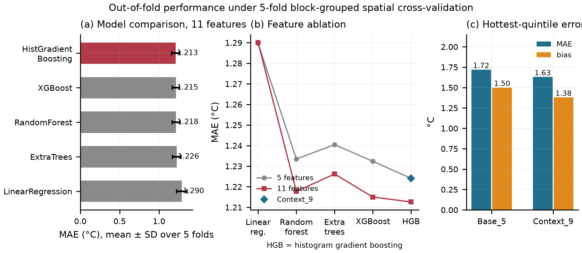
Fig. 3. Model panels: (a) model comparison with fold dispersion, (b) feature ablation, and (c) hottest-quintile error and bias before and after adding neighbourhood context.

B. Feature audit and index redundancy
The per-cell means of NDBI and NDMI correlate at exactly $−1.0000$, and their univariate Spearman association with the target is identical at 0.7416 and $−0.7416$ respectively. This is an algebraic identity of definitions (1)–(3), not an empirical finding, and it means the apparent contribution of two indices in the 11-feature base set is one. The remaining redundancy structure is milder but non-trivial: NDVI mean and median correlate at 0.9793, building coverage and building area at 0.9990, and population count and density at 0.9985.

C. Neighbourhood context and error balance
Adding four neighbourhood-mean features improves every reported metric, and improves the hottest cells more than the average cell.
Table III. Feature-set ablation (five block-grouped folds).
Feature set | MAE (°C) | RMSE (°C) | R² | Q5 MAE (°C) | Q5 bias (°C)
Reduced (5) | 1.2241 | 1.6060 | 0.6286 | 1.7198 | +1.5005
Context (9) | 1.1738 | 1.5478 | 0.6548 | 1.6305 | +1.3792
Change | −4.11% | −3.62% | +0.026 | −5.19% | −8.08%
The 3.62% RMSE reduction and +0.026 R² gain are modest but consistent. The more informative result is the bias column. In the hottest quintile the mean observed value exceeds the mean prediction by 1.38 °C — a systematic under-prediction of precisely the cells a heat-adaptation programme would target first. Neighbourhood context reduces this bias by 8.08%, which is directionally encouraging but does not eliminate it. We regard the residual bias, not the headline MAE, as the principal modelling finding of this study.
Attribution for the context model (Fig. 4) shows that the four neighbourhood features jointly account for 45.42% of total attribution — more than the four focal features combined (54.58%). NDMI alone, summing focal and neighbourhood contributions, accounts for 49.38%. This is the quantitative basis for propagating attribution into the downstream benefit model rather than presenting it only as a diagnostic.
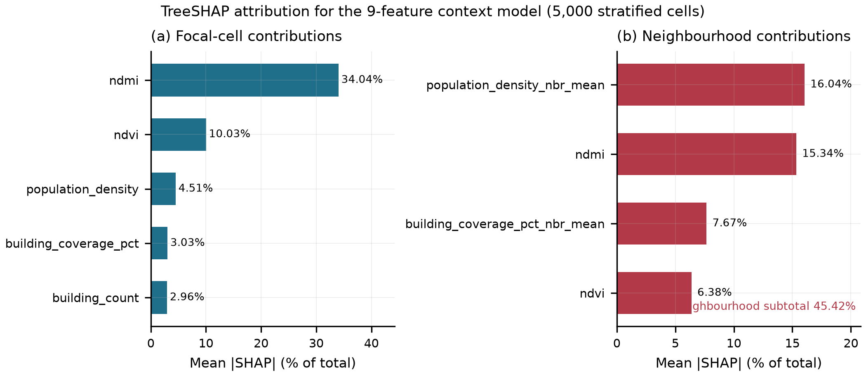
Fig. 4. TreeSHAP global attribution for the context model, split into focal-cell and neighbourhood contributions. Attributions are associational model decompositions, not causal effects.
We also report an additivity diagnostic, since the explainer uses interventional perturbation estimated from a 100-row background sample and therefore satisfies additivity only approximately. The absolute discrepancy between base+j​ϕj and the model prediction has median $1.5×{10}^{−8}$ °C and mean $4.6×{10}^{−4}$ °C, but a maximum of 1.09 °C; 19 of 5,000 evaluated cells (0.38%) exceed 0.01 °C. For the worst affected cell this residual is comparable to a full model error, so we report the distribution rather than a summary statistic alone.
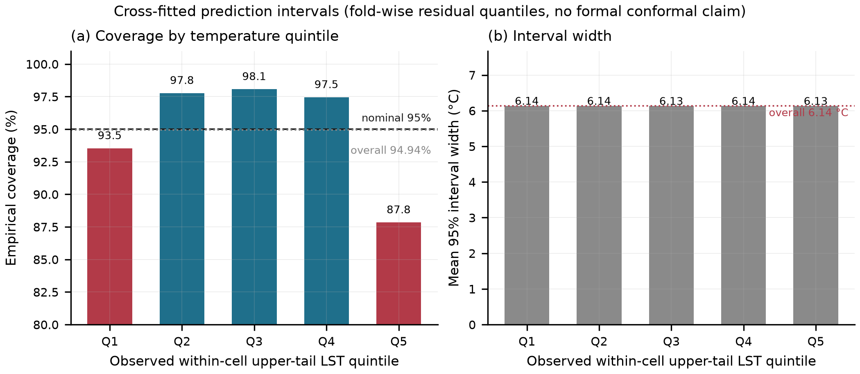
Fig. 5. Cross-fitted 95% prediction intervals: empirical coverage and width by observed temperature quintile. Overall coverage is 94.94%.

D. Predictive uncertainty
Cross-fitted intervals achieve 94.94% overall coverage at a mean width of 6.14 °C (Table IV). Width is effectively constant across quintiles (6.134–6.138 °C), which is a direct consequence of the symmetric, quantile-based construction: it cannot adapt to heteroscedasticity. The consequence is visible in coverage, which ranges from 98.07% in the third quintile to 87.85% in the hottest quintile. The pooled number is therefore close to nominal for a reason that does not hold in the part of the distribution that matters most: the model is over-confident where it is warmest, and the residual bias documented in Section VI-C is the direct cause. A heteroscedastic scheme was also implemented, but its calibration factor is estimated on the same cells whose coverage it then reports, so its 95.00% coverage is close to definitional and its half-widths are roughly 2.5 times the model’s typical error; we do not present it as validated. It is retained in the codebase only as a relative risk-ranking layer, which is the sole use the priority construction makes of it.
Table IV. Cross-fitted 95% prediction intervals (21,815 cells).
Group | Cells | Coverage (%) | Mean width (°C)
All | 21,815 | 94.94 | 6.136
Q1 (coolest) | 4,364 | 93.54 | 6.138
Q2 | 4,362 | 97.78 | 6.136
Q3 | 4,363 | 98.07 | 6.134
Q4 | 4,365 | 97.46 | 6.135
Q5 (hottest) | 4,361 | 87.85 | 6.134

E. Equity-constrained allocation
Table V. Scenario parameters (dimensionless index units).
Intervention | Unit cost | Effect coefficient | Capacity (cells)
Urban tree | 1.0 | 1.0 | 1,000
Shade structure | 1.4 | 1.2 | 1,500
Cool roof | 2.0 | 1.1 | 800
Cooling centre | 2.5 | 1.3 | 800
The equity-priority set $E$ comprises the top 30% of cells by structural vulnerability. As Section III-G notes, structural vulnerability is a monotone function of log population density scaled by built-form capacity, so $E$ is effectively a high-density set. The equity constraint (9) is consequently a density-weighted benefit-share floor and should be read as such.
E.1 Capacity-bound configuration. With per-type capacities binding and the budget slack at 35.6% utilisation, the mixed-integer optimum selects 4,100 cells — every capacity ceiling exactly — for a total benefit of 2074.49. A benefit-per-cost greedy selects 3,629 cells for a benefit of 1616.44, an apparent 28.34% gap. We report this number with its mechanism attached: it is a capacity-saturation result, not a budget-efficiency result. The optimiser gains because it is free to fill every ceiling, whereas greedy stops when no further item fits its ratio ordering. An equity floor of $α=0.6$ leaves the solution unchanged, because the unconstrained optimum already delivers a 62.16% equity share; the row is identical to the unconstrained row and carries no information. Only $α=0.7$ binds, reducing benefit to 1996.90, a 3.74% cost.
E.2 Budget-bound configuration. Setting the budget to $f$ times the cost of filling every capacity makes the budget the active constraint. Total benefit rises from 859.57 at $f=0.25$ to 2074.49 at $f=1.0$, while the equity share falls from 94.0% to 62.2% — a genuine and interpretable trade-off in which scarce budget is disproportionately absorbed by cells outside the equity set. Equity floors at or below 0.6 are inert at every budget level (the solution is unchanged), so only $α=0.7$ and 0.8 produce distinct allocations; at $f=0.75$, $α=0.8$ forces benefit down to 1750.75.
Table VI. Allocation results. Costs and benefits are dimensionless scenario units.
Configuration | Constraint active | Equity floor | Cells | Cost | Benefit | Equity share
Capacity-bound | Capacity (budget 35.6% used) | — | 4,100 | 6,700 | 2074.49 | 0.6216
Capacity-bound | Capacity | 0.60 | 4,100 | 6,700 | 2074.49 | 0.6216 (inactive)
Capacity-bound | Capacity | 0.70 | 4,100 | 6,700 | 1996.90 | 0.7000
Budget-bound | Budget ($f$ = 0.25) | — | 1,482 | 1,674.8 | 859.57 | 0.9401
Budget-bound | Budget ($f$ = 0.50) | — | 2,609 | 3,350 | 1502.00 | 0.8233
Budget-bound | Budget ($f$ = 0.75) | — | 3,287 | 5,024.5 | 1874.02 | 0.7250
Budget-bound | Budget ($f$ = 1.00) | — | 4,100 | 6,700 | 2074.49 | 0.6216
Budget-bound | Budget ($f$ = 0.75) | 0.80 | 3,147 | 5,024.0 | 1750.75 | 0.8000
A second configuration, in which the budget is defined as a fraction of mean per-cell cost and no capacity limits apply, yields the clearest measure of what the equity constraint costs. Its unconstrained optimum (benefit 2470.69, equity share 0.5687) is reproduced exactly by a simple ranking baseline, which independently confirms optimality. Imposing floors then gives: $α=0.5$ no change; $α=0.6$ benefit 2341.74 (−5.22%); $α=0.7$ benefit 2007.31 (−18.76%), with the equity share pinned at the target in each case and solver status optimal with relative MIP gap below $8×{10}^{−5}$. Requiring that 70% of benefit accrue to equity-priority cells costs 18.76% of total benefit; a 60% floor costs 5.22%.
E.3 What the effect coefficients can and cannot do. Because ${effect}_{t}$ is cell-invariant in (4), it cannot change which intervention is preferred at any cell, nor any per-cell ranking of cells. We verified this directly: multiplying all effect coefficients by a common scalar leaves every allocation decision unchanged. We therefore make no claim about the relative effectiveness of the four intervention types. Their only influence is through the cost–benefit trade-off, where a higher effect and a higher cost together determine which types a tight budget favours — an assumption we state rather than a result we estimate.
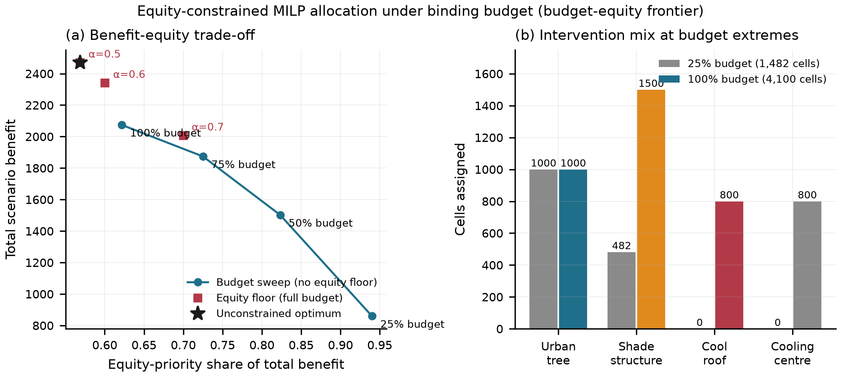
Fig. 6. Allocation panels: (a) benefit–equity trade-off for the budget sweep and the equity floors, and (b) intervention mix at the budget extremes, where the 25% budget is absorbed almost entirely by urban trees while the full budget saturates all four types.

F. Eligibility
5,084 of 21,815 cells (23.3%) are eligible for at least one intervention: 4,192 for urban trees, 3,274 for cool roofs, 2,925 for shade structures and 2,520 for cooling centres. This rate should not be read as an empirical finding about Bengaluru. Every gate is a conjunction of in-sample median and quartile thresholds, so 23.3% is close to what the threshold definitions imply rather than a property of the city. Externally justified thresholds — canopy targets or planning standards — would be required to make the number informative.

G. Robustness
Of 500 Monte Carlo runs, 475 return a certified-optimal solution and 25 terminate on the 20-second time limit, which is recorded as a missing value rather than as a failure flag. All 192 certified-optimal equity runs satisfy their equity target; the 8 time-limited equity runs cannot be assessed. Each run perturbs cost and effect by up to ±30% and capacities by up to ±20%. The 500 runs share 150 distinct parameter draws, each evaluated across several budget and equity settings, so the budget and equity levels are not independent replications.

VII. Discussion
Three results carry practical significance.
Neighbourhood context is worth more for error balance than for accuracy. A 3.62% RMSE reduction is a modest gain that a practitioner might reasonably dismiss. The 8.08% reduction in hottest-quintile bias is a different kind of result, because the hottest quintile is where an adaptation budget should be concentrated and where the model was demonstrably least trustworthy.
Pooled uncertainty metrics conceal the failure mode that matters. Reporting 94.94% coverage would be accurate and uninformative. The 87.85% figure in the hottest quintile, paired with a constant interval width, identifies a specific, actionable weakness: the interval construction is symmetric and cannot widen where the model is over-confident. A municipality relying on these intervals to trigger intervention would find the trigger firing too late in exactly the neighbourhoods where heat is most dangerous. We regard the per-quintile breakdown as a reporting requirement for any spatial prediction interval, not an optional diagnostic.
Equity has a measurable price, and the price depends on how binding the constraint is. A 60% equity floor costs 5.22% of benefit; a 70% floor costs 18.76%. Meanwhile budgets below full capacity deliver higher equity shares for free in benefit terms — the $f=0.25$ solution is 94.0% equitable, because scarce budget is absorbed disproportionately outside the equity set. For a municipality operating under severe fiscal constraint, this is the practically important finding: tightening the budget is itself an equity measure, and a formal equity constraint on top of a tight budget mostly redistributes allocation rather than increasing total benefit.
Two negative results deserve equal visibility. First, the effect coefficients cannot influence allocation preference (Section VI-E.3); any study that reports intervention-type preferences derived from cell-invariant coefficients is reporting its own opportunity weights back to itself. Second, the NDBI/NDMI identity (Section VI-B) means index-based UHI studies that include both are double-counting a single axis, which may contribute to the persistent difficulty in separating built-form from vegetation effects.

VIII. Limitations
We enumerate limitations that materially constrain interpretation, separating those that changed how results are framed from those that remain open.
L1 — Single-date spatial percentile, not a temporal extreme. The target is the 95th percentile of valid 30 m pixels within one 250 m cell on one acquisition. It is not a daily maximum, a heatwave intensity, or a climatological extreme, and no temporal stack exists in the implementation. Every result in this paper is conditional on that definition. A multi-date hot-season composite is the single most important extension and would change all reported numbers.
L2 — Surface temperature is not air temperature. LST is a validated but imperfect proxy for human thermal exposure [3]–[5], [11], and the divergence depends on time of day, season and surface moisture. HeatScope does not estimate air temperature, thermal comfort, or any health outcome.
L3 — Systematic under-prediction of the hottest cells. A +1.38 °C bias in the hottest quintile survives at 8.08% reduction with added context features. Because this bias coincides with the under-coverage reported in Section VI-D, it is the most consequential empirical weakness in the pipeline, and it biases exposure estimates downward precisely where they matter most.
L4 — Intervals lack a coverage guarantee. Quantiles are estimated by linear interpolation rather than the conformal index, and calibration residuals for a fold originate from models trained on folds including it [30], [31]. The reported 94.94% is an empirical measurement on this dataset, not a guarantee for future data.
L5 — Equity is population density. The equity set is a monotone function of log population density scaled by built-form capacity. A genuine equity criterion would require health, demographic or socioeconomic layers the study does not contain.
L6 — Eligibility rates are definitional. The 23.3% eligibility rate follows from in-sample quantile gates and is not an empirical property of the city.
L7 — Scenario parameters are assumptions. Costs, effect coefficients and capacities are dimensionless index units with no empirical calibration. Benefit totals and cost-of-equity figures are internal to this scenario and must not be read as degrees, currency, or health outcomes.
L8 — Vulnerability index weights are unjustified. The exposure and capacity weights are expert-elicited, untested, and combined multiplicatively, which collapses cells that are simultaneously low-vegetation, low-population and high-built toward zero before a second rescaling. The sensitivity component is a single variable. We report the index as one descriptive layer, not a validated construct.
L9 — Study region and resolution. The region is a bounding box rather than an administrative boundary; 30 boundary cells have area as small as 10.54 m², and their p95 target derives from approximately one source pixel. Equity findings are known to be sensitive to analysis scale [35].
L10 — Data provenance gaps. The population raster has no recorded release DOI, licence or checksum, and is aggregated without proportional-area weighting. The building layer comes from a single quadkey tile of a 2026-08-13 conflation snapshot with no in-repository downloader, no de-duplication of overlapping footprints, no minimum-area gate on boundary slivers, and its available height attribute is discarded.
L11 — Reproducibility gaps. Acquisition is not idempotent: the search window derives from the current date and the lowest-cloud scene is selected, so re-running selects a different scene and silently invalidates all downstream artifacts. The declared dependency set omits scikit-learn, SHAP, SciPy, XGBoost and the STAC clients, and XGBoost is imported defensively so its benchmark row depends on an undeclared environment. No hardware, runtime or memory metadata is recorded. The public repository excludes all data and result directories.
L12 — Solver robustness. 25 of 500 sensitivity runs hit the time limit and are recorded as missing values; no MIP gap is passed in that experiment. Equity targets at or below 0.6 are inert in both reported configurations.
L13 — No verified prior formulation. We could not verify a peer-reviewed mixed-integer or linear programme allocating urban heat mitigation under equity constraints. The novelty claim is therefore stated as “no directly comparable framework was identified in the literature we verified” rather than as an absolute priority claim.
L14 — Single region, single date. All results are for one bounding box on one acquisition date. Transfer to other cities, other seasons, or other dates is untested, and the region cannot be shown to represent Bengaluru’s administrative area.

IX. Conclusion
We presented HeatScope, an auditable pipeline for urban heat exposure mapping and mitigation prioritisation at 250 m resolution for Bengaluru, and we reported its results together with the findings that constrain how they may be used. Spatially structured validation across 240 blocks, a 3.62% RMSE improvement from neighbourhood context, 94.94% empirical interval coverage with an exposed 87.85% coverage deficit in the hottest quintile, and an equity-constrained allocation in which a 70% benefit-share floor costs 18.76% of benefit, together constitute the empirical contribution.
The negative results are equally part of that contribution. We established that a widely used pair of spectral indices is algebraically redundant; that cell-invariant effect coefficients cannot influence allocation preference; that pooled coverage metrics conceal a systematic failure in the hottest quintile; and that six claims one might reasonably have expected to hold — heatwave intensity, causal attribution, air-temperature prediction, conformal coverage, physical benefit units, and methodological novelty — do not hold for this system and are reported here as such.
Priority for future work follows directly: build a multi-date hot-season composite so that the target is a temporal statistic; obtain the socioeconomic layers required for an equity criterion that is not a restatement of population density; replace the symmetric interval construction with a heteroscedastic, split-disjoint scheme that can widen where the model is over-confident; and calibrate cost, effect and capacity parameters against observed outcomes so that the allocation stage produces quantities with physical units. Code, intermediate artifacts, and the full audit trail accompanying this paper are available at the project repository.

Acknowledgment
The author thanks the maintainers of the Landsat, WorldPop and Overture Maps programmes for open access to the data products used in this work.

References
[1] U.S. Geological Survey, “How do I use a scale factor for Landsat Level-2 science products?” Landsat Collection 2 FAQ, U.S. Department of the Interior. [Online]. Available: https://www.usgs.gov/faqs/how-do-i-use-a-scale-factor-landsat-level-2-science-products
[2] U.S. Geological Survey EROS, “Landsat Collection 2 surface temperature.” [Online]. Available: https://www.usgs.gov/landsat-missions/landsat-collection-2-surface-temperature
[3] X. Meng, J. Cheng, B. Yao, and Y. Guo, “Validation of the ECOSTRESS land surface temperature product using ground measurements,” IEEE Geosci. Remote Sens. Lett., vol. 19, pp. 1–5, 2022.
[4] S. Li, J. Wang, D. Li, Z. Ran, and B. Yang, “Evaluation of Landsat 8-like land surface temperature by fusing Landsat 8 and MODIS land surface temperature product,” Processes, vol. 9, no. 12, art. 2262, 2021.
[5] J. A. Voogt and T. R. Oke, “Thermal remote sensing of urban climates,” Remote Sens. Environ., vol. 86, no. 3, pp. 370–384, 2003.
[6] D. Zhou et al., “Satellite remote sensing of surface urban heat islands: progress, challenges, and perspectives,” Remote Sens., vol. 11, no. 1, art. 48, 2019.
[7] C. R. Almeida, A. C. Teodoro, and A. Gonçalves, “Study of the urban heat island (UHI) using remote sensing data/techniques: a systematic review,” Environments, vol. 8, no. 10, art. 105, 2021.
[8] M. Santamouris, “Recent progress on urban overheating and heat island research. Integrated assessment of the energy, environmental, vulnerability and health impact,” Energy Build., vol. 207, art. 109482, 2020.
[9] K. Deilami, M. Kamruzzaman, and Q. Liu, “Urban heat island effect: a systematic review of spatio-temporal factors, data, methods, and mitigation measures,” Int. J. Appl. Earth Obs. Geoinf., vol. 67, pp. 30–42, 2018.
[10] G. Manoli et al., “Magnitude of urban heat islands largely explained by climate and population,” Nature, vol. 573, no. 7772, pp. 55–60, 2019.
[11] C. Heaviside, H. Macintyre, and S. Vardoulakis, “The urban heat island: implications for health in a changing environment,” Curr. Environ. Health Rep., vol. 4, no. 3, pp. 296–305, 2017.
[12] E. L. Kruger, C. A. Tamura, P. Bröde, M. Schweiker, and A. Wagner, “Short- and long-term acclimatization in outdoor spaces: exposure time, seasonal and heatwave adaptation effects,” Build. Environ., vol. 116, pp. 17–29, 2017.
[13] N. Mondal and P. Anand, “Influence of urbanization on heat exposure risk across Indian cities,” Sustain. Cities Soc., vol. 135, art. 106960, 2025.
[14] A. Hsu, G. Sheriff, T. Chakraborty, and D. Manya, “Disproportionate exposure to urban heat island intensity across major US cities,” Nat. Commun., vol. 12, no. 1, art. 2721, 2021.
[15] B.-C. Gao, “NDWI — A normalized difference water index for remote sensing of vegetation liquid water from space,” Remote Sens. Environ., vol. 58, no. 3, pp. 257–266, 1996.
[16] Y. Zha, J. Gao, and S. Ni, “Use of normalized difference built-up index in automatically mapping urban areas from TM imagery,” Int. J. Remote Sens., vol. 24, no. 3, pp. 583–594, 2003.
[17] J. W. Rouse, S. N. Goward, and V. I. V, “Vegetation in sensor space,” Remote Sens. Environ., vol. 3, pp. 295–309, 1974.
[18] C. T. Lloyd, A. Sorichetta, and A. J. Tatem, “High resolution global gridded data for use in population studies,” Sci. Data, vol. 4, art. 170001, 2017.
[19] F. R. Stevens, A. E. Gaughan, C. Linard, and A. J. Tatem, “Disaggregating census data for population mapping using remotely-sensed and ancillary data,” PLoS ONE, vol. 10, no. 2, e0107042, 2015.
[20] WorldPop, University of Southampton, “WorldPop global high resolution population denominators project (100m),” doi: 10.5258/SOTON/WP00107.
[21] Overture Maps Foundation, “Buildings theme,” Overture Maps documentation, release snapshot 2026-08-13, ODbL. [Online]. Available: https://docs.overturemaps.org/
[22] J. H. Friedman, “Greedy function approximation: a gradient boosting machine,” Ann. Stat., vol. 29, no. 5, pp. 1189–1231, 2001.
[23] T. Chen and C. Guestrin, “XGBoost: a scalable tree boosting system,” in Proc. 22nd ACM SIGKDD Int. Conf. Knowl. Discov. Data Mining, 2016, pp. 785–794.
[24] P. Geurts, D. Ernst, and L. Wehenkel, “Extremely randomized trees,” Mach. Learn., vol. 63, no. 1, pp. 3–42, 2006.
[25] L. Breiman, “Random forests,” Mach. Learn., vol. 45, no. 1, pp. 5–32, 2001.
[26] D. R. Roberts et al., “Cross-validation strategies for data with temporal, spatial, hierarchical, or phylogenetic structure,” Ecography, vol. 40, no. 8, pp. 913–929, 2017.
[27] P. Ploton et al., “Spatial validation reveals poor predictive performance of large-scale ecological mapping models,” Nat. Commun., vol. 11, no. 1, art. 4540, 2020.
[28] S. M. Lundberg, G. Erion, H. Chen, A. DeGrave, J. M. Prutkin, B. Nair, R. Katz, J. Himmelfarb, N. Bansal, and S.-I. Lee, “From local explanations to global understanding with explainable AI for trees,” Nat. Mach. Intell., vol. 2, no. 1, pp. 56–67, 2020.
[29] S. M. Lundberg and S.-I. Lee, “A unified approach to interpreting model predictions,” in Adv. Neural Inf. Process. Syst., vol. 30, 2017.
[30] J. Lei, M. J. G’Sell, A. Rinaldo, R. J. Tibshirani, and L. Wasserman, “Distribution-free predictive inference for regression,” J. Amer. Stat. Assoc., vol. 113, no. 523, pp. 1094–1111, 2018.
[31] A. N. Angelopoulos and S. Bates, “Conformal prediction: a gentle introduction,” Found. Trends Mach. Learn., vol. 16, no. 4, pp. 494–591, 2023.
[32] A. Saltelli, K. Aleksankina, W. Becker, P. Fennell, F. Ferretti, N. Holst, S. Li, and Q. Wu, “Why so many published sensitivity analyses are false: a systematic review of sensitivity analysis practices,” Environ. Model. Softw., vol. 114, pp. 29–39, 2019.
[33] E. K. Chu and C. E. B. Cannon, “Equity, inclusion, and justice as criteria for decision-making on climate adaptation in cities,” Curr. Opin. Environ. Sustain., vol. 51, pp. 85–94, 2021.
[34] S. Juhola, M. Heikkinen, T. Pietilä, F. Groundstroem, and J. Käyhkö, “Connecting climate justice and adaptation planning: an adaptation justice index,” Environ. Sci. Policy, vol. 136, pp. 609–619, 2022.
[35] C. Carvalho, A. G. Del Campo, and D. de Carvalho Cabral, “Scales of inequality: the role of spatial extent in environmental justice analysis,” Landsc. Urban Plan., vol. 221, art. 104369, 2022.
[36] S. Kanga et al., “Understanding the linkage between urban growth and land surface temperature — a case study of Bangalore city, India,” Remote Sens., vol. 14, no. 17, art. 4241, 2022.
[37] N. R. Govind and H. Ramesh, “Exploring the relationship between LST and land cover of Bengaluru by concentric ring approach,” Environ. Monit. Assess., vol. 192, no. 10, art. 650, 2020.
[38] H. Sussman, A. Dai, and P. E. Roundy, “The controlling factors of urban heat in Bengaluru, India,” Urban Clim., vol. 38, art. 100881, 2021.
[39] A. Mathew, S. Khandelwal, and N. Kaul, “Investigating spatial and seasonal variations of urban heat island effect over Jaipur city and its relationship with vegetation, urbanization and elevation parameters,” Sustain. Cities Soc., vol. 35, pp. 157–177, 2017.
[40] Q. Huangfu and J. A. J. Hall, “Parallelizing the dual revised simplex method,” Math. Program. Comput., vol. 10, no. 1, pp. 119–142, 2018.
[41] Q. Huangfu and J. A. J. Hall, “HiGHS — high performance software for linear optimization,” in Proc. 23rd Int. Symp. Math. Program. Theory Oper. Res. (ISMP 2023), 2023.

