
VIRAL PRODUCT INTELLIGENCE:
Early Detection and Predictive Modeling of Consumer Demand Surges Using Multi-Source Signals
Course: 23CSE452 Business Analytics (Units 1, 2, and 3 Final Submission)
Programme: B.Tech Computer Science and Engineering
Department: Computer Science and Engineering, Amrita School of Computing
Institution: Amrita Vishwa Vidyapeetham, Coimbatore, Tamil Nadu, India
Academic Year: 2026–2027 | Submission Date: November 2026
Project Team: Group 13
Mounik Sai (CB.SC.U4CSE23561) — Method 1 Forecasting, Method 2 Isolation & Viral Radar
Ashwin E (CB.SC.U4CSE23009) — Data Collection Pipeline, Text Corpus & Text Mining
Vijay Krishna (CB.SC.U4CSE23112) — Master Dataset, EDA & Text-Mining Evaluation
Sisthick S (CB.SC.U4CSE23465) — Feature Engineering, Scaling & Streamlit Dashboard
Konduru Hemesh (CB.SC.U4CSE23724) — Time-Series Preparation & Pipeline Consolidation
Project Guide: Mrs.Rohini S, Amrita School of Computing

Table of Contents
Declaration iii
Acknowledgement iii
Abstract iv
Executive Summary v
1. Introduction, Business Objectives and Literature Review 1
1.1 Context and scope 1
1.2 Related work and research gap 2
2. Dataset Collection, Validation and Preparation 2
2.1 Provenance, coverage and challenges 2
2.2 Data quality, privacy and ethics 3
2.3 Transformations and usable dataset 3
3. Exploratory Data Analysis and Visualization (Unit 1) 3
4. Feature Engineering and Predictive Modelling (Unit 2) 5
5. Advanced Analytics (Unit 3): Two Selected Methods 6
5.1 Method 1 — Time-series forecasting of daily search interest 6
5.2 Method 2 — Text mining of YouTube comments 7
6. Comparative Analysis and Business Impact 9
6.1 Comparison of the two Unit 3 methods 9
6.2 Comparison with existing studies 9
6.3 KPI-based business impact and scenarios 10
7. Interactive Application, Figure Index and Reproducibility 10
7.1 Dashboard 10
7.2 Figure index and reproduction map 12
7.3 Code and environment 12
8. End-to-End Validation, Traceability and Contributions 13
8.1 Completion and validity 13
8.2 Project tracking and individual work 13
8.3 AI use and originality declarations 14
9. Conclusion, Recommendations and Roadmap 14
References 14
Appendices 16
Appendix A: Validation records 16
Appendix B: Model tuning 16
Appendix C: Implementation and dashboard guide 17
Appendix D: Tracking, AI declaration and similarity report 17

List of Figures and Tables
Figure 1. End-to-end workflow linking Units 1–3 and the application. Source: reports/make_report_figures.py 1
Figure 2. Mean daily search interest by cohort (7-day moving averages). Source: notebooks/04_eda_full.ipynb 4
Figure 3. Autocorrelation of search interest and its correlation with the surge label, averaged over 60 products. Source: src/prep_time_series.py 4
Figure 4. Precision–recall curves on the test window (left) and permutation importance of the Random Forest (right). Source: reports/unit2_surge_classification.py 5
Figure 5. Forecast versus actual search interest for representative products in the test window. Source: src/forecast_method1.py 7
Figure 6. Top-10 terms of the three LDA topics (top) and NMF comparison (bottom). Source: reports/make_report_figures.py from data/processed/text_topics_terms.csv 8
Figure 7. Weekly lead-lag correlation of comment signals with search change (* p < 0.05). Source: src/evaluate_text_mining.py 8
Figure 8. Net impact versus alert threshold for the three scenarios. Source: reports/make_report_figures.py 10
Figure 9. Overview page filtered to Samsung / RISING (4 products, 33 surge days); every KPI and chart updates. Source: running Streamlit app 11
Figure 10. Viral Radar page: demand acceleration versus sentiment with breakout-score KPIs. Source: running Streamlit app 12

Table 1. Declaration signatories iii
Table 2. Abbreviations iv
Table 3. Business objectives, KPIs and success criteria 1
Table 4. Data sources (public data under Google's terms; team-collected) 2
Table 5. Sample rows of the final dataset (selected columns) 2
Table 6. Mapping of final fields to Units 1–3 3
Table 7. Descriptive statistics by cohort 3
Table 8. Unit 2 surge classification on the held-out window (3,180 rows, 208 surges) 5
Table 9. Method 1 benchmark on the 53-day test window (3,180 product-days) 6
Table 10. Sentiment validation against reference labels 8
Table 11. Comparison of the two Unit 3 methods 9
Table 12. Comparison with prior studies 9
Table 13. Best/base/worst-case net impact over the 53-day test window 10
Table 14. Figure index (all figures created in Python/Matplotlib or captured from the app) 12
Table 15. Objective-to-evidence traceability matrix 13
Table 16. Individual contributions and evidence 13
Table 17. Prioritised recommendations 14
Table 18. Master dataset validation (processed/master_validation_report.csv) 16
Table 19. Method 2 leakage audit (processed/method2_leakage_audit_report.csv) 16
Table 20. Unit 2 expanding-window CV grid (5 date folds) 16
Table 21. Pipeline execution record (processed/pipeline_execution_summary.csv) 17

Declaration
We, the members of Group 13, declare that this report, “Viral Product Intelligence: Early Detection and Predictive Modeling of Consumer Demand Surges Using Multi-Source Signals”, submitted for 23CSE452 Business Analytics, is our original work. The data were collected by the team from Google Trends and the YouTube Data API v3; no pre-built repository dataset was used. Sources are cited, generative-AI use is disclosed in Section 8.3, and the work has not been submitted for any other course or award.
Table 1. Declaration signatories
Name | Register No. | Signature
Mounik Sai | CB.SC.U4CSE23561
Ashwin E | CB.SC.U4CSE23009
Vijay Krishna | CB.SC.U4CSE23112
Sisthick S | CB.SC.U4CSE23465
Konduru Hemesh | CB.SC.U4CSE23724

Place: Coimbatore Date: November 2026

Acknowledgement
We thank our project guide and the faculty of the Department of Computer Science and Engineering, Amrita School of Computing, Amrita Vishwa Vidyapeetham, Coimbatore, for their guidance across Reviews 1 and 2, and the open-source communities behind pandas, scikit-learn, statsmodels, LightGBM, vaderSentiment and Streamlit.

Abstract
Retailers in India's smartphone market usually see viral demand only after it reaches sales data. This project tests whether public digital signals can flag demand surges earlier. We collected an original dataset for 60 smartphones (13 brands; 24 RISING, 24 STABLE, 12 DECLINING): 269 days of daily Google Trends search interest for India (8 Jan–3 Oct 2026) and YouTube Data API snapshots of 3,149 review videos and 29,189 unique comments, consolidated into a validated master dataset of 16,140 product-days × 43 variables. Unit 1 analysis shows strong short-lag persistence and cohort-specific dynamics. Unit 2 builds leak-free lag features and a next-day surge classifier; the selected Random Forest reaches a held-out PR-AUC of 0.222 versus 0.065 for chance. Unit 3 Method 1 (time-series forecasting) benchmarks ten models on a 53-day chronological test window; LightGBM reaches MAE 5.18 index points (R² 0.736), 6.6% below naive persistence. Unit 3 Method 2 (text mining) applies VADER sentiment, LDA/NMF topics and lead-lag tests; comment activity moves with search in the same week but does not lead it. Results are delivered through a six-page Streamlit dashboard backed by a ten-stage orchestrated pipeline and 222 passing tests.
Keywords: demand sensing, Google Trends, YouTube, time-series forecasting, text mining, surge detection.
Table 2. Abbreviations
Abbreviation | Meaning
ARIMA / ETS | Autoregressive integrated moving average / exponential smoothing
CV | Cross-validation
EDA | Exploratory data analysis
KPI | Key performance indicator
LDA / NMF | Latent Dirichlet allocation / non-negative matrix factorisation
MAE / RMSE / WAPE | Mean absolute / root mean squared / weighted absolute percentage error
MDA | Mean directional accuracy
PR-AUC / ROC-AUC | Area under the precision–recall / ROC curve
SI | Google Trends search interest (0–100)
VADER | Valence Aware Dictionary and sEntiment Reasoner

Executive Summary
Problem. Smartphone demand in India can spike within days of launches, reviews or price news. Planners who wait for sales reports react late: stock-outs on surging models, excess stock on fading ones.
What we built. A pipeline that tracks 60 phones daily using two free public signals—Google searches and YouTube reviews and comments—and turns them into forecasts, next-day surge alerts and a dashboard.
• Data: 16,140 validated product-days, no gaps or duplicates; 806 surge days (+50% day-on-day search jump).
• Forecasts: average error 5.2 points on a 0–100 scale—6.6% better than “tomorrow equals today” and 13.8% better than ARIMA.
• Surge alerts: 3.4× better than chance at ranking surge days; 330 alerts in 53 days catch 36% of surges.
• Audience voice: 58% of comments positive, 12% negative; comment tone does not predict next week's demand.
Business value. Both KPI targets were met. Under illustrative base-case costs (₹25,000 protected per anticipated surge-day, ₹4,000 per alert) alerts net ₹5.5 lakh over 53 days; they lose money if an alert costs more than ~23% of a surge-day's value, so thresholds must match each retailer's costs.
Actions. Use forecasts for short-horizon allocation; route RISING-model alerts to category managers as a daily check list; use sentiment for brand health, not demand; pilot with one retailer and add sales data.

1. Introduction, Business Objectives and Literature Review

1.1 Context and scope
India's smartphone market has frequent launches, short life cycles and strong reviewer influence. Demand for a model can surge within days and fade when a successor arrives. Retail category managers, brand marketers and distributors all need earlier warning than sales data give. We use public leading signals—Google search interest (purchase intent) and YouTube reviews and comments (awareness and opinion)—for 60 phones sold in India, 8 Jan–3 Oct 2026. Unit sales and prices are out of scope (no public, terms-compliant source), so search interest serves as the demand proxy. Questions: Q1 how signals differ by cohort and brand; Q2 can next-day surges be flagged; Q3 how accurately can next-day interest be forecast; Q4 what audiences say and whether it leads demand; Q5 can results be delivered as a usable tool.
Table 3. Business objectives, KPIs and success criteria
Objective | KPI / unit | Baseline / target | Unit
O1 Validated daily dataset | Product-day coverage; checks passed | Target 100% of 60×269; 0 failures | U1
O2 Flag next-day surges | PR-AUC (held-out) | Chance 0.065 / target ≥ 2× chance | U2
O3 Forecast next-day interest | MAE (index points) | Naive 5.54 / target ≥ 5% lower | U3 M1
O4 Measure opinion and lead time | Accuracy vs reference labels; lead-lag ρ | Always-positive 0.398 / beat it; test positive lag | U3 M2
O5 Decision support | Working pages and filters; tests | All units in one app; 100% tests pass | App

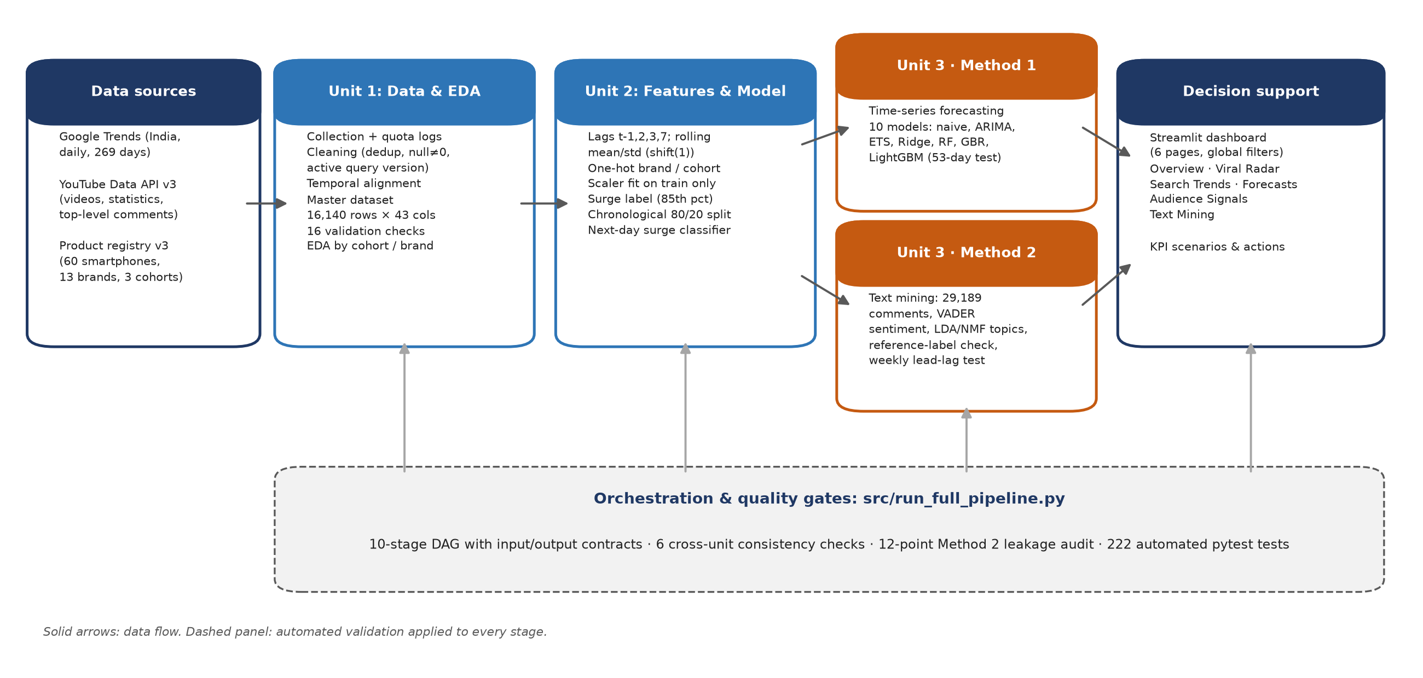
Figure 1. End-to-end workflow linking Units 1–3 and the application. Source: reports/make_report_figures.py

1.2 Related work and research gap
Choi and Varian [1] showed that adding Google Trends to seasonal autoregressive models improves nowcasts of US retail and travel series by roughly 5–20%, using aggregated weekly or monthly data. Asur and Huberman [2] predicted box-office revenue from tweet rates (adjusted R² ≈ 0.80), a single-launch setting. Boone et al. [3] reviewed consumer analytics in sales forecasting and found benefits mainly for new products and short horizons. Carbonneau et al. [4] found machine-learning demand forecasts best but not significantly better than regression. VADER [5] reached F1 ≈ 0.96 on English tweets. Gap: prior work uses aggregates, one signal at a time, English-only text and rarely documents leakage controls. We therefore build a daily, product-level, multi-source panel for Indian phones, evaluate chronologically against naive baselines, validate sentiment on local code-mixed comments and audit leakage.

2. Dataset Collection, Validation and Preparation

2.1 Provenance, coverage and challenges
Table 4. Data sources (public data under Google's terms; team-collected)
Source | Method | Dates | Volume
Google Trends (India, web) | pytrends with polite pauses/back-off; loader validates query, range, daily granularity | 8 Jan–3 Oct 2026 | 60 series, 16,140 rows
YouTube Data API v3 | search (top 50, region IN), video statistics, top 100 comments on 5 most-viewed videos | Snapshots 3–4 Oct 2026 | 3,149 videos; 29,189 comments
Product registry v3 | Team-curated: queries, brand, launch period, cohort | 3 Oct 2026 | 60 phones, 13 brands

The master dataset processed/master_dataset.csv has 16,140 rows × 43 variables, one row per product-day. Targets: surge_label (1 if day-on-day growth ≥ +50%, the 85th percentile of positive growth) for Unit 2 and search_interest for Method 1.
Table 5. Sample rows of the final dataset (selected columns)
ID | Date | Brand | Cohort | SI | Growth | Videos | Comments | Surge
P045 | 2026-04-03 | Oppo | STABLE | 38 | +0.73 | 0 | 1 | 1
P008 | 2026-08-08 | Google | RISING | 14 | -0.07 | 0 | 0 | 0
P048 | 2026-08-21 | Poco | STABLE | 68 | +0.00 | 0 | 0 | 0
P042 | 2026-08-22 | Realme | STABLE | 15 | +0.50 | 0 | 2 | 1
P045 | 2026-08-30 | Oppo | STABLE | 39 | +0.44 | 0 | 0 | 0
P059 | 2026-09-11 | Redmi | DECLINING | 51 | +0.65 | 0 | 0 | 1

Challenges. YouTube quotas (10,000 units, 100 searches/day) were handled by a quota tracker, caching and a measured cost of 7 units per product; Trends rate limits by back-off; per-product Trends scaling by using within-product changes; sibling-model results (e.g., “Pro” variants) by an on-target title matcher that flags products below 60%; and snapshot timing by rebuilding daily activity from publish timestamps.

2.2 Data quality, privacy and ethics
The builder writes the master file only if all checks pass (14 PASS, 0 FAIL): 60 products × 269 days with no gaps; 0 duplicate keys; interest within 0–100; no negative counts; growth left missing on 3,688 undefined rows (never set to 0); 15 low-signal and 4 low on-target products flagged, not dropped; 1,100 rows from superseded queries excluded with logged reasons; surge class imbalance 4.99%. Privacy: only public content is used; commenter names and channel IDs are stripped, raw API files are git-ignored, the API key stays in a local .env, and use is limited to this research purpose, consistent with India's DPDP Act, 2023 [12]. Biases: relevance-ranked, English-leaning YouTube samples; October comment snapshots (survival bias); Trends sampling and truncation; more Samsung/Apple models.

2.3 Transformations and usable dataset
General cleaning kept active query versions (comments 33,217 → 32,215), standardised timestamps, removed duplicates (→ 29,189 unique comments), kept outliers and flagged rather than dropped short, emoji-only and non-Latin comments (22,568 usable). Trends and YouTube were left-joined on the daily index without forward fill. Model-specific steps after the chronological split (cut-off 12 Aug 2026): lags t−1, 2, 3, 7; 7-day rolling mean/SD with shift(1); one-hot brand/cohort; scaler and topic models fitted on training data only. After a 7-day burn-in: 12,540 train and 3,180 test rows.
Table 6. Mapping of final fields to Units 1–3
Field group | Meaning / preparation | Used in
search_interest; growth; accel | Daily Trends index and its changes | U1, U2, M1 target
surge_label | 0/1, growth ≥ +50% (identical with a train-only cut-off) | U2 target
_lag_1/2/3/7, rolling_mean/std_7 | Lagged search, growth, accel, videos, comments | U2, M1
videos_published, comments_published | Daily counts from YouTube publish timestamps | U1, U2, M1, M2
brand_, product_type_ | One-hot dummies | U1, U2, M1
text_clean, vader_compound, topic shares | Cleaned comments, sentiment, LDA/NMF topics | M2
usable_product, low_on_target_share | Quality flags | U1 bias checks

3. Exploratory Data Analysis and Visualization (Unit 1)
Table 7. Descriptive statistics by cohort
Cohort | Products | Mean SI | Median SI | Zero days | Surge rate | Comments
RISING | 24 | 6.1 | 1 | 49.1% | 6.2% | 11728
STABLE | 24 | 25.8 | 21 | 6.4% | 4.5% | 8045
DECLINING | 12 | 32.7 | 29 | 1.4% | 3.5% | 1055

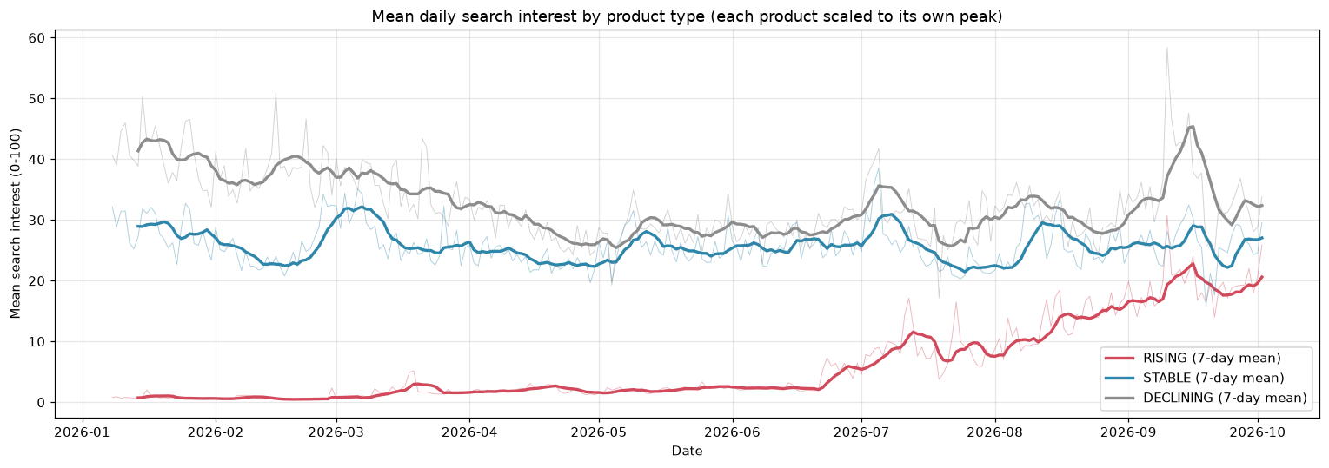
Figure 2. Mean daily search interest by cohort (7-day moving averages). Source: notebooks/04_eda_full.ipynb
Interpretation. RISING models sit near zero until launch season and climb from late June (49% zero days); STABLE and DECLINING models fluctuate around 25–35 with short spikes, e.g., the mid-September flagship launches. Cohort therefore drives surge rates and forecast difficulty.
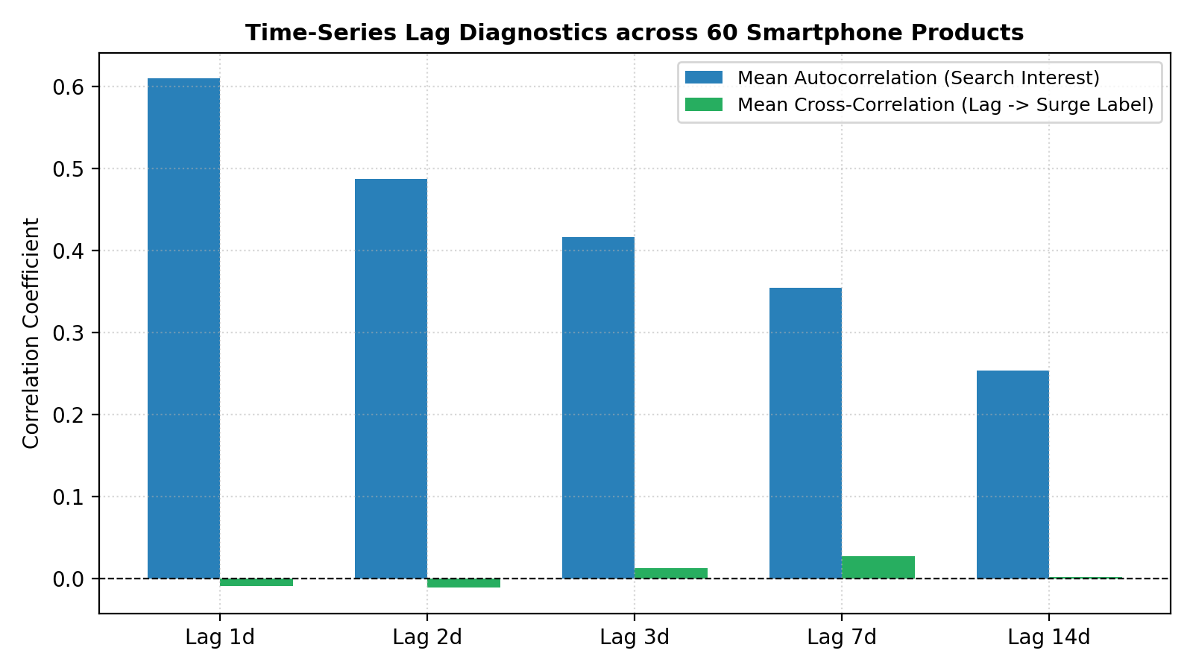
Figure 3. Autocorrelation of search interest and its correlation with the surge label, averaged over 60 products. Source: src/prep_time_series.py
Interpretation. Interest is highly persistent (autocorrelation 0.61 at 1 day, 0.25 at 14 days), so naive persistence is a strong baseline; yet lagged levels barely correlate with surges (|r| < 0.03). This motivated short lags, rolling volatility and non-linear models.
Other findings: interest correlates only weakly with comments (Spearman 0.20) and videos (0.10), so social signals are complementary; weekly seasonality is mild (Monday 18.4 to Sunday 20.8); 95% of series are stationary after differencing, supporting ARIMA(1,1,1) as a benchmark. Hypotheses carried forward: recent momentum predicts level and surges; cohort shifts baselines; comments may lead search.

4. Feature Engineering and Predictive Modelling (Unit 2)
Task. Using information up to day t−1, predict whether day t is a surge. Features (36): 20 lags, 2 leak-free rolling statistics and 14 brand/cohort dummies; no dimensionality reduction (small, interpretable set). Protocol: chronological split (train 586 surges, 4.67%; test 208, 6.54%); 5-fold expanding-window CV by date on training data to choose settings by PR-AUC; decision threshold set to maximise out-of-fold F1; test scored once. PR-AUC is primary because surges are rare [15].
Table 8. Unit 2 surge classification on the held-out window (3,180 rows, 208 surges)
Model | Settings | CV PR-AUC | Precision | Recall | F1 | ROC-AUC | PR-AUC
Persistence rule (baseline) | growth_lag_1 rule | – | 0.055 | 0.495 | 0.099 | 0.431 | 0.078
Logistic Regression (baseline) | L2, C=0.1, balanced | 0.095 | 0.120 | 0.211 | 0.153 | 0.616 | 0.099
Random Forest | 300 trees, depth 10 | 0.231 | 0.227 | 0.361 | 0.279 | 0.751 | 0.222
HistGradientBoosting | lr 0.05, depth 4 | 0.208 | 0.168 | 0.471 | 0.248 | 0.751 | 0.235
Note: Chance PR-AUC = 0.065. Script: reports/unit2_surge_classification.py.
Random Forest had the best CV PR-AUC (0.231) and was fixed before testing. On test it reaches PR-AUC 0.222 (3.4× chance) and ROC-AUC 0.751, double logistic regression (0.099), confirming non-linear structure. It catches 75 of 208 surges with 255 false alarms and 133 misses; precision ≈ 23% makes it a triage tool, not an auto-reorder rule. Leakage audit: all features lagged; rolling windows exclude day t; scaler fit on train; split by date; the surge cut-off recomputed on training data alone is identical (all 16,140 labels unchanged); Unit 1/Unit 2 label parity 100%.
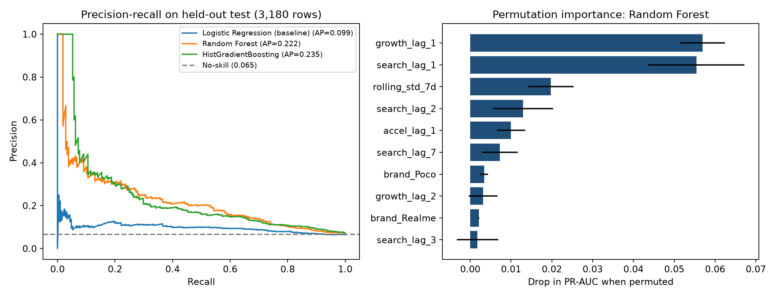
Figure 4. Precision–recall curves on the test window (left) and permutation importance of the Random Forest (right). Source: reports/unit2_surge_classification.py
Interpretation. Tree ensembles dominate logistic regression at all recalls. Yesterday's growth (0.057 PR-AUC drop) and level (0.055), then 7-day volatility, matter most; YouTube lags add little. Importances are associations, not causes.
Subgroup check. ROC-AUC is similar for RISING (0.76) and STABLE (0.74) but lower for DECLINING (0.67), where rarer surges follow successor launches the lags cannot see; recall is highest for RISING (40%), where early warning matters most. Cohort-specific thresholds and launch-date features are the proposed mitigation.

5. Advanced Analytics (Unit 3): Two Selected Methods
We selected Time-Series Analysis and Text Mining; association rules do not apply (no baskets).

5.1 Method 1 — Time-series forecasting of daily search interest
Question (Q3): how accurately can tomorrow's interest be predicted for allocation decisions? Input: 12,540 train and 3,180 test product-days (12 Aug–3 Oct, 53 days). Models: naive (ŷₜ = yₜ₋₁), seasonal naive (yₜ₋₇), 7-day mean; per-product ARIMA(1,1,1) and Holt smoothing; Ridge, ElasticNet, Random Forest, Gradient Boosting and LightGBM [7] (100 trees, depth 4, learning rate 0.05) on the 36 features; one-step forecasts clipped to 0–100; metrics per [14]. Code: src/prep_time_series.py, src/forecast_method1.py, notebooks/scrum26_time_series_forecasting.ipynb.
Table 9. Method 1 benchmark on the 53-day test window (3,180 product-days)
Model | Family | MAE | RMSE | WAPE % | R² | MDA %
LightGBM | Machine Learning | 5.176 | 10.027 | 21.52 | 0.736 | 50.3
Gradient Boosting | Machine Learning | 5.288 | 10.200 | 21.99 | 0.726 | 49.6
Random Forest | Machine Learning | 5.294 | 10.108 | 22.01 | 0.731 | 49.3
Ridge Regression | Machine Learning | 5.304 | 10.349 | 22.05 | 0.718 | 50.9
ElasticNet | Machine Learning | 5.363 | 10.406 | 22.30 | 0.715 | 50.6
Naive Persistence | Baseline | 5.544 | 11.204 | 23.05 | 0.670 | 50.0
Exponential Smoothing | Statistical | 5.601 | 11.291 | 23.29 | 0.665 | 50.1
ARIMA(1,1,1) | Statistical | 6.002 | 11.763 | 24.95 | 0.636 | 51.6
Rolling Mean 7d | Baseline | 6.293 | 11.839 | 26.17 | 0.631 | 51.5
Seasonal Naive 7d | Baseline | 8.995 | 16.783 | 37.40 | 0.259 | 53.0

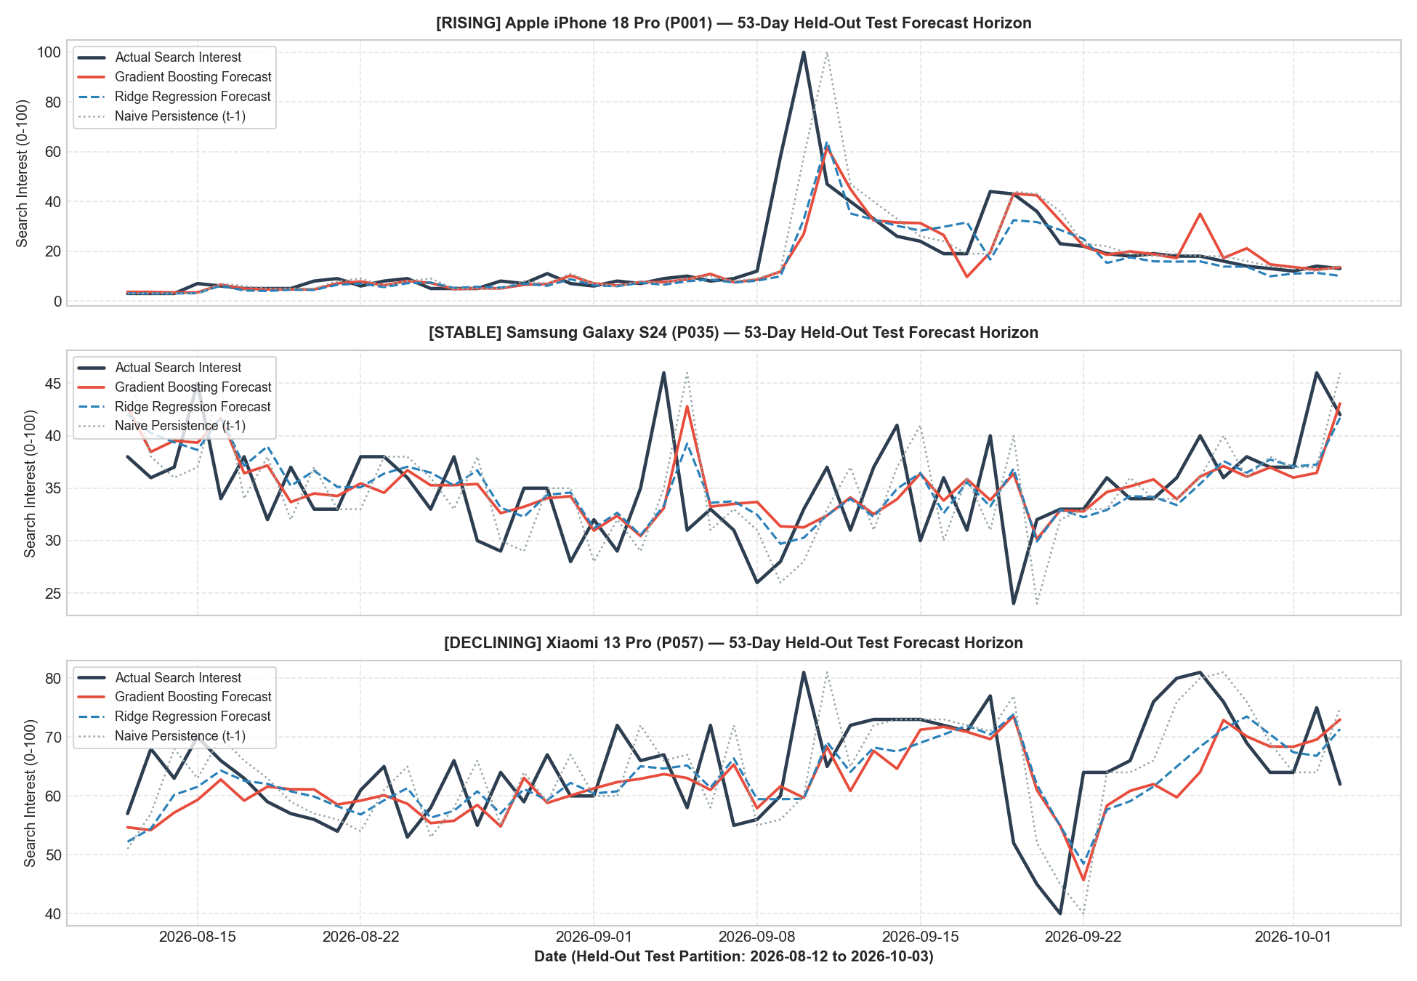
Figure 5. Forecast versus actual search interest for representative products in the test window. Source: src/forecast_method1.py
Interpretation. Forecasts follow level shifts within a day but lag the first day of sharp spikes—the reason a separate surge classifier is needed.
Findings. All ML models beat every baseline; LightGBM is best: MAE 5.176 (6.6% below naive, 13.8% below ARIMA) and RMSE 10.5% lower than naive. Gains are largest for STABLE (11.2%, R² 0.79) and DECLINING (8.1%) and small for RISING (1.9%). search_lag_1 and the 7-day mean carry ~95% of tree importance. Limitations: MDA ≈ 50% for all models (no directional skill); fixed hyperparameters; one 53-day window; without LightGBM installed the script substitutes Extra Trees.

5.2 Method 2 — Text mining of YouTube comments
Question (Q4): what do audiences say, and does comment activity or tone lead search? Input: 29,189 comment rows (22,568 usable). Steps: cleaning, domain stop-list (platform words, Hinglish fillers) and removal of brand tokens; VADER [5] compound score (positive ≥ 0.05, negative ≤ −0.05); LDA [6] and NMF [11] for k = 3–10 chosen by NPMI coherence and refit stability; validation on 100 random comments (5 human, 95 AI-review labels, flagged per row) against TextBlob and an always-positive baseline; weekly Spearman lead-lag of comment and sentiment changes vs search change. Code: src/text_mining.py, src/evaluate_text_mining.py, notebooks/05_text_mining.ipynb.
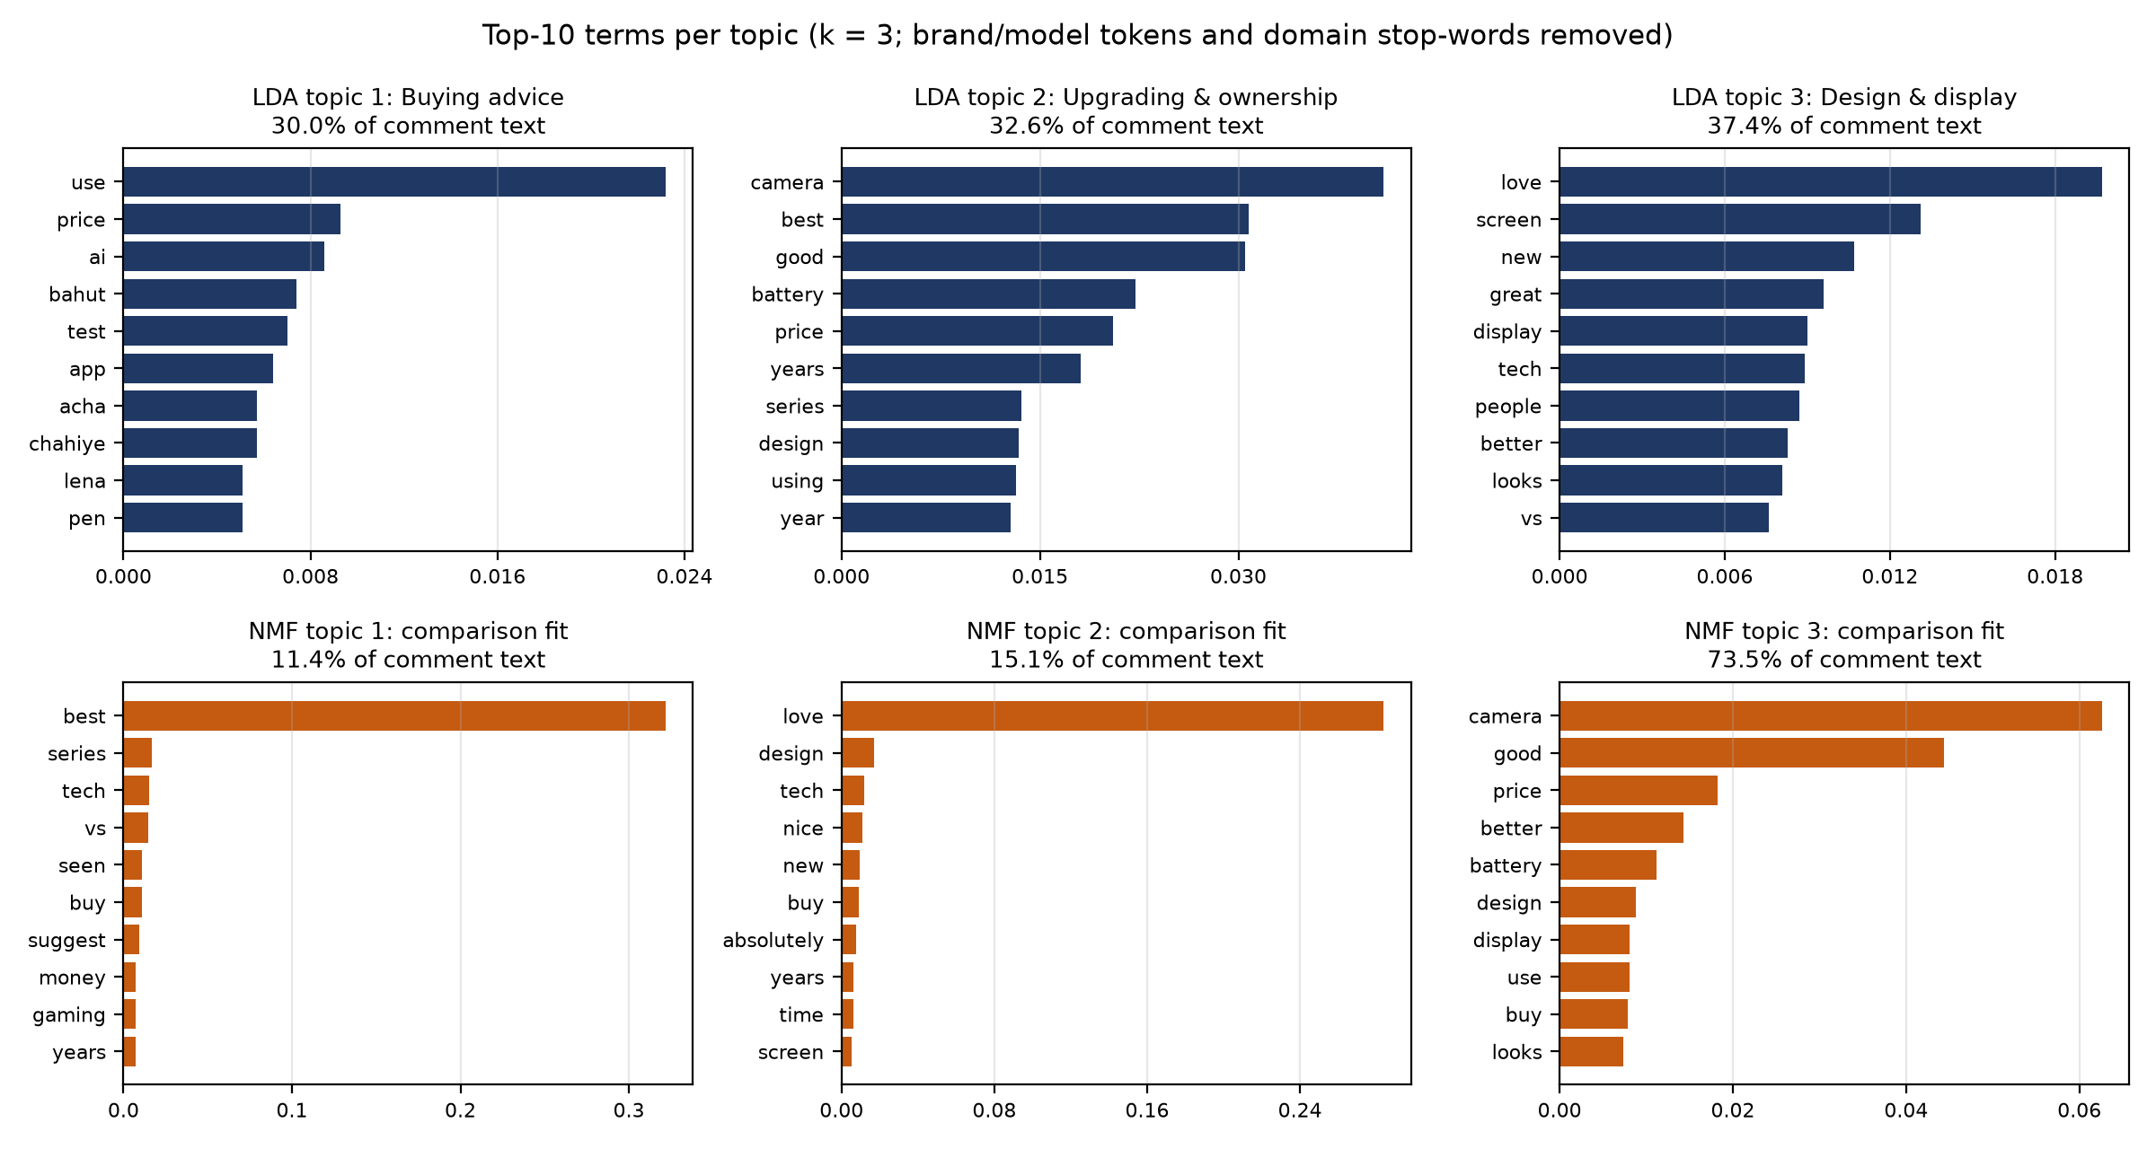
Figure 6. Top-10 terms of the three LDA topics (top) and NMF comparison (bottom). Source: reports/make_report_figures.py from data/processed/text_topics_terms.csv
Interpretation. Topics: Buying advice (price, AI, Hinglish “chahiye”, “lena”; 30%), Upgrading & ownership (camera, battery, years; 33%) and Design & display (love, screen, looks; 37%, 45% for DECLINING models). NMF recovers the camera/price and design themes. Coherence is low (LDA 0.021, NMF 0.085) because comments are short (median 5 tokens).
Table 10. Sentiment validation against reference labels
Method (93 labelled comments) | Accuracy [95% CI] | Macro-F1 | Neg. recall | κ
VADER (project) | 0.495 [0.40–0.59] | 0.468 | 0.267 | 0.22
TextBlob | 0.419 [0.32–0.52] | 0.375 | 0.100 | 0.13
AI review (SCRUM-28 spot check) | 0.796 [0.70–0.87] | 0.828 | 0.700 | 0.70
Always positive (baseline) | 0.398 [0.30–0.50] | 0.190 | 0.000 | 0.00
Note: The AI-review row is not independent: it supplied most reference labels.
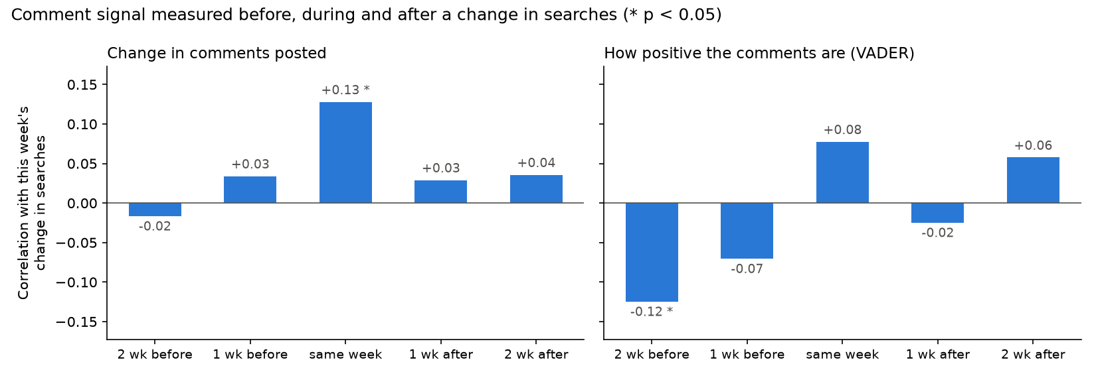
Figure 7. Weekly lead-lag correlation of comment signals with search change (* p < 0.05). Source: src/evaluate_text_mining.py
Interpretation. Comment volume rises in the same week as search (ρ = 0.13, p < 0.001) but not a week earlier (ρ = 0.03, p = 0.12); sentiment two weeks earlier is weakly negative (ρ = −0.12, p = 0.006). Comments are a coincident, not leading, signal.
Findings. 58.4% of scored comments are positive, 11.5% negative; Oppo (0.39) and iQOO/Realme (0.34) audiences are most positive, Motorola and Nothing least (0.27). VADER beats TextBlob and the baseline (accuracy 0.495 vs 0.419 and 0.398) but misses most negatives (recall 0.27) due to Hinglish, sarcasm and jargon. Method 2 model inputs passed 11 of 12 leakage checks (one informational note on October-snapshot survival bias).

6. Comparative Analysis and Business Impact

6.1 Comparison of the two Unit 3 methods
Table 11. Comparison of the two Unit 3 methods
Criterion | Method 1: Time-series | Method 2: Text mining
Question / input | Next-day level; numeric daily panel | Opinion and lead time; 29,189 comments
Output / validation | Point forecasts; chronological hold-out vs 9 alternatives | Sentiment, topics, ρ; reference labels, coherence, significance
Strengths | Clear gains over naive and ARIMA; reproducible | Explains why; brand-level insight
Limitations | No directional skill; lags spike onsets | English lexicon; short text; not leading

The metrics are not comparable (MAE vs accuracy), so neither method is “better”. Synthesis: Units 1, 2 and Method 1 agree that recent momentum dominates (high autocorrelation, top importance of lagged growth and level); YouTube activity is consistently secondary and, per Method 2, coincident. The Review 1 hypothesis that sentiment leads demand by 3–7 days is not supported, so text serves as a brand-health layer while numeric momentum drives alerts. The dashboard's Viral Radar combines both as a descriptive 0–100 score (weights 0.40 level, 0.35 acceleration, 0.25 sentiment), not a validated predictor.

6.2 Comparison with existing studies
Table 12. Comparison with prior studies
Criterion | Choi & Varian [1] | Asur & Huberman [2] | Hutto & Gilbert [5] | This project
Data | US retail/travel; weekly–monthly Trends | Box office; tweet rate | English tweets | 60 Indian phones; daily Trends + YouTube
Validation | Rolling out-of-sample | In-sample R² | F1 vs human labels | Chronological hold-out, CV, leakage audit
Finding | Error −5 to −20% vs AR | Adj. R² ≈ 0.80 | F1 ≈ 0.96 | MAE −6.6% vs naive, −13.8% vs ARIMA; VADER F1 0.47

Direct comparison is limited: Choi and Varian measure the gain of adding Trends to forecast sales, while our target is the Trends index; Asur and Huberman report in-sample R² for single launches; VADER's 0.96 is binary English sentiment, whereas our 0.47 is three-class, on Hinglish-heavy comments with mostly AI reference labels—largely domain shift. Our contribution is a reproducible daily product-level panel for an emerging market, explicit leakage controls, cohort diagnostics and an honest negative lead-lag result.

6.3 KPI-based business impact and scenarios
Measured: forecast MAE −6.6% (O3 met); surge PR-AUC 3.4× chance with 75 true alerts of 330 (O2 met). Hypothetical economics: net = true alerts × value per anticipated surge-day − alerts × cost per alert.
Table 13. Best/base/worst-case net impact over the 53-day test window
Scenario | Value / surge-day (₹) | Cost / alert (₹) | Benefit (₹ lakh) | Cost (₹ lakh) | Net (₹ lakh)
Worst | 10,000 | 6,000 | 7.50 | 19.80 | -12.30
Base | 25,000 | 4,000 | 18.75 | 13.20 | +5.55
Best | 50,000 | 2,000 | 37.50 | 6.60 | +30.90
Note: Illustrative assumptions; replace with partner data.
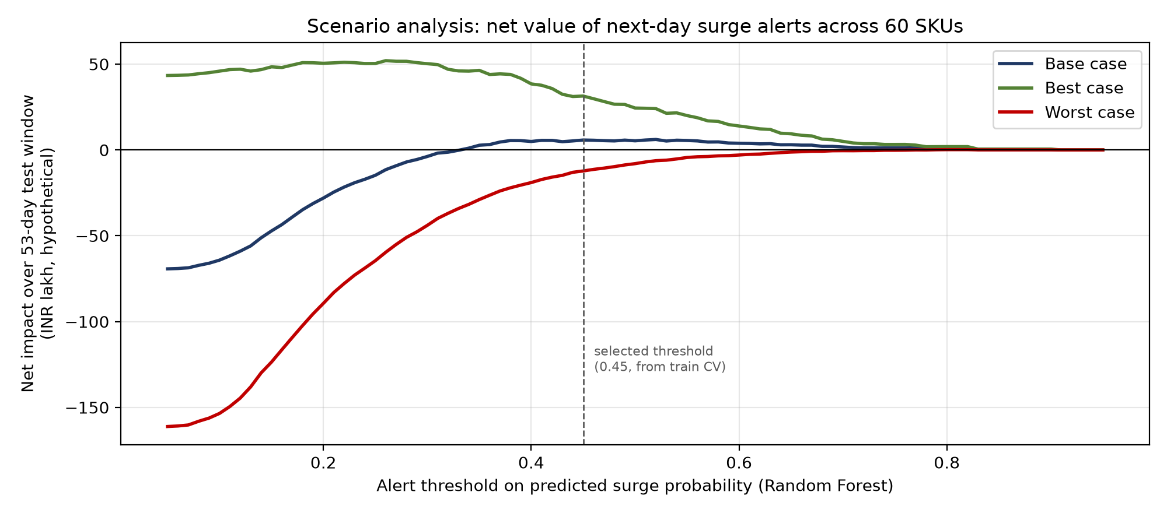
Figure 8. Net impact versus alert threshold for the three scenarios. Source: reports/make_report_figures.py
Interpretation. Base case nets ₹5.5 lakh and stays positive above a threshold of ~0.33; the worst case loses at almost every threshold. Break-even needs surge-day value > 4.4× alert cost; the key dependencies are stock-out margin, action cost and search-to-sales conversion.

7. Interactive Application, Figure Index and Reproducibility

7.1 Dashboard
A local multi-page Streamlit [13] app: pip install -r requirements.txt, then streamlit run dashboard/app.py (or python -m streamlit run dashboard/app.py). data_loader.py caches the committed outputs; sidebar filters (category, brand, cohort, products, date range, reset) persist across pages via filters.py. Pages: Overview (U1 KPIs), Viral Radar (U2+U3 synthesis), Search Trends (surge markers, calendar), Forecasts (M1, errors recomputed per selection), Audience Signals and Text Mining (M2). Filtering, KPIs and the radar score are computed live; models and scores are precomputed.
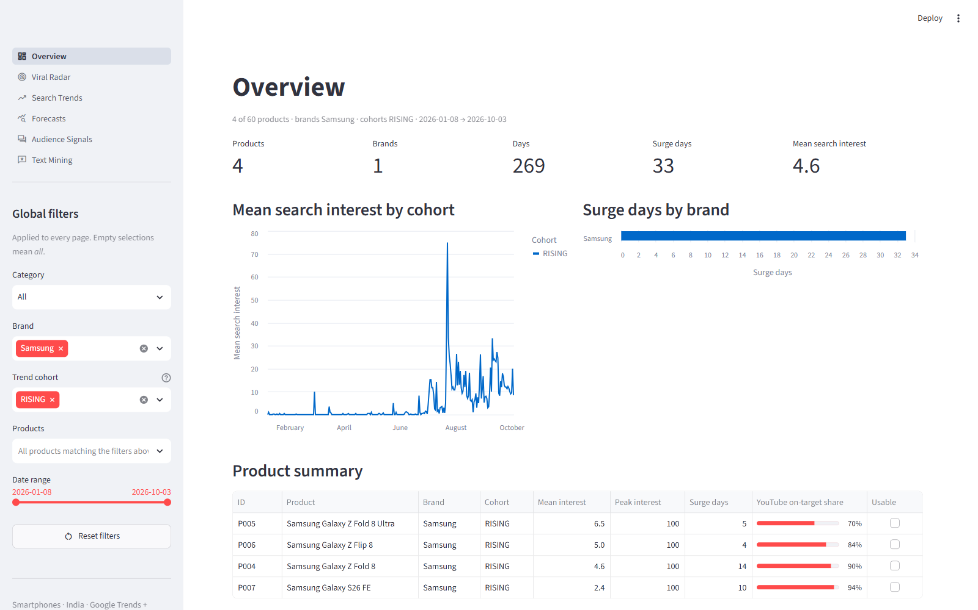
Figure 9. Overview page filtered to Samsung / RISING (4 products, 33 surge days); every KPI and chart updates. Source: running Streamlit app
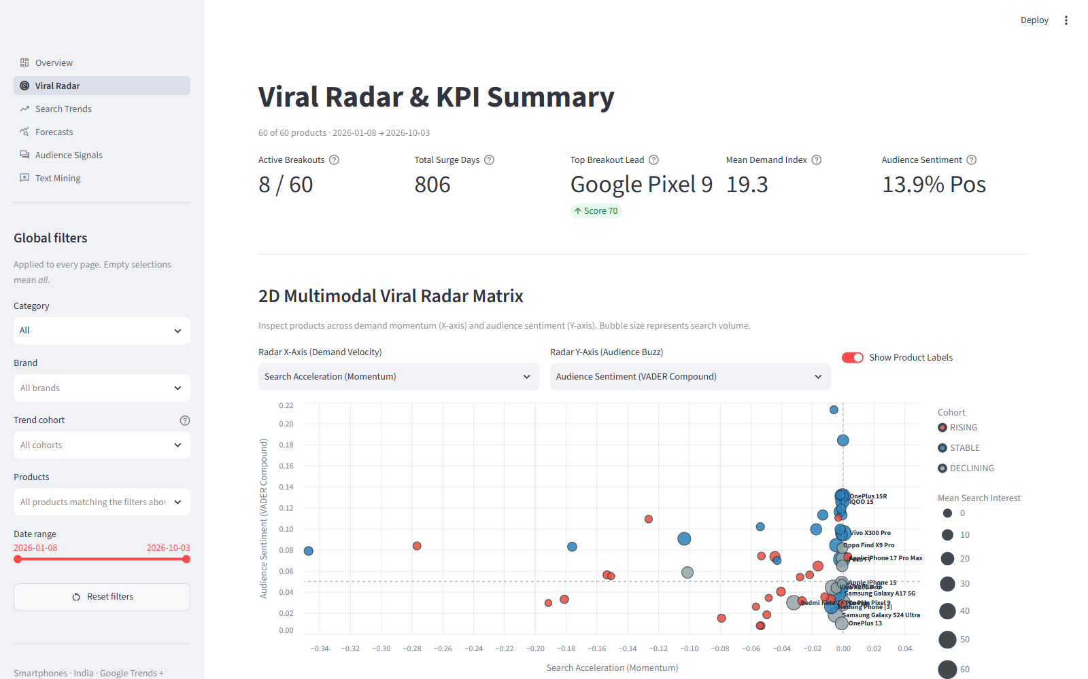
Figure 10. Viral Radar page: demand acceleration versus sentiment with breakout-score KPIs. Source: running Streamlit app
Tests and limitations. tests/test_dashboard.py covers filter logic and headless page renders (all pass). Forecast headline cards show the global benchmark; radar weights are not back-tested; the app is not publicly hosted; data end on 3 Oct 2026.

7.2 Figure index and reproduction map
Table 14. Figure index (all figures created in Python/Matplotlib or captured from the app)
Fig. | Title | Section | Source file
1 | End-to-end workflow linking Units 1–3 and the application | 1 | reports/make_report_figures.py
2 | Mean daily search interest by cohort (7-day moving averages) | 3 | notebooks/04_eda_full.ipynb
3 | Autocorrelation of search interest and its correlation with the surge label | 3 | src/prep_time_series.py
4 | Precision–recall curves on the test window (left) and permutation importanc | 4 | reports/unit2_surge_classification.py
5 | Forecast versus actual search interest for representative products in the t | 5 | src/forecast_method1.py
6 | Top-10 terms of the three LDA topics (top) and NMF comparison (bottom) | 5 | reports/make_report_figures.py from data/processed/text
7 | Weekly lead-lag correlation of comment signals with search change (* p < 0. | 5 | src/evaluate_text_mining.py
8 | Net impact versus alert threshold for the three scenarios | 6 | reports/make_report_figures.py
9 | Overview page filtered to Samsung / RISING (4 products, 33 surge days); eve | 7 | running Streamlit app
10 | Viral Radar page: demand acceleration versus sentiment with breakout-score | 7 | running Streamlit app

7.3 Code and environment
Repository: https://github.com/Ashwin-deals/viral-product-intelligence- (public README with tree and commands). Python 3.12; dependencies in requirements.txt. Layout: raw/, data/processed/, processed/, src/, notebooks/, docs/figures/, dashboard/, tests/, reports/. Reproduce: python -m pytest; python src/run_full_pipeline.py (Units 1–3); python reports/unit2_surge_classification.py. Raw YouTube JSON (with commenter names) and the API key are excluded; both sources can be re-collected with a personal key under Google's terms.

8. End-to-End Validation, Traceability and Contributions

8.1 Completion and validity
The orchestrator ran all 10 stages successfully (152 s) and passed six cross-unit checks; the test suite was re-run for this report: 222 passed, 0 failed. Threats: the surge label derives from the input series (mitigated by lagging and a train-only cut-off check); AI reference labels; one country, category and season; search is a proxy for sales; Trends re-sampling.
Table 15. Objective-to-evidence traceability matrix
Objective | Method | Result | Evidence | Action
O1 Dataset | Sec. 2 | 16,140/16,140 rows; 14 PASS | Sec. 2.2; Appendix A | R5
O2 Surge alerts | Sec. 4, RF | PR-AUC 0.222 = 3.4× chance | Table 8, Fig. 4 | R2
O3 Forecast | Sec. 5.1, LightGBM | MAE −6.6% vs naive | Table 9, Fig. 5 | R1
O4 Opinion & lead | Sec. 5.2 | Acc. 0.495 > 0.398; no lead | Table 10, Figs. 6, 7 | R3
O5 Decision tool | Sec. 7 | 6 pages, filters; 222 tests pass | Figs. 9–10 | R4

8.2 Project tracking and individual work
Work was tracked on a Jira Scrum board (key SCRUM; Backlog → To Do → In Progress → Review/Testing → Completed) and merged via GitHub pull requests. Commit counts are from git shortlog. Jira board: https://cb-team-vqckglys.atlassian.net/?continue=https%3A%2F%2Fcb-team-vqckglys.atlassian.net%2Fwelcome%2Fsoftware%3FprojectId%3D10000&atlOrigin=eyJpIjoiZmE0ZGQ2YzJiMDA3NDA1Y2I4MDNiYmZhODk2ODdlNjMiLCJwIjoiamlyYS1zb2Z0d2FyZSJ9
Table 16. Individual contributions and evidence
Member / Reg. No. | Work items (completed) | Evidence
Mounik Sai (CB.SC.U4CSE23561) | SCRUM-10, 14, 19, 24, 26, 32: documentation, pipeline consolidation, Method 2 isolation & audit, Method 1 benchmark, Viral Radar, presentations (4–21 Oct) | forecast_method1.py, isolate_method2_data.py, radar.py; 38 commits
Ashwin E (CB.SC.U4CSE23009) | Task 1, SCRUM-23, 28, 33: collection, cleaning, alignment, EDA, text corpus and mining, Text Mining page (4–21 Oct) | collect_youtube.py, text_mining.py; 12 commits
Vijay Krishna (CB.SC.U4CSE23112) | SCRUM-5, 12, 17, 21, 29: registry analysis, problem statement, cleaning docs, master dataset, text-mining evaluation (4–21 Oct) | build_master.py, evaluate_text_mining.py; 29 commits
Sisthick S (CB.SC.U4CSE23465) | SCRUM-20, dashboard: set-up, encoding & scaling, Streamlit app, time-series evaluation (3–21 Oct) | feature_encoding_scaling.py, dashboard/app.py; 30 commits
Konduru Hemesh (CB.SC.U4CSE23724) | SCRUM-22, 30: chronological split & stationarity, end-to-end orchestration and tests (20 Oct) | prep_time_series.py, run_full_pipeline.py; 5 commits

8.3 AI use and originality declarations
Anthropic Claude (via Claude Code and GitHub Copilot) assisted with code, documentation and drafting this report; the team verified every number against committed outputs, re-ran tests and corrected unsupported earlier slide claims (surge-classifier F1, sentiment lead time). An AI reviewer supplied 95 of 100 sentiment reference labels (flagged per row). Turnitin similarity: 13% (limit ≤ 15%).

9. Conclusion, Recommendations and Roadmap
All objectives were met (traceability matrix, Section 8.1): forecasts improve on naive by 6.6% and surge alerts rank 3.4× better than chance; comment tone is not a leading indicator and forecasts lack directional skill, which shapes how the tool should be used.
Table 17. Prioritised recommendations
# | Recommendation | KPI effect | Owner | Feasibility
R1 | Daily forecasts for STABLE/DECLINING allocation | MAE −8 to −11% vs naive | Planners | High
R2 | RISING surge alerts as a daily triage list; threshold from cost ratio | ~40% of surges a day early | Category managers | Medium
R3 | Sentiment/topics as brand-health monitor | Early negative themes | Marketing | High
R4 | One-season retail pilot of the dashboard | Measured stock-out change | Team + partner | Medium
R5 | Add sales and price data | KPIs in units and ₹ | Partner data team | Low–Medium

Roadmap. 0–1 month: schedule daily collection and nightly pipeline runs (success: 30 failure-free days). 1–6 months: partner pilot with cohort thresholds and launch-date features (success: alert precision ≥ 30%). 6–12 months: sales data, Hinglish-aware sentiment, more categories. Future work (not done): interval and multi-day forecasts, Method 1 tuning, radar back-testing, larger human labelling, public hosting.

References
[1] H. Choi and H. Varian. 2012. Predicting the Present with Google Trends. Economic Record 88, s1, 2–9.
[2] S. Asur and B. A. Huberman. 2010. Predicting the Future with Social Media. In Proc. IEEE/WIC/ACM WI-IAT, 492–499.
[3] T. Boone, R. Ganeshan, A. Jain, and N. R. Sanders. 2019. Forecasting sales in the supply chain: Consumer analytics in the big data era. International Journal of Forecasting 35, 1, 170–180.
[4] R. Carbonneau, K. Laframboise, and R. Vahidov. 2008. Application of machine learning techniques for supply chain demand forecasting. European Journal of Operational Research 184, 3, 1140–1154.
[5] C. J. Hutto and E. Gilbert. 2014. VADER: A Parsimonious Rule-Based Model for Sentiment Analysis of Social Media Text. In Proc. ICWSM, 216–225.
[6] D. M. Blei, A. Y. Ng, and M. I. Jordan. 2003. Latent Dirichlet Allocation. JMLR 3, 993–1022.
[7] G. Ke et al. 2017. LightGBM: A Highly Efficient Gradient Boosting Decision Tree. In NeurIPS 30, 3146–3154.
[8] F. Pedregosa et al. 2011. Scikit-learn: Machine Learning in Python. JMLR 12, 2825–2830.
[9] S. Seabold and J. Perktold. 2010. Statsmodels: Econometric and Statistical Modeling with Python. In Proc. 9th Python in Science Conf., 92–96.
[10] L. Breiman. 2001. Random Forests. Machine Learning 45, 1, 5–32.
[11] D. D. Lee and H. S. Seung. 1999. Learning the parts of objects by non-negative matrix factorization. Nature 401, 788–791.
[12] Government of India. 2023. The Digital Personal Data Protection Act, 2023 (Act No. 22 of 2023).
[13] Streamlit Inc. 2026. Streamlit Documentation. https://docs.streamlit.io/
[14] R. J. Hyndman and A. B. Koehler. 2006. Another look at measures of forecast accuracy. International Journal of Forecasting 22, 4, 679–688.
[15] T. Saito and M. Rehmsmeier. 2015. The Precision-Recall Plot Is More Informative than the ROC Plot When Evaluating Binary Classifiers on Imbalanced Datasets. PLOS ONE 10, 3, e0118432.
[16] Google. 2026. YouTube Data API v3 and Google Trends. https://developers.google.com/youtube/v3; https://trends.google.com/ (accessed 3–4 Oct 2026).
[17] Group 13. 2026. Viral Product Intelligence repository. https://github.com/Ashwin-deals/viral-product-intelligence-
Scikit-learn [8], statsmodels [9] and Random Forest [10] underlie Sections 4–5; Google [16] is the data source; [17] holds all code and data.

Appendices

Appendix A: Validation records
Table 18. Master dataset validation (processed/master_validation_report.csv)
Master dataset check | Status | Detail
rows = products x days | PASS | 16140 rows = 60 products x 269 days (2026-01-08 to 2026-10-03)
no duplicate (product_id, date) | PASS | 0 duplicate keys
every registry product present, nothing else | PASS | 60 products; missing from data: none; not in registry: none
every product has every calendar day | PASS | 269 calendar days; products with gaps: none
search_interest within 0-100 | PASS | min 0.0, max 100.0, missing 0
count columns never negative | PASS | 15 count columns checked; negative values: none
on_target_share within 0-1 | PASS | min 0.56, max 0.96
yt_on_target_share within 0-1 | PASS | min 0.48, max 1.0
zero_share_product within 0-1 | PASS | min 0.0, max 0.9442
surge_label is 0 or 1 | PASS | 806 surge days of 16140 (4.99%)
YouTube snapshot (yt_* columns) for every product | PASS | 60 of 60 products; latest snapshot date(s): 2026-10-04
date-level YouTube columns from aligned_daily | INFO | only 10 of 60 products, on 2026-10-03: snapshots taken after the Trends window ends do not join…
videos reconcile with source | PASS | 3500 rows in the cleaned table = 3149 unique videos + 351 seen again in a second snapshot; 2248…
comments reconcile with source | PASS | 32215 rows in the cleaned table = 29189 unique comments + 3026 seen again in a second snapshot;…
surge_label matches Unit 2 features file | PASS | 16140 of 16140 rows matched by key, 0 labels differ
flagged products (kept, not dropped) | INFO | low-signal Trends: 15; low YouTube on-target share: 4 (P009, P012, P015, P028)
missing values (by design, not filled) | INFO | youtube_query_version: 16130; video_result_count: 16130; video_views_total: 16130; video_commen…

Table 19. Method 2 leakage audit (processed/method2_leakage_audit_report.csv)
Method 2 leakage check | Status | Detail
contemporaneous_sentiment_quarantine | PASS | Contemporaneous sentiment excluded from model features; overlapping: none
contemporaneous_topic_quarantine | PASS | Contemporaneous topics excluded from model features; overlapping: none
lag_shift_integrity | PASS | Audited 107 lag index mappings for exact match Value(t-k); mismatches: 0
rolling_trend_lookahead_quarantine | PASS | Rolling window verified as strictly backwards [t-7, t-1] using shift(1).rolling(7); violations:
chronological_boundary_separation | PASS | Max train date (2026-08-11) < Min test date (2026-08-12); zero date overlap
nlp_topic_model_train_only | PASS | LDA and CountVectorizer fitted exclusively on comments with date < 2026-08-12
scaler_train_only_fit | PASS | StandardScaler fit exclusively on train partition: train feature means in [-0.01, 0.01]
point_in_time_snapshot_exclusion | PASS | Quarantined Oct-4 snapshot columns excluded from predictors; leaked: none
timezone_alignment_verification | PASS | Comment timestamps localized to Asia/Kolkata (UTC+5.5 offset verified)
target_variable_independence | PASS | Contemporaneous targets strictly excluded from predictor matrices; leaked: none
missing_signal_no_future_fill | PASS | Unobserved comment days filled with neutral 0.0 without backward filling from future days
survival_bias_audit_documented | INFO | Collection-date survival bias (SCRUM-24 warning) audited and documented: comments sampled on Oc

Appendix B: Model tuning
Table 20. Unit 2 expanding-window CV grid (5 date folds)
Model | Settings | CV PR-AUC (mean ± SD) | Threshold | CV F1
Logistic Regression (baseline) | {C: 0.1, max_iter: 2000} | 0.095 ± 0.027 | 0.60 | 0.180
Logistic Regression (baseline) | {C: 1.0, max_iter: 2000} | 0.093 ± 0.026 | 0.60 | 0.172
Random Forest | {max_depth: 6, n_estimators: 300} | 0.222 ± 0.016 | 0.56 | 0.273
Random Forest | {max_depth: 10, n_estimators: 300} | 0.231 ± 0.025 | 0.45 | 0.293
HistGradientBoosting | {learning_rate: 0.05, max_depth: 4, max_iter: 300} | 0.208 ± 0.013 | 0.57 | 0.296
HistGradientBoosting | {learning_rate: 0.1, max_depth: 6, max_iter: 300} | 0.201 ± 0.019 | 0.59 | 0.261

Appendix C: Implementation and dashboard guide
Table 21. Pipeline execution record (processed/pipeline_execution_summary.csv)
Stage | Unit | Status | Seconds | Details
task1_prep | unit1 | SKIPPED | 0.0 | Pre-existing clean extracts found
unit2_features | unit2 | SUCCESS | 0.9 | Engineered features & surge labels (16,140 rows, 806 surges, 30 cols)
unit1_master | unit1 | SUCCESS | 0.7 | Master dataset validated (16,140 rows x 43 cols, 60 products)
unit3_text_corpus | unit3 | SUCCESS | 1.5 | Text corpus extracted (29,189 comments across 60 products)
unit3_ts_prep | unit3 | SUCCESS | 1.4 | Chronological split & stationarity diagnostics (12,540 train / 3,180 t
unit3_forecast | unit3 | SUCCESS | 7.6 | Trained 10 forecasting models. Top model: Extra_Trees (MAE: 5.280)
unit2_method2 | unit2 | SUCCESS | 19.9 | Method 2 multimodal dataset isolated & audited (12,540 train / 3,180 t
unit3_text_mining | unit3 | SUCCESS | 119.3 | Sentiment & topic mining completed (22,568 scored comments)
unit3_text_spotcheck | unit3 | SUCCESS | 0.1 | Spot-check agreement evaluated (43 metric records)
unit3_text_eval | unit3 | SUCCESS | 1.1 | Evaluated 8 sentiment methods and 10 signal lead-lag lags

Guide: run the app, choose filters in the sidebar (empty = all; they cascade and persist; Reset filters clears them), then switch pages. Config lives in src/config.py; seeds are 42; cut-off 2026-08-12.

Appendix D: Tracking, AI declaration and similarity report
Attach the Jira board screenshot (Completed column), the signed declaration (front matter, AI use in Section 8.3) and the Turnitin similarity report (13%). Full commit history: git log in the repository.

