E-Commerce Dashboard – Detailed Project Report
This document is a complete end-to-end project report explaining the business objective, dataset, KPIs, methodology, insights, and visuals extracted from the dashboard.

1. Introduction
The E-commerce Dashboard Project aims to understand business performance across various dimensions such as sales, profit, category, region, and customer segment. This project is designed to demonstrate real-world reporting and analytics skills.

2. Dataset Description
The dataset contains 300 rows and 8 columns.
Columns include: Order Date, Category, Region, Segment, Sales, Profit, Quantity.

3. Data Analysis & Visuals
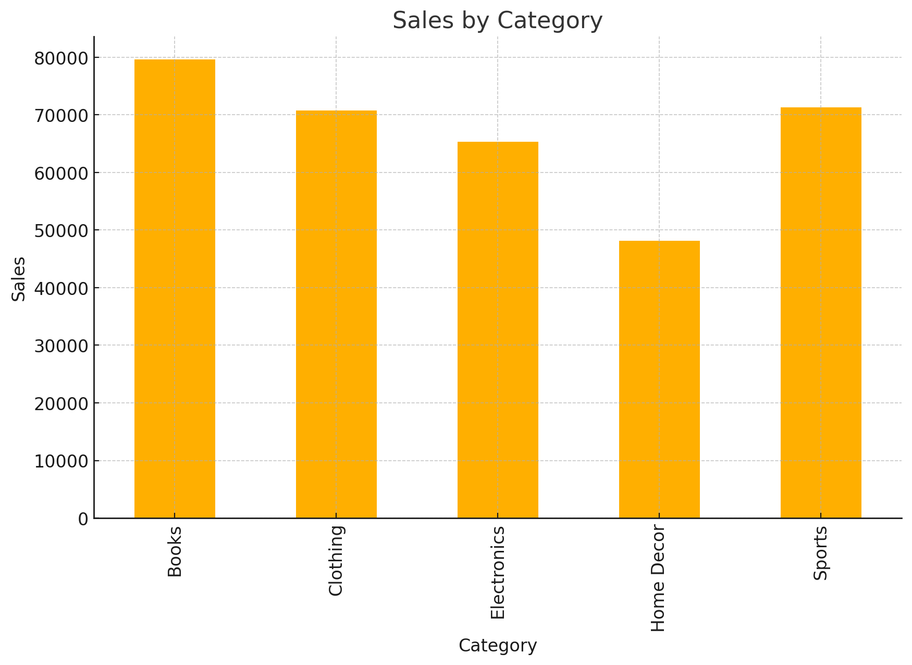
Sales By Category
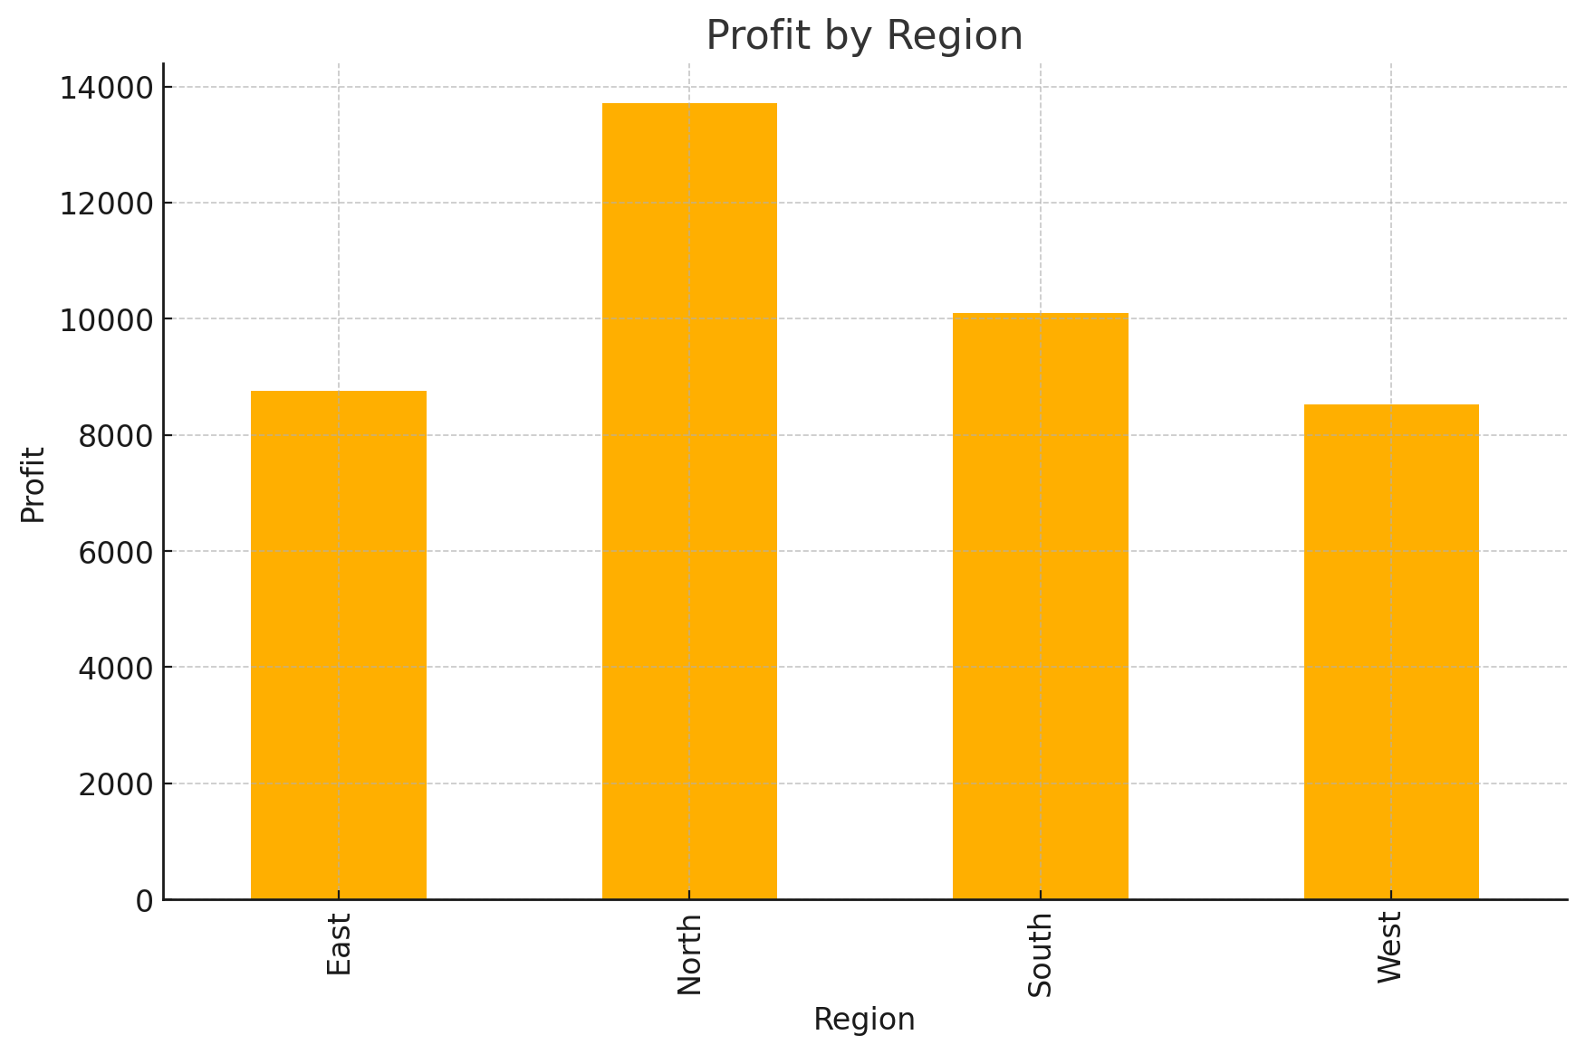
Profit By Region
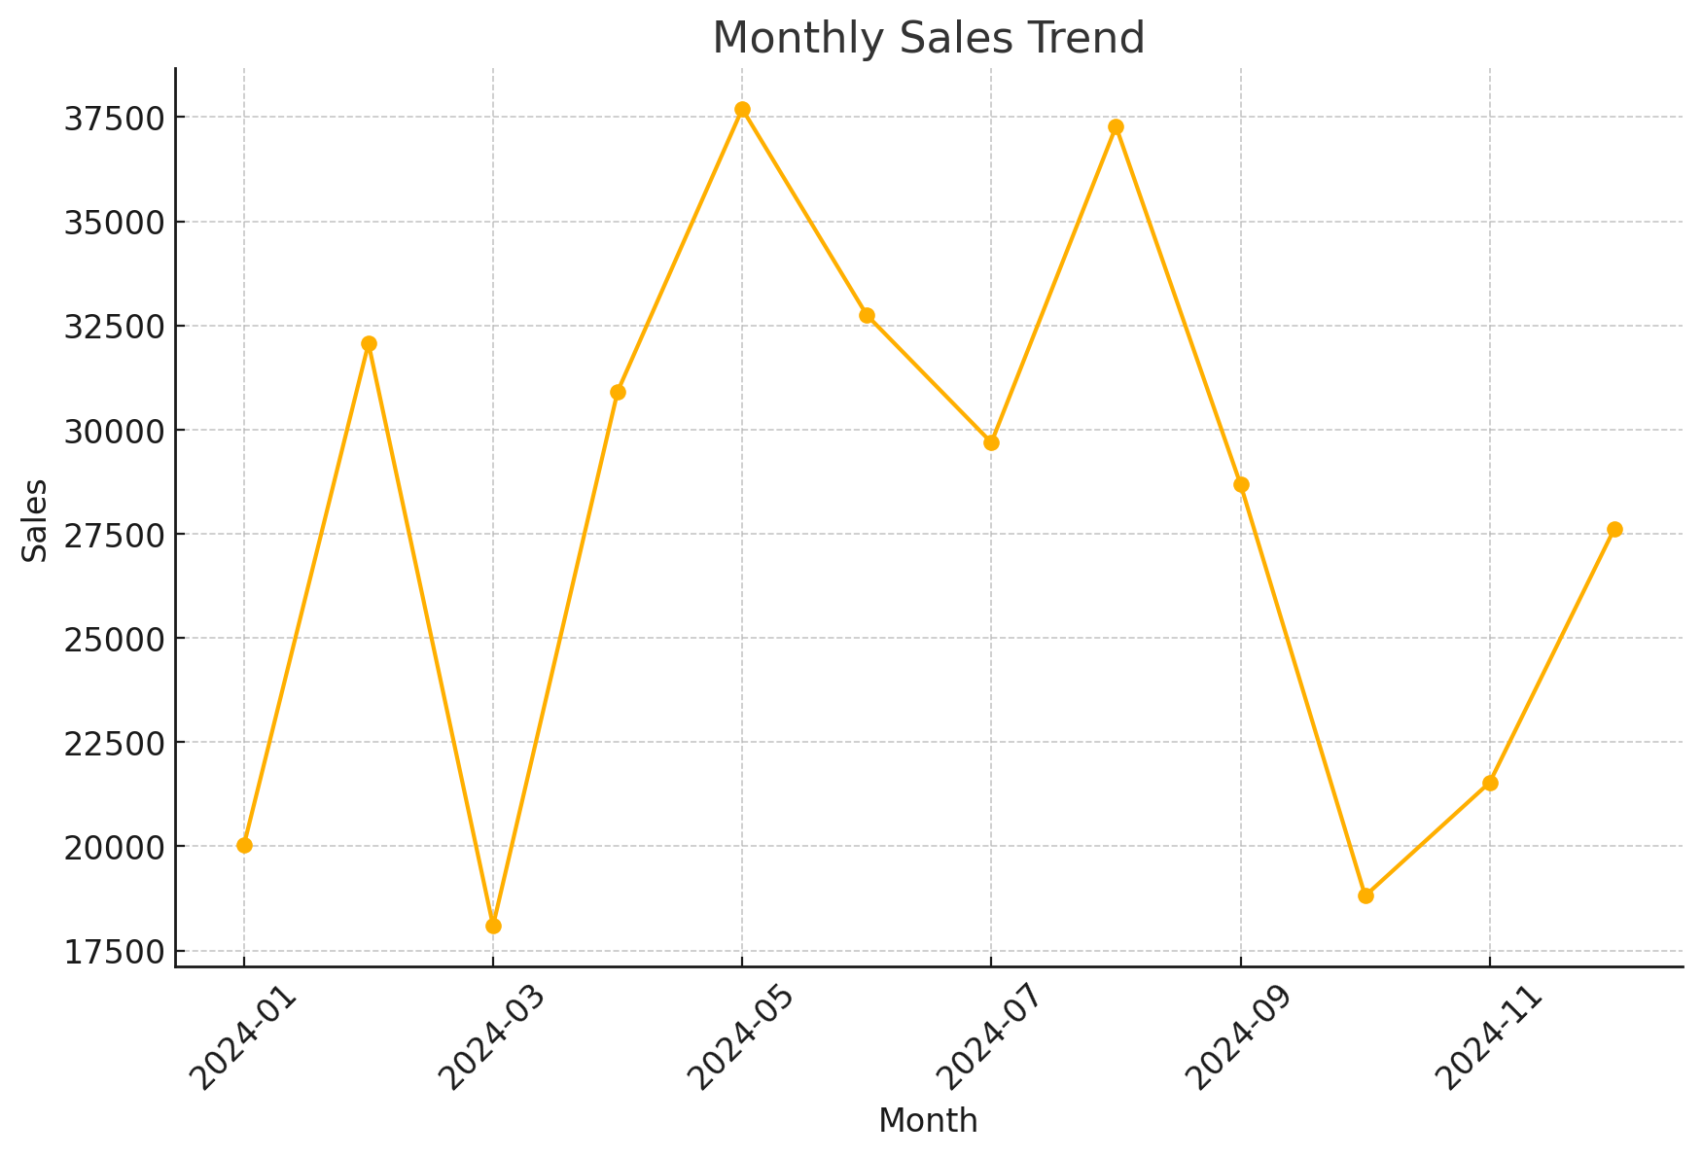
Monthly Sales Trend

4. Key Insights
• Electronics and Clothing categories generate the highest sales.
• South and West regions show stronger profit performance.
• Monthly sales show seasonality with peak months observed.
• Segment-wise analysis suggests Consumer segment dominates overall orders.

5. Conclusion
This dashboard helps management make faster and data-driven decisions. It highlights important trends, identifies profitable regions, and monitors category performance.

