**Titanic Submission**

This graph shows survival percentage of population according to the age group. From this visualization we can find out that children with age 0-9 were the once that had most percentage of survival.

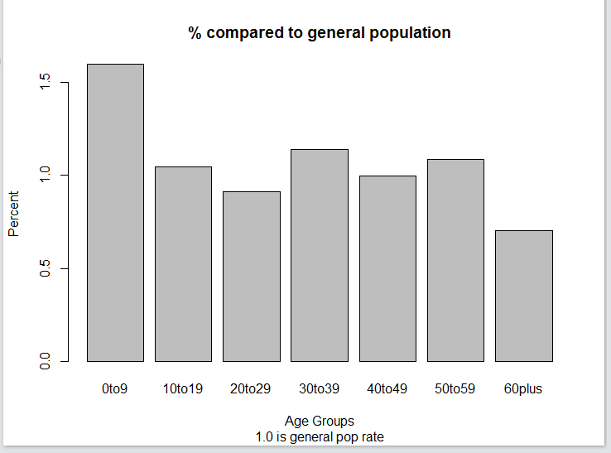

The following graph shows survival percent by fare. We have categorized different fare groups for the sake of this visualization. We can see that people who paid 90-200$ and more than 200 had more number of survivals.

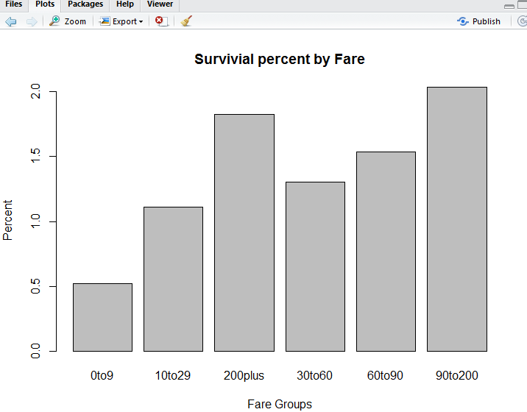

This graph shows % comparison of survival of males and females. We can see that % survivals for females is more than males.

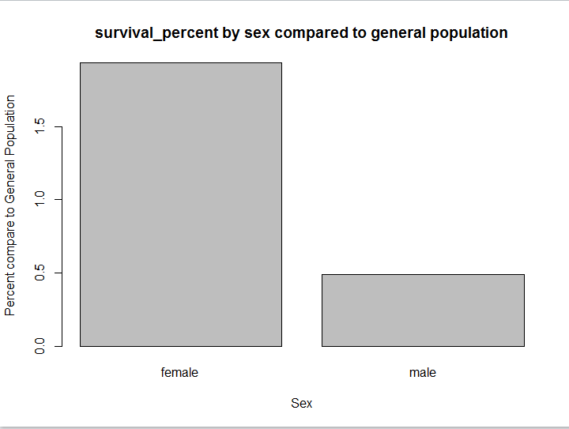

Following graph shows survival percent by pclass. We can see that people with Pclass 1 have more survival percentage compared to other classes.

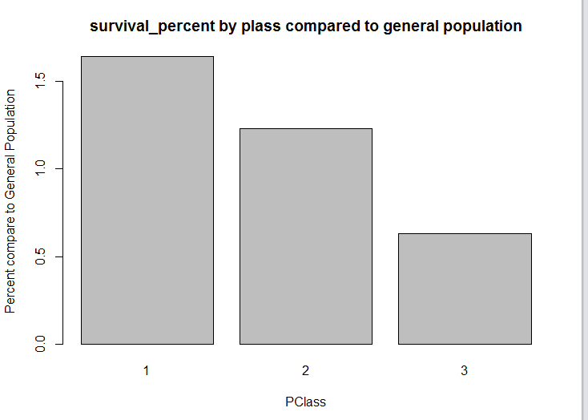

This graph shows survival percent by sibsp. People with 1 sibling had more percentage of survival compared to others.

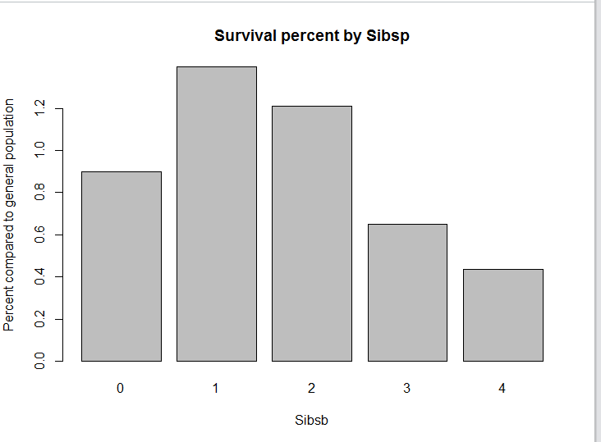

Code

mymodel = rpart(Survived ~ Pclass + Sex + Age + SibSp + Parch + Fare + Embarked, data=traindata, method="class")

predictions = predict(mymodel, newdata = testdata, type="class")

submitcsv = data.frame(PassengerId = testdata$PassengerId, Survived = predictions)

write.csv(submitcsv, file = "ashwin_titanic_2.csv", row.names = FALSE)

barplot(rate_surviving_compared_general_rate, main = "% compared to general population",sub = "1.0 is general pop rate",xlab = "Age Groups", ylab = "Percent")

barplot(survival_fare_general, main = "Survivial percent by Fare", xlab = "Fare Groups",ylab = "Percent")

barplot(survive_per_sex_comp_to_gen_pop, main = "survival_percent by sex compared to general population",xlab = "Sex",ylab = "Percent compare to General Population")

barplot(survive_per_Pclass_comp_to_gen_pop, main = "survival_percent by plass compared to general population",xlab = "PClass",ylab = "Percent compare to General Population")

barplot(Survive_per_Sibsp_to_gen_pop, main = "Survival percent by Sibsp", xlab = "Sibsb",ylab = "Percent compared to general population")