library(RcmdrPlugin.IPSUR)

data(RcmdrTestDrive)

Perform the below operations:

1. Compute the measures of central tendency for salary and reduction which variable has highest center?

ANS.

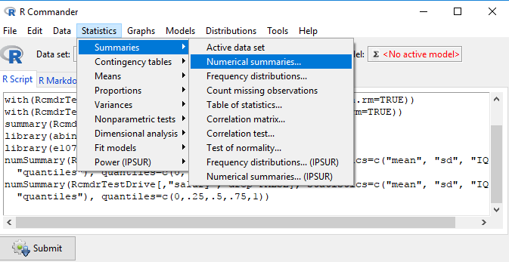

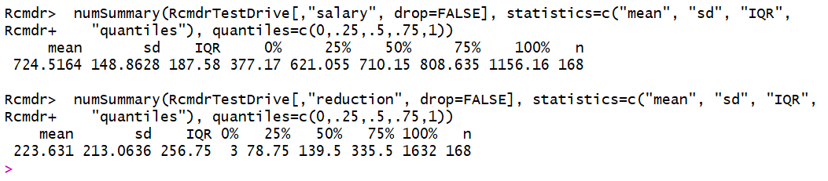

Salary has highest center.

2. Which measure of center is more appropriate for before and after?

ANS.

Mean is most appropriate measure of center for before and after.

