Q1. TRUE or FALSE

1. Prescriptive Analytics used to predict the future outcomes?

ANS-------FALSE- predictive analysis is used for predicting while prescriptive analysis is used for suggesting appropriate recommendations.

1. Base R packages installed automatically?

ANS------TRUE.

Q2. What is Recycling of elements in a vector?

When applying an operation to two vectors that requires them to be the same length, R automatically *recycles*, or repeats, the shorter one, until it is long enough to match the longer one.

Q3. Give an example of recycling of elements.

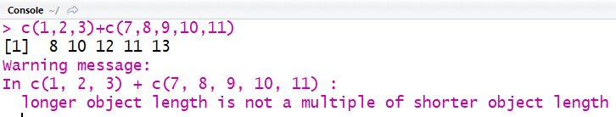

NOTE: We get a warning message NOT AN ERROR.