1. Use the given link Data Set.

Answer the below questions:

a. Visualize the correlation between all variables in a meaningful and clear way of representing. Find out top 3 reasons for having more crime in a city.

ANS.

**corrplot(cor(plot_data),type="full","circle")**

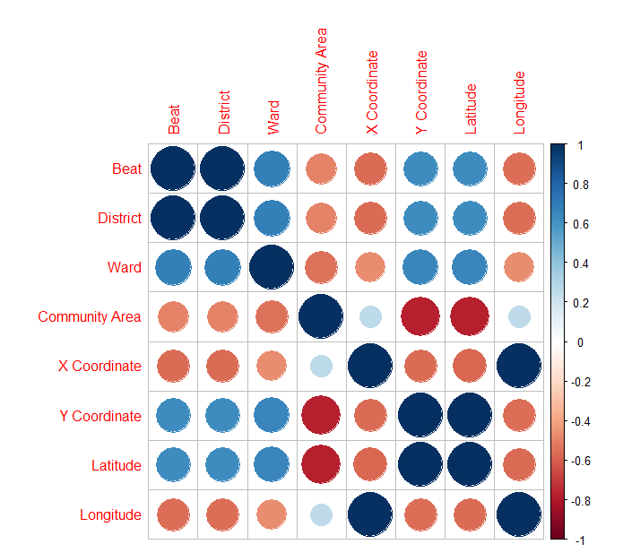

**corrplot(cor(plot_data),type="full","shade")**

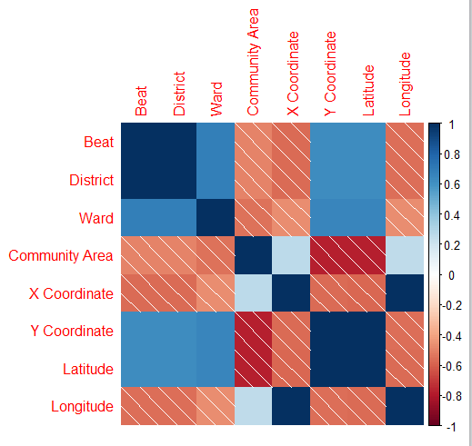

**corrplot(cor(plot_data),type="lower","color")**

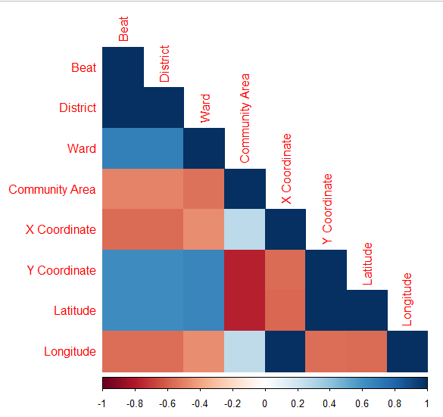

b. What is the difference between co-variance and correlation? Take an example from this dataset and show the differences if any?

ANS.

#A measure used to indicate the extent to which two random variables change in tandem is known as covariance.

#A measure used to represent how strongly two random variables are related #known as correlation

#Covariance is nothing but a measure of correlation. On the contrary,

#correlation refers to the scaled form of covariance

#The value of correlation takes place between -1 and +1.

#Conversely, the value of covariance lies between -∞ and +∞

#Covariance is affected by the change in scale, i.e. if all the value of one variable is multiplied

#by a constant and all the value of another variable are multiplied, by a similar or different constant, then the covariance is changed.

#As against this, correlation is not influenced by the change in scale

#Correlation is dimensionless, i.e. it is a unit-free measure of the relationship between variables. Unlike covariance,

#where the value is obtained by the product of the units of the two variables