1. Read multiple JSON files into a directory to convert into a dataset.

I have files text1, text2, text3 in the directory JSON.

**ANS.**

**json_text1 <- fromJSON( file = "C:/Users/Ashwin/Desktop/Data Analytics course material/text1.json" )**

**json_df_1 <- data.frame(json_text1)**

**#---------reading json file and converting to a data frame**

**json_text2 <- fromJSON( file = "C:/Users/Ashwin/Desktop/Data Analytics course material/text2.json" )**

**json_df_2 <- data.frame(json_text2)**

**json_text3 <- fromJSON( file = "C:/Users/Ashwin/Desktop/Data Analytics course material/text3.json" )**

**json_df_3 <- data.frame(json_text3)**

**json_df <- merge(x=json_df_1,y=json_df_2)**

**json_df <- merge(x=json_df,y=json_df_3)**

**#------------merging all data frames to get a combined file.**

**write.csv(json_df,"C:/target_directory/target.csv")**

**#-----------finally writing or creating a single CSV file out of them**

2. Parse the following JSON into a data frame.

js<-'{

"name": null, "release_date_local": null, "title": "3 (2011)",

"opening_weekend_take": 1234, "year": 2011,

"release_date_wide": "2011-09-16", "gross": 59954

}'

**ANS.**

**library(rjson)**

**js <- fromJSON(file="C:/Users/Ashwin/Desktop/Data Analytics course material/other/text.json")**

**js_df <- as.matrix(js)**

**js_df <- as.data.frame(js_df)**

**View(js_df)**

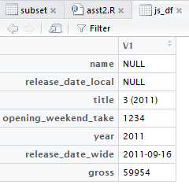

3. Write a script for Variable Binning using R.

ANS.

Binning simply means from continuous to categorical.

We will take table cs2m in which Age is continuous so we are performing binning on it using ***cut*** command.

