df1 = data.frame(CustId = c(1:6), Product = c(rep("TV", 3), rep("Radio", 3)))

df2 = data.frame(CustId = c(2, 4, 6), State = c(rep("Texas", 2), rep("NYC", 1)))

df1 #left table

df2 #right table

For the above given data frames and tables perform the following operations:

Q1. Return only the rows in which the left table have match

**ANS.**

**result <- merge(x=df1,y=df2) # ONLY MATCHING ROWS**

**View(result)**

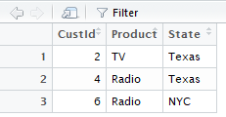

**merge() returns only matching rows from both the data frames.**

Q2. Return all rows from both tables, join records from the left which have matching keys in the right table.

**ANS.**

**View(merge(x=df1,y=df2,by="CustId",all.x = T))**

**#OR**

**View(merge(x=df1,y=df2,by="CustId",all = T))**

**# BOTH GIVE DESIRED OUTPUT**

