Q1. x <- c(‘data.science.in.R’, ‘machine.learning.in.R’)

Perform the below string Operation:

• Replace the period character "." within each string with another character i.e. "-" minus sign.

ANS.

**x <- c('data.science.in.R','machine.learning.in.R')**

**x <- gsub("\\.","-",x)**

**x**

**OUTPUT:**

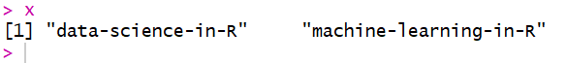

**gsub() is used for replacement purpose. But if we simply use “.” It gives wrong output as “.” replaces every character of string. Therefore we ESCAPE “.” using “\”. Now single “\” also needs to be replaced. Thus we use double “\\”.**

Q2. x <- c('data.science.in.R','machine.learning.in.R')

Perform the below String Operation:

• Append again with “-“ minus sign character at the start of the each string and finally concatenate all the

string within the vector to form a final single string and assigning it the object.

ANS.

**x <- c('data.science.in.R','machine.learning.in.R')**

**x <- gsub("\\.","-",x)**

**x <- paste0("-",x)**

**paste(x,collapse = "")**

**OUTPUT:**

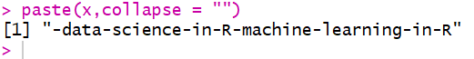

**paste0( ) is used to append “-“ at the START of string and paste( ) is used to CONCATENATE these two strings into one.**