Q1. States = rownames(US Arrests)

Get states names with ‘w’.

Get states names with ‘W’.

ANS.

***index <- grep("W",States)***

***for (i in 1:length(index)){***

***print(States[index[i]])***

***}***

***OUTPUT:***

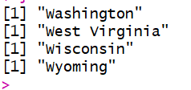

***index <- grep("w",States)***

***for (i in 1:length(index)){***

***print(States[index[i]])***

***}***

***OUTPUT:***

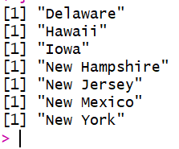

Q2. Prepare a Histogram of the number of characters in each US state.

ANS.

***ans <- c(0)***

***for(i in 1:50){***

***temp <- States[i]***

***len <- nchar(temp)***

***ans <- c(ans,len)***

***}***

***hist(ans[2:51],xlab="No. of characters in each state")***

***# As 1st element we have added is 0 which we do not want in output so we are getting rid of it. Therefore starting with 2.***

