Q1. How many vowels are there in the names of USA States?

ANS.

ip1 <- c('a','e','i','o','u')

ip2 <- rep(0,times=5)

input <- data.frame(ip1,ip2)

for(i in 1:50){

test <- States[i]

n <- nchar(test)

test <- strsplit(test,"")

temp <- test[[1]]

k <- 1

while(k <= n){

if( temp[k] == 'a' || temp[k] == 'A' )

{input[1,2]=input[1,2]+1}

if( temp[k] == 'e' || temp[k] == 'E' )

{input[2,2]=input[2,2]+1}

if( temp[k] == 'i' || temp[k] == 'I' )

{input[3,2]=input[3,2]+1}

if( temp[k] == 'o' || temp[k] == 'O' )

{input[4,2]=input[4,2]+1}

if( temp[k] == 'u' || temp[k] == 'U' )

{input[5,2]=input[5,2]+1}

k <- k + 1

}

}

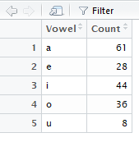

Q2. Visualize the vowels distribution.

ANS.

barplot(input$ip2,names.arg = c('A','E','I','O','U'),xlab = "Vowels",ylab="Frequency")

