1. Obtain the elements of the union between two character vectors.

vec1 = c(rownames(mtcars[1:15,]))

vec2 = c(rownames(mtcars[10:32,]))

**ANS.**

**union(vec1,vec2)**

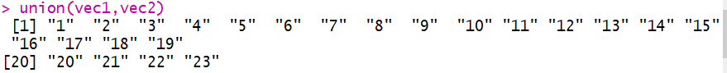

2. Get those elements that are common to both vectors.

vec1 = c(rownames(mtcars[1:15,]))

vec2 = c(rownames(mtcars[10:32,]))

**ANS.**

**intersect(vec1,vec2)**



3. Get the difference of the elements between two character vectors.

vec1 = c(rownames(mtcars[1:15,]))

vec2 = c(rownames(mtcars[10:32,]))

**ANS.**

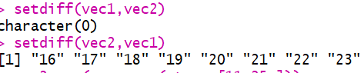

**Means vec1 is SUBSET of vec2.**

4. Test the equality of two character vectors.

vec1 = c(rownames(mtcars[1:15,]))

vec2 = c(rownames(mtcars[11:25,]))

**ANS.**

**vec2 = c(rownames(mtcars[11:25,]))**

**setequal(vec1,vec2)**

